Wellness Recovery Action Plan® (WRAP®) Updated Edition

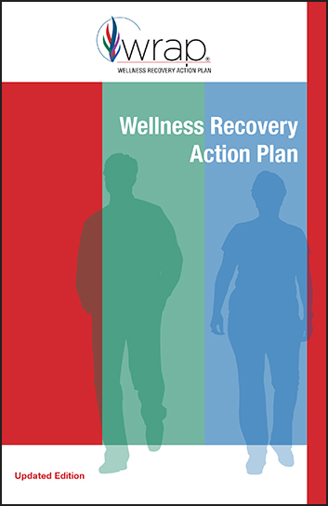
$10.00
This 2018 edition of Wellness Recovery Action Plan (WRAP) is the first substantial update to the WRAP “Red Book” in 20 years. Though revised, it offers the same simple wellness process that anybody can use to address a variety of physical, mental health, and life issues to help you achieve your wellness your way.
The updated version includes new features such as:
- A revised introduction
- Two all-new chapters
- Changes to the wellness toolbox and daily plan
- Addition of trauma-informed language
- Updates to stressors (formerly “triggers”)
- Expansion of crisis plan information
- New appendices
- Enhanced design and layout
As an evidence-based practice, WRAP peer-group intervention has been shown to increase hopefulness, improve quality of life, increase people's ability to self-advocate, increase feelings of empowerment, reduce the need to use healthcare services over time, and improve recovery outcomes.

Wellness Recovery Action Plan, often called the Red Book, summarizes the principles of this evidence-based practice and is the “go-to” book for people seeking a recovery resource or starting their own personal WRAP program. It lays the foundation for the program and explains the benefits of WRAP while guiding you through developing your own WRAP.

The updated Red Book will help you:
- Discover your own simple, safe wellness tools
- Develop a daily plan to help you stay as well as possible
- Identify upsetting events or circumstances and develop action plans for responding to them
- Create a strategy to gain support and stay in control of your wellness during and after a crisis

Who this Item is for
As with the original version, the revised Red Book is for anyone, any time. Even if you already own the Red Book, you may want to have the enhanced content that’s provided in this revised edition.
This book is used by people in all kinds of circumstances and by healthcare and mental health systems all over the world. If you want to improve wellness and feel empowered in any of these areas, WRAP is for you:
- Mental health
- Substance use and addictions
- Physical health conditions
- Lifestyle issues
This book is designed to support individuals in creating and using their own WRAP. They can use it by themselves or alongside a co-facilitated WRAP group. Agencies and organizations often purchase this well-respected book for distribution to people working with a care provider or for those working in evidence-based WRAP groups.
Please note: This book is not a guide to facilitating WRAP groups; certified WRAP Facilitators use the Facilitator Training Manual to lead groups.

Special Features
- New design with more space for notes and doodling
- Foundational book for any WRAP program; lays the groundwork for all other WRAP materials
- For use individually or in conjunction with an evidence-based WRAP group
- Emphasizes safe, simple tools and strategies anyone can use to achieve wellness
- Compatible with other health and wellness strategies, supports, and treatment programs

WRAP Workbook

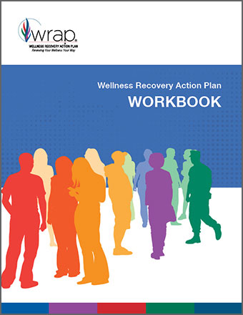
$5.00
The new WRAP Workbook has been fully revised and updated to match the new editions of your favorite WRAP books, including Wellness Recovery Action Plan (aka, The Red Book) and WRAP for Veterans, Active Service Members, and Military in Transition. New in the revised workbook:
- Prompts to help you bring WRAP’s five key concepts into your everyday life
- Tools to help you set goals in every area of your life, from your living space, to relationships, to your employment situation, to your overall health and self-care, and more

- Broader prompts in the crisis plan section to help you create a WRAP for any area of your life and wellness
- Trauma-informed language that matches recent updates to other WRAP materials
This workbook is designed to be used alongside one of the core WRAP books or while you participate in a WRAP group led by a pair of certified WRAP Facilitators.

Please note: This workbook is for individual use only. Photocopying of blank pages is not permitted. If you wish to photocopy blank forms for use in a group setting or to share with others, please refer to the handouts included in the WRAP Facilitator Training Manual or contact our permissions team for help.

Who this Item is for

Anyone creating or updating their WRAP will love having all parts of the WRAP neatly organized in this handy book of forms. This workbook is designed to work smoothly with any use of WRAP—WRAP for addictions, WRAP for trauma, WRAP for veterans, WRAP for incarceration and re-entry, WRAP for physical health conditions, and any other use of WRAP that you find helpful.

- Lay-flat design makes it easy to photocopy your completed plan so you can share it with supporters
- Standard page size makes it easy to hole-punch for a binder, store in a folder, or even carry your WRAP at all times
- Spanish version coming soon! ¡La versión en español próximamente!

Special Features
- Bound workbook keeps all WRAP forms together for easy reference—no loose pages
- Enhanced design and layout, with more room to write your WRAP on the large, lay-flat pages

