BY THE SPIRIT MINISTRIES CHRISTIAN CHURCH
Presents
GOSPEL LINE DANCING
COME GET YOUR PRAISE AND EXERCISE ON
(TAUGHT BY THE CRG LINE DANCE INSTRUCTORS)
“CHRISTIANS ROCKING THE GOSPEL”
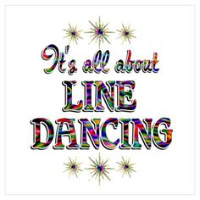
FRIDAY JUNE 1, 2018
7:00 – 9:00 PM

EVENT LOCATION
EJM EVENT CENTER
563 RITCHIE ROAD
CAPITOL HEIGHTS, MD. 20743

DONATION $10.00
(Purchase 10 tickets AND get ONE FREE)

FOR TICKETS & MORE INFORMATION CONTACT:
SISTER LAVERNE BARNUM (301) 806-1144
TRUSTEE LAVERNE HENRY (410) 212-5499
LIMITED SPACE (NO TICKETS SOLD AT THE DOOR)
***VENDORS ***CONCESSION STAND***GREAT FUN

3012 KAVERTON ROAD, DISTRICT HEIGHTS, MD. 20747
CHURCH OFFICE (301) 669-1901* CHURCH WEBSITE: www.bythespiritministries.com
BISHOP DR. ANTHONY WRIGHT, SR., PASTOR

