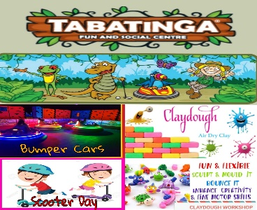

**AUSSIE KIDS FUN & FITNESS – VACATION CARE PROGRAM**

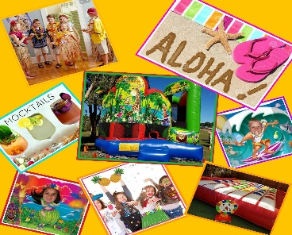











For Bookings please contact Kim on 0413974775. **NOTE:** Some Excursions require a minimum amount of attendances to proceed. All excursions/inclusions costs are incorporated into the daily fee. **Absences/Cancellations:** A minimum of 2 weeks’ notice must be given for changes or cancellations. Children must wear sun safe clothing and enclosed footwear.

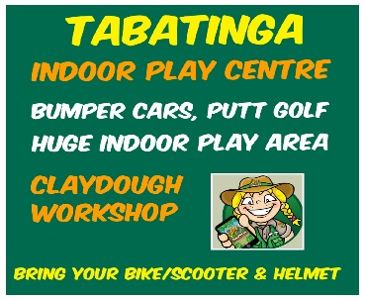

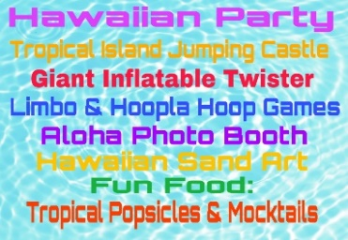











**Monday 15th April – Ratio 1:11 Venue: 54/68 Gollan Dr, Tweed Heads West Time: 9.30 am – 3.00 pm Phone: 0413974775 Tabatinga: 07 55879035 Bring: Socks, Water Bottle, Lunch, Morning & Afternoon Tea, Hat, Spare Clothes, Sunscreen, Scooter or bike, HELMET (NO NUTS)**

**Tuesday 16th April – Ratio 1:15 Venue: Collier St Cudgen, Cudgen Public School Time: Inclusion Phone: 0413974775 Bring: Water Bottle, Lunch, Morning & Afternoon Tea, Hat, Spare Clothes, Sunscreen. Option: Come dressed in Hawaii Theme**

**Wednesday 17th April – Ratio 1: 11 Venue: Mooball Street, Murwillumbah Show Grounds (Hoopla Circus) Brisbane Street, Murwillumbah (Knox Park) Time: 9.30 am – 3.30 pm Phone: 0413974775 Hoopla Circus: 0438721019 Bring: Socks, Water Bottle, Morning & Afternoon Tea, Hat, Spare Clothes, Sunscreen.**

**Thursday 18th April – Ratio 1: 11 Venue: 55 Wharf Street, Tweed Heads Time: 10.00am - 12.30 pm Phone: 0413974775 Tenpin Bowling: 07 55361606 Bring: Socks**, **Water Bottle, Morning & Afternoon Tea, Hat, Spare Clothes, Sunscreen.**

**Tuesday 23rd April – Ratio 1:15 Venue: Collier St Cudgen, Cudgen Public School Time: Inclusion Phone: 0413974775 Bring: Water Bottle, Lunch, Morning & Afternoon Tea, Hat, Spare Clothes, Sunscreen.**

**Wednesday 24th April – Ratio 1: 11 Venue: 29 Duranbah Rd, Duranbah Time: 9.30am – 3.30pm Phone: 0413974775 Fruit World: 02 66777222 Bring: Water Bottle, Lunch, Morning & Afternoon Tea, Hat, Spare Clothes, Sunscreen.**

**Friday 26th April – Ratio 1: 11 Venue: 14/23 Enterprise Ave, Tweed Heads Time: 9.30 – 3.00pm Phone: 0413974775 Kids Biz: 07 55239911 Bring: Socks, Water Bottle, Lunch, Morning & Afternoon Tea, Hat, Spare Clothes, Sunscreen. (NO NUTS)**