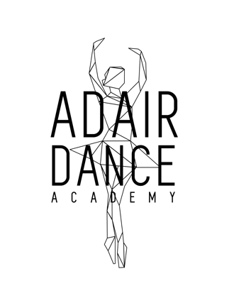

2019-2020 Registration Form
www.adair-dance.com stef@adair-dance.com
Check us out on Facebook! @adairdanceacademy

SECTION 1: DANCER INFORMATION
Student Name: ______________________________________________DOB: ______________
Address: ______________________________________________________________________
Parent/Guardian: _______________________________________________________________
Phone Number(s): ______________________________________________________________
Email(s): ______________________________________________________________________
Medical condition(s)/allergies: ___Y ___N If yes, please explain: _______________________ ____________________________________________________________________________________________________________________________________________________________

SECTION 2: REFERRAL INFORMATION
Please select all that apply: How did you hear about Adair Dance Academy?
___ Facebook ___ Internet search ___Word of Mouth ___ Newspaper
___ Friend ___ Current student ___ Other___________________________

SECTION 3: CLASS INFORMATION
Please select below what your child is interested in taking. Please note the suggested age notations beside each genre. Stef will place and enroll you as she sees fit.
___ Ballet ___ Tap (ages 4+) ___ Jazz (ages 7/8+) ___ Hip Hop (ages 5+)
___ Lyrical (ages 9+) ___ Pointe (must be approved by Stef, ages 12+)
___ Tumbling

SECTION 4: PAYMENT
A $50.00 non-refundable registration fee is required in order to guarantee your spot for class. Classes are all capped at a certain quantity so if a class reaches that capacity prior to receiving your registration fee, your child will be moved to a different class.

$50 non-refundable registration fee paid: ___Y ___ N ___ Check ___ Cash ___ Card

Signature: _________________________________________________________________
Adair Dance Academy 1100 Broad St. Adair, IA 641-740-0161 www.adair-dance.com

