Parish Council News

We’ve had a busy month both physically and organizationally. The Council decided to take some time considering the role of the Parish Clerk. Councillor Ruth Whitfield has stepped in as Interim Parish Clerk . Her key responsibilities will be to guide us in compliance with legislation and procedure. She will update the website and the email address is : clerk@westononthegreen-pc.gov.uk.
Councillor Graeme Forbes will manage Finances, Councillor Henry Donne is in charge of Planning applications and Councillors Robin Stafford-Allen and Kieran Evans are in charge of Works (to include problems and projects). Councillor Neil Mullane continues his work on Traffic. Please direct concerns in these areas to them but if in doubt contact the Clerk or, of course, myself.

I would urge you to go to the website for information about the Parish Council and read the latest Minutes. This past month we discussed:

- the Oxford-Cambridge Expressway
- how each advisory group will work
- the efficiency of our ‘action plan’ strategy
- specific planning applications and longer running enforcement issues
- plans for future work on our traffic issues
- a grant opportunity to help with some issues around the village
- the village work day supported by Dalcour Maclaren
- councillor training with Oxfordshire Association of Local Councils

We’ve been active in writing to government and local leaders with our concerns about the expressway possibly coming through the A34 route. We’ve questioned the idea of a string of housing developments along an expressway and even wondered why we need another major road when other modes of transport are more sensible. As a result of campaigning from the village, we have the attention of our MP John Howell who will be coming to the village, along with Iain Stewart MP on June 30th at 2.30 pm in the Village Hall.

As part of our working with business in the community, we are pleased to cooperate with The Manor in the planning and activities on the Food and Drink Festival on September 30th, 2018. Most organisations in the village are engaged with the project.

Following are reports from councillors with specific responsibilities. We have melded into a good team and as you can see, have set to work!

Cllr. Diane Bohm, Chair

Stepping into the shoes of our hugely experienced Clerk, Bob Hessian, veteran of many a parish issue has been quite a daunting experience. But, as I sit typing on the new parish clerk laptop, with our new clerk’s printer at the ready (all paid for care of a grant Bob applied for) I feel armed with the tools of the trade.
The clerk@westononthegreen-pc.gov.uk email address is manned and ready for action. Please do get in touch to share your issues, questions or feedback on the works you are seeing around the village.
Cllr Ruth Whitfield, Interim Parish Clerk.

Well, what a day it turned out to be! Threats of rain? ---poo! Heatstroke more like.
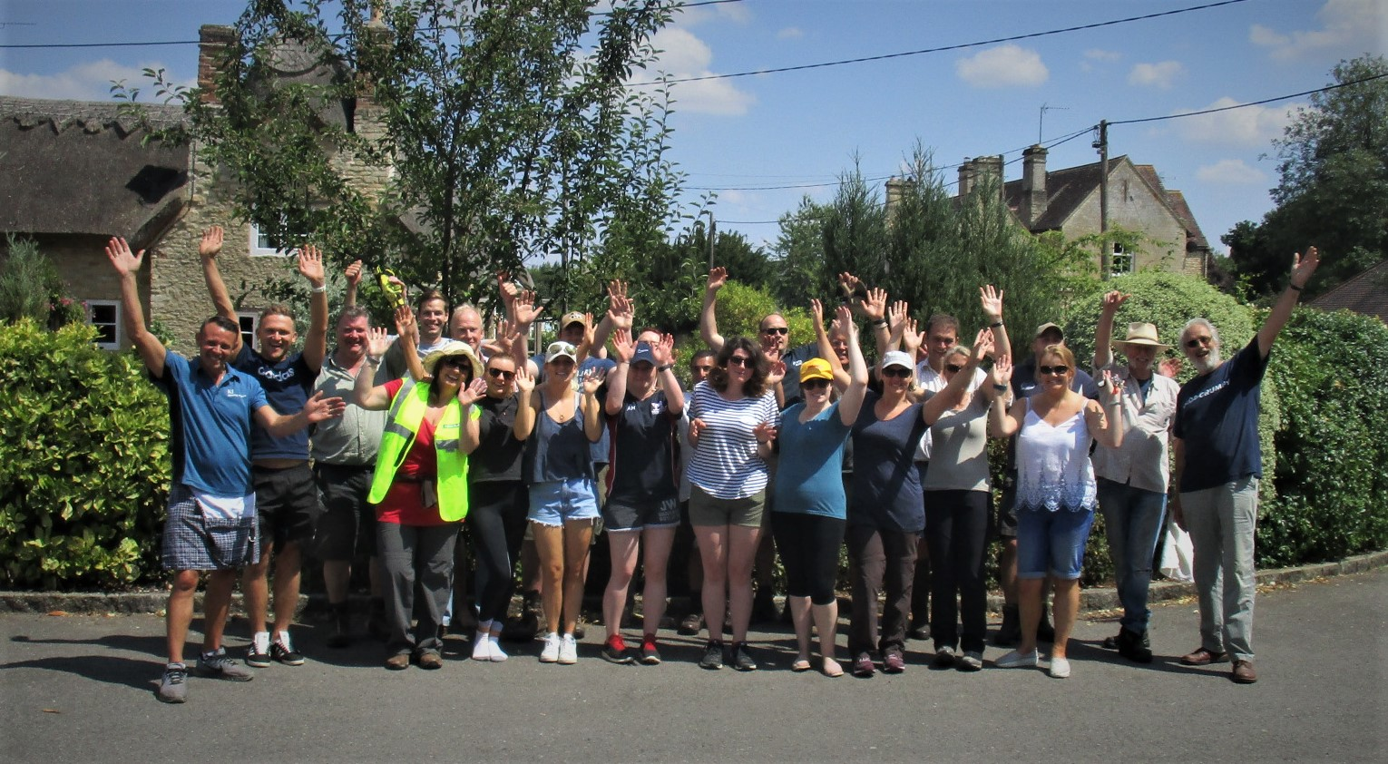
We achieved so much in the day with the 20 plus people from Dalcour Maclaren, a company from Staplehurst, who gave the village a “Community Day” in the form of labour for whatever benefited the community. Half the day was sponsored by the company and the other half was taken as holiday by the participant.
We gathered at the Village Hall as our base for the day (thank you Village Hall Committee for the gift of the hall for the day) and a group set off under Graham Barnett’s supervision on a village-wide Litter-pick.
A second smaller group set off to the stocks to renovate the benches there under Norman Machin and Eric Bohm, and the majority set off to the Playing Field to clear the perimeter and trim the car-park hedges there.

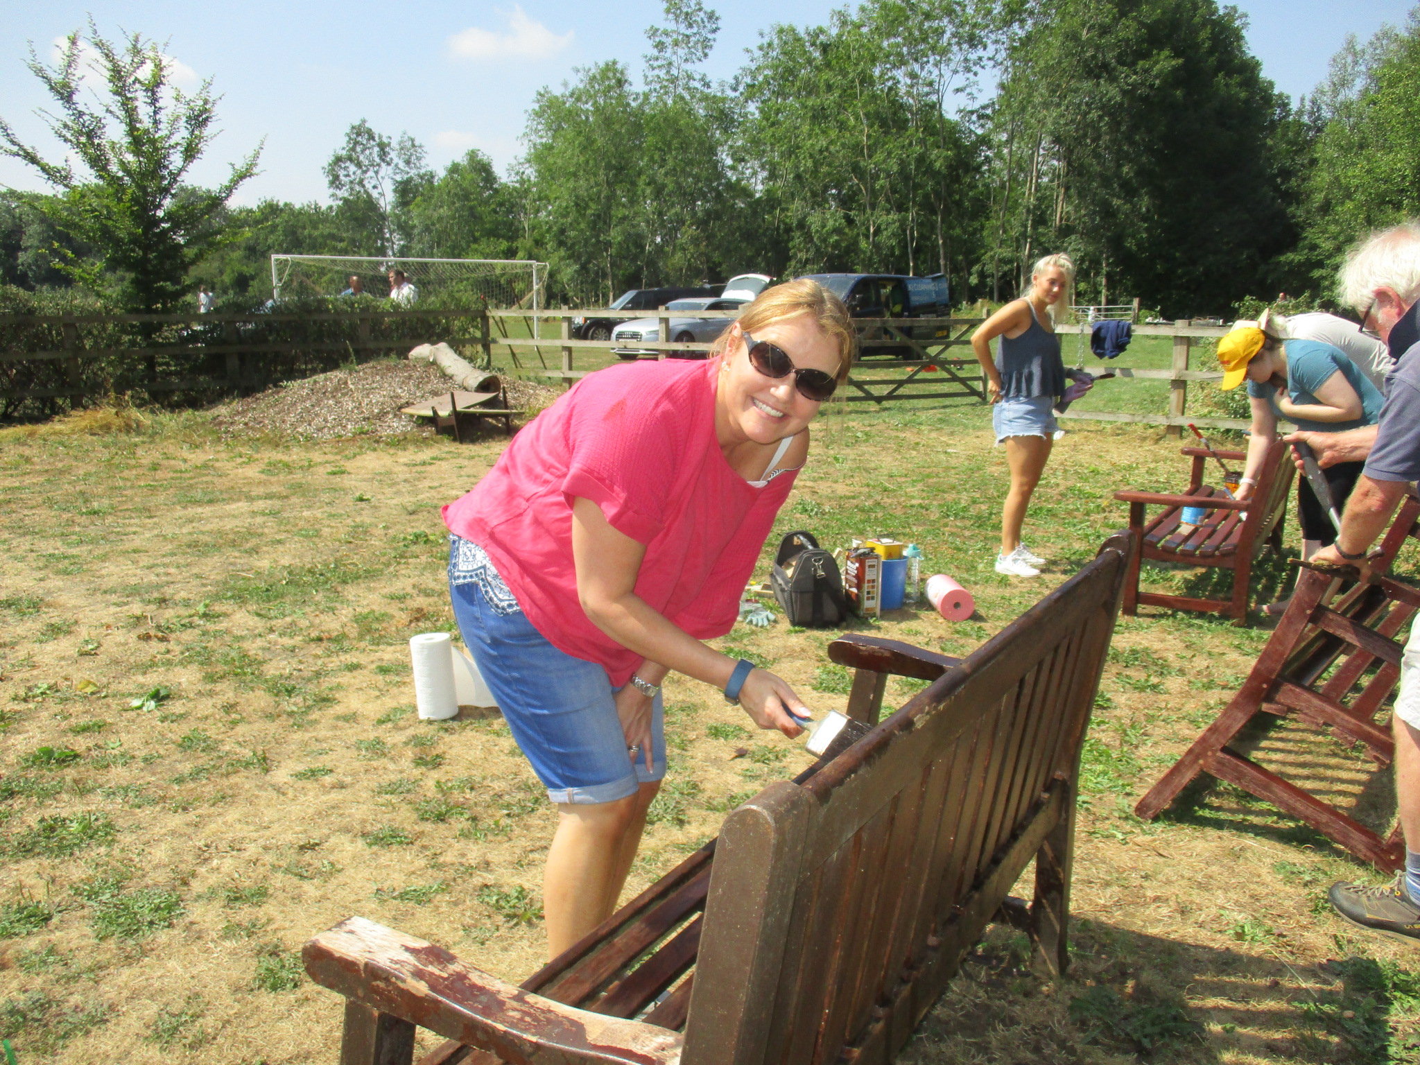
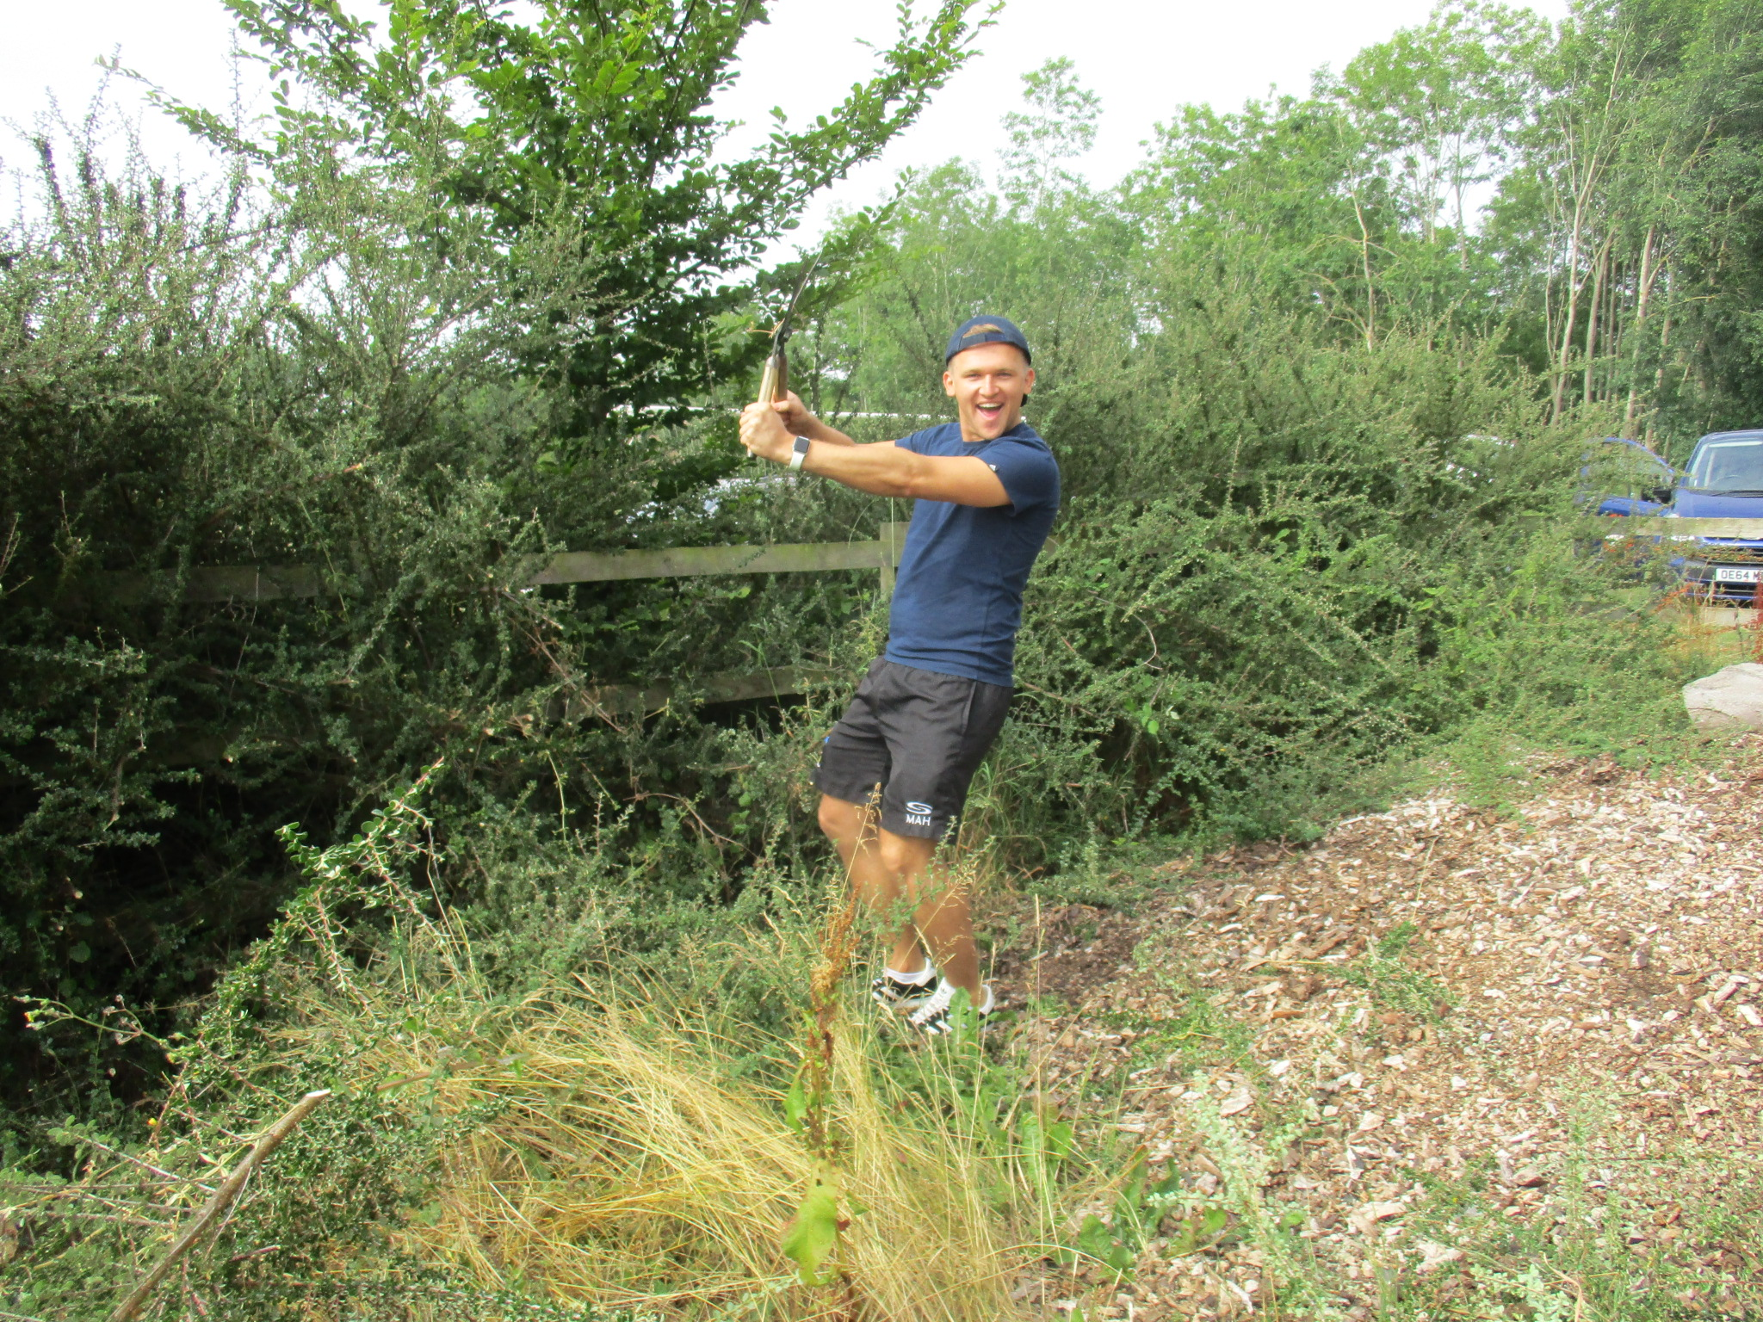

A staggering amount of work was completed before the heat became almost unbearable, and everyone stopped for lunch; a barbecue supplied by Kieran Evans’ company with desserts by Peter Driver. This went down very well with the working team.
After lunch the variety of work included clearance around the North Lane pond and gardening in a variety of gardens belonging to the “Respected Elders” of the village. The huge amount of undergrowth and branches created during the day was cleared up by John Miller to whom we owe a debt of gratitude for disposing of it all.
Cllr Robin Stafford-Allen

The TCAG group continues to make good progress as we move through Summer. One of our biggest priorities has been to implement the “20’s Plenty” signs that were suggested at the meeting with residents of Church Road/Lane meeting.

We took this approach as to get an official speed limit change can take a considerable amount of time. These were installed in late June by members of the group. We identified up to 17 different locations at changes in viewpoints where we felt reminders would be useful. However, we have not installed all of the signs to ensure we keep a balance of appropriate signage in the village whilst ensuring we get our message across.

The idea behind the signs is to provide an advisory guide to motorists and to trigger a change in their “mindset”. 30mph is the maximum desirable traffic speed, however it does not mean it is the most appropriate speed and this will depend on the environment of the area. The signs are temporary and we will move them around Church Lane/Road to keep it “fresh” in the minds of road users. We have had interest from Kirtlington and Hampton Poyle in regards to the signs and they are looking at similar solutions. A big thanks to the residents for the suggestion, to the Parish Council for the funds and to the TCAG group for the work in getting them in place.

For a number of weeks we have been working with Thames Valley Police to arrange for the Speed Indicator Device to come to the village to allow us to check speeds and report drivers who exceed the speed limit. On the 20th of July PC Rob Webb visited the village to give us access to the device and train villagers on the usage. We have the device for over two weeks and by the time this article goes to press we will be reaching the end of the test. Each driver that exceeds the speed limit will be noted and details passed onto the police. They will write to the driver and advise that they have been seen speeding, they will not be given a ticket at this point. If they are caught on these devices or have three reports for “anti-social” (police term!) driving made against them across the county then the police will visit them and take any required action. We will be using the device along the B430 in both directions and on Church Lane/Road at various points. It is our intention to gain regular access to this device and so if you would like to help support in the future then please contact Neil Mullane via email.

Finally, our battle with OCC to gain a permanent speed limit carries on with a constant chasing by email and phone. The next step is a speed survey consisting of the speed strips on the road to evidence that average speeds exceed 24mph.

If you have any thoughts or ideas to improve conditions within the village then please do not hesitate to contact us

Cllr Neil Mullane
Chair – TCAG
Email – neilmullane1@btinternet.com

Planning is an aspect that is discussed at most Parish Council meetings. The Parish Clerk is usually notified of planning applications in the village but you can always keep an eye on applications yourself by using the Cherwell District Council portal at https://www.publicaccess.cherwell.gov.uk/online-applications/
The following applications / issues were put before Weston on the Green Parish Council on 4th July
18/00261/DISC of 18/00357/LB | Williams Cottage North Lane - Discharge of Conditions 3 (stone sample panel) 4 (welsh slate 5 (doors and windows) - This was discussed and the PC made no objections.
18/00919/F | | Stonehouse Northampton Road - Extend current driveway entrance by 3.5 metres, and retrospective approval for erection of garage (constructed September 2017) This was discussed, issues had been raised by neighbours and there is an outstanding Enforcement issue on the site. PC looking to write noting both parts of the application should be rejected due to Conservation Area issues.
18/00843/F & LB - The School, North Lane. External stair and gate - Alterations to current planning 15/01293/F - This was discussed and PC made no objections.
18/00794/F | Former Little Chef (Starbucks Coffee on A34 by BP) - Erection of a drive-thru access lane and bin storage for coffee shop (Use Class A1). Previous application was refused - This was discussed and PC agreed to comment on development in Green Belt.

18/00194/ENFC: Chequered Flags - Northampton Rd - The PC received complaints from neighbours about the extension added to this property (see 15/02209/F) and further developments in the garden including a large Garage built. This was discussed and agreed for Clerk to further contact Planning and the Enforcement Team.

Land north of Oak View - Issues on the Access footpath which have arisen during the S.278 application that is regarding the works to the public highway. A pathway next to the B430 has been accepted for planning purposes but not what it will look like. The Clerk has confirmation of the listing of the Oak Tree (TPO). - This was discussed and PC agreed to contact OCC and CDC on the issue of path and Tree.

18/01157/F | Kelberg Ltd Northampton Road Weston On The Green Bicester OX25 3TH
Erection of detached steel portal framed workshop | The PC discussed concerns about the effect such a further large extension will have to the rural nature of the area, the increase in car traffic due to the expansion and the impact of extended operating hours. It agreed to write to CDC to highlight these concerns and the potential impact on the village.
Notices of Recent Decisions made by Cherwell District Council in June/July were:
18/00016/DISC | Sycamore House, Shepherds Close Discharge conditions 3 (external materials), 4 (stone sample), 6 (joinery details and rain water goods), 7 (landscaping scheme), 11 (means of access), 14 (biodiversity method statement) & 15 (mitigation strategy for bats) of 15/00187/F - conditions cleared by CDC
18/00168/F | Westfield Farm Barn Shepherds Close Weston on the Green. Erection of 2 no. detached dwellings with associated parking and landscaping | Refused
Cllr Henry Donne

