Ignite Your Energy - 101
Divine Daily Energy Routine
Five Minute Energy Exercise
The Five Minute Energy Routine packs many of the principles of energy medicine and Energy Psychology into a compact, practical form. It can be used in the morning to center yourself before starting your day, I recommended this, or when you’re feeling stressed. This set of techniques also works well any time you are feeling tired or scrambled, can’t think clearly, feel hysterical or out of control, feel droopy and out of energy, or need a pick-me-up. It represents the distilled wisdom of a quarter century of practice by the gifted energy healer Donna Eden. As a certified EEMCP of Donna Eden. Please see www.DivineEnergyHealingInc.com for additional Energy work or any level of advanced or basic Spiritual Healing needs at www.StormyLake.Us This abbreviated version is for a better understanding of the derivation of Spirit Clearing & Energy Healing , as well as a host of other methods for use in specific energy situations, Energy Medicine is a valuable guide.
The Five Minute Energy Routine consists of seven postures and movements, and takes under five minutes to perform. Note how you feel in your body before doing the routine, and how you feel afterwards. Most people who practice the routine feel a marked shift in the five little minutes required to complete the process. The routine includes:
1.The Three Thumps
2. The Spleen Tap/ Rub 3. The Cross Crawl
4. The Wayne Cook Posture 5. The Crown Pull
6. Neurolymphatic Massage 7. The Zip Up
8. The Hook Up
Here’s how you do the routine:
1. The Three Thumps - 2. The Spleen Rub
Tap or thump the indicated collarbone points with the tips of your four fingers, or the front of your fist, for about twenty seconds. Then tap over your thymus gland. Than Rub the sides of rib cage vigorously for a few seconds with deep breathing.
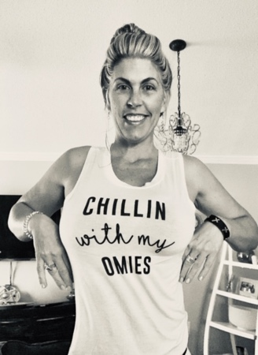

3. The Cross Crawl
The Cross Crawl looks like marching in place. That is how you start in a marching place. Rotate the sides left and right 12xtimes. Than you swing your left arm up whilst raising your right leg, and vice versa. 24 times. Move your arms in an exaggerated arc up and down, whilst also crossing the midline of your body.
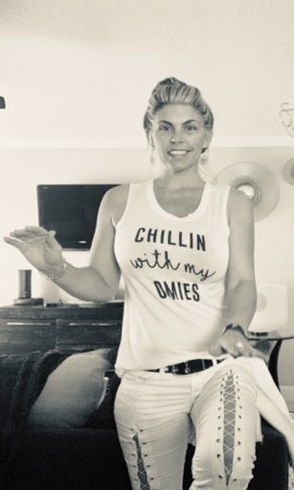
4. The Wayne Cook Posture
Sit down and place your right leg over your left knee. Wrap your left palm around your right ankle. Wrap your right palm around your instep. Breathe slowly in through your nose, and out through your mouth for the duration of this pose.
Do the mirror image of this posture.
Place your thumbs on the bridge of your nose, with your fingertips together, and take three deep breaths.
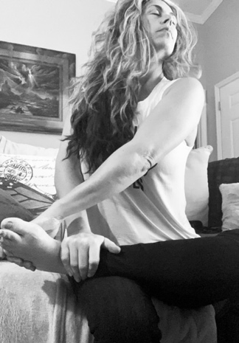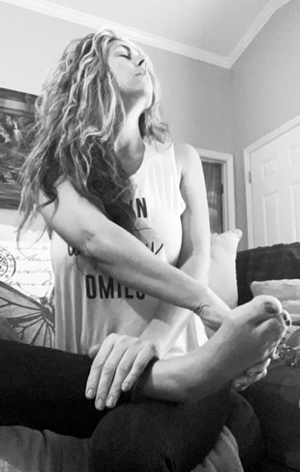

6. The Crown Pull
Place your fingertips on the centerline of your forehead. Using moderate pressure, pull them apart. Repeat this pull several times, each time moving your fingers up, till you’ve moved over the top of your head, and around back of head to ears, you are pulling at the back of your skull, opening space. Some areas will be tender, so be mindful.
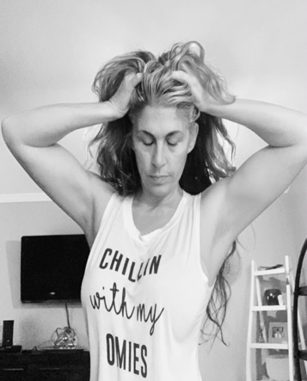

6. Neurolymphatic Massage
Massage the following places with your fingertips: Under your collarbone
Where the fronts of your arms connect to your torso down the front of your breastbone
Under your breasts
Under your ribcage, and 1 inch to each side of your breastbone
The outside edge of each thigh, from the hips to the knees
The back of your neck, from the base of your skull, then traveling as far down as you can reach.

7. The Zip Up – A nervous System Protocol.
Place your fingertips on your pubic bone.
Take a deep inbreath, whilst moving your hand up the center of your body, to your mouth. I take it to chin for picture poses purposes, however take it all the way up to mouth or above the head.
Repeat two more times. This is used for protecting the EMPATH, and the nervous system. Guard your body with this modality before work, leaving the house, speaking in public, etc.
Helps to maintain your personal power and your sensitivities to the outside world. 3 Times with deep breath while tracing upwards motion.
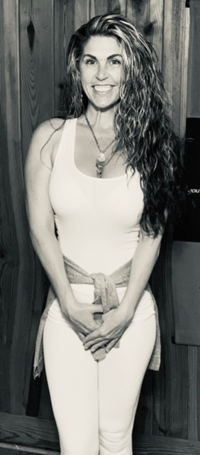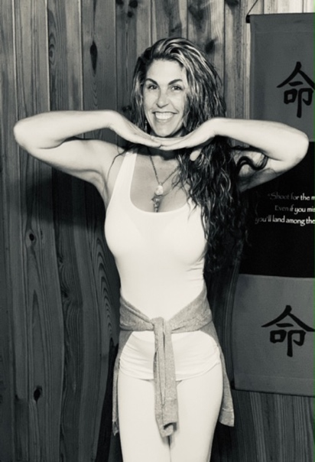

8. The Hook Up – Align Your Energy
Place a fingertip in your navel.
Place a fingertip of your other hand between your eyebrows. Pull up gently with both fingertips as you take a deep breath. This aligned the energy centers or new age term Chakras. Creates body balance and brings about focus.

That’s it! Five minutes have gone by, and most people find themselves rejuvenated.

After you’ve tried out the Energy Routine daily, you’ll find it useful anytime you need a quick boost, to center yourself at the beginning of your day’s activities, or when you’re about to enter a situation you suspect will be stressful. Beyond the immediate benefits, the routine, when practiced regularly, is designed to establish healthier “energy habits” throughout your body. Break habitual patterns of chronic emotions and elevate you energy frequency.

