Newsletter - Luau 2019 MaryJoBrown.org

Kindness Campaign Finalists

Aloha! It is hard to believe that Luau #8 and Kindness Campaign #6 have come and gone! Once again we held another successful event thanks to the hard work and support of so many people! And,of course, the highlight of the day-our 2019 Kindness Campaign Nominees who inspire us with their efforts to make the world a better place.
We arrived at noon and started setup which went as smooth as could be thanks to the assistance of cousin Ken DeCristoforo and his lovely lady Bonnie Douglas! Once we officially opened for business things just took off—with the Pats game on the TV and our emcee and DJ to the Stars, Denise “DJ Deja” LaCarubba keeping everything moving along and Amy Chabot of Snapbooth photo booth rentals making sure everyone went home with souvenirs of the day! New to us this year was college freshman, Fancina Roberts who provided us with photo and video coverage. We even got media coverage and appeared on Channel 5/WCVB’s “5 for Good” segment on Monday evening!
Our Ace of Hearts Tom Brown provided us with another delicious hot Polynesian buffet that was served with love and efficiency by MaryJo’s cousins who have supported us every single year: Bob and Michelle O’Brien, DJ Cora (who brought his lovely girlfriend Isela Flores to help) and cousin Sharon Cora who coordinated the buffet and the dessert station so seamlessly that we never had to think twice about it. We had a wide variety of dessert offerings thanks to the generosity of Bova’s Bakery (Vicki Kluse and Connie Allen you never forget us), Tracy Shea and Jim Kelble.
Our Silent Auction was a great success and we were extremely fortunate to add many new vendors to our supporter list. See the end of this newsletter for a list and, if you visit our website, you will not only see their names but a direct link to the website of each business. Should you choose to visit any of them, please mention our name!
Many folks were fortunate to win some great prizes in our 50/50 and more raffle—the pot grew to over $2200 and we were so happy to see our friend Chris Bingham of the Saugus Elks win! We are so appreciative of her donating some of her winnings back to us.

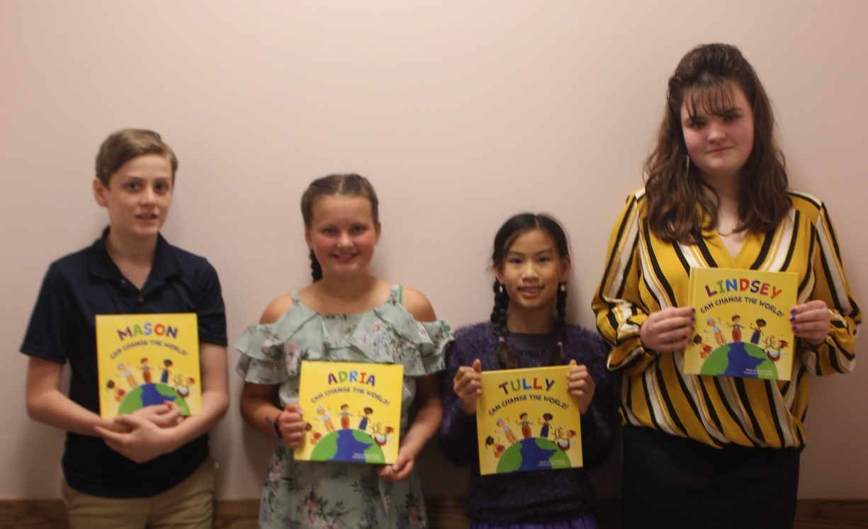
HIGHLIGHT OF THE DAY-OUR 2019 KINDNESS CAMPAIGN FINALISTS
Mason Wetmore, Adria Gregoire, Tully O’Keeffe and Lindsey Pacios
These children and their stories deserve to be shared—following are the presentations of President Christina Brown and Secretary Sharon Macone
Tully O’Keeffe is an 11 year old 6th grade student at the West Middle School in Andover and is nominated for her fundraising work on behalf of the Rock Paper Scissors Children’s Fund, a small non-profit based in Connecticut whose sole purpose is to provide education and opportunity for young girls living in poverty in Viet Nam. This organization is important to Tully as she was adopted from Viet Nam in 2008 when she was only 8 months old. In Viet Nam school ends at the 5th grade and girls do not have the same access as their brothers. There are no moms waiting in line in their SUV’s to drop the kids off—these children have a 2 to 3 hour walk to and from school—a walk that exposes girls to the risk of being kidnapped and trafficked—and the fear of this causes many to drop out of class. So providing them with a bicycle is a game changer—if they can get to school they can get an education—get a job and end the cycle of poverty. For the past four years Tully has raised money for Rock Paper Scissors. In 2016, 8 year-old Tully launched her first “Bikes for Girls In Vietnam” effort and asked for donations instead of birthday gifts. Her tagline was “educate a girl and change the world”. That first year she raised $450 -enough for 7 girls to receive a bike, helmet, tire pump and instructions in how to care for their new ride. Her fundraising has grown each year: in 2017 she raised enough for 11 bikes and in 2018 for her 10th birthday she amassed nearly $1600 –raising funds through Crowdwise in addition to her birthday wish of “No Gifts-Just Donations”. This was a very special year -through Facetime Tully was able to watch as 26 young girls were presented with a bike that she was able to provide for them.
This year in 2019 she raised nearly $3500 enough for 58 bikes for 58 girls. To spread the word to her classmates, Tully spoke to the entire student body at her elementary school---she explained her connection to the girls in Viet Nam—her enthusiasm for education—and her personal story of adoption and family. Her eloquence in sharing her story was heartfelt and was filled with passion, knowledge and appreciation.
Her plans for 2020 are to continue her personal fundraising and expand it to connect with bike shops and manufacturers to enlist their help. She also intends to give more presentations about the power of giving back so that girls everywhere have the same opportunities. We wish that we could do a power point presentation to show you the photos of all the smiles on the faces of these young girls as they received their bicycles—each picture is worth far more than 1000 words and shows us just how much one determined child can accomplish.

Adria Gregoire is an 11 year-old 6th grade student at the Whittier Middle School in Haverhill. She is nominated today for the work she has done for the past four years improving the life of elderly residents in nursing home/assisted care facilities in Haverhill as well as clients at the Senior Class Day Care Facility in Hampstead, N.H. This all began when 7 year old Adria was at Friendlys with her family and noticed an older woman who was there sitting alone—Adria who is always surrounded by family and friends asked her mom if she could please sit with the woman and provide her with some company. From this grew her empathy for seniors and, with a little guidance, she began to use her crafting skills and that year she made 23 tied fleece blankets and delivered them at Christmas to the residents in a local nursing home. Christmas is not the only time that Adria visits her elderly friends. At Easter she brings chocolates—or stuffed bunnies for those with dietary restrictions. She also visits during the summer with her project called Christmas in July where the residents receive stockings filled with treats, bubbles and kazoos. At Halloween she delivers treat bags that include socks which she enhances with grippers on the bottom –with cooler weather coming she makes sure that their feet are warm—and that they also be safe from falls. Adria funds these projects by selling her handmade pen bouquets and other items at local craft fairs, earning money by mowing lawns and doing other chores. She includes her own birthday monies to increase her shopping budget.
Christmas 2018 she raised enough money to purchase, collect or make and wrap 200 fleece and knitted blankets. These were delivered to two Haverhill nursing facilities as
girl named Bella from South Carolina that she befriended on Instagram. Bella was the same age as Lindsey and battling Osteosarcoma. The focus of Team Cure is to provide care packages, as well as spread awareness. Packages are sent, not only to children and teens that are battling cancer, but to their siblings as well. These well as the clients at the senior day care. During her visits she noticed several residents with memory issues who were either pacing or showing other signs of anxiety. Resourceful as she is, she researched this by watching videos and began reading about mechanical or robotic pets that worked well in calming people. Once again she sold crafts, earned money and pooled her own money gifts in order to purchase five of these robotic pets at a cost of $100 each to ease the anxiety and help her senior friends have a more peaceful existence. Adria is also aware of the love and care and hard work of the employees and when she visits there are treats for them as well. According to Donna Bova at the Senior Class Day Care, Adria is an inspiration to the facility management, the staff and the clients who range in age from 63 to 103. She is an amazing young lady who brings sunshine with her on every visit. For someone so young to put these elders ahead of herself brings everyone to tears. The residents may have memory issues but they always remember Adria and feel blessed to haver her come and spend time with them. Each gift that she hands to a patient is accompanied with a hug. Thus the name of her project: Warm Hugs by Adria.

Mason Wetmore is 13 and in 8th grade at the Swampscott Middle School. Mason’s grandmother, Judi, tells us he is a typical, active middle school boy, who, to quote one of his middle school teachers, is kind, smart, and funny. English and math are his favorite subjects. Some of his favorite activities include reading, rollerblading, kayaking, swimming, and cheering on his favorite sports teams, especially the New England Patriots.
In fourth grade, when an unusual stomachache and sudden weight loss abruptly sidelined him from all of these activities, a series of tests confirmed he had Crohn’s Disease, a debilitating, medically incurable disease that attacks the digestive system. An estimated 1.6 million Americans are affected by Crohn’s.
Learning that Crohn’s is a lifelong disease, Mason set out to educate the local community and to raise funds for research toward a cure. Beginning in 2016, Mason became involved with the Crohn’s and Colitis Foundation (CCF), speaking at workshops and participating in panel discussions. When his classmates began to ask him questions, he became passionate about educating those around him. Through these efforts, he has met other students in his school who also suffer from Crohn’s. Mason has offered to be a supportive friend and educational resource to children newly diagnosed, so that no child will feel alone.
He has become a leader in “Take Steps for a Cure,” a one-hour walk held in Boston where hundreds of Crohn’s and Colitis warriors, living with inflammatory bowel disease, or IBD, come together to raise money that provides funding for IBD research, advancing professional education, and patient support services. Mason formed team “Mason’s Marchers,” comprised of family members and friends whom he encourages to participate with him. For the past several years, dozens of friends and family have joined him on the walk and truly made a difference in his life, giving him strength and resolve in his endeavor.
In four years, Mason has raised over $38,000 towards a cure, and shows no signs of slowing down. He is among the top fundraisers in the New England Region for the Take Steps Walk, leading by example with his fundraising to help find a cure for these diseases. Colleen Marfione, the Walk Director, tells us that Mason was recognized as the “local Pediatric Honored Hero” and took the stage in front of 1,500 people on Boston Common to share his story and share a message of hope to others living with IBD. He may have been nervous to speak openly in front of so many about his struggles with IBD, but had the insight to know that doing so would help many people with their own IBD journeys, so put his personal comfort levels aside
Mason has given the CCF permission to connect him with any other child who receives an IBD diagnosis, so he can help them to not feel alone in their journey. He advocates, shares his story with bravery, and spreads hope to others like him.
Dr. Jess Kaplan from MGH for Children describes Mason as a kind, selfless young man with a huge heart and says, “His impact on children with Chrohn’s disease in our area is tangible.”
As part of Mason’s determination to raise awareness, he has helped to plan two well-attended brunch fundraisers, where there were 100 silent auction items. One of those auction items included a hand-crafted wooden American flag, made in Mason’s honor in memory of a veteran. At each event, Mason spoke about the need for research and explained exactly what Crohn’s disease is and how it can affect a person.
Mason’s story has also been shared in print by the Boston Herald and several regional papers.
Through an application process involving the story of Mason’s journey and fundraising, the CCF was chosen to be the recipient of funds from the Ferguson Bath, Kitchen, and Lighting Gallery annual charity golf this past July.
Former Patriot, Matt Light, who also struggles with Crohn’s Disease, sent two encouraging and congratulatory videos with Mason and called him a rock star for his fundraising and outreach efforts at such a young age!

Lindsey Pacios is 15 years old and a sophomore at North Andover High School. Lindsey founded Team Cure when she was 12 years old, after sending her first care package to a packages have recently expanded to include “Congratulations Packages” when a celebration is in order such as the last day of treatment, or cancer free anniversaries. Care packages are boxes of fun goodies, customized to include items based on the child's likes and interests, and may include items like coloring books, journals, toys, stuffed animals, headbands, and arts and crafts. When she first started, her mom Vickie, thought it was "cute" and a "nice gesture", but now that Lindsey will be turning 16 in November, she has an even stronger passion for helping these kids get through the biggest fight of their life. Lindsey has organized many fundraising events to pay for these, partnered on her own with various businesses for donations, and collected school supplies for families that could not afford them due to medical bills. Lindsey has a whole space in the Pacios home dedicated to Team Cure.
Lindsey wants to provide more awareness around childhood cancer for more research funding. People are losing their kids to these treatments more than the disease. This year, Lindsey started visiting kids that live close by, in addition to sending packages across the U.S. as well as internationally. She started a "sponsorship program" where people can directly contribute to specific kids and their needs, as making sure people see where their money goes is important to Lindsey. Karen Burnett, the mom of one of Lindsey’s friends, said Team Cure is something Lindsey is passionate about and it is great to see a teenager care so strongly about something. Lindsey has done the majority of this work on her own. Now she is moving onto bigger things, like getting bunk beds, and a new car seat for a child that was sick in her own seat from chemo. It’s amazing that Lindsey continues to do this even though some of these stories don't have a happy ending.
On her website, Lindsey has a bulleted list of accomplishments in the three years since Team Cure was founded. These include:
- We have made 120 packages to date. We have sent them to 4 different countries, 33 different US States and gave 5 packages in person to children fighting cancer
- Expanded our organization to cover siblings
- Started a blog
- Been on the news and gave an interview on a radio show
- Made countless connections with families * Collaborate with 18 brands
Faced my fear of working with more than one person. Made a lot of new friends * Learned how to get a bunch of 12 year olds involved with Team Cure
Learned how a bank account and credit card works
Stayed up until 3 am many nights working on Team Cure
Gained 10,000 followers on Instagram
- Learned more about childhood cancer than I ever thought I would
- Given a PowerPoint on Osteosarcoma to her class and taught 10,000+ people about childhood cancer
- Found out what it means to have something mean the world to you
- Found out how fragile life is and found out how lucky I am

And here is our grand prize winner: Lindsey Pacios!

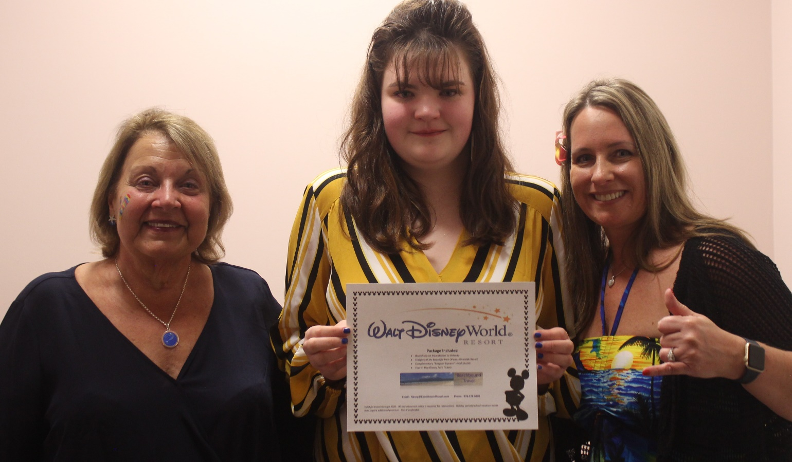

None of this would be possible without the hard work of our event staff and our supporters.
Our hearfelt thanks to: Kevin (50/50) Furlong, Denise “DJ Deja” LaCarubba, Amy Chabot, Fancina Roberts, Ken DeCristoforo, Bonnie Douglas, the Ace of our Hearts-Tom Brown, Nick Macone, Steve Young, the staff at the Saugus Elks.
And then there are the incredible businesses and individuals who donated services, silent auction items and financial support.
Blue Man Group; Boston Pizza Tours/Martin Elliot; Boston Red SoxOrganization; Briar Group Restaurants; Butcher Boy Market; Cabot Cheese; Caffe Italia; Calareso’s Farm Stand and Garden Center: Cheesecake Factory; Chili’s; Connie’s Beauty Shop; Copper Door Restaurant; Costco Wholesale; Cranmore Mountain Resort; Edaville Theme Park; Essex River Cruises; Gaslight Restaurant, Lynnfield; Greater Boston Stage Company; House of Seven Gables; Institute of Contemorary Art: I See Me Children’s Books and Gifts: Kelly’s Roast Beef and Seafood; King’s Bowl, Lynnfield; Kowloon; Lucky Strike Social; Mill River Winery; Mohegan Tribal Gaming Authority; Mystic Aquarium; Nathaniel’s at the Hawthorne Hotel; New England Aquarium; New England Patriots; Old Sturbridge Village; Otto Pizza; Planet Fitness; Ring 4 Boxing Association; Saco Bound: Sparkling Image Car Wash; Sportworld; Southwick Zoo; Swan Boats; The Salem Was Museum; Tides Restaurant; Trader Joe’s, Saugus; Tree Top Adventures, Canton; Turner’s Seafood, Melrose; Wachusett Mountain; Wegman’s
Don Algeni; Bruce Aslanian; Chris Baron; Tom Brown; Lauren and Glenn D'Addario; Ken DeCristoforo; Dianne Fanjoy; John and Phyllis Festa; Christina and Kevin Furlong;Pat Furlong;Glenda Gilleran; Donna Hicks; Kathy Macchiarola; Sharon and Nick Macone; Maryanne Mascone; Derek Mohammed; Tara Pronco; Sissy Sacrimone; Ini Tomeu ;Bea Youn; Marcy and Steve Young;Kelly Vernarelli; Chandler Winchester

SO dear friends—it’s a wrap! TWO more things:
SAVE THE DATE
Luau #9 Sunday October 4, 2020
Saugus Elks Hall 3PM-7PM
And
May all your dreams come true!

