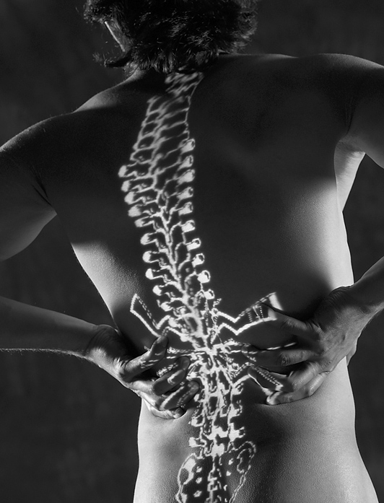
TREATMENT
Chiropractic care works on correcting misaligned or out of place vertebrae and can remove the pressure placed on the sciatic nerve, reducing pain and improving flexibility and function.

Renewed Life Chiropractic • Dr. Darcy Monti • 913.837.3310
156 Harvest Dr. • Louisburg, KS 66053
www.renewedlifechiro.com
SYMPTOMS:

♦ SENSATION CHANGES ON THE BACK OF THE CALF OR THE SOLE OF THE FOOT

♦ NUMBNESS, TINGLING, BURNING, PAIN IN BACK OF CALF OR THE SOLE OF THE FOOT

♦ WEAKNESS OF THE KNEE OR FOOT

♦ DIFFICULTY WALKING

♦ INABILITY TO MOVE THE FOOT (in severe cases)

♦ INABILITY TO BEND THE KNEE (in severe cases)

Sciatica
Definition

Sciatica is defined as pain that radiates from the lower back into the buttocks and down the back of one or both legs, caused by the irritation of the sciatic nerves, the largest nerves of the body. It usually begins as an acute pain in the lower back and then radiates down the back of either or both legs. There are 5 pairs of nerves that exit the spine in the lower back. These nerves make up what we know as the sciatic nerves. If the vertebrae or bones in the lower back are misaligned or out of place; or the disc between the vertebrae are swollen, bulged or herniated, the result is pressure on those nearby nerves. This can cause tremendous pain and normal daily activities become almost impossible.

