Kroger Community Rewards
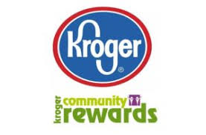
Please join the new Kroger Community Rewards Program! A portion of money spent at Kroger will be donated to our DeKeyser PTCG. A Kroger PLUS Card and online account is required. To sign up:

- Visit www.kroger.com
- Click on the ‘WELCOME’ drop-down in the upper-right corner of the Kroger home page.
- Select ‘Sign-In’ to login to your account or to setup a new account.
- Once logged in to your account, click on ‘Hi <your name>’ icon in upper-right corner of the page.
- Select ‘My Account’.
- Once you are in ‘Account Summary’, click on ‘Community Rewards’ on left hand side of screen.
- Search by School Name or enter our school code: KT148.
- Click ‘Enroll’.
- Please swipe your Kroger PLUS card each time you shop at Kroger. DeKeyser PTCG will now begin earning rewards!
*If you do not have a Kroger PLUS card, one may be picked up at the Customer Service Desk at your local Kroger.

Questions? Please contact us at dekeyserptcginfo@yahoo.com

