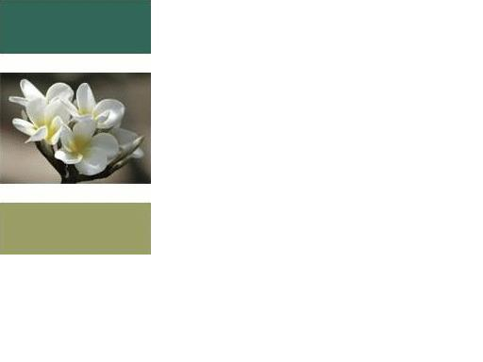

AFFIRMATIONS

Affirmations are short phrases or a short group of sentences that have a positive message for content. Affirmations are usually read or said in repetitive manner. An efficient way of this is usually in groups of three. You can practice affirmations weekly, daily, or hourly, or even by the minute. The more frequent you practice, the faster the message of the affirmation takes hold in your life.
Affirmations are used to basically help you to change an old belief that doesn’t work anymore or to help you believe something new. Some affirmations are even used to help create what you desire. Affirmations are also used to help you maintain a pure thought. (Pure thought is a thought that you have without contradicting it.)
With affirmations experience works better than explanation. To help you get started with experiencing this I try some of the following suggestions.
I am Love. I deserve a nice house.
I am Peace. I deserve a nice car.
I am Light. I am loving.
I am Beautiful. I am Caring.
I deserve good things. I am good at what I do.
I deserve prosperity. I am happy.
I am wealthy. I am supported.
I am healthy. I deserve a loving relationship.
You can try any of these or make your own. These are just examples of what you can use. If you like you can even use these but change them to better suit who you are. Try one 2 times a day for a month then change affirmations if you like.

Peace and Love,
David

