Therapeutic solutions
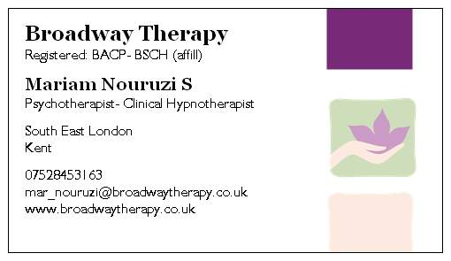

Group therapy

General open group

Well come to our therapy group

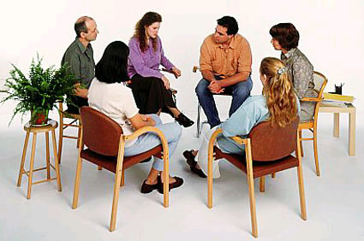
First meeting is free

The first meeting will be an open therapeutic group which will deal with every day issues of life. An opportunity to have a place to air you concern about anything that is affecting your life. At the same time learn new skills on how to deal with these issues. This first session will look at what the participants find problematic in their lives. Everyone who wants to then join the programme will register themselves in the most appropriate group to suit their particular issues. Every week there will be a relaxation session where a highly qualify hypnotherapist will work with you to teach you self relaxation techniques.
Group themes
Weight control and healthy eating: Healthy Diet-> how to eat to be healthy and to look good. Psychological issues relating to diets. How to understand our body to listen to it to be kind to our self physically and mentally. WHEE (holistic eye desensitization and EFT) -> positive memory
Group members will develop a more realistic appraisal of weight and body-size through identification of irrational beliefs about their self-image and eating behaviour.
Stress managements/ Anxiety disorders / Breathing-> Its effect on health our mental well being. Relaxation ->how and why-Self hypnosis; how to use it to heal our selves
Relationship issues / family members-> teenagers. Why we behave the way we do. (S.T.A.R.T) Situation/ Trigger/ Automatic response/ Reaction/ Tale. Relationship -> how to cope with others -> except people for who they are

How it works
You simply call or email us and book a space in one of the meetings. These will be open meetings so you can bring along any one you want. You come when you want and if you missed any dates it will not be an issue. Dates will be advertised in advance in the media / leaflets /internet sites/ in your GP. There are limited numbers in each group and if you book yourself in to all the 12 you will only pay for 10 meetings. As we would like to offer our services to as many people as possible we only charge £15 for every session or £150 for the whole 12 course. This will include relaxation session, a lecture on the topic/theme, discussions, group hypnotherapy specifically designed to deal with issues related with the topic of the session and refreshments.
To join the group you need to be 16 and over. Go through an interview process and accept the group roles and conditions.
The organisers have the right to refuse or withdraw the rights to join the group to any one at any time without any explanation.
Model of Treatment
This open group will have an Eclectic theoretical format encompassing multiple theories. Such theories will include that of Cognitive-Behavioural, Gestalt, Psycho-educational, hypnotherapy, Self-Help and Existential. Techniques may be drawn from other disciplines to fit the group. The focus of the group and its use of specific theories are likely to alter slightly based on the group members’ specific needs.

Specific therapy groups

What is a specific therapeutic Support group?
- Therapeutic groups are made up of people going through shared life experiences, exploring these with the help of their peers and a skilled facilitator
- They differ from other informal support groups and ‘drop-ins’ in that they are structured; operating within a set of ‘ground rules’ agreed on by their members and are time limited
- Therapeutic groups can offer its members a safe environment in which to discuss their feelings
- Peer support can enable members to ‘move on’ emotionally and feel more in control of their lives. Inclusion in such a group can increase self-confidence and self esteem
- Receiving genuine support and understanding can help to reduce some of the tensions and stresses inherent in
These groups will be offered to members who have been attending the open well being group. Or anyone who is referred by other health professionals (GPs) or would like to self refer. They will be more specialised and run in smaller groups
There will be an interview process for external or self referrals.
These groups will have to be only open for two weeks and then no new members can join from week three. This is to protect the process and allow the members to bond and to help the confidentiality issues.
Specific group’s titles:
- Anxiety: General or performance related / phobias
- Weight-> loss or gain
Eating disorders-overeating -binge eating/ bulimia.
- Group members will identify anxiety provoking events, thoughts or feelings/emotions associated with eating disordered behaviour. Group members will be educated about alternative coping strategies to lead to termination of disordered behaviour. Group members will identify individual goals for their treatment in addition to pre-established treatment goals.
Relationships-> couples/ family/ mothers and daughters
- Group members will develop better understanding of their interpersonal communication skills and assertiveness that will allow them to identify and verbalize their emotions and needs from others, rather than keeping them internalized.
- self-harm
- How to be a better parent
Group facilitator: Mariam Nouruzi MBACP & BACH (psychotherapist- Hypnotherapist) www.broadwaytherapy.co.uk
mar_nouruzi@broadwaytherapy.co.uk or mar_nouruzi@yahoo.
Group process and roles
Group members will understand the group process to be a non-threatening environment to overcome emotional barriers and psychological barriers through use of empathy, unconditional positive regard, genuineness, etc.

Group members will be educated about and develop “self-reward” methods to be used upon the successful implementation of various coping mechanisms in replacement of negative thoughts.
Group members will identify goals they have for their future in order to better understand their desire to heal, through existential meaning.
Group members will be given the opportunity to reflect and evaluate their success throughout the length of the group.
Upon the recognition of the thoughts/emotions associated with triggering eating disorder behavior, the group will be introduced to a stimulus control strategy to reduce/eliminate destructive behavior.

