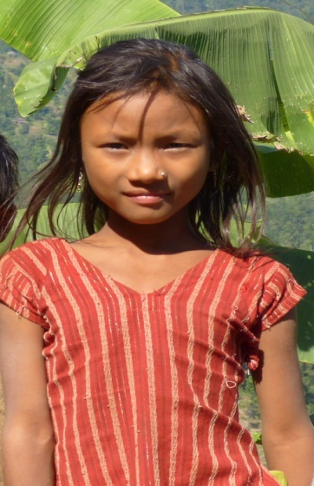
Martha
Date of Birth : Apr 18 2003
Age: 9 Year
Religion : Christian
Martha is 9 years old and she lived in Khairang-2 with her family. There are 6 members in her family. Her father doesn't have a permanent job and her mother is suffering from finger cancer since long time ago. Her family is homeless. They don't have their own land. That's why they work at the field of others to fulfill their daily needs. Field work is dependant on the season so he works 9 months in the year and 3 months he doesn't get work so at that period they have eaten Gitta. Her family has lots of problems. Because of the poverty no one gets a chance to go to school from her family. She wants to go to the school but her family is not able to send her to the school. So they are uneducated. Raksirang is a very rural area and lots of the girls have been sold from this area in the past. She isn't aware of the human trafficking. But she is at risk of being trafficked.

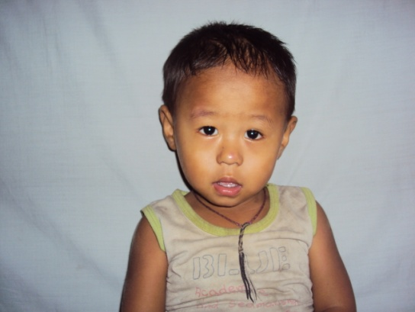
NIMESH 2 YEARS OLD
CHILD’S ID NO :WPP
DOB : August 31, 2010

Nimesh is the son of Sita Shrestha, who is a former survivor who stayed in a brothel in India for a long time. She was kicked out of the brothel when she became HIV infected. Sita often gets sick and she is without any income. They struggle every day to buy food, medicine and to meet their basic needs. Nimesh is very small. He hardly gets any nutritious food to eat. He also gets sick often and desperately needs sponsorship to cover his medicine and food expenses.

