Lei Welch  Like Da Juice |  | 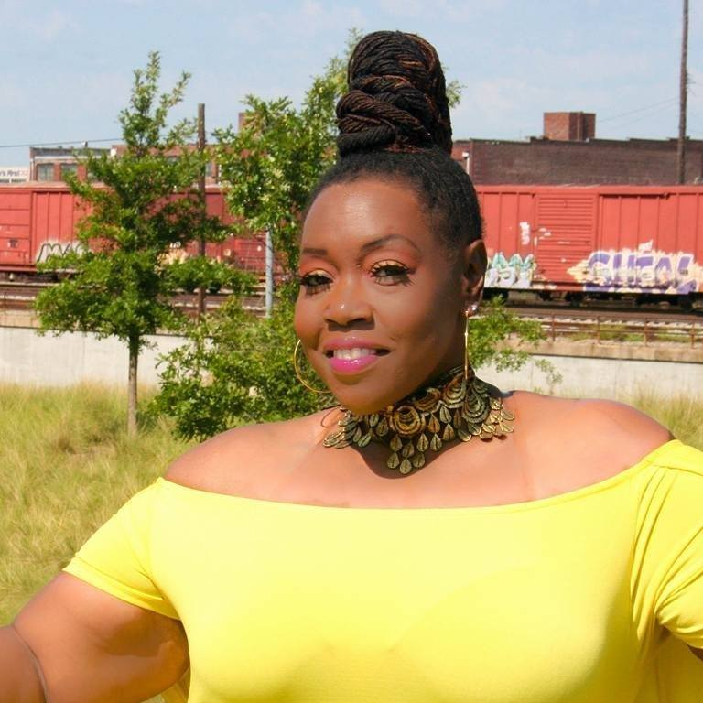

Bio
My resolve is to help people to address low self-esteem. Then to heal and maintain a healthy one. This will have a huge impact on your confidence. I suffered in silence for years with low self-esteem, because I believed that I was ugly. It was only when I became an adult and with God’s help, I was able to heal.

I realize there are still many adults who are struggling, wounded from childhood hurts and still hurting from echoes of life. Hence, I am the Self-Esteem Healer, Creator of Da Great I Am and best-selling Author of Who Says You Can’t!

Reviews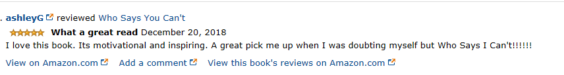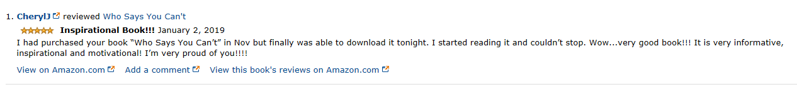

Speaking Topics
Don’t Take Ownership
Important Factors to Reclaim or Reboot Your Self-Esteem
Key Factors of Getting You in Order

Accomplishments
Who Says You Can’t! Best Seller on release date
Interviewed Frazer Ramsey Podcast creator of Ramsey Unleased from London
Interview with Desiree Lee Founder of Authors In Business
Selected for best read in December with Courageous Women Magazine
Selected for March read with Club Reads Between The Wines

 |  | Contact
 |  | Birmingham Al 35208
 |  | 205 598-7738
 |  | leiwelch@dagreatiam.com
 |  | likedajuice.com
 |  | Social Platforms

