Nutrition Plus, Inc.
Emily Roark Patti Brenn Susan Morrell
(620) 221-2777 (620) 218-4994 (785) 224-4104
roark2@cox.net pattibrenn@cox.net smorrell12@gmail.com
www.nutritionplusinc.com
March is:
National Celery Month
National Flour Month
National Frozen Food Month
National Noodle Month
National Nutrition Month
National Peanut Month

Important dates to remember:

“Infant Feeding in the CACFP”

March 23rd - Topeka Workshop at library 6:30 pm
March 26th – Winfield Workshop at Presbyterian church
6:30 pm
March 27th – Checks and direct deposits go out

Grocery shopping on a budget
Part 1 of 2. To be continued next month.
Some of these tips might sound familiar, but some may be new! I hope you find something on this list helpful in order to shop smart and save money.

- Eat before you go. You will be surrounded by food and are at risk of making purchases based on what sounds good in the moment.
- Make a shopping list (and stick to it). Use your menus as a resource on your needs and don’t be tempted to veer away from what you actually need.
- Shop once a week. This will reduce food wastage and help with time management.

March 2020

- Check store adds before you go. This will help you find out what’s on sale and give you time to adjust your menus accordingly so you don’t always have to spend full price.
- Sign up for and use local stores’ rewards programs. These are free and rack up points toward coupons and/or free items.
- Time your shopping trip. At least weekly, stores mark inventory as clearanced when they are approaching their expiration date. You can time your trip to take advantage of these discounted prices on meat, produce and bakery items. Freeze meats immediately if you can’t use them right away. This is a huge help!
- Check your receipt. Make sure all sale prices are registered when checking out. Sometimes the original price is scanned incorrectly.
- Watch out for aisle end items. Many stores use the ends of aisles to get seasonal appropriate items out in front of the public eye. Don’t be fooled by these. Many times, lower priced brands are in the aisles and can save you money.
- Look up and down. Eye-level shelves are where the higher-priced, name brand items are stored. Generic brands tend to be above and below these. Many times, these are the smarter option. Don’t discount store or generic brands. Don’t forget to check prices of name brand vs. other brands. Sometimes sale prices are better on name brands than the original price on a generic item.
- Don’t assume sale prices are saving you money! The sale item may not be the best deal. Compare price per ounce. This is posted in many stores to help you make an easy compareson.

More tips to come next month. Stay tuned!!
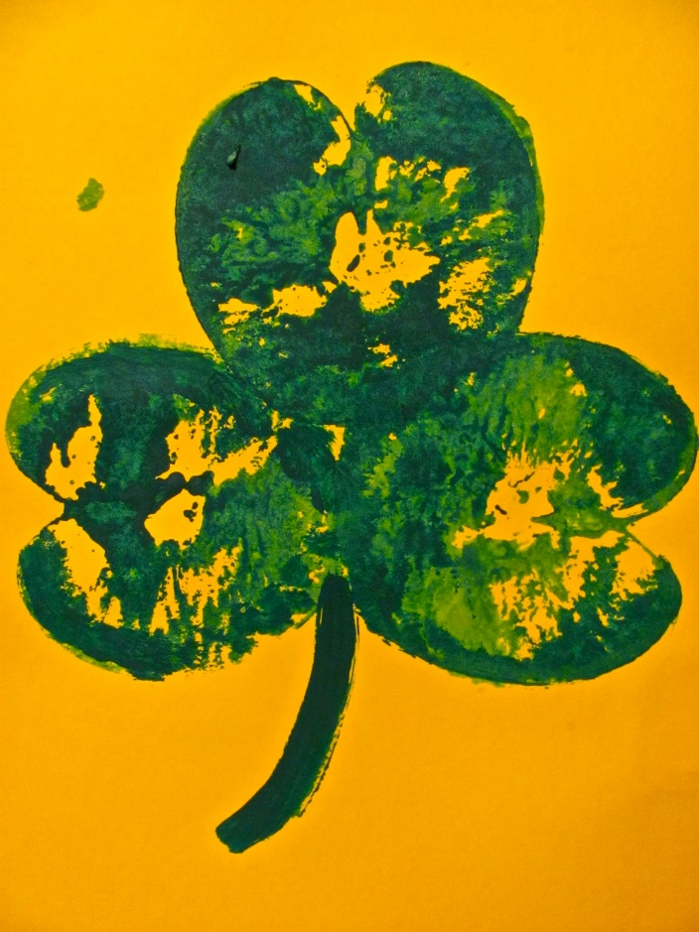
Apple Shamrock Artwork!
You will need:
an apple
a knife
paper plates
green paint
construction paper
a paper towel

Paint one half of the apple with the green paint, or you can have the kids dip it on the paper plate.

Start by cutting the apple right down the middle and pick out the little seeds.

Have the kids stamp the apple against the paper REALLY hard so the paint goes on well.

Have them do it 3 or 4 times to make a shamrock or 4-leaf clover shape.

Grab a paintbrush and add a stem coming out from the bottom with green paint.

Carrots ends can be cut into heart shapes to make little shamrock shapes around the larger apple shamrocks for extra decoration for older kids if interested.
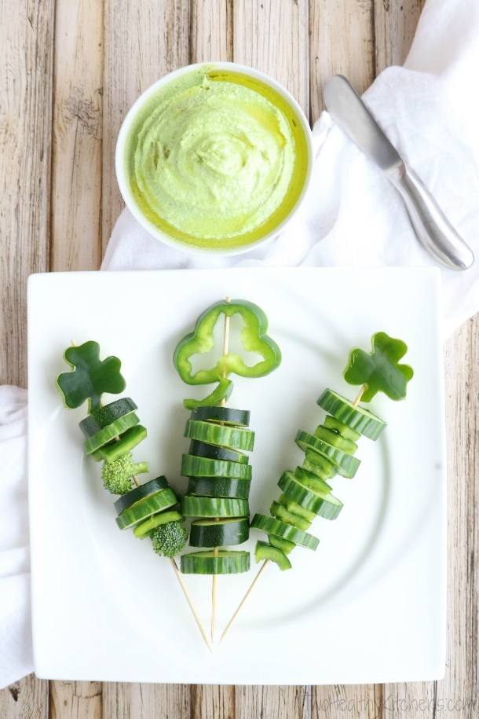
St. Patrick’s Day Snack Skewers

You will need:

Assorted Green veggies (broccoli, snap peas, cucumbers, green peppers (for making shamrocks), cut into bite-size pieces) and Mozzarella cheese stick, cut into bite-size pieces

Thread assorted green veggies onto wooden skewers, adding in cheese every couple of layers, leaving enough room at the top to finish each with a shamrock-shaped pepper.

To make the shamrock peppers for the top of each skewer, you have two options, as shown in the photos in our post: (1) Cut your green peppers with a metal shamrock-shaped cookie cutters. The cutter we used was about 1¾". (2) Or, use small green peppers, and cut them with a sharp knife horizontally into "rings." The shape of the pepper rings should look a bit like a shamrock. If you'd like, as you thread these on your skewers, you can add thin slices of green pepper underneath them as "stems” to finish the treat!

Serve with hummus or ranch dip.

Thanks for being the best part of Nutrition Plus! Emily, Patti and Susan

