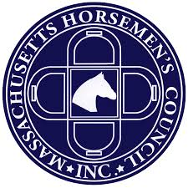
2018 MHC AWARDS BANQUET
Award Pick-up Request

If you, as the award winner, are unable to attend the 2018 MHC Awards Banquet, but you would like to make arrangements for an assigned person to represent you and accept your award on your behalf please complete the below information.
This is very helpful in our processing to assure that all of the award recipients are provided the appropriate awards that they have won.

Please provide the following:
Award Recipient Name: __________________________________________________________
Award Recipient Address: ________________________________________________________
Award Recipient Phone Number: __________________________________________________
Recipient’s Date of Birth: ___________________________
Award Division (s): ____________________________ Award: __________________
____________________________ Award: __________________
____________________________ Award: __________________

Assigned Representative: ________________________________________________________
(Please Print Name)
Representatives Confirmation Signature upon receipt: ________________________________
MHC Board Member Confirmation Award has been given: _____________________________

THANK YOU, and CONGRATULATIONS on your award!!

