Health Implications of Lead Contamination
Ghaida Alsadah
May 2, 2016
GCH 360-002
Shannyn Snyder

Abstract
“There are approximately half a million U.S. children ages 1-5 with blood lead levels above 5 micrograms per deciliter (µg/dl).” (Centers for Disease Control and Prevention [CDC], 2016). Lead’s effects on children are significant due to children’s sensitive bodies, along with being exposed due to playing with certain objects. Not only children are affected by lead poisoning but also adults, especially pregnant women (Environmental Protection Agency [EPA], 2015). Lead in pregnancy cause health implications on both the mother and the fetus. Some health implication from lead poisoning in pregnancy are abortion, compromised neurodevelopment, and low-birth weight (ACOG, 2012). Therefore, the existence of lead in one’s body has health implications that could put children and pregnant women at risk. This paper is aimed to look at two cases involving lead poisoning, along with displaying health implications from lead for both children and pregnant women.

Introduction
According to the CDC (2016), there is no safe amount of lead in the body, and lead in one’s body can affect all body systems. Lead particles usually cannot be seen by our eyes because they are very small (National Safety Council [NSC], 2009). Lead can be found in cosmetics, water, food, household dust, paint, and soil (NSC, 2009). Before 1978, Lead was mainly used in painting houses, which in long periods may come out from the paint and contaminate soil or dust (NSC, 2009). Therefore, children who play outside with the soil may inhale/ingest the contaminated soil and get poisoned. In addition, when doing renovations to a house, where leaded paint was used, it could harm both children and adults (NSC, 2009). Children and adults can also become poisoned by lead when being exposed to leaded gasoline. According to the National Safety Council (2009), leaded gasoline, which was “only recently banned in this country, contributed greatly to the number of cases of childhood lead poisoning in the US during the last sixty years or so.” Lead accumulates over time, which makes it more dangerous to humans’ health. Leaded gasoline’s emissions may end up on soil. Therefore, children can get poisoned by playing in contaminated soil with their toys through hand-mouth activity. They can also take the lead with them from outside, which could be tracked potentially to their homes and cause lead exposure to other members of the family (NSC, 2009). Furthermore, lead can be found in water, which comes from lead pipes, brass faucets, and fixtures and solder (EPA, 2016). Leaded water can especially harm infants, leading them to have lead poisoning, when they drink their formula with contaminated water (NSC, 2009). Lead exposure has health implications for children and pregnant women, however, lead exposure can be prevented.

Background: Regulations
Although regulations regarding the use of lead have reduced the number of cases of lead poisoning, there still are many children and adults exposed to lead. One of the regulations is the Toxic Substance Control Act of 1976, which gives the Environmental Protection Agency the responsibility to oversee specific toxic chemicals’ usage and disposal such as lead-based paint (EPA, 2015). Another law that is purposed to protect children from lead poisoning and prevent the use of lead-based paint is the Residential Lead-Based Paint Hazard Reduction Act of 1992. The act aims to eliminate the use of lead-based paint in housing and raise awareness regarding lead-based paint hazards (EPA, 2015). One of the most important acts is the Safe Drinking Water Act of 1974, which is aimed to protect the public and assures them that the tap water they use is clean and safe for consumption. The act gives the EPA responsibility to put protection standards for drinking water. There are also other acts that are involved in regulating the usage of lead in various products, to help decrease lead poisoning cases among the population in the United States.
Methods of research:
The research needed to provide the health implications of lead poisoning is based on elevated blood lead level (BLL) in one’s body. My research was conducted to find journals and articles written about the people affected by lead poisoning. What I found in my studies is that, to prove that health implications seen are caused by lead, one’s blood lead level must be elevated.
Health implications: Children
“Lead poisoning accounts for about 0.6% of the global burden of disease.” (World Health Organization [WHO], 2012). Children are more susceptible to lead exposure than adults for various reasons (WHO, 2012). Babies can acquire lead from their mothers while in the womb; the lead can travel from the placenta to the fetus (NSC, 2009). Subsequently, the damage done by the lead can be more severe on children because they are in a stage where their bodies are still growing and forming (NSC, 2009). A child’s brain can be affected when being exposed to lead during growth, which is irreversible (WHO, 2012). With high-exposure to lead, symptoms can be obvious due to lead poisoning (WHO, 2012). Children can get encephalopathy that can lead to coma, death, and ataxia. Other symptoms are anemia, fatigue, colic, and constipation. According to the CDC (2011), a boy aged 4 died in 2006 due to acute lead poisoning. If an exposed child does not die, he or she is going to have problems with his/her neurodevelopmental function (WHO, 2012). At low-level exposure to lead, symptoms may not be obvious but lead has effects on the body even in low doses. Lead can affect the brain and lower the intelligence quotient (IQ). As the blood lead level increases in a child’s body, IQ point decreases. For each 1 µg/dl BLL, ¼ to ½ point is reduced from the IQ (WHO, 2012). In addition, BLL affect peripheral nerve function and can lead to hearing problems, and ADHD (Agency for Toxic Substances and Disease Registry [ATSDR], 2007). BLL can also lead to 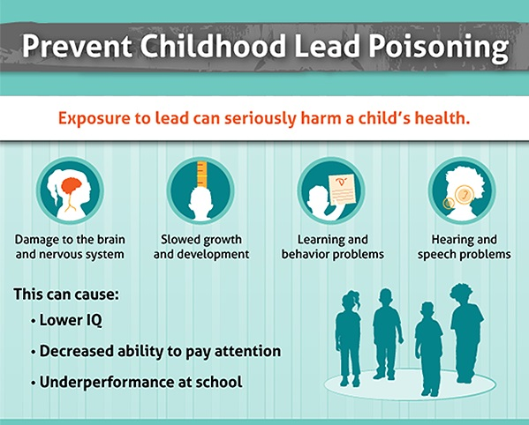learning disabilities, behavioral problems, antisocial behavior, renal effects, and impact on reproductive and immune functions (WHO, 2015).

Figure 1: health implications of lead poisoning on children (Centers for Disease Control and Prevention, 2013).

Health Implications: Pregnancy
Some evidence shows that exposure to lead during pregnancy may cause spontaneous abortion although more evidence regarding it are still needed (American Congress of Obstetricians and Gynecologists [ACOG], 2014). Some studies suggest that exposure to lead during pregnancy can result in low-birth weight infants, and high lead in the umbilical cord of a preterm infant (ACOG, 2014). Also, lead exposure can affect an infant’s length, head circumference, and weight at birth. In addition, high blood lead level in an anemic pregnant woman can rise lead absorption in the body.
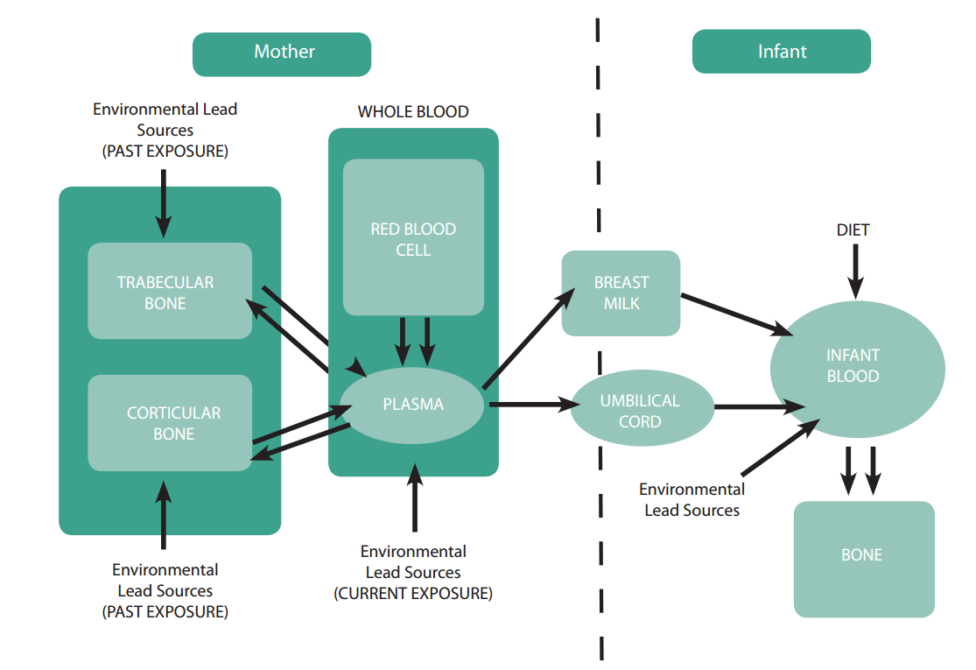

Figure 2: Lead exposure and transfer from a mother to an infant (Centers for Disease Control and Prevention, 2010).

Case Study 1:
The first case was conducted by the Department of Health and Mental Hygiene in New York City in corporation with the Centers for Disease Control and Prevention, reports a boy aged one, who had lead poisoning in 2009 (CDC, 2011). The boy was born in the United States but his parents are from Cambodia. The boy, who had a cousin that was tested positive for lead, had Blood lead level of 10 µg/ dl. During the first inspection by the EPA, there was not any specific leaded objects found. The boy’s father told the EPA that they do not have any imported objects. After three months, the boy’s blood lead level was tested and risen to 20 µg/ dl. Before doing another inspection, the father was called and he said that the boy did not wear any jewelry or charms, but then he told the EPA that his boy wears an amulet for protection. The boy’s family said that they got the amulet from a Cambodian market, and that the boy has been wearing it since he was three months old. They also have seen the boy putting the amulet in his mouth. After the second inspection, the EPA found a small amount of leaded paint and non-paint leaded sources such as rice, spices, and the amulet. The amulet had 45% lead, however, other items were below the limits of detection. After 8 days of removing the amulet, the boy’s blood lead level decreased to 14 µg/ dl. Lead paint was also removed and after six months, the boy’s BLL was down to 10 and by five months it was down to 5 µg/ dl.
Case Study 2:
The second case was conducted by the Ambulatory Pediatrics Association in 2003, and it is focused on lead poisoning during pregnancy (Shannon, 2003). Fifteen pregnant women from different ethnicities, most of the pregnant women were at 32 weeks, but 2 of them were in their third trimester. Most of their ethnic origins were identified, 2 Indians, 7 Latina, and 1 Caucasian and five of the women’s ethnic origins were not stated. Initial range of maternal blood level varies from 40 to 104 µg/ dl. Symptoms appeared are fatigue, anemia, and malaise for all women, and basophilic stippling for two of them. 83% of the women, the Latina, got the lead poisoning from ingesting soil and clay-substances. Other sources of lead were from contaminated calcium supplement, and home renovations. Five out of ten women went through chelation, which did not pose any negative impact on both mother and fetus.

Analysis:
Low-blood lead level may not show any symptoms, which makes lead even more dangerous than other elements. Effects of lead may vary from one person to another based on the dose of lead in one’s body. Exposure to lead, either low or high dose, can be preventable. Many people know that lead is dangerous, but they may not know where they get it from. The most common sources of lead are from paint and contaminated soil. According to the Centers for Disease Control and Prevention (2014), to prevent being exposed to lead from paint, we are recommended to test the paint if a house was built before 1978, and make sure all the time that children do not peel the painted surfaces. Also, being away from old houses’ renovations can prevent children and pregnant women from being exposed to lead. In addition, parents should make sure that their children do not play with bare soil because it might be contaminated. Parents also should clean their children’s toys and should wash their hands frequently (CDC, 2014). In the first case study, the boy got lead poisoning from jewelry. Some imported jewelry contain lead, that can put children’s lives at risk. To prevent exposure from leaded jewelry, parents should pay attention to where they get their stuff from, and should read recalls of leaded items, to protect their children. In some cultures, there are some rituals of pregnant women eating soil. There are also women who experience pica cravings that lead to consume soil (American Pregnancy, 2015). In both examples, soil can be contaminated with lead, which cause lead poisoning to pregnant women. They are various sources where children and pregnant women can get exposed to lead. For example, recently in Flint Michigan, many children and adults have been exposed to lead in water from old pipes. According to A Publication of the American Public Health Association (2016), there was an increase in children’s blood lead level after what happened in Flint. Therefore, those children are at risk of lead poisoning, and they are going to experience health implications due to that crisis. Flint crisis happened not because parents did not protect their children but because people in Flint were not protected by government officials.
Conclusion:
To sum up, lead can be found in various items and places such as jewelry, paint, gasoline, and soil. Exposure to lead has health implications that can affect both children and pregnant women. Lead dose, either high or low can harmfully affect one’s body although symptoms vary based on the level of lead’s concentration in the blood. However, there are some steps parents and pregnant women can follow to prevent being exposed to lead.

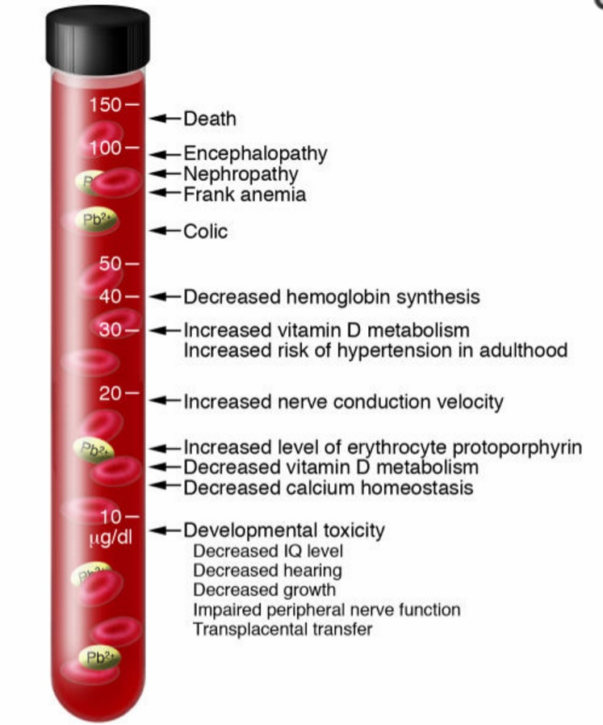

Figure 3: Symptoms associated with various blood lead levels (Bellinger & Bellinger, 2006).
References
Agency for Toxic Substances and Disease Registry. (2007, August 20). Lead Toxicity: What Are the Physiologic Effects of Lead Exposure? Retrieved April 14, 2016, from http://www.atsdr.cdc.gov/csem/csem.asp?csem=7
American Congress of Obstetricians and Gynecologists. (2014). Lead Screening During Pregnancy and Lactation. Retrieved April 15, 2016, from http://www.acog.org/Resources-And-Publications/Committee-Opinions/Committee-on-Obstetric-Practice/Lead-Screening-During-Pregnancy-and-Lactation
American Pregnancy Association. (2015, July). Pregnancy and Pica. Retrieved April 19, 2016, from http://americanpregnancy.org/pregnancy-health/unusual-cravings-pica/
American Public Health Association. (2015, November 21). Elevated Blood Lead Levels in Children Associated With the Flint Drinking Water Crisis: A Spatial Analysis of Risk and Public Health Response. Retrieved April 22, 2016, from http://ajph.aphapublications.org/doi/full/10.2105/AJPH.2015.303003
Centers for Disease Control and Prevention. (2016, January 29). Lead. Retrieved April 17, 2016, from http://www.cdc.gov/nceh/lead/
Centers for Disease Control and Prevention. (2011, January 28). Lead Poisoning of a Child Associated with Use of a Cambodian Amulet --- New York City, 2009. Retrieved April 16, 2016, from http://www.cdc.gov/mmwr/preview/mmwrhtml/mm6003a2.htm
Environmental Protection Agency. (2015). Lead Laws and Regulations. Retrieved April 20, 2016, from https://www.epa.gov/lead/lead-laws-and-regulations
Environmental Protection Agency. (2016, March 17). Basic Information about Lead in Drinking Water. Retrieved April 23, 2016, from https://www.epa.gov/your-drinking-water/basic-information-about-lead-drinking-water#getinto
National Safety Council. (2009, April). Lead Poisoning. Retrieved April 18, 2016, from http://www.nsc.org/NSCDocuments_Advocacy/Fact Sheets/Lead-Poisoning-Fact-Sheet.pdf
Shannon, M. (2003). Severe Lead Poisoning in Pregnancy. Ambulatory Pediatrics, 3(1), 37-39. doi:10.1367/1539-4409(2003)0032.0.co;2
World Health Organization. (2010). Childhood Lead Poisoning [Pamphlet]. Geneva, Switzerland: WHO.
Digital Images
Bellinger, D. C., & Bellinger, A. M. (2006, April). [Lowest observed effect levels (μg/dl) of inorganic lead in children.]. Retrieved April 29, 2016, from http://www.ncbi.nlm.nih.gov/pubmed/16585952
Centers for Disease Control and Prevention. (2010, November). [Major Lead Exposure Pathways from Mother to Infant]. Retrieved April 25, 2016, from http://www.cdc.gov/nceh/lead/publications/leadandpregnancy2010.pdf
Centers for Disease Control and Prevention. (2013, December 18). Prevent Childhood Lead Poisoning [Digital image]. Retrieved April 30, 2016, from http://www.cdc.gov/nceh/lead/infographic.htm

