Life-long Practice of Music-making: a Credible Alternative to Mindfulness Meditation Practice?

Katrina Gordon, University of Aberdeen
Author contact: katrina@caithnessmusic.com +44 1847 893517

Acknowledgements
The author is grateful for the co-operation of all participants.
I would also like to thank the staff at the University of Aberdeen for their guidance, and those friends who were generous enough to share their insights and criticisms during our discussions.
Special thanks go to Fiona Matthews for her contribution as Research Assistant.
Table of Contents
Research Report 2
Background 3
Aim 3
Rationale 3
Literature Review 4
Defining “mindfulness” 4
Long-term practice 5
Mindfulness and music-making 5
Attention and awareness in music-making 6
The implications and benefits of practising music mindfully 7
Research Questions 7
Methodology 8
Epistemological stance and research paradigm 8
Recruitment 9
Data-collection tools 9
Process of analysis 11
Presentation and Discussion of the Results 12
Musical experience of participants 12
Physical self-awareness 13
Present-moment attention 15
Extrospective awareness 17
Attitude 19
Summary of results 23
Limitations of the Research 25
Conclusions, Implications and Recommendations 26
To what extent can music-making be considered a “mindfulness practice”? 26
Is there a correlation between lifetime hours of music practice and the development of: 27
Implications and recommendations 27
APPENDIX: Sample page of a completed present-moment experience questionnaire 29
Bibliography 30

Research Report

Background
The Buddhist concept of mindfulness has developed over more than two millennia and is described in the Pali Canon as being “the one-way path… for the overcoming of sorrow and lamentation, for the passing away of pain and displeasure” (Bodhi, 2011, p21). Interest in secular approaches to the strengthening of mindfulness in individuals has risen exponentially over recent decades (Williams and Kabat-Zinn, 2013). Mindfulness practice is a method of “transforming the mind” (Olendzki, 2011, p66) and meditation is generally considered to be the primary vehicle for this (Siegel, Germer et al., 2009, p21). This study examines to what extent music practice might be worthy of consideration as an alternative secular vehicle for strengthening mindfulness.
To date, there has been no published research into long-term music-making as a mindfulness practice.
The author is the co-founder of a musical social enterprise with the aim “to promote health and well-being through group music making” (Gordon, 2016). This secular organisation uses four principles to guide all its activities - honesty, kindness, inclusivity and generosity - based on an assumption that a positive attitude is the key to well-being.
This paper investigates the correlation between the long-term practice of music-making and the mindfulness of twelve musicians during a community jazz-band rehearsal.

Aim
The aim of this study is to provide empirical data in the field of music and mindfulness and to inform future research in order to increase understanding of, and thus maximise, the health-giving potential of music-making as a mindfulness practice.

Rationale
This study is of interest to musicians because, despite the seemingly mindful nature of music-making, addiction and mental health problems are faced by an inexplicably high percentage of professional musicians (Dobson, 2011; Jones, 2016; Gross and Musgrave, 2016). By contrast, learning a musical instrument has been shown to be beneficial to both academic achievement and well-being (Creech, Hallam et al., 2013; Chanda and Levitin, 2013; dos Santos-Luiz, Mónico et al., 2015). Also, the brains of orchestral musicians have been shown to contain more grey matter which is retained during the aging process compared to non-musical controls (Sluming, Barrick et al., 2002). The author’s long-term aim is to explore and explain this paradox with the goal of benefitting musicians who suffer with mental health problems.
This study is also relevant to mindfulness practitioners. Music-making is just one example of mindfulness in daily life, referred to as “informal practice” by the Mindfulness Association (2015, p23). Many people find maintaining mindfulness during the activity of daily life challenging (Kabat-Zinn, 1994; Williams, Teasdale et al., 2007). If music-making can strengthen mindfulness, then this additional practice may be of benefit to meditators who struggle with mindfulness in daily life. For others, meditation itself has risks: one study of meditators revealed that 7% suffered “profound adverse effects” following retreats (Shapiro, 1992). Despite limited research in this area, there are many anecdotal stories of people who have suffered severe adverse effects from meditation (Farais and Wikholm, 2015). For people such as these, the prospect of formally developing and strengthening mindfulness through an activity like music-making might offer a safer alternative to meditation practice.

Literature Review
There is very little extant research in the field of music-making as a mindfulness practice, although there is much which is tangentially relevant.

Defining “mindfulness”
This study adopted a primary working definition of mindfulness as: “the optimal interaction between moments of attention and moments of awareness” (Yates, Immergut et al., 2017 , p425). Yates et al. (2017) describe the need for a balance of attention and awareness which is highly relevant to the working musician’s practice.
The definition of mindfulness used in Mindfulness Based Cognitive Therapy also includes being “non-judgemental” (Gethin, 2011, p273). This attitude is tested by musical activity - without judgement, or at least discernment, one would simply have noise rather than music, despite participants being “mindful” according to our working definition. However, there can be no doubt that attitude plays a vital role in defining “right mindfulness” in a Buddhist context: Maex suggests that “without kindness, respect and dignity, it is not right (samma) mindfulness at all” (2011, p169). This attitudinal aspect of mindfulness seems relevant to mental health and so was also a core element of this study.

Long-term practice
Both musicians and Buddhist mindfulness practitioners engage in long-term daily practice, sometimes over a whole lifetime. Ericsson et al. (1993) conducted two empirical studies into the role of deliberate practice in a musical context, using classical violinists and pianists as subjects. They suggested that the optimal amount of time to practice is 2 to 4 hours per day over at least 10 years in order to become “expert” (ibid., p392-393). This type of practice involves the interaction of attention, awareness and attitude.

Mindfulness and music-making
There is a paucity of literature on the topic of mindfulness in music-making. Langer et al. (2008) uniquely studied the effect of mindful orchestral music-making on an audience, but unfortunately did not examine what was happening in the minds of the participating musicians.
Only one published paper has examined the relationship between mindfulness and music-making from the perspective of the practising musician (Steinfeld and Brewer, 2015). The authors argue that the practice of music can be usefully reframed as a practice of mindfulness meditation. The paper highlights many similarities between the practice of music and the practice of mindfulness meditation:
- A relaxed, upright posture
- An experience of concentration which is firmly grounded in the present moment
- A requirement to rest one’s attention on something
- Similarities in the teaching lineage of musicians and lineage of Buddhist practitioners
- A wider context of cultural tradition
- A need to notice one’s mind and its activity during the practice session
- A requirement for the experience of self during silence as part of the practice
- A willingness to scrutinise oneself honestly and thoroughly
- The repetitive returning of attention to the object of one’s practice

Attention and awareness in music-making
Steinfeld and Brewer (2015, p86) propose that the sole “object of the musical meditation” is the act of imagining the sound of the music in one’s mind just prior to playing it, which they term “music in mind”. However, the author’s understanding is that while an experienced musician’s attention can be placed firmly and consciously in any one moment, the exact placing of that attention depends on the musical demands of each moment. This view is reinforced by the work of Sloboda (1985) and Green (1986). Sometimes a practising musician’s attention does rest with “music in mind” (i.e. the pitch or phrasing) but there are many competing potential foci of attention, e.g. the actions of the conductor, the written page, the technique of a specific body part, communication with the audience, etc. Musicians, therefore, must consciously and frequently switch the focus of their attention whilst managing to avoid distraction (Loubriel, 2009, pp 65-66).
This viewpoint is validated by a recent study (Moradzadeh, Blumenthal et al., 2015) which examined task-switching capability in musicians. It showed that participants who had undergone long term musical training of more than 10 years demonstrated significantly increased ability to switch their attention quickly and consciously from one task to another compared to non-musicians and suggest that this is due to higher levels of wider awareness.
This constant switching of attention is a feature of music-making, and whether it is deliberate or not is of interest. From a Buddhist standpoint, uncontrolled flickering of attention is known as künjung, “the origin of suffering” (Trungpa, 2013b, p400) and is a symptom of the untrained mind. While the minds of musicians are undoubtedly highly trained, perhaps becoming more conscious of the placing of their attention might alleviate the very real suffering of practising musicians (Dobson, 2011; Jones, 2016).

The implications and benefits of practising music mindfully
Steinfeld and Brewer (2015) present the implications of viewing music practice as a mindfulness practice by considering only two issues: performance anxiety and practice avoidance. Other papers have also considered these issues in relation to mindfulness; in particular, one study demonstrating that practising mediation had a positive effect on performance quality and resulted in a reduction in performance anxiety (Lin, Chang et al., 2008), which is an issue for 75% of musicians (Jones, 2016).
While performance anxiety and practice avoidance are worthy and relevant areas of study in the field of mindfulness and music-making, Steinfeld and Brewer (2015) did not examine the many other potential benefits. Another future area of study could be whether the many proven health benefits of mindfulness meditation (Grossman, Niemann et al., 2004) might also apply to mindful music practice, and an investigation of how more mindful practice habits might be nurtured in musicians.

Research Questions
While Steinfeld and Brewer (2015) suggest reframing music-making as a mindfulness meditation practice, they provide no primary data to support this. Building on their theoretical work, this empirical study has been designed to answer one main research question:
- To what extent can music-making be considered a “mindfulness practice”?
It also seeks to investigate the relationship between the development of mindfulness (defined through aspects of attention, awareness and attitude) and the long-term practice of music-making:
- Is there a correlation between lifetime hours of music practice and the development of:
(a) present-moment attention?
(b) extrospective awareness?
(c) attitude, especially an attitude of equanimity?

Methodology
The present-moment experiences of twelve musicians (including the author) were collected during a community jazz-band rehearsal. These were compared to each musician’s long-term experience of music practice. No mindfulness meditation training was given before or during the study, and only one participant (the author) reported having any significant experience of mindfulness meditation.

Epistemological stance and research paradigm
Research was conducted from the epistemological stance of Absolute Idealism (Sprigge, 1983; 1985; Grayling, 1986). One can only know one’s own experience: it is wrong to assume that what is true from one individual’s perspective is also true from another’s, even if both have experienced the same event in the same moment. Asking other musicians about the phenomenon of their specific experience of each moment revealed their unique perceptions of our shared reality. Some aspects of experience were widely shared while others were personal to each ego’s perspective. This approach enabled a phenomenological investigation of how habits of perception correlate with attitude and with measures of long-term practice.
This ethnographic phenomenological study (Creswell, 1998) was framed within an advocacy/participatory paradigm (Creswell, 2003, p9). The study had an underlying intention of creating change and was highly collaborative, working directly with other musicians with the aim of empowering them as participants and collaborators rather than treating them only as subjects to be observed. The band exists within a wider, well-established cultural context of amateur western music-making: an ethnographic approach to the research (Creswell, 1998, p58) has allowed parallels to be drawn between the musicians’ culture versus the culture of mindfulness meditators.
A mixed-methods approach (Denscombe, 2008) was chosen: practising phenomenological, community-based participatory research (Banks and Manners, 2012). A concurrent nested strategy for data collection was implemented, collecting predominantly qualitative data at the same time as a significant proportion of quantitative data (Creswell, 2003, p218). The qualitative data had the advantage of painting a clear picture of the phenomenon of each musician’s experience during rehearsal, while the quantitative element enabled general conclusions to be drawn about the correlation between long-term practice and the elements of attitude, awareness and attention.

Recruitment
The author is also the bandleader of the adult learners’ jazz band which was studied. The band’s members have a range of experience and ability and the group is unauditioned. All twenty-four members were invited by email to participate in the research. Twelve agreed, two declined, and ten were unavailable on the study date. Written consent was obtained from all participants and ethical issues were considered (Banks and Manners, 2012). A range of ages was represented, from 19 to over 60 years old, and also a range of professional backgrounds, including students, teachers, scientist-researchers and a pharmacist. The two participants with the most hours of musical experience were both classically trained professional musicians, playing in this band as amateurs, on instruments they had learned to play only recently and just for fun.

Data-collection tools
The research instruments were chosen and created in order to determine participants’ personal experiences of present-moment attention, awareness and attitude compared to their levels of experience of music practice.
Face-to-face interviews (Opdenakker, 2006) were conducted to collect data on the number of hours of music practice completed so far during each musician’s lifetime, in the form of informed estimates. It is likely that these revealed the level of practice to which the musicians aspired rather than the actual amount they had done, but Ericsson et al. (1993, p378) suggest that “estimates of weekly practice appear to be valid, albeit biased, indicators of actual practice”. Ericsson et al. (1993) conducted detailed interviews about music practice history and compared them to a 7-day diary of actual practice for each participant, finding that the interview data successfully correlated with the reality of each musician’s working week, and so this seems to be a robust instrument. This tool made it possible to order the participants according to the number of hours of music practice they had reported.
The definition of “deliberate practice” (ibid., p368) as activity which consciously brings about change with a goal of maximising improvement was accepted, but their assumption that this “requires effort and is not inherently enjoyable” (ibid., p368) was rejected as a flawed precept. The author’s personal experience is that most music-making is inherently enjoyable and that joy need not be considered a barrier to either improvement or the development of mindfulness. Indeed, more recently, it has been argued that joy is a catalyst for continued successful learning (Ainley and Ainley, 2011). Therefore, for the purposes of this study, long-term practice was defined as any time spent engaged with any musical instrument or the singing voice (paid or unpaid, solo or as part of a group, enjoyable or not) plus time spent actively studying music (theory, teaching, coaching, etc.).
A question was included in the interview regarding the practice of any other potentially mindful activities such as martial arts, sports, visual arts, meditation, etc. There was an unavoidable issue here with confounding variables (Creswell, 2003, p95): it was impossible to isolate the effect of musical activity in participants’ lives. While useful information regarding potential confounding variables was revealed during the interview process this of course did not reduce any measurement error.
As no precedent could be found in the literature for present-moment data collection during a music rehearsal, a bespoke research instrument was created. This was inspired by the app created by Killingsworth and Gilbert (2010) for their study of mind-wandering in daily life. Four data sets were collected during a 90-minute rehearsal, on the aural cue of a doorbell which could successfully cut through the sound of the whole band playing. Each “moment” was also captured on video for the purposes of analysis. A musically literate research assistant was recruited to operate the bell and video camera. She was instructed to ring the bell four times at approximately 15 minute intervals at any moment of her choosing, but ideally when most of the band was playing. Data were collected in the form of self-reporting written questionnaires. An example of a completed questionnaire page is provided in the Appendix.

Process of analysis
An excel spreadsheet was created to enable analysis of the data.
Q1 “What were you doing?” was codified (Creswell, 2003, p192): the raw data were scrutinised using both the video evidence and the musical score. It should be made clear that this was not an assessment of how accurate the participant’s performance had been, but an assessment of whether they were actually doing what they had reported, regardless of whether they were lost or playing wrong notes.
Q2 & Q3 were used to inform the present-moment quantitative data of Q4, and also inform the analysis of awareness (Q5) and attitude (Q6&7). So, although these two questions did not produce any hard data, they provided invaluable supplementary information.
Q4 and Q7 were both quantitative data and so were straightforward to code.
Q5 Extrospective awareness data was only analysed for Moment 3, because this was the only moment where there was an obvious issue affecting the whole band. From the responses, it was possible to code these data into two distinct groups.
Q6 “Please describe your general attitude…” proved to be the most challenging to code, but after in-depth analysis, which included taking into account each participant’s responses to the other questions, themes began to emerge from the Q6 data and finally these open-ended responses were distilled into six distinct groups. The coding for this question underwent “member-checking” (ibid., p196) with several band members to inspect the validity of the chosen themes and in an attempt to avoid researcher bias.
Total hours of experience data from the interviews were added to the spreadsheet, each player was allocated a number and all responses were anonymised. Graphs and pie-charts were created in order to illustrate the results.

Presentation and Discussion of the Results

Musical experience of participants
There was a wide range of experience within the band (Fig. 1). The least experienced player reported 1000 hours of practice to date. Four participants had completed under 5000 hours of practice and a further four had completed between 5000 and 6000 hours. Two participants had done approximately 10,000 hours of practice, and a further two had completed approximately 30,000 hours.
This leaves gaps in the knowledge-base about the experience of total beginners, of players who fall between 10,000 and 30,000 hours, and of players with 30,000+ hours: this is acknowledged as a major weakness of this small-scale study.
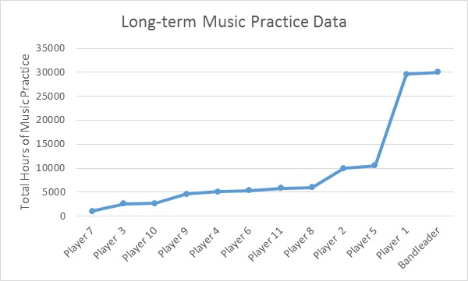
Figure 1: Showing the range of experience within the band

Physical self-awareness
Initial analysis of data from Q1 along with the score and video footage revealed that 61% of the responses demonstrated complete physical self-awareness, e.g. Player 5: “Playing Eb 3 bars from end” was doing exactly that when the bell sounded. 35% of responses showed some evidence of self-awareness, but responses were not detailed enough to be sure that they were clear about what they were doing in exactly the moment the bell rang, e.g. Player 7: “Following the written notes in my head but not getting the fingers to follow” may have been doing this for some time previously.
4% of responses revealed moments when players were inaccurate in their reporting of what they were doing, e.g. Player 3 reported “High B's and D's half way through [section] C”. The video showed that when the bell rang, Player 3 was actually playing successfully along with the rest of the band, and it was several bars after the quoted moment. This player’s mind had latched on to the memory of a difficult passage a few bars earlier. Despite being unable to let go of this thought, they had carried on playing accurately while their conscious mind was temporarily caught up in a past moment.
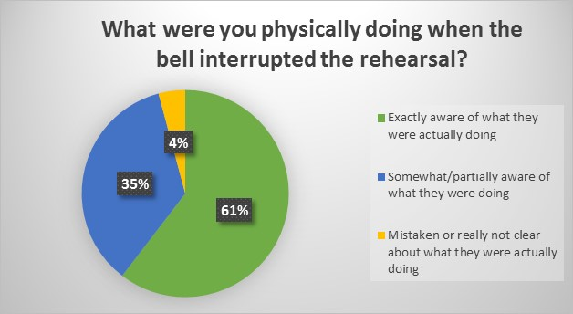
Figure 2: Physical self-awareness data
Further analysis revealed a positive correlation between physical self-awareness and hours of music practice (fig.3). While it may seem obvious that a learner doesn’t know what they are doing as clearly as an experienced player does, there were no real beginners in the band at this rehearsal: the least experienced player had completed 1000 hours of music practice. To secure the benefit of being absolutely sure of physical self-awareness, figure 3 shows that we must look beyond 9,900 hours of practice, which matches almost exactly with the assertion that 10,000 hours of deliberate practice results in expertise (Ericsson, Krampe et al., 1993). The data reveal a musical learning process which manifests over decades and results in a mastery of physical self-awareness: this echoes the Buddhist eightfold path which leads towards complete introspective self-awareness (Maex, 2011, p168).
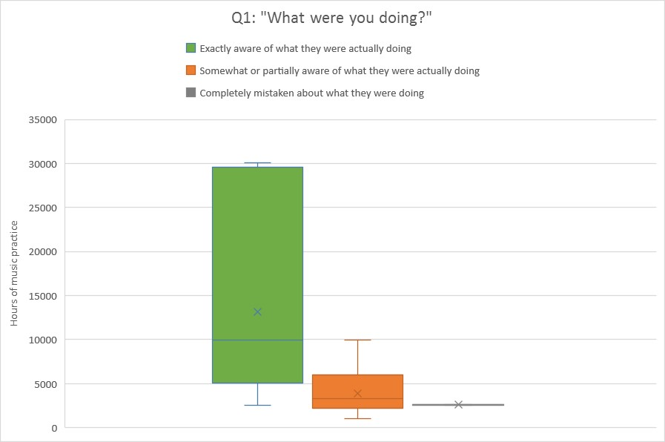
Figure 3: Physical self-awareness demonstrates a positive correlation with hours of music practice
(X represents mean value)

Present-moment attention
In 90% of responses, participants indicated that they were thinking about the present moment (fig.4). No responses indicated past-thinking, daydreaming or uncertainty. This is a startling result, as studies have shown that mind-wandering typically occurs in a minimum of 30% of samples, regardless of what subjects are doing (Killingsworth and Gilbert, 2010; Stawarczyk, Majerus et al., 2012).
There were only two instances of future-thinking. These came from player 7: “I was thinking this will be fine after a few practises at home I hope” and player 3, who was thinking about the solo coming up in the same piece. These were examples of future thinking within the context of the task at hand rather than escapist mind-wandering.
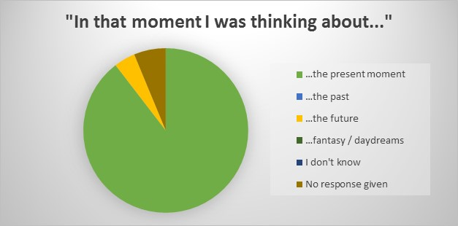
Figure 4: Present-moment attention data
When this present-moment attention data is juxtaposed with long-term practice data, despite the two most experienced musicians being treated as outliers, a positive correlation is clear:
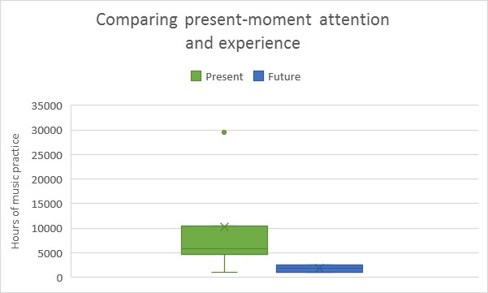
Figure 5: Correlation between present-moment attention and hours of music practice.
(Dots represent outliers.)
These data suggest that present-moment attention while playing may become an established habit between 2,500 and 5000 hours of music practice, much earlier than physical self-awareness had become established. This follows a similar trajectory to Buddhist meditation, where beginners start with shamatha practice (establishing mindful attention) and once this is somewhat established, they also include vipashyana practice, which expands both introspective and extrospective awareness and leads to insight and wisdom (Trungpa, 2013b). This overcoming of mind-wandering is “Milestone One” in the ten stages of meditation, and it marks the defining characteristic of becoming a “skilled” rather than a “novice” meditator (Yates, Immergut et al., 2017, pp.6-8).

Extrospective awareness
Moment 3 was a fascinating moment. The video showed that one section of the band was rushing while another section remained steady and that the drummer, in protest, had stopped playing. This was a moment where, to maintain musical structural integrity, most band members would have needed to have both awareness about what was happening elsewhere in the room and the generosity of spirit to work together to solve the problem. This level of awareness is considered by the author to be quite an advanced musical skill which is often lacking in youth orchestra or amateur band settings. Of the 12 players, exactly half demonstrated their awareness of this issue, and the other half appeared, from the data they supplied, to be oblivious.
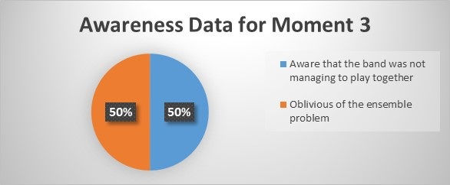
Figure 6: Extrospective Awareness Data
Comparison shows a positive correlation between extrospective awareness and long-term practice, this time with the marker point for extrospective awareness becoming sure at approximately 6000 hours (fig. 7).
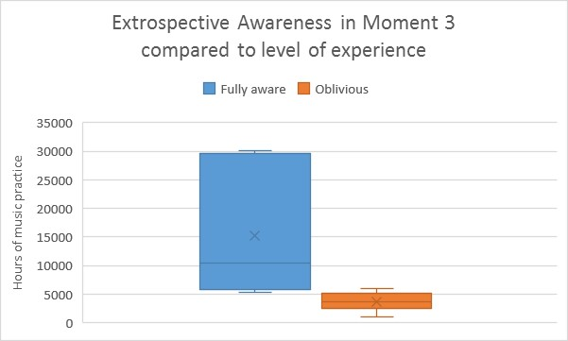
Figure 7: Showing another positive correlation, this time between extrospective awareness and hours of music practice
This suggests that musicians may master stable attention first, by around 5000 hours, then develop a steady conscious awareness of their wider environment at around 6000 hours, finally developing an accurate sense of physical self-awareness at around 10,000 hours of music practice. This corresponds with the assertion of Yates et al. (2017, p163) that continuous exercising of conscious attention leads to the development of a wider peripheral awareness.
Yates et al. (2017, p219) describe the ability to be aware of potential sensory distractions and yet maintain a conscious intention to keep one’s attention stable (i.e. not be distracted by that awareness) as a key feature of stage six of the ten stages of meditation. Not allowing oneself to become emotionally upset or to be led off-task by the potential distractions within one’s internal or external awareness is a key skill of an advanced musician (Green and Gallwey, 1986, p51). The data revealed that of the six players who showed awareness, two also described associated attitudes of anxiety, frustration or confusion, indicating a lack of equanimity (Trungpa, 2013a, p75). Four described more positive attitudes including amusement, indicating a greater degree of equanimity (ibid.). Here, the place where equanimity became sure was just after 10,000 hours of practice, and this approximately equates with the meditator’s “Milestone Two: sustained exclusive focus of attention” (Yates, Immergut et al., 2017, p10, p233). However, this study did not examine whether, as well as demonstrating physical self-awareness and extrospective awareness, these experienced musicians could also demonstrate full metacognitive introspective awareness, i.e. equanimous awareness of one’s own mind, which would be required by Yates et al. to define this stage for meditators.

Attitude
Of all the measures in question, attitude was the most difficult to determine. Some meditators do not even include attitude within their definition of mindfulness (Chiesa, 2013). Others include attitude simply as “non-judgemental awareness” (e.g. Kabat-Zinn, 2011, p291). Meanwhile, Buddhists have many ways of describing a variety of attitudes, both wholesome and unwholesome, e.g. “The Four Brahmaviharas” (Trungpa, 2013a, p453) or “The Twenty Mountains of Ego” (ibid, p.465).
Developing a wholesome attitude is a vital part of the eightfold path, where each of the eight elements is labelled as “right”, e.g. “right mindfulness.” The translated word “right” comes from the Sanskrit “samma” or “samayak” which is musical vocabulary describing harmony as opposed to discord (Maex, 2011, p168). The development of an harmonious attitude along the path towards equanimity may be a central issue to the mindfulness paradox afflicting those professional musicians who are suffering poor mental health. In the words of the wise jazz pianist Hal Galper, “Attitude is everything” (Galper, 2013).
It was surprising that in response to the multiple-choice Q7 regarding attitude, some players chose “positive” even after having made negative comments about their experience in the moment. For example, Player 3 reported: “Bit lost in the music, not keeping up…” but reported their attitude as remaining positive, indicating some equanimity (Trungpa, 2013a, p75). This was an invaluable quantitative response which avoided researcher bias and/or misinterpretation of qualitative data.
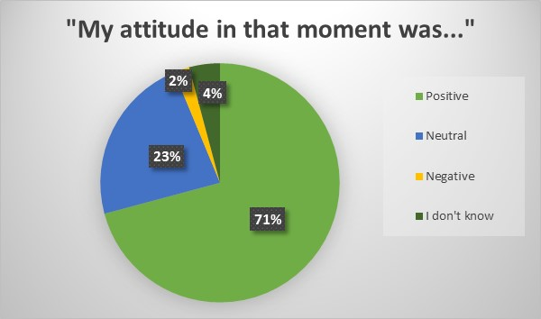
Figure 8: Multiple choice attitude data
The single “negative” response was worthy of note: “Positive [circled then scored out and changed to] Negative” supported by the self-critical comment “Slightly unhappy with myself – must practice the solo faster...” This came from a player who had completed around 2500 hours of practice – enough to attempt the solo line and feel frustrated by it, but perhaps not quite enough yet to have gained the patience and equanimity to accept things as they were in that moment (Green and Gallwey, 1986, p61).
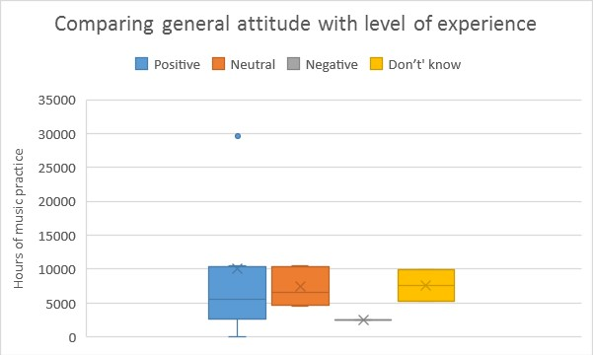
Figure 9: There was an indistinct correlation between general attitude and hours of practice
When data on general attitude were compared with hours of practice (fig. 9), it became clear that all levels of experience had reported positive attitude, while sometimes those between 5000 and 10,000 hours had also reported being either neutral or unsure, and the one negative response came from a player yet to reach 3000 hours.
Q6 provided more detail, allowing participants to describe their attitude in their own words. Responses here were varied and ranged from Player 11’s “highly entertained” through Player 4’s “relaxed” to Player 7’s “a little bit panicking about being lost.” In-depth analysis eventually allowed Q6 responses to be categorised into six categories (fig. 10).
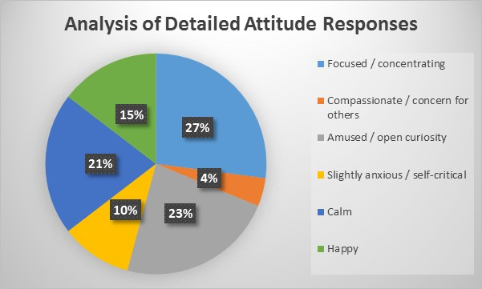
Figure 10: Detailed attitude data as a percentage of total responses
This provides a much clearer picture of participants’ present-moment attitude to the task of group music-making, and the comparison with hours of practice reveals an even more distinct picture (fig. 11).
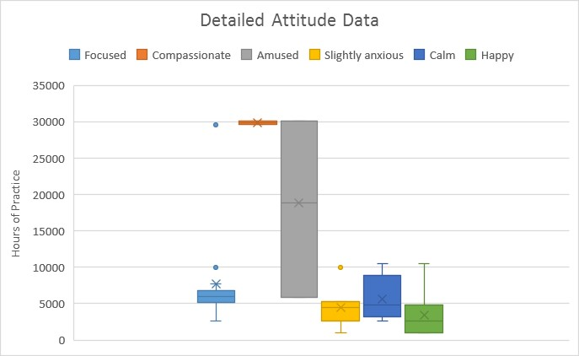
Figure 11: Analysis shows that focus was present across the band, but compassion and anxiety were present only at opposite ends of the experience spectrum.
A simply “happy” attitude was reported by five participants (mean = 3431 hours of practice). Mild anxiety (mean = 4445 hours) was reported by four participants, three of whom also had reported being “happy” in another moment. This contrast indicates a lack of equanimity (Trungpa, 2013a, p75) in these players, who ranged from 1000 hours’ practice up to nearly 10,000 hours.
As the learner musicians gradually gain greater awareness through practice, they appear to exchange the attitude of simple happiness with increasing self-criticism and dissatisfaction, perhaps stemming from greater clarity, in a phenomenon which may be akin to the meditator’s “Dark Night of the Soul” (Farais and Wikholm, 2015, pp150-152).
Of the five players who reported having a “calm” attitude (mean = 5664), only one had also reported anxiety. The other four co-reported happiness and/or focus, indicating greater equanimity (Trungpa, 2013a, p75), and these ranged from 2,600 up to 10,000 hours. Focus was reported by eight players across a very wide range of experience (mean = 7667). Humour and compassion were the most startling results: an amused, humorous or openly curious attitude was reported by five players, all of whom had over 5,000 hours of experience (mean = 18,779). Compassion with a complete absence of anxiety was reported only by the two most experienced musicians, each of whom had completed around 30,000 hours of practice (mean = 29,813).
Figure 12 summarises the emerging story which appears to arise through long-term music practice, by comparing the mean values associated with each attitude category.
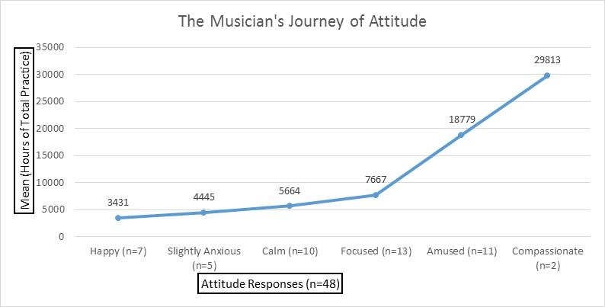
Figure 12: Demonstrating the potential effect of long-term music practice on attitude

Summary of results
The parallels with Buddhist mindfulness training here seem robust: those two participants who had completed the most practice demonstrated high level equanimity, reporting only attitudes of humour, compassion and focus throughout the rehearsal. They had also demonstrated accurate physical self-awareness, continuous present moment attention, accurate extrospective awareness and only ever reported a positive attitude. This compares favourably with the description of an “adept meditator, one who can consistently achieve and effortlessly maintain exclusive attention and powerful mindfulness” (Yates, Immergut et al., 2017, p262). These were two kind-hearted professional musicians, “off-duty”, making music for fun with friends and pupils. It would be interesting to study similarly experienced professional musicians playing in different contexts to test this result.
Meanwhile, those players in the mid-range of experience, with between 5000 and 10,000 hours of music practice showed they were on the path towards equanimity, mostly demonstrating an attitude of focus and calm, with occasional humorous interludes and only very occasional moments of anxiety. They all reported present-moment attention and either neutral or positive attitudes throughout, and had some level of physical self-awareness. Those with over 6000 hours of practice also demonstrated accurate extrospective awareness while concentrating on their task. They equate approximately to a “Skilled Meditator” working towards “sustained exclusive focus of attention” (Yates, Immergut et al., 2017, p6).
The least experienced musicians, with between 1000 and 5000 hours of practice, demonstrated attention mostly in the present moment, a frequently positive attitude, were generally focussed, calm or happy, but reported some experiences of mild anxiety. They were not always aware of what was going on around them, and very occasionally not fully aware of what they themselves were doing, and so their mind-states would equate to those of a “Novice Meditator”, working towards establishing good practice habits to extend attention and strengthen mindfulness (ibid.).
The phenomenon of an individual attaining the more advanced meditator’s attributes of stable attention, keen extrospective awareness and equanimity without ever having practiced meditation is somewhat controversial:
“Surgeons, chess players, professional athletes and air traffic controllers are also examples of people who have developed an extraordinary capacity for stable focused attention. But the stable attention of skilled meditators is different; they can sustain attention regardless of how important they consider the object to be. In addition, the quality of attention of trained professionals only reaches Stage Four (this first Milestone). Reaching the higher levels requires techniques unique to meditation. That is, mastery for the surgeon is just the beginning for the skilled meditator.” [Emphasis in the original] (Yates, Immergut et al., 2017, p435)
A feature of music-making is that it is not important (Werner, 1996, p45). Yet advanced musicians must maintain a self-recognised illusion of the importance of intonation, timing, ensemble, etc., so that they and the group can progress towards greater harmony. This is perhaps much closer to the role of an adept meditator than has been previously acknowledged, because a lama also chooses to maintain an illusion of importance for the greater good:
“Things are not so solid, and in this context, nothing is important. But then, we all exist… so it is important to try to help one another.” (Jigme Rinpoche, 2016)
Maintaining a conscious illusion of importance is not unique to advanced meditators and may be a topic worthy of further research in relation to both mindfulness and music-making, especially with regard to the mental health of practitioners.

Limitations of the Research
Participants had received no mindfulness training, and there was some confusion in the responses showing that it was difficult for some to distinguish between attention, thoughts and awareness. The data revealed this to be a vocabulary issue, as evidence was shown of some level of metacognitive introspective awareness in all participants, even though they did not always report their mind-observations in the expected box. There was also a difficulty with, and some reluctance to answer, the open-ended question about attitude as player 5 reported: “Q6 – difficult to understand the question.” Despite this reluctance, the question revealed some rich data.
For future studies, the research assistant should be out of view of the band so as to avoid her becoming a distraction and/or her movements forecasting the bell. This issue was reported by only one participant who demonstrated high-level extrospective awareness. This would become more relevant if all participants were professional musicians with potentially high levels of wider awareness.
This band has been under the same musical director (the author) for over 15 years, and under the philosophy of our social enterprise (Gordon, 2016) for the past 5 years. It is likely that the culture of the band stems largely from the ethos of the bandleader, and this may be reflected in these results. In order to draw general conclusions about the wider musical community, it will be necessary to conduct similar research with other groups of musicians from different schools of training.
It is also not possible to draw conclusive general results with such a small sample size, and a much wider ranging study will be needed to validate the findings of this research.

Conclusions, Implications and Recommendations
The fact that none of the participants were given any mindfulness meditation training as part of the study brought with it a real risk: without the ability to stand back and observe their own minds while they were playing, no relevant data might be collected and the graphs may have illustrated nothing but confusion. Therefore, it was somewhat surprising, even to the author, that analysis of the data revealed results which provided clear answers to the research questions.
Clear parallels also emerged regarding the development of attention, awareness and attitude in music practitioners compared to the development of those mindfulness skills in meditation practitioners.

To what extent can music-making be considered a “mindfulness practice”?
In terms of Nyaponika’s “understanding of mindfulness as bare attention” (Gethin, 2011, p267), every participant demonstrated present-moment attention. Therefore, from this basic perspective, music-making can be viewed as a practice with the potential to strengthen mindfulness.
Considering mindfulness as “an optimal interaction between attention and peripheral awareness” (Yates, Immergut et al., 2017, p425), six participants demonstrated an interaction of attention and peripheral awareness. Of these, four achieved an “optimal” balance, illustrated by equanimity during awareness of adverse circumstances. The data suggest that music practice may be an important factor in developing this awareness.
Results suggest that long term practice of music-making may be an effective vehicle to develop self-awareness, mindfulness and equanimity.

Is there a correlation between lifetime hours of music practice and the development of:

present-moment attention?
In this group and at this rehearsal, a positive correlation was shown: more experienced players were more likely to demonstrate present-moment attention, and this appeared to be established as a habit in players with between 2,500 and 5,000 hours of practice.

extrospective awareness?
Another positive correlation was shown: more experienced players demonstrated extrospective awareness and less experienced players did not. The watershed for this difference in experience was between 5,000 and 6,000 hours of practice.

attitude, especially an attitude of equanimity?
A positive correlation was again observed: less experienced players reported mixed attitudes including both happiness and mild anxiety, while the most experienced players reported only positive attitudes including open curiosity, humour and compassion, indicating greater equanimity (Trungpa, 2013a, p75).

Implications and recommendations
The culture of western classical music has a well-established history, and for many musicians the proposal that present-moment attention is the musical norm but that wider awareness develops only in more advanced musicians will seem obvious: it has been thus for centuries. However, further consideration of the data regarding attitude may help to develop new theories about mental health in musicians. The attitudes of these amateur musicians is likely to be different from the attitudes of professionals, where a momentary lapse of attention or a failure to have wider awareness during a performance could end a career. Sustaining equanimity in a community context is different from doing so under commercial pressures. Wider ranging studies are required to understand how choice of attitude relates to the health of community versus professional musicians.
It is possible that some musicians are only mindful when playing their instrument, and that this is not a skill which is naturally transferred into their wider lives. A future study might incorporate measurement of mindfulness in daily life as well as in the rehearsal room to investigate this.
Within the mindfulness community, this study challenges the ubiquitous assumption that meditation is the only, or the best, pathway for individuals wishing to strengthen mindfulness. In light of the findings of this study, mindfulness meditation teachers might wish to consider placing the active practice of “mindfulness in daily life” at the core of their teaching.

APPENDIX: Sample page of a completed present-moment experience questionnaire
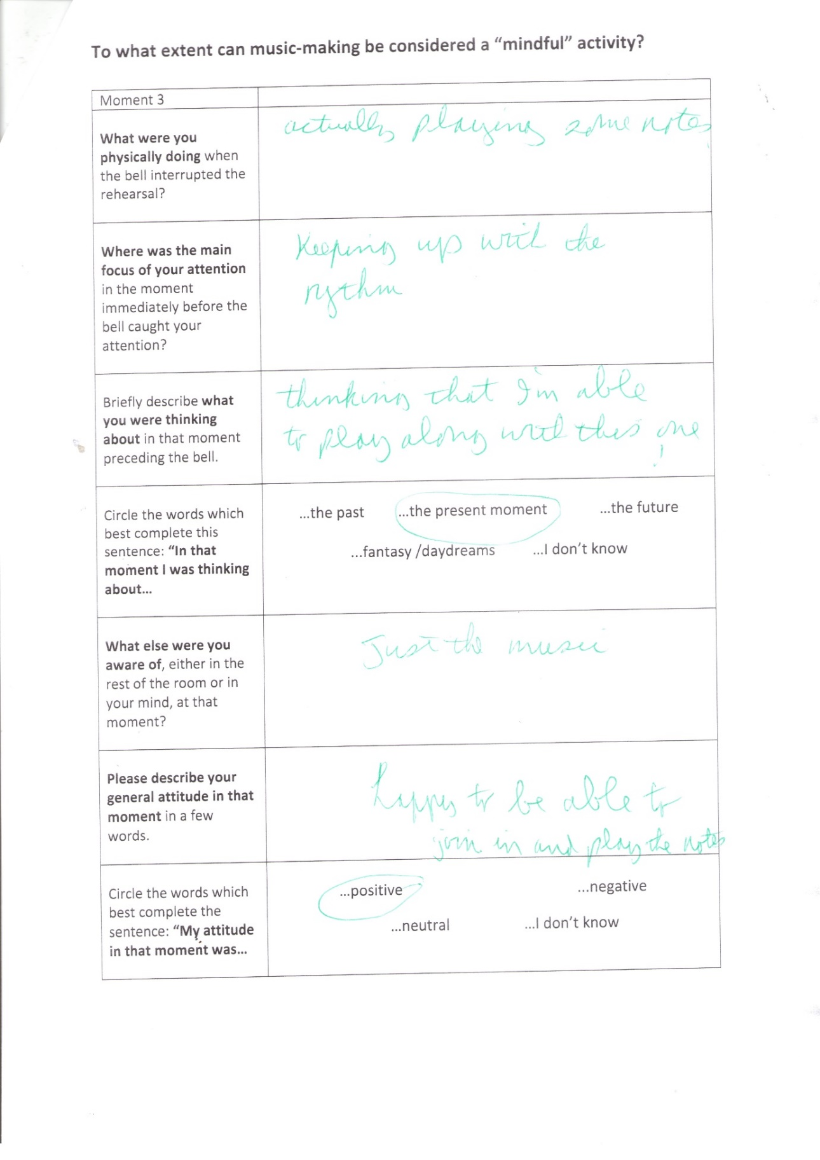

Bibliography
AINLEY, M. and AINLEY, J., 2011. Student engagement with science in early adolescence: The contribution of enjoyment to students’ continuing interest in learning about science. Contemporary educational psychology, 36(1), pp. 4-12.
AKONG, R., 1994. Taming the Tiger - Tibetan Teachings for Improving Daily Life. London: Random House.
ARNOLD, D., 2008. Buddhist Idealism, Epistemic and Otherwise: Thoughts on the Alternating Perspectives of Dharmakirti. Sophia, 47(1), pp. 3-28.
AZULAY, N. and TABORY, E., 2008. "A House of Prayer for All Nations": Unorthodox Prayer Houses for Nonreligious Israeli Jews. Sociological Papers, 13, pp. http://www.socpapers.org/sp2008/sp2008-3.htm.
BANKS, S. and MANNERS, P., 2012. Community-based participatory research A guide to ethical principles and practice Centre for Social Justice and Community Action, https://www.publicengagement.ac.uk/sites/default/files/CBPR%20Ethics%20Guide%20web%20November%202012.pdf: Durham University National Co-ordinating Centre for Public Engagement.
BATCHELOR, S., 2012. A Secular Buddhism. Journal of Global Buddhism, 13, pp. 87-107.
BODHI, B., 2011. What does mindfulness really mean? A canonical perspective. Contemporary Buddhism, 12(1), pp. 19-39.
BREAZEALE, D., 2014-last update, Johann Gottlieb Fichte, The Stanford Encyclopedia of Philosophy (Spring 2014 Edition), Edward N. Zalta (ed.) [Homepage of Stanford University], [Online]. Available: https://plato.stanford.edu/archives/spr2014/entries/johann-fichte/ [04/16, 2017].
CHANDA, M.L. and LEVITIN, D.J., 2013. The neurochemistry of music. Trends in Cognitive Sciences, 17(4), pp. 179-193.
CHIESA, A., 2013. The Difficulty of Defining Mindfulness: Current Thought and Critical Issues. Mindfulness, 4(3), pp. 255-268.
CHÖDRÖN, P., 2001. The Wisdom of No Escape. London: Harper Collins Element.
CLAXTON, G., 1999. Hare Brain, Tortoise Mind: How Intelligence Increases When You Think Less. USA: The ECCO Press.
CREECH, A., HALLAM, S., VARVARIGOU, M., MCQUEEN, H. and GAUNT, H., 2013. Active music making: a route to enhanced subjective well-being among older people. Perspectives in Public Health, 133(1), pp. 36-43.
CRESWELL, J.W., 2003. Research Design: Qualitative, Quantitative and Mixed Methods Approaches. Thousand Oaks, California: Sage.
CRESWELL, J.W., 1998. Qualitative Inquiry and Research Design: Choosing among Five Traditions. Thousand Oaks, California: Sage Publications Ltd.
DENSCOMBE, M., 2008. Communities of practice a research paradigm for the mixed methods approach. Journal of mixed methods research, 2(3), pp. 270-283.
DOBSON, M.C., 2011. Insecurity, professional sociability, and alcohol: Young freelance musicians’ perspectives on work and life in the music profession. Psychology of Music, 39(2), pp. 240-260.
DOS SANTOS-LUIZ, C., MÓNICO, L.S.M., ALMEIDA, L.S. and COIMBRA, D., 2015. Exploring the long-term associations between adolescents’ music training and academic achievement. Musicae Scientiae, , pp. 1029864915623613.
ELLIS, A., 1980. Rational-emotive therapy and cognitive behavior therapy: Similarities and differences. Cognitive therapy and research, 4(4), pp. 325-340.
ELLIS, A., 1977. Fun as psychotherapy. Rational Living, .
ERICSSON, K.A., KRAMPE, R.T. and TESCH-RÖMER, C., 1993. The role of deliberate practice in the acquisition of expert performance. http://dx.doi.org/10.1037/0033-295X.100.3.363. Psychological Review, Vol 100(3), pp. 363--406.
FARAIS, M. and WIKHOLM, C., 2015. The Buddha Pill. London: Watkins.
FICHTE, J.G., 1808 / 2008. Addresses to the German Nation. Cambridge: Cambridge University Press.
GALPER, H., 2013-last update, Attitude is Everything. Available: https://www.youtube.com/watch?list=FLab8H6muJGfCx-XfO-JC6fQ&v=U9TavIO6PYU [11/30, 2016].
GETHIN, R., 2011. On some definitions of mindfulness. Contemporary Buddhism, 12(1), pp. 263-279.
GORDON, K., 2016-last update, caithnessmusic.com - Musical Social Enterprise. Available: http://www.caithnessmusic.com/Musical-Social-Enterprise.html [03/28, 2016].
GRAYLING, A.C., 1986. Book Review of "The Vindication of Absolute Idealism" by T.L.S. Sprigge (1983). The Philosophical Quarterly, 36(142), pp. 85-88.
GREEN, B. and GALLWEY, W.T., 1986. The Inner Game of Music. New York: Pan.
GROSS, S.A. and MUSGRAVE, G., 2016. Can Music Make You Sick? Music and Depression
A study into the incidence of musicians’ mental health. Help Musicians UK: University of Westminster / Music Tank.
GROSSMAN, P., NIEMANN, L., SCHMIDT, S. and WALACH, H., 2004. Mindfulness-based stress reduction and health benefits: A meta-analysis. Journal of psychosomatic research, 57(1), pp. 35-43.
GUYER, P. and HORSTMANN, R., 2015-last update, "Idealism", The Stanford Encyclopedia of Philosophy [Homepage of Stanford University], [Online]. Available: https://plato.stanford.edu/archives/fall2015/entries/idealism/ [04/15, 2017].
HH DALAI LAMA XIV, 2002. Advice on Dying and Living a Better Life. London: Rider.
JIGME RINPOCHE, 2016-last update, The Six Paramitas [Homepage of Dhagpo Kagyu Ling], [Online]. Available: http://www.dhagpo.org/en/index.php/multimedia/teachings/166-the-six-paramitas [04/15, 2017].
JONES, R., 2016. State of Mind - life as a musician can lead to a range of mental health issues. Journal of the Musicians' Union, Autumn, pp. 22-24.
KABAT-ZINN, J., 2011. Some reflections on the origins of MBSR, skillful means, and the trouble with maps. Contemporary Buddhism, 12(1), pp. 281-306.
KABAT-ZINN, J., 1994. Wherever You Go, There You Are: Mindfulness Meditation for Everyday Life. London: Piatkus.
KILLINGSWORTH, M.A. and GILBERT, D.T., 2010. A Wandering Mind is an Unhappy Mind. Science, 330(6006), pp. 932.
LANGER, E., RUSSELL, T. and EISENKRAFT, N., 2008. Orchestral performance and the footprint of mindfulness. Psychology of Music, .
LAO-TZU and DYER, W., 2007. Change Your Thoughts, Change Your Mind; Living the Wisdom of the Tao. UK: Hay House.
LIN, P., CHANG, J., ZEMON, V. and MIDLARSKY, E., 2008. Silent illumination: a study on Chan (Zen) meditation, anxiety, and musical performance quality. Psychology of Music, 36(2), pp. 139-155.
LOUBRIEL, L.E., 2009. Back to Basics for Trumpeters
The Teaching of Vincent Cichowicz. Chicago: Scholar Publications.
MAEX, E., 2011. The Buddhist roots of mindfulness training: a practitioner's view. Contemporary Buddhism, 12(1), pp. 165-175.
MAGEE, W.L., CLARK, I., TAMPLIN, J. and BRADT, J., 2017. Music interventions for acquired brain injury. http://onlinelibrary.wiley.com/doi/10.1002/14651858.CD006787.pub3/full: John Wiley & Sons, Ltd.
MASTIN, L., 2008-last update, The Basics of Philosophy - Idealism. Available: http://www.philosophybasics.com/branch_idealism.html [02/06, 2017].
MCMURTRY, D., 2015-last update, Introduction to Social Science Research Sept. 2015 (Powerpoint presentation) [Homepage of University of Aberdeen], [Online]. Available: https://abdn.blackboard.com/webapps/blackboard/content/listContent.jsp?course_id=_25529_1&content_id=_891793_1&mode=reset2017].
MINDFULNESS ASSOCIATION LTD, 2015. Postgraduate Studies in Mindfulness MSc. Mindfulness Module - Weekend Two Handbook. University of Aberdeen.
MORADZADEH, L., BLUMENTHAL, G. and WISEHEART, M., 2015. Musical Training, Bilingualism, and Executive Function: A Closer Look at Task Switching and Dual-Task Performance. Cognitive Science, 39(5), pp. 992-1020.
NAGARJUNA, 1997. Master of Wisdom. USA: Dharma Publishing.
OLENDZKI, A., 2011. The construction of mindfulness. Contemporary Buddhism, 12(1), pp. 55-70.
OPDENAKKER, R., 2006. Advantages and disadvantages of four interview techniques in qualitative research. Qualitative Social Research, 7(4), pp. Art.11.
RICHARDS, K., CAMPENNI, C. and MUSE-BURKE, J., 2010. Self-care and Well-being in Mental Health Professionals: The Mediating Effects of Self-awareness and Mindfulness. Journal of Mental Health Counseling, 32(3), pp. 247-264.
RINGU, R., 2012. Dealing with Emotions, Scattering the Clouds. Second Edition, 2013 edn. Oxford, UK: Bodhicharya Publications.
SCARFE, A., 2006. Hegelian ‘Absolute Idealism’ with Yogācāra Buddhism on Consciousness, Concept (Begriff), and Co-dependent Origination (Pratītyasamutpāda). Contemporary Buddhism, 7(1), pp. 47-73.
SHAPIRO, D.H., 1992. Adverse effects of meditation: A preliminary investigation of long-term meditators. . International Journal of Psychosomatics, 39(1-4), pp. 62-67.
SIEGEL, R.D., GERMER, C.K. and OLENDZKI, A., 2009. Mindfulness : what is it, where did it come from? Clinical handbook of mindfulness. New York: Springer, pp. 17-36.
SLOBODA, J.A., 1985. The Musical Mind - The Cognitive Psychology of Music. Oxford, UK: Oxford University Press.
SLUMING, V., BARRICK, T., HOWARD, M., CEZAYIRLI, E., MAYES, A. and ROBERTS, N., 2002. Voxel-Based Morphometry Reveals Increased Gray Matter Density in Broca's Area in Male Symphony Orchestra Musicians. NeuroImage, 17(3), pp. 1613-1622.
SPRIGGE, T.L.S., 1985. Theories of Existence. London: Penguin.
SPRIGGE, T.L., 1983. The Vindication of Absolute Idealism. Edinburgh: Edinburgh University Press.
STANG, N.F., 2016-last update, "Kant's Transcendental Idealism", The Stanford Encyclopedia of Philosophy
[Homepage of Stanford University], [Online]. Available: https://plato.stanford.edu/archives/spr2016/entries/kant-transcendental-idealism [04/15, 2017].
STAWARCZYK, D., MAJERUS, S., VAN DER LINDEN, M. and D'ARGEMBEUA, A., 2012. Using the daydreaming frequency scale to investigate the relationships between mind-wandering, psychological well-being, and present-moment awareness. Frontiers in Psychology, 3(363), pp. doi: 10.3389/fpsyg.2012.00363.
STEINFELD, M. and BREWER, J., 2015. The Psychological Benefits from Reconceptualizing Music-Making as Mindfulness Practice. . Med Probl Perform Art, Jun:30(2), pp. 84--89.
TRUNGPA, C., 2013a. The Bodhisattva Path of Wisdom & Compassion. First Paperback Edition edn. Boston: Shambala Publications Inc.
TRUNGPA, C., 2013b. The Path of Individual Liberation. Boulder, USA: Shambhala.
TRUNGPA, C., 2013c. The Profound Treasury of the Ocean of Dharma, Volume Three. Boston: Shambhala Publications Inc.
WERNER, K., 1996. Effortless Mastery. New Albany, IN: Jamey Abersold Jazz.
WILLIAMS, M., TEASDALE, J., SEGAL, Z. and KABAT-ZINN, J., 2007. The Mindful Way Through Depression: Freeing Yourself from Chronic Unhappiness. New York ; London: Guilford Press.
WILLIAMS, J.M.G. and KABAT-ZINN, J., 2013. Mindfulness: Diverse Perspectives on its Meaning, Origins and Applications. London: Routledge.
YATES, J., IMMERGUT, M. and GRAVES, J., 2017. The Mind Illuminated - a complete meditation guide integrating Buddhist wisdom and brain science for greater mindfulness. New York: Touchstone.
YESHE, L., 2016. Private Interview 2 (18th Nov 2016). Samye Ling Monastery, Eskdalemuir: .

