\
ESCAPE THE MUNDANE
WITH DAVRON TOURS
To a relaxing weekend getaway to the

June 5-7, 2020
The Jazz Festival With "SOUL!"
Featuring Nearly 30 National Jazz And Soul Artists on TWO Big Stages....
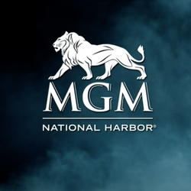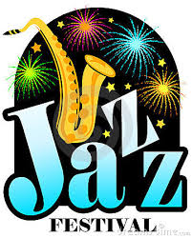
Your weekend will include:
A Visit to the National Museum of African American History and Culture in Washington, D.C.
A Visit to the MGM Grand Casino, the entertainment capital of the capital
Optional Shopping at Tangier Outlet
Happy Hour at Hotel on Friday Night with complimentary open bar
A weekend you will never forget and more…
Overnight accommodations are at the beautiful full service Fairfield Park Marriot in Falls Church, Virginia. The Fairview Park Marriott is situated in a beautifully landscaped, park-like setting with jogging paths criss-crossing through woods around a lake. This hotel has all the amenities of a 4 star resort. Relax and enjoy their refreshing indoor pool, flooded by natural light. Accompanying the pool is a fitness center with both cardio and weight training equipment. Fairview Park Marriott is the perfect place to relax and escape from the everyday. With a beautiful setting filled with flowers, trees and walking paths, you'll find experiencing nature easier than ever at this hotel.
For more information or to make a reservation call us at 973-900-2245

