Locomotion Theatre Presents…
Teen Studio Theatre
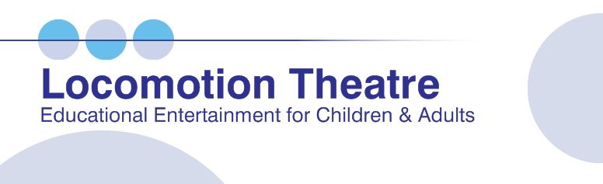

www.locomotiontheatre.com
office: 561.361.8318
cell: 561.445.1305
info@locomotiontheatre.com
After-School, Spring Break & Summer Camp Shows Presented at Your Location.
● Teen Studio Theatre
for 5-12th grade audiences
Critical thinking and problem solving are highlighted in this interactive and thought provoking talk-show style program! Led by a psychotherapist, this exciting format creates a forum for guided discussion and dialogue about topics of importance, including bullying, responsible behavior, and the value of learning.
● Shows for K-5th Grade Audiences
5 Great audience participation shows that are fun, funny, and highlight character education concepts! Shows all include a wacky game show! Topics about bullying, anger management, positivity and responsible behavior.
● Shows for Preschool- Age 7
4 Delightful age appropriate audience participation shows filled with music and make-believe! Imaginative themes that emphasize early learning skills and friendship.
● Staff Training Workshops
for camp / after-school counselors & supervisory staff Interactive, effective and engaging custom trainings led by a psychotherapist. Topics include bullying, dealing with a child’s difficult behavior, leadership, communication & more.
For a complete listing of shows, staff trainings & programs, please see our website: www.locomotiontheatre.com

For more information & pricing:
Contact: Andrea Ellison
Tel: 561-361-8318
info@locomotiontheatre.com

Great Audience Participation Shows for Grades 5-12!
Approved by Palm Beach, Broward, Miami-Dade, Martin, Lee, Volusia & Osceola School Districts ● State of Florida Vendor/Contractor Badges Broward CSC/Broward Cultural Division Partnership Approved Artists
_________________________________________________________________
FOR IMMEDIATE RELEASE: Wednesday, January 16, 2019
CONTACT: Andrea Ellison - info@locomotiontheatre.com

(Boca Raton, FL) – Locomotion Theatre, one of South Florida’s longest established and most respected educational entertainment companies, is now booking great shows for your afterschool, spring break and summer camp!
We come to your location to present all shows, programs & workshops.

Teen Studio Theatre This thought-provoking and entertaining talk-show style audience participation show really holds the attention of this age group, and most of all, is lots of fun! It’s effective and sparks a dialogue about topics important to pre-teens & teens.

Here’s the way it works: First, we’ll talk with you and help you select 3 or 4 topics that would be best for your group. Some of the most requested topics are bullying & cyber-bullying, peer pressure, personal choices and responsible behavior, decision making/critical thinking, the importance of learning and staying in school, dating & friendship, and family issues. For more topic choices, please see our website. After the topics are selected, Locomotion Theatre will put together a custom presentation for your group.

The format is fun and keeps everyone involved and interested. The 2 actors present a series of short skits about the selected topics. Each skit is left open-ended so the audience can 'talk-back' to the characters in the skit. The students can comment and give their suggestions as to how to solve the problems presented. What makes it really intriguing, is that during the ‘talk-back’, the actors stay in character and speak to the students as though they were those people portrayed in the skit!

The skits and guided discussions during the ‘talk-back’ are all led by a licensed and experienced psychotherapist. He has worked extensively with children, teens, and families. He has a vibrant and friendly professional manner that encourages lots of student participation.

Teen Studio Theatre is a great way to open a forum for a guided discussion about a full range of issues and subjects! Critical thinking, brainstorming and exploring options to find a solution to a problem are key skills your students will have the opportunity to practice during this unique show. You can book one show or a series. Easy to use lesson plans are available for post-show follow-up.

Please contact us. We will be happy to spend the time with you over the phone or through email to put together the program that’s right for your site!

