KUWABARA CHIROPRACTIC & PHYSICAL REHABILITATION
Initial Patient Health Questionnaire

Please mark on X on the picture where you have pain or other symptoms. 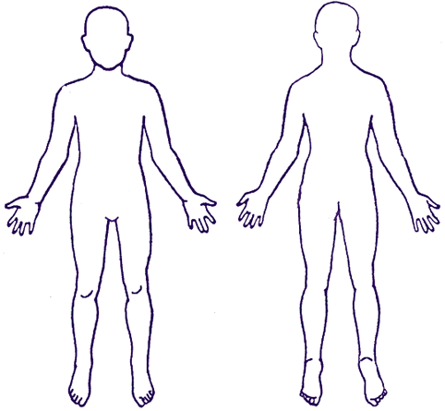
DESCRIBE YOUR CURRENT PROBLEM AND HOW IT BEGAN:

Current complaint (how you feel today):
[_________________________________________]
1 2 3 4 5 6 7 8 9 10
No pain Unbearable
How often are your symptoms present? (check which one applies)
___ 0-25% ___26-50% ___51-75% ___76-100%

Can you perform your daily activities? (check) ___YES or ___NO (if no please explain):_______________________________________________________________________________________________________________________________________

Have you had any X-RAYS, MRI’S or CT scans done? (check) ___YES or ___NO
If you answered YES which areas were taken? __________________________________

Please ONLY check the conditions that apply to you:
___ Numbness in groin/buttocks ___ Recent fever
___ HIV/AIDS ___ Aortic Aneurysm
___ Diabetes ___Cancer/Tumor
___ Corticosteroid Use ___ Osteoporosis
___ Use of Birth Control Pills ___ Recent Trauma
___ High Blood Pressure ___ Prostate Problem
___ Painful Urination ___ Epilepsy/Seizures
___ Dizziness/fainting ___ Pregnancy # of births ______
___ Visual Disturbances ___ History of neck/back pain
___ Arthritis ___ History of Alcohol use
___ History of Tobacco Use ___ Surgeries
History of: Cancer Diabetes High Blood Pressure Heart Problems Stroke
(Circle the ones that apply)
I certify that the above information is complete and accurate. I understand that my Chiropractor may need to contact my Physician if my condition needs to be co-managed. Therefore I give my Authorization to my Chiropractor to contact my Physician, if necessary.

Patient Signature: _________________________________ Date: ____________

