Please select approved colors by placing your initials in the boxes provided. Place an **“X”** in box if it doesn’t apply. If a playground unit was ordered place the product number here (Product number on your invoice).Email or fax back to complete order. [AllAquatics@ymail.com](mailto:AllAquatics@ymail.com) or 836-369-7713

EPS #_____________________________________________APS #________________________________________

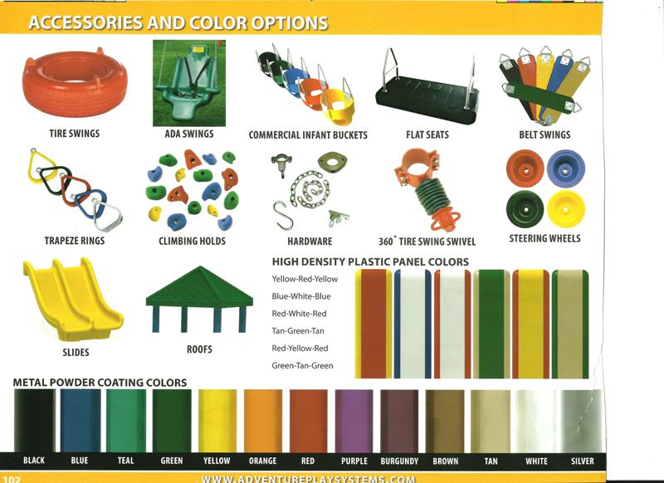

All Aquatics & Kids Playgrounds wants to assure a satisfactory order. We will not order any playground equipment or accessories without approved colors selections by the owner or customer.

Slides:

Belt swing

Flat swing

Wheels

Swing swivels

Hardware

Silver

White

Tan

Brown

Burgundy

Purple

Red

Orange

Yellow

Green

Teal

Blue

Black

#1

#2

#3

#6

#5

#4

Roofs:

Trapeze rings:

Rock Handles

Tire Swing:

Toddler swing:

ADA Swing: