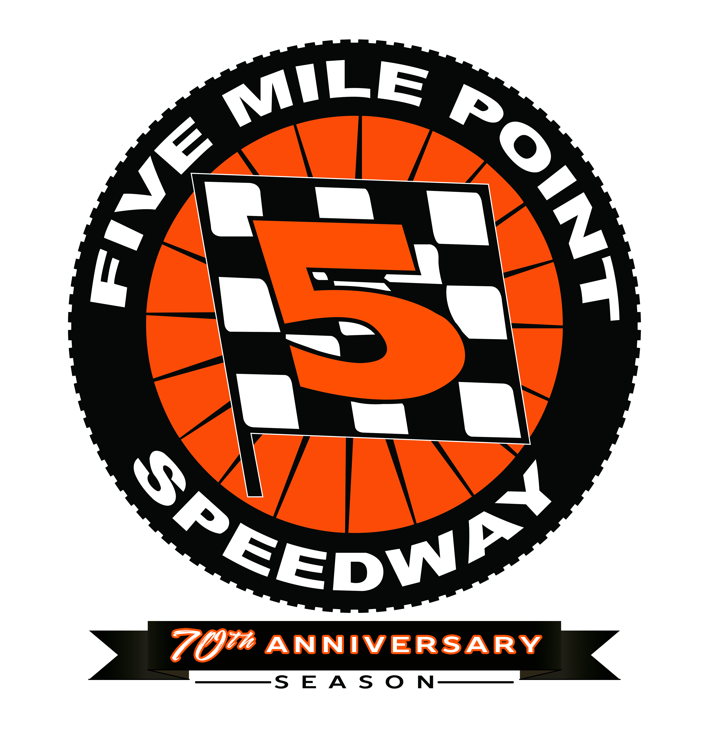
607-651-4421
www.5milepointspeedway.com
KIDS 12 AND YOUNGER FREE!

Weekly Saturday night racing begins at 7 p.m. unless otherwise noted…
Saturday, March 21st – Paid Open Practice (12 p.m. to 3:30 p.m.) Free grandstand admission with the donation of a non-perishable food item. CANCELLED
Saturday, March 28th – Paid Open Practice (12 p.m. to 3:30 p.m.) Free grandstand admission with the donation of a non-perishable food item. CANCELLED
*Saturday, April 4 – 5 p.m. GRIT Crate Sportsman Opener – 600 Modifieds, Tommy Boy 20 for Factory Stocks, FWD Four Cylinders. rain date Sunday, April 5th – POSTPONED – RESCHEDULE DATE TBA
Saturday, April 11th – Paid Open Practice (12 p.m. to 3:30 p.m.) Free grandstand admission with the donation of a non-perishable food item. CANCELLED
*Saturday, April 18th – 6 p.m. Mike Colsten Remembered 51 Southern Tier Open (non-point event), Season Opening point races for Crate Sportsman, 600 Mods, Four Cylinder (Experts and Novice), Southern Tier Street Stock Series, Factory Stocks off. – POSTPONED – RESCHEDULE DATE TBA
Saturday, April 25th – 6 p.m. Modified and Factory Stock point openers. Complete racing program. Junior 600 and Junior Slingshot Opening Night. Harpursville/Sanitaria Springs/Ninevah Community Nights (town residents free in grandstand with photo i.d.). – POSTPONED – RESCHEDULE DATE TBA

Saturday, May 2nd – Paid Open Practice (12 p.m. to 3:30 p.m.). Free grandstand admission with the donation of a non-perishable food item.
*Sunday, May 3rd – STSS Modified Tour plus Crate Sportsman and Four Cylinders.
Saturday, May 9th – No racing.

Saturday, May 16th – Complete racing program. Bradford County (PA) Community Night – (county residents free in grandstand with photo i.d.). Kids Bike Races.
Saturday, May 23rd – Complete racing program. Montrose (PA) Community Night - (town residents free in grandstand with photo i.d.).
*Saturday, May 30th – Spring Championship Night for all classes. Modifieds 30 laps - $1,500 to win. Championship points awarded in all classes plus NY6A Mini Sprints.

Saturday, June 6th – Honoring Brian “The Dream” Weaver - Dirt Modified Nostalgia Tour plus complete racing program.
Saturday, June 13th – Complete racing program. Susquehanna, Great Bend (PA) Community Night - (town residents free in grandstand with photo i.d.). Kiddie Rides.
Saturday, June 20th – No racing.
Saturday, June 27th – Complete Racing Program. Graduation Weekend – Windsor/Deposit Community Night (town residents free in grandstand with photo i.d.). Youth Night (Kids 17 and younger admitted FREE).
Saturday, July 4 – No racing.
*Saturday, July 11th – Mid-Season Championship Night for all classes. Modifieds 30 laps - $1,500 to win.
Championship points awarded in all classes.

Saturday, July 18th – Complete racing program. Conklin Community Night - (town residents free in grandstand with photo i.d.).
Saturday, July 25th – Complete racing program.
*Saturday, August 1st – 56th Heath Memorial Modifieds 56 laps $2,500 to win! – 70 All-Time Greatest Driver Inductions– Racer’s Reunion – Mods, SM, FWD Four Cylinder Experts/Novice, Southern Tier Street Stock Series, 600 Mods. Factory Stocks off.
Saturday, August 8th - Complete racing program plus NY6A Mini Sprints.
Saturday, August 15th – No racing.
Saturday, August 22nd – Complete Racing Program. Kirkwood Community Night (town residents free in grandstand with photo i.d.). Kids Backpack Giveaway Night! Southern Tier Classic Dirt Modified Tour.
*Saturday, August 29th – Season Championship Night – Final Point Races (Championship points all classes).
*Sunday, September 20th – Southern Tier Showdown for GRIT Crate Sportsman, Street Stock/Factory Stock Shootout,
FWD Four Cylinder $400 to win, 600 Modifieds

*Friday, October 16th and 17th - NATIONAL QUARTER MILE DIRT TRACK CHAMPIONSHIP WEEKEND (will include Modifieds, GRIT Crate Sportsman, Street Stocks, FWD Four Cylinders, Factory Stocks, 600 Modifieds and more.
Rain date – Sunday October 18th.
--------------------------------------------------------------------------------------------------------------------------------------------------------------
Weekly racing divisions – Modifieds, Crate Sportsman, 600 Modifieds, Factory Stocks, FWD Four Cylinder Experts/Novice, Junior 600 Mod/Slingshots (inner loop).
--------------------------------------------------------------------------------------------------------------------schedule subject to change
* indicates special event admission pricing increase…
Weekly Regular Event Pricing Information:
Grandstand Admission: Adults $12, Seniors (65 + over): $10, Youth (ages 13 to 17): $5
Kids 12 years old and younger admitted FREE in the grandstands weekly!

Pit Admission: Members: $30
Temp-Members: $35

