Client Information Sheet
Massage Inn

Name: ______________________________Phone: ________________________DOB: ______
Address: _________________________________________________________________________
Email: _______________________________________Occupation: _______________________

Are you under the age of 17? If yes, you must have the written consent of your parent or guardian to received massage therapy services.

Please check below all that apply:

Spinal Problems Allergies High Blood Pressure Bruise Easily

Various Veins Migraines Heart Conditions Injuries

Smoke Surgeries Currently Pregnant? Due Date: __________

Please explain any conditions you’ve checked above: __________________________________
_______________________________________________________________________________________________

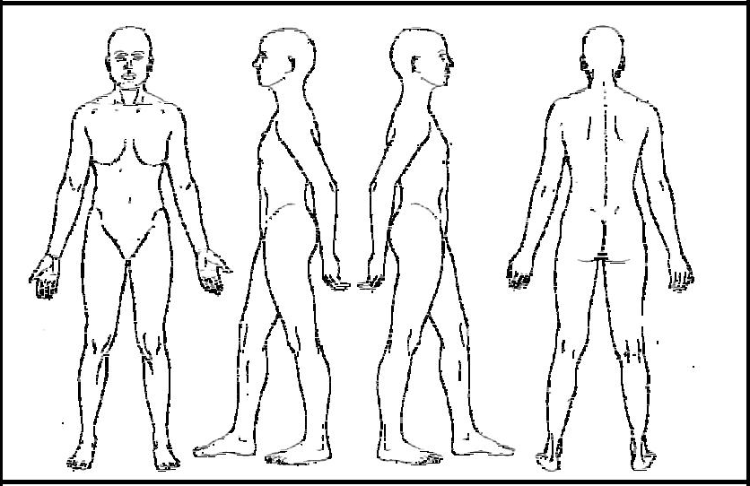
Please circle any specific areas you would like the massage therapist to concentrate on during the session:

Any medical conditions your therapist should be made aware of?
Current Medications: _______________________________________________________

Type of massage you are requesting (please circle one or more below):

Swedish/Relaxation Deep Tissue Couples Massage Hot Stone
Aromatherapy (use essential oils) Reflexology/Foot Massage Back Walking Suction Cupping Therapy Sports Massage (More Stretching)
Pregnancy Massage Trigger Point Back Neck and Shoulder
Combined Massages (Use different Techniques)

Massage therapy is not a substitute for medical examination or diagnosis. It is recommended that I see a physician for any physical ailment that I may have. I understand that the massage therapist does not prescribe medical treatments or pharmaceuticals, and does not perform any spinal adjustments. I am aware that if I have any serious medical diagnosis I must provide a physician’s written consent prior to services

The Massage therapist will not perform breast massage on female clients. Client should ask the massage therapist to adjust the pressure if necessary.

Draping will be used during the massage session. There will not be any type of sexually oriented massage. Any inappropriate contact with the therapist will terminate the session without refund.

If the client or the massage therapist is uncomfortable for any reason, the client or the massage therapist may ask to end the massage session, and the session will be ended.

Client Signature __________________________________ Date: ___________________________

To be completed by the massage therapist:

Type of Massage Technique to be used: __________________________________________________

Parts of the body to be massaged (Including indications and contraindications):

______________________________________________________________________________________________

Therapist Signature: ________________________________ Date:_________________________

