Sacrifice – we must give us something today for something in the future.

Discipline – repeat the process of budgeting, paying down debt and savings

Organization – set a simple system in place for you to manage

Habits are formed

by doing.

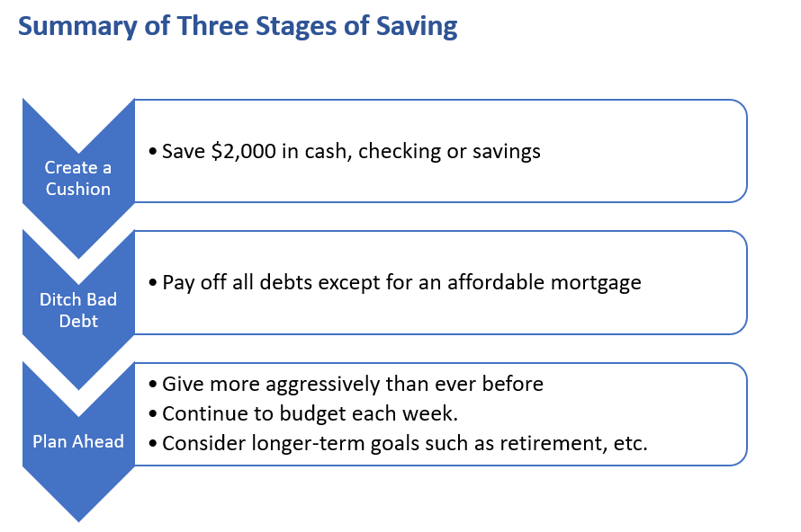

**Debt Elimination Process**

1. Do not ignore Debt! Pull your credit report and review it! [www.annualcreditreport.com](http://www.annualcreditreport.com)
2. Stop incurring more debt, that is spend less than what you make. *How can* *you reduce living expenses?*
3. Work first on debt that can get you in real trouble

* Got jail debt (Court fines, Child Support, Parole or Probation Fees)
* Garnishment of wages debt (Back income taxes owed, Child Support)
* Ruin your credit debt (Finance companies, banks, Credit Cards)
* Personal debt (debt to family and friends is not on credit report)

In SC, wages cannot be garnished for consumer debt and there is a maximum that can be taken.

1. Work out payment plans first with those that can get you in real trouble, i.e. “Got to jail debt”
2. Negotiate amount you owe with each creditor, even the IRS
3. List all your consumer debt from smallest amount to biggest amount
4. After finding out the largest amount currently that you can pay towards debt start paying on smallest debt while paying minimum on the other debts. After getting smallest one payed off start paying all of that amount toward next largest debt