Hi Everyone,

Hope you are all still keeping safe and well. Missing you all. Please remember these are only a guide to things you can be working on at home. No pressure to complete any of this.
Feel free to contact me through Class Dojo any time or send me photos.

Take Care,
Aoife

Religion
Our theme for this month is “May is the month of Mary”. At school we would create a May altar in our classroom. This could be done at home. The children can pick some flowers while on a nature walk for your space.
You can say the Hail Mary with your children.
The children can colour the picture of Mary.

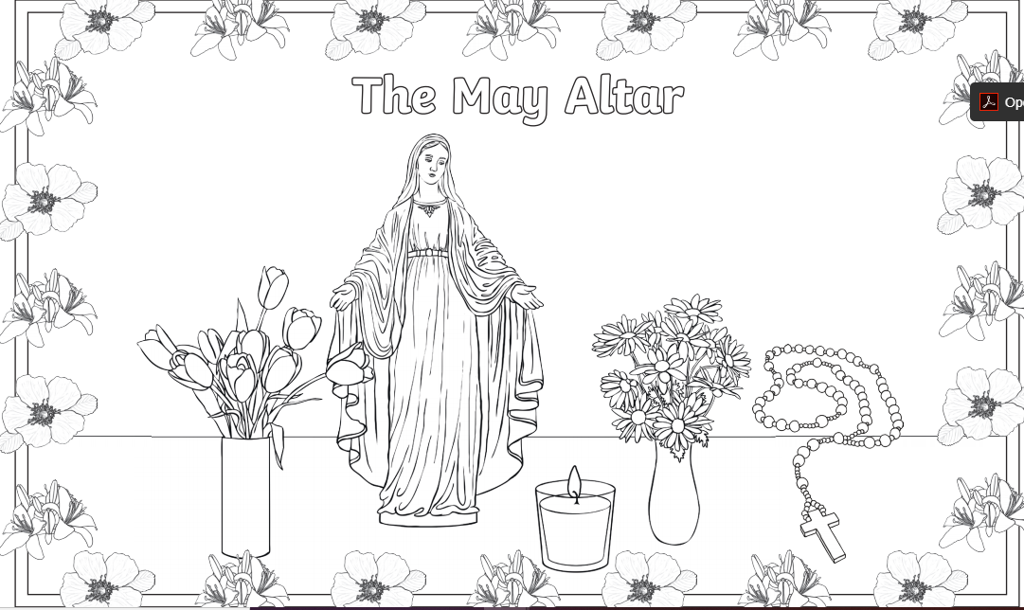

PE
Warm up- Using traffic lights the children can walk to the colour orange, run to green and stop for red.
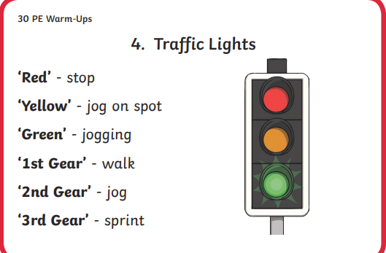
Lesson- Place two cones on the ground and between these cones place different sheets of paper within stepping distance apart. The class must travel between the two cones by stepping on the paper. This can be altered for the more able e.g. crawling, shuffling, hopping.
Cool Down-Do some simple stretches with your children and finish with a walk.

Typing-(Larry, Maksim and Fohad)
Continue practicing their typing daily. Give them a page from a book to type. Encourage full stops, capital letters and spacing.
S.P.H.E
The class would be working on feelings. Keeping it simple to begin with. Just happy and sad. Get the children to choose the correct one. Ask them to show you a happy face or a sad face.
Using images on google of happy people and sad people, ask them how is this person feeling? Encourage them to choose the correct card.
https://www.youtube.com/watch?v=-J7HcVLsCrY
https://www.youtube.com/watch?v=UsISd1AMNYU
(Songs the children can listen to and sing around feelings)
https://www.do2learn.com/games/feelingsgame/index.htm (Interactive game around feelings)

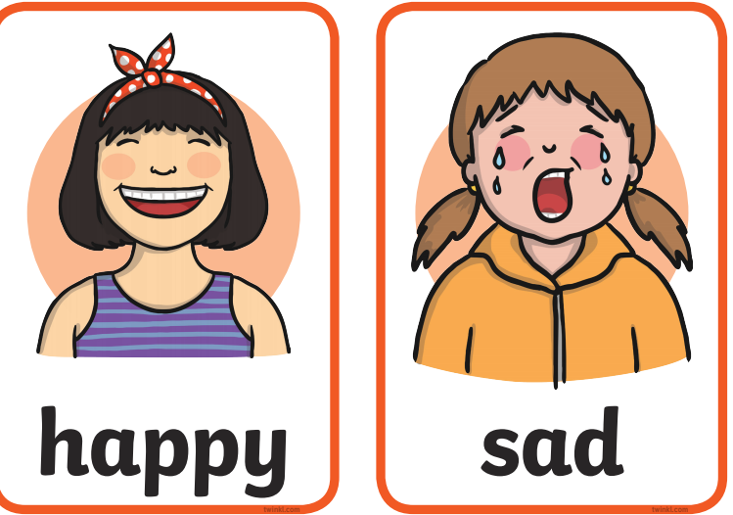

Stay Safe
Worksheet 18
“These people keep us clean and healthy”
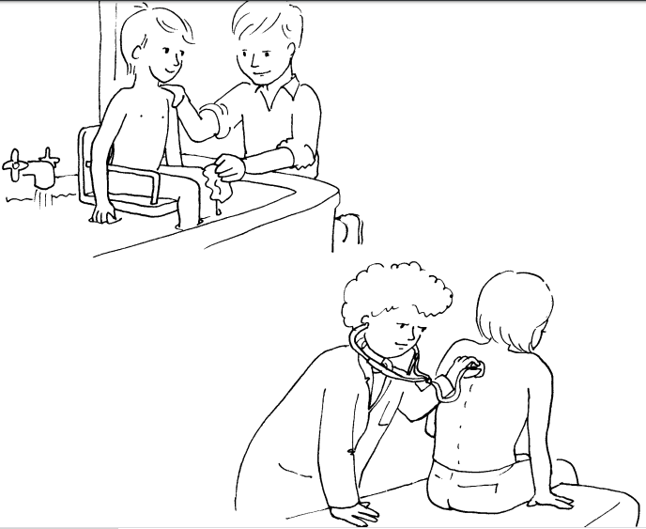
With all that going on at the minute. It’s important for the children to know that we need to keep clean and look after our health.
https://www.youtube.com/watch?v=bwx2Z69S0YA (A video about visiting the doctor)
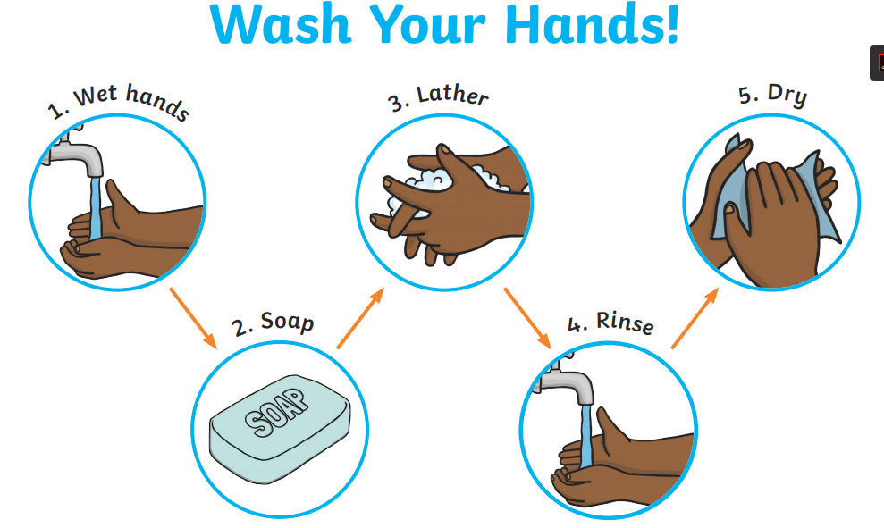
Encourage hand washing at all times using the about poster.
Use this tick box to ensure your child understands the importance of hygiene on a daily basis.
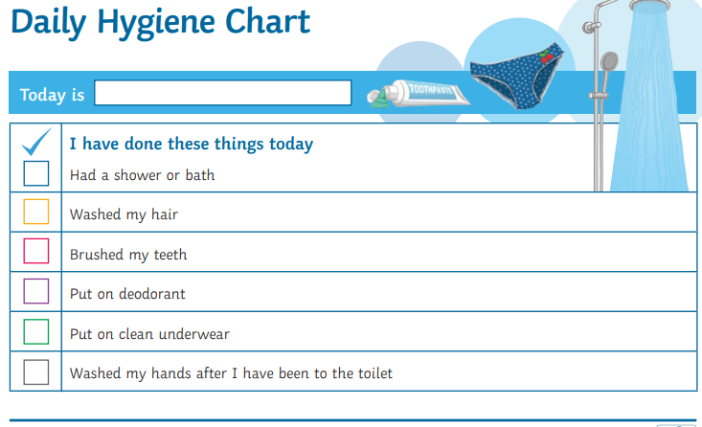

Art
Using their fingers. The children can create a summer tree. All you need is a template of a tree and green and brown paint. Dipping their finger into the paint they can create the leaves on the tree and the bark.
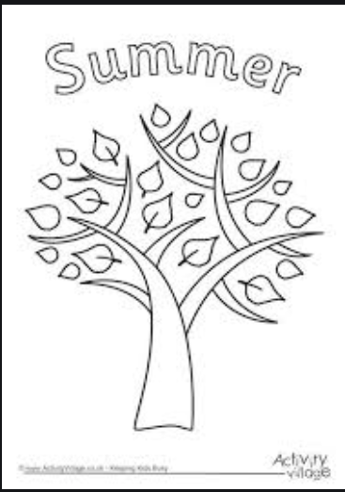

Using an A3 page the children can paint half the page blue and half the page sand colour. When this is dry, choose a colour to paint their feet. This will be their footprints in the sand.
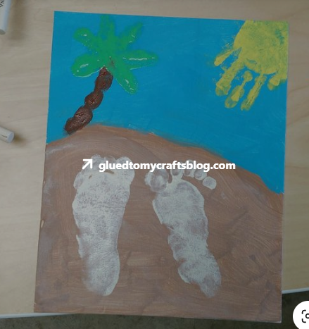

Geography
Encourage the children to partake in recycling at home. Get the children to organise and separate with help paper, cardboard, glass, plastic, general rubbish etc.
Bring your child to the bottle bank and let them help you sort the bottles.
Here is some pictures to talk about.
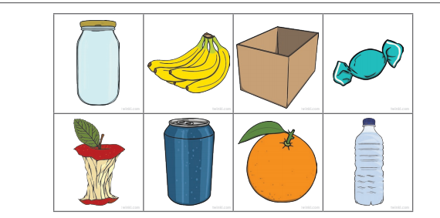

Science
Plant sunflower seeds and continue to look after them as they grow.

Writing
Keep an eye on the post! You should have received your postcard. I would love if the children could send a postcard back with their name. Depending on their ability the children could write a little message or just trace their name.
(Postcards available in the post office and no stamp is required to send)
Address: Aoife Byrne, 5 The Meadows, Mullacrew, Louth Village, Dundalk, Co. Louth.

