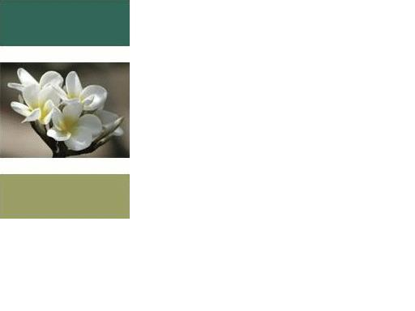

What is 2012
There is a lot being said about 2012 these days. Hollywood made a movie according what they think. Doom sayers seem to think that it will be the end of All creation as we know it. New Agers seem to think that there will be an instantaneous shift in consciousness. This shift includes humanity becoming highly evolved beings. The Mayans started all of this with writing that in 2012 there will be a great change where the “Old” is destroyed and the “New” will be an age of peace or a Golden Age as they call it. I could go on about what all the different ways 2012 is being perceived but that is not what this is about. There happens to be an infinite number of thoughts on 2012. I will be sharing my thoughts which are inspired by my Spiritual Guides.
2012 for the most part is just another year on the Roman calendar. That is if the calculations are even accurate, the calendar is based on events that when it was made the time of these events was not even accurate. So as far as we know it could be 2013 or even 2011 or an even bigger discrepancy. I don’t want to get into all the theories and particulars of the calendar. Let us get back to 2012 as we will call for the rest of this blog. According to many during the year 2012 there will be an event in our galaxy that takes place once in every 5,000 years or so. Please forgive my lack of specifics on this but that is not what this is about. This event is supposedly capable of creating a lot of natural disasters. Well from what I can see I think people are making a much bigger deal than is necessary. According to my Spiritual Guides during the year 2012 all that is really going to happen is that there will be more natural phenomenon such as tornados, hurricanes, and tsunamis. There may also be increased activity when it comes to war, terrorist attacks, and global warming. All these events are nothing more than cries for love.
Many of the events that will be experienced have already been experienced. Just to name a few lets look at some: 9/11, Katrina, the tsunami in Southeast Asia, the various influenza outbreaks, droughts and severe winters. What all of these events have in common is that we as humans came together in many ways to help promote peace, administer aid, and lend a helping hand to the victims of these events. We reached out to others with love and compassion instead of fear. The events of 2012 will also be a cry for love and help.
So what does this have to do with 2009? Well the events of 2012 are not in stone. These events may never happen. All it will take is for humanity to reach out in love to each other on a daily basis and to start living their lives from love instead of fear. For all intense purposes this is the transition that is to take place in 2012. Sorry to say though that it won’t be instantaneous, even though all spiritual theories says it is possible, humanity is just not ready for that kind of shift.
For now what is important is to leave 2012 in the future and to live our lives Now in Love. The next time someone brings up 2012 just tell them “I am Living in a Loving way Now so I do not have to worry about 2012.”
In a nut shell prophecies are there so we can make changes Now, not for the prophecy to come true. Please stop worrying about 2012 and take any prophecy about it with a grain of salt knowing that by being Loving Now is the key to a Peaceful Loving future.
Peace and Love,
David

