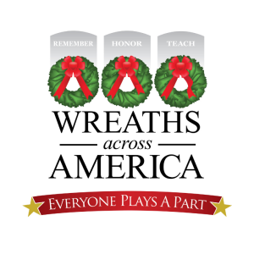
August 5, 2019

Greetings Sir Knights of the Grand Commandery of Kansas:

In 2017 the Grand Commandery of Knights Templar of Kansas launched a new fundraising opportunity within our commanderies. We chose Wreaths Across America (WAA) because it embodies both a patriotic and chivalric duty for our departed Veterans and their families.
Through the generosity of our Sir Knights we have been able to sponsor hundreds of wreaths at the Fort Leavenworth National Federal Cemetery and strengthen our Holy Land Pilgrimage funding efforts.
Knights Templar from across Kansas promoted how we REMEMBER our lost servicemen and women, HONOR and respect their sacrifice and TEACH our children their legacy of service to our Nation. It is our intension to continue to sponsor an annual WAA Fundraising Campaign in hopes of improving our donations and expanding the number of Sir Knights and their families participating in 2019.
As you may recall, for every $15.00 wreath sponsored through our Grand Commandery WAA Campaign, $5.00 is returned to the Grand Commandery for deposit in our Holy Land Pilgrimage Fund. This fund continues to be utilized to send Christian Ministers on a Grand Encampment of Knights Templar of the United States of America 11 day Holy Land Pilgrimage with outstanding success.
On December 14, 2019 Sir Knights from across Kansas will return to Fort Leavenworth National Federal Cemetery to lay our sponsored wreaths at the headstones of our departed Veterans to honor the service and sacrifice of each Veteran and his/her family. We hope you are able to sponsor a wreath and join with us in this worthy charitable event.
Attached for your use are the Grand Commandery Wreaths Across America Website Credit Card Sponsorship Procedures for 2019.

Courteously,

Sir Knight James R. Burns, III
Right Eminent Past Grand Commander
Chairman, Wreaths Across America Committee

