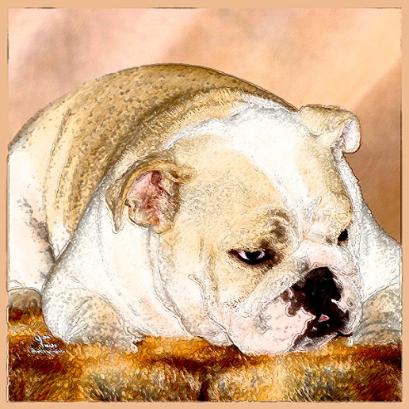
Sandra Martinez
BruMar’s Bulldogs
brumarsbulldogs@aol.com
www.thebulldog.info

Puppy Questionnaire

- Name(s):
- Age (s): Occupation:
- Phone: ( ) Email Address:
- Referred by:
- Why do you want a bulldog?
- What research have you done regarding this breed?
- Have you ever had a bulldog yourself?
- Please list the breeds you have owned and currently own.
- How many pets do you have now? Please include age and breed also.
  - If you currently have a pet are they spayed/neutered?
- Names and ages of the family members living in your household. If you have small children, have they ever had any experience with dogs?
- What is your timeframe for bringing home a puppy?
- Are you interested in a male or female puppy and why?
- Are you open to the possibility of an older puppy (6 mo to 1yr), dog (1yr +), or retired champion (3yrs+)?
- What activities do you plan on doing with your dog?
- Please describe any changes you expect in your household in the next few years; e.g. new children, job changes, moving, etc.
- How long will the puppy/dog be home alone each day?
- What do you plan on doing with your puppy/dog while you are not at home or asleep?
- What type of area do you reside in? (rural, suburban, city)
- Do you have a fenced in home, if yes please explain the material of fence and height?
- If you live in an apartment, have you contacted your landlord to see if puppies are accepted?
- Do you have any ponds, pools, lakes, etc on your property?
  - If Yes, how deep are they and are they fully fenced in?
- Have you ever re-homed one of your dogs?
- Have you ever lost a dog?
- Please list the name, address, and phone number of your current vet. If you do not have a current vet, please list a previous vet.
- Will you agree to keep us updated on the puppy’s progress health wise and also keep us updated with pictures on a regular basis?
- Puppies purchased as pets will be sold on a spay or neuter contract with limited registration. The pup must be spayed or neutered by 10 mo. of age, at which point we will need to see proof from your Vet that the procedure was completed and then the AKC registration papers will be mailed to you. Do you have any issues with this?

- Additional comments or questions for consideration:

Thank you for taking the time to complete our questionnaire.
We believe it will assist us in finding the best possible homes for our Bulldog babies.

