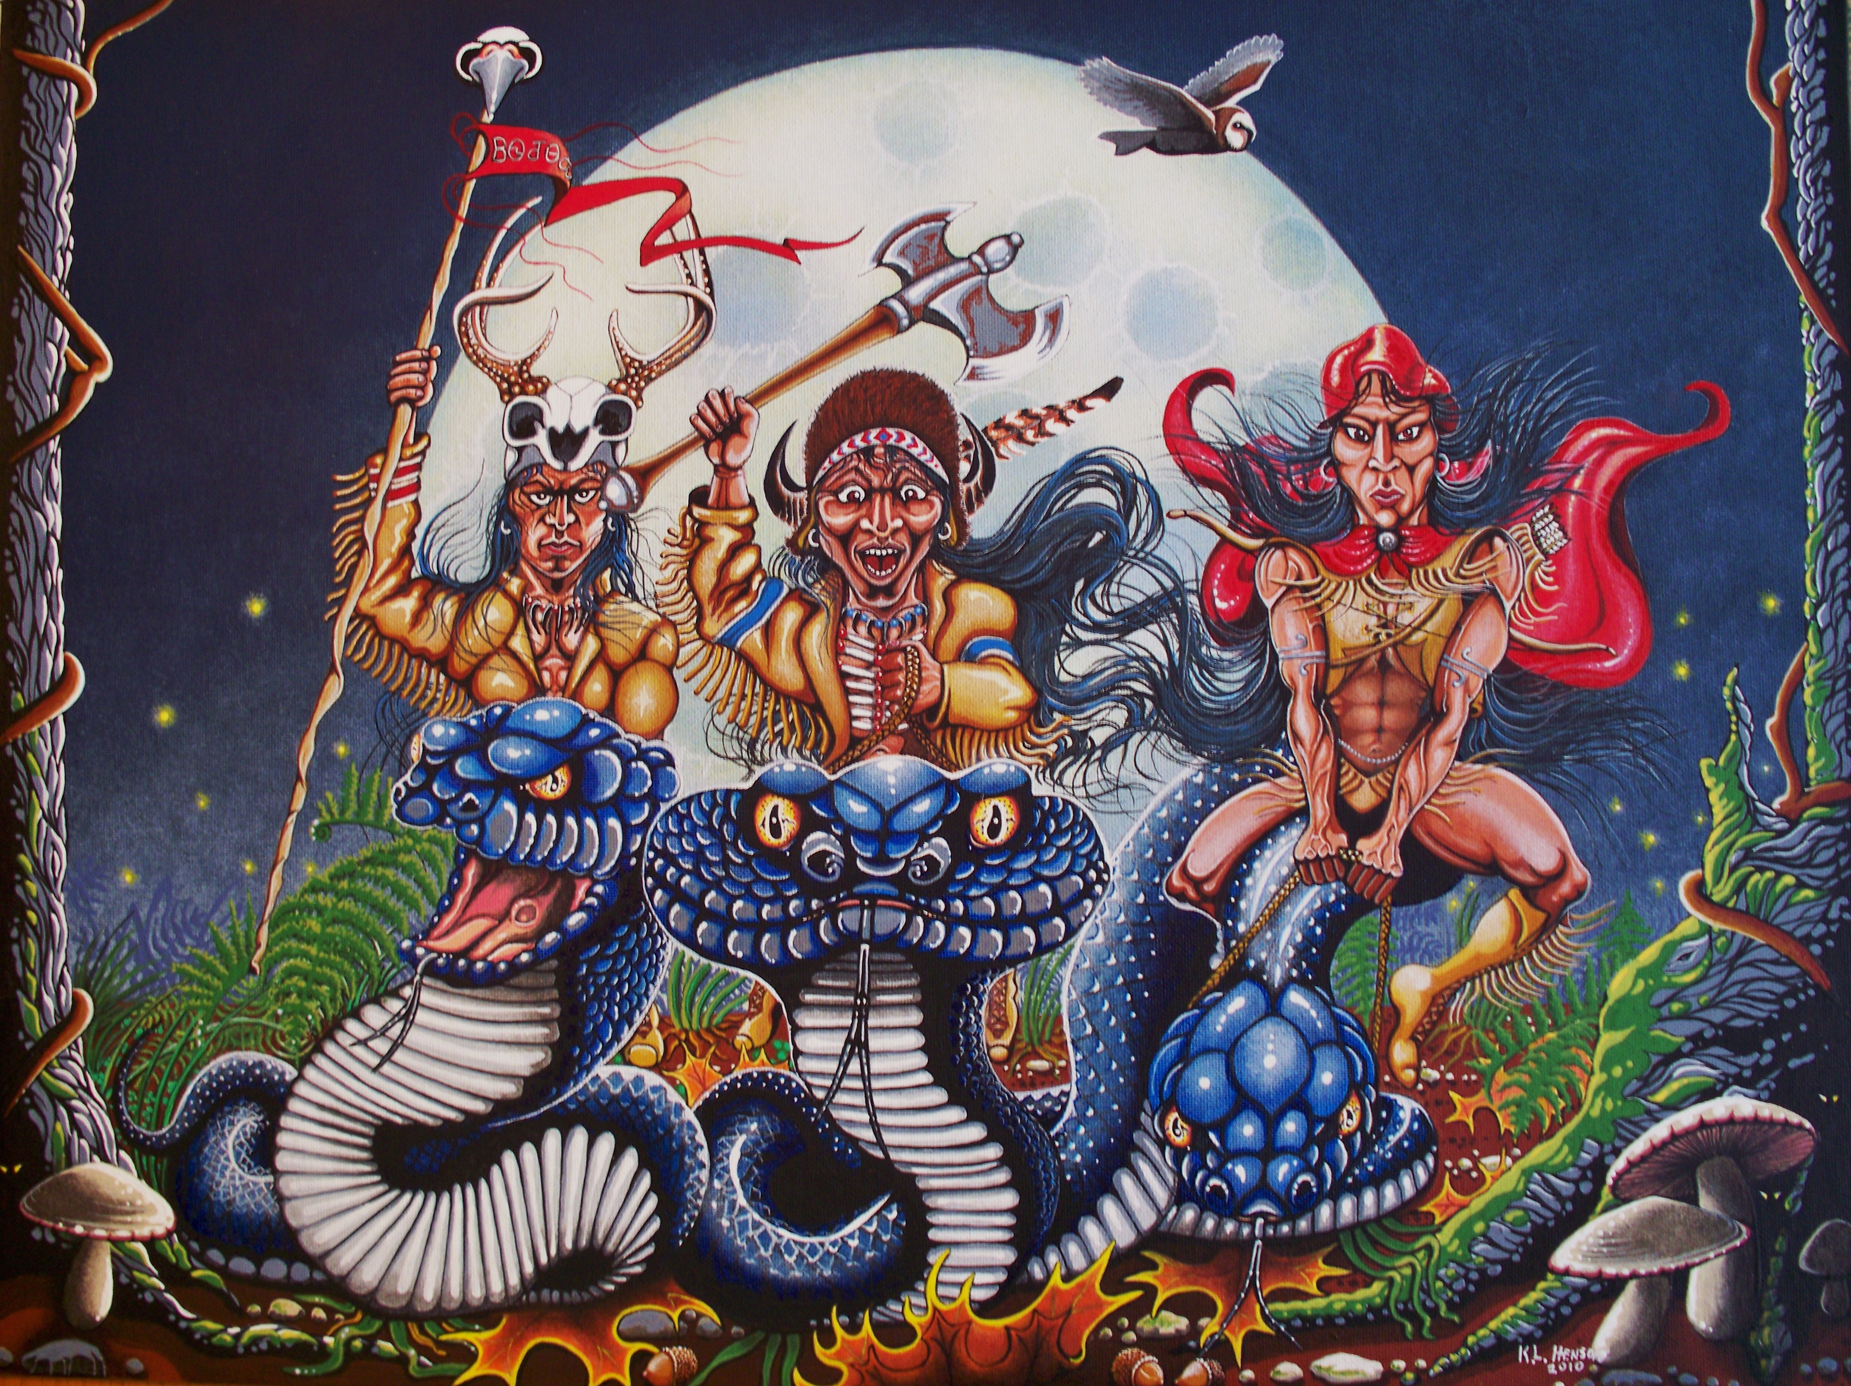

“Grandfather, tell me a story”
Written by Kenny Henson

When I was a small boy I would enjoy any time spent with my Grandfather, who was a full blood Cherokee Indian. He was an inspiration to me and I didn’t realize just how much until I grew up and started a family of my own. He was a very busy man at that time because he was a Baptist Minister and he traveled all over the Cherokee territory preaching at different churches and holding revivals. He never did learn to drive so my father would take him where ever he needed to go, in our big old blue Buick and I would always tag along right along beside my father and my grandfather wherever the road took them.
As my father would drive, some times the trips were long into different counties. This would be my opportunity to spend some time with my grandfather, one on one and he would tell me tales about when he was a little boy about my age and as he told me these tales and adventures I would imagine them in my head because he could tell them so vivid and clear that it was like I was there.
It would always start out like this, I would say “Grandfather, tell me a story “and he would say Ok, but you must listen carefully because this is a story I have not told in a long time, probably about the time your father was about your age.
This story takes place along time ago, the war was over and times were hard for families and especially for families that lost their men to the war. At this time, the Cherokees were torn between their traditional ways and the new industrial age so there was a lot of confused people but they needed to find their place in society and especially their Cherokee Society.
There was this little boy about the age of ten or eleven, but he thought he was a man because he did not have a father around. After the father went off to war, no one ever heard from him again, some said he was killed and others said he was captured and taken prisoner but they prayed that one day he would return home, so it was just his mother and two sisters, one older and one younger than himself that took care of the old home place. Because the boy was the only male in the family, he didn’t think he needed to listen to the women folk. He would always say he was going to run away by hitching a ride on the next train that came through their home place and go to the big city. He was a very disturbed little boy that was always getting into trouble. He would shoot birds and small animals with his little bow and arrow that his uncle had made for him and his mother would scold him and tell him that he should not kill the creatures of the earth unless they were to be used for food to feed the family but as always, he would not listen and just continue on, as if he did not hear what she said.
On one of these occasions when he was feeling mischievous, his mother told him to go gather some wood for her so she could cook supper, he told her “that is women’s work” and he was going hunting instead, so he got his little bow and gathered his three arrows and headed off through the back yard to the little patch of woods that lay behind their house. This patch of woods was too rough to farm and not very big, maybe about five or six acres or so with a little stream that ran through it where they would gather water cress when in season and a wall of bluffs bordered the north side of the woods that was known to harbor a den of rattlesnakes when the weather turned cool but he didn’t worry because it was the fall harvest season and he figured the snakes were asleep anyway, even though no matter what time of year it was, his mother would always say to him, “watch where you step and be careful because you could step on a snake”, but he never listened because he figured, it was just a mothers worries and he knew best anyhow.
As he entered the woods just outside his yard, he noticed the woods was dark and not as recognizable as he had always remembered them to be, so as he turned to see where his house was so to get his directions in order. He did not see his house anymore and he began to panic, just a little because he had never been out of site of his house, which he had always kept in his view when he was out exploring the woods. As he wondered through the woods trying to find a familiar site, he began to worry even more and think about his mother and two sisters who were at home, and what would they do if he couldn’t find his way home and he began to think of all the good meals his mother fixed and how nice his warm bed felt when he was tired because about this time he was getting hungry and cold.
Just as he began to lose hope that he would not find his way home before nightfall, He heard a voice call his name, so he went toward the voice thinking it would be his mother looking for him, so he followed a well worn trail that was going toward that voice he heard and as he walked faster thinking to see his mother at any moment, he seen a small figure in the trail but this was not a figure of his mother or any other adult that he was expecting to see. It was the figure of a little man to about the size of his waist with long black hair that flowed down to his knees and dressed in buckskin leather like he had never seen before but he had a friendly face that calmed him so he was not afraid at all and he began to except the little mans presents and for some reason he knew he would be safe with the little man.
The little man asked him why he was so sad when he found him and the boy told him he missed his family and they were probably worried to death about his whereabouts and he was wondering if he would ever see them again and would they pray that he would return like they did when his father never came home. The little man said I can help you find your way home if you would like but first you must come with me to meet my family and when the time is right, I will take you home so the boy happily agreed because now he felt safe and for some reason he knew the little man was telling him the truth and he would soon be home.
As they walked the trail for a ways, and walked on a fallen log that crossed the rippling stream, they came to a wall of bluffs and as they got closer he could smell the aroma of food cooking and it smelled so good because by now he was so hungry. Finally, they came to an opening in the side of the bluffs and from the opening, came a bright light that was very welcoming and the little man said welcome to my home, which was really a cave in the bluffs that he had never noticed before because he thought he had explored every place in the little patch of woods behind his house. As he entered the home the little man introduced him to his beautiful wife and his two small children, a boy and a girl that were hiding behind the mother, giggling so innocently that it made him feel even more welcome and unafraid.
The little woman said “just in time, dinner is ready, so they sat down to a bountiful spread on a small wooden table of baked wild turkey, fresh greens, wild mushrooms, and big ol’ cat head biscuits just like his mother would fix and sassafras tea with apple dumplins for dessert. After dinner he was invited to the next room to set down by a warm fire that was in the center of the room, so they could talk and hear of the boys adventures but as he started to sat down on one of the many seats that lined the room, he began to notice that the nice round black comfortable seats were moving in and out just so slightly as to be breathing and as he got even closer he noticed that these were not seats or chairs at all but large black snakes all coiled up in tight round formations with their heads in the middle of the coil and just for a moment he was afraid because he remembered what his mother had told him about watching where he stepped because he could step on a snake but just as his fear came, it went away when the little man told him that these snakes would not harm him or anyone because they were a part of his home and they have an understanding with us, we take care of them and they take care of us. They are our furniture, our beds and even our transportation so treat them with respect and they will respect you.
As the evening grew later, the little man said you look tired and exhausted so let’s get some rest and I will take you home tomorrow so the boy agreed because he was very tired and sleepy and he was so tired that the thought of sleeping on the big black snakes didn’t even matter to him at the moment and as he lay down on the snakes, they formed a perfect bed that fit him just perfectly and he went to sleep instantly.
The next morning, he woke up refreshed to the smell of black coffee and pancakes which was his favorite breakfast when he was at home. As he finished eating his pancakes and telling the little woman how good her food was and that it reminded him of his mother’s cooking, he began to feel home sick for his family, but again the little man sensed his sadness and he quickly assured him, he would take him home soon but on the way, he wanted to show him some things that would help his family and his people so as they went on their way, they were suddenly joined by other little people that arrived in such a dramatic fashion that it caught him by surprise and startled him. They were all riding on big black snakes as big as stove pipes as if they were horses, like he would see his father and uncles ride before his father went off to war. All the little people were dressed in all their own fashion with shiny trinkets in their hair and on their buckskin clothes, they were all happy and laughing as if they were going to a party.
The little people showed the boy how to find precious roots that was used for medicines and what kind of trees had the best medicine and leaves that could be ground to a pulp that was used for healing and they also showed him what kind of plants could be used for food and at last they told him to respect nature and only kill what you can eat and no more. They also told the boy, “When you hunt and kill for food on our land, leave us an offering of respect, so we will know you are sincere and remember what we have taught you because we live in a balanced world and if we take care of the earth, the earth will take care of us”. The boy listened and took in all that they had told him because they were so sincere that he knew it must be true.
The day went by quickly because he was so fascinated by what they had taught him and he was so inspired by their presents that he didn’t even realize it was getting late in the evening so he told the little man that he was ready to go home now and the little man said “I believe you are ready too” and the little man said look behind you were the sun is setting and as the boy did as he was told, he seen his house and his back yard and he was so excited that he forgot to tell the little people good bye, but they understood because by the time the boy seen his house, they had already gone back to there own world, riding on the backs of their big black snakes and in the same dramatic fashion as they had arrived.
When the boy reached his backdoor, he flung it open with such force it almost came off its hinges, and he ran into the kitchen yelling, “Mother, mother”. The mother was making biscuits and replied, “What’s all the ruckus son?”. The boy said “didn’t you miss me, did you look for me, aren’t you going ask me where I’ve been for the last two days?” and the mother replied “why? my little man, you’ve only been gone for less than an hour”.
This was one of my favorite stories my Grandfather told me and I take it to be true because my Grandfather was that little boy.

The End

