Geography
The Local Natural Environment
Minibeast Hunt
- Introduce your child to the phrase minibeast. Explain that the insects that we find in our gardens and both inside and outside of our houses can be called minibeasts.
- These include, but are not limited to:

- Ants
- Bees
- wasps
- Flies
- Beetles
- Worms
- Caterpillars
- Slugs
- Snails
- Spiders
- Lady bird

- Copy and paste the link below into search engine and it will play a short video detailing insect and their characteristics

https://youtu.be/rKQfJFAHW8Q
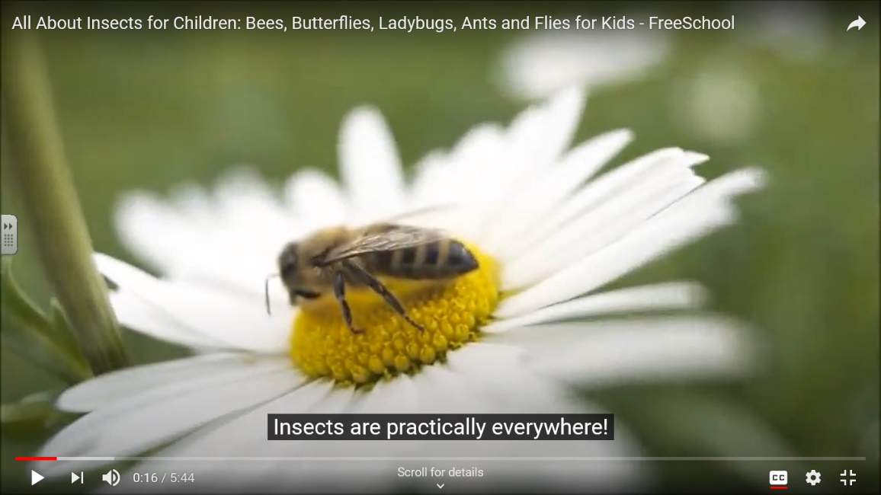

- Explain to your child that you are going on an exciting hunt to find some of these minibeasts. Begin in the garden or yard and encourage your child to look under rocks/stones pots etc. Many insects live in these areas. If any are found praise your child and get them to record it in their printed chart (below).
- Encourage your child to lead the hunt (safely) by letting them search an area of their choice independently but supervised.

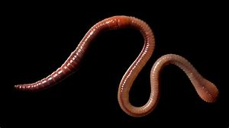

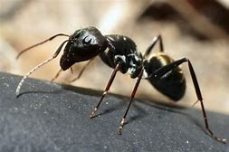

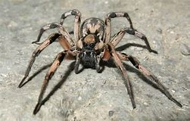

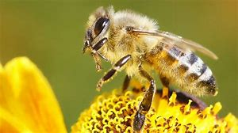

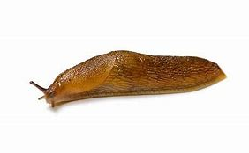

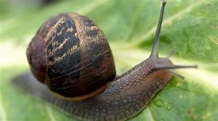

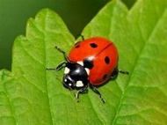

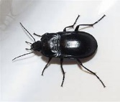

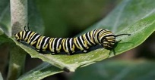

If any others are found simply record it and talk about characteristics. Let them draw and colour the minibeasts they find.

