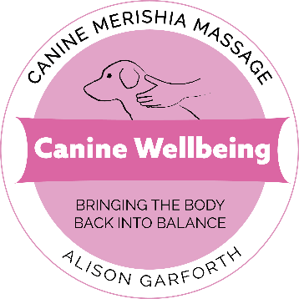
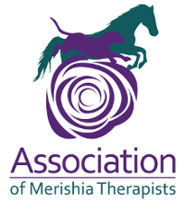

Canine Wellbeing
Merishia Massage Therapist
Alison Garforth
A.DipCBM, Dip AMT, APDT (UK)
www.canine-wellbeing.co.uk
Tel: 07739 080803

Request for Veterinary Consent
Owner details:
Name of owner:
Address:
Postcode:
Telephone number:

Dog details:
Name:
Breed:
Sex:
Age:

Veterinary details:
Vet Name:
Practice Name:
Address:
Postcode:
Telephone Number:
Relevant medical history of animal:

Current Medication:
Reason for session: maintenance / support for rehabilitation or recovery:

I am a Canine Merishia Massage Therapist, insured, and work in conjunction with the Veterinary Act.

Veterinary Surgeon’s Declaration:
The animal stated above is in a suitable condition to undergo massage therapy.
Name Signed
Date

Please inform me of any additional medical details you think I should be aware of prior to the session.

You can scan and email this form to alisongarforth@yahoo.co.uk
If you have any questions, please email or ring me.

Kind regards
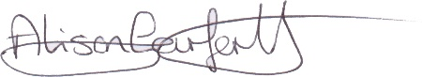
Alison Garforth

