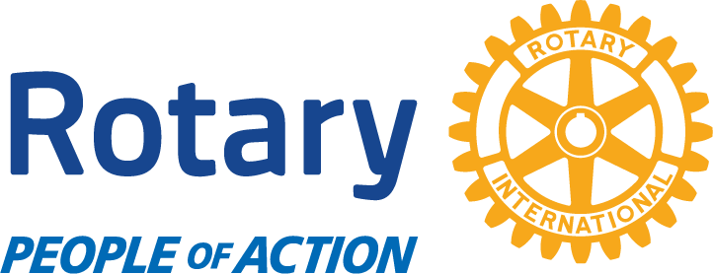

Rotary Club of Spruce Pine

The Rotary Club of Spruce Pine was established in 1928 and has served our Mitchell County communities continuously for over 90 years.
Our Spruce Pine BBQ & Bluegrass Festival is our annual fundraiser to provide for our charitable giving and an affordable entertainment venue for our local
area. Non-profits are provided free booth space to interact with the public. With the generous help of our sponsors, the Town of Spruce Pine, the Town of
Bakersville, and Mitchell County, we are or have been involved in the projects listed below by donating time and money.

American Cancer Society - Relay for Life
Blue Ridge Partnership for Children
Blue Ridge Regional Hospital Foundation
Boy Scouts
Brad Reagan Sports Complex
Coins for Alzheimer's Research Trust
Deyton Elementary School – Raleigh Trip
Four Way Test Essay Awards
Habitat for Humanity
Harris Middle School Student of the Year Award
Honor Air Flights for WW II Veterans
Imagination Library
Kids Play – Riverside Park playground
Lamplighters Literacy
Mayland Community College Nursing Scholarship
Mitchell County Animal Rescue
Mitchell County Safe Place Kennel Project
Mitchell High School Seniors of the Month
Mitchell High School Future Business Leaders of America Trip
Mitchell High School College Scholarships
Overmountain Victory Trail
Penland School of Crafts – Kid’s Camp
Rotary Youth Leadership Academy – Camp for rising MHS Seniors
Rural Education Partners
Shepherd’s Staff food pantry
SP Main Street Central Park Project
The Altapass Foundation
Troutacular Trout Festival – Spruce Pine
Tornado Relief United Way of Mitchell County
W.A.M.Y.
International Giving
Rise Against Hunger Meal Packaging
Rotary District 7670 Wheel Chair Project
Shelter Box International
Project World Water Relief – Water System for Ecole St, Pierre, Mirebalais, Haiti
The Rotary Foundation Programs:
Polio Plus, Rotary Peace Fellowships, Rotary Ambassadorial Scholarships, and Rotary Group Study Exchange, plus many more.

