The Way Forward
Bubble Baths and Sparkling Wine
Courage Compassion Creativity

Wow. What happened? One minute, life was returning to normal after an eventful year. The next minute we were ‘locked down’. Truthfully, for me, in rural Wales, isolation is not new. But when most of the world is locked down, that is new. When the possibility of travel is no longer a possibility, when the relief and refreshment of a visit to the grocery store or the coffee shop can no longer happen, well…. this is really different. Of course, I spent the first several weeks on my phone checking updates, up to 5 hours a day. Gradually, helped immensely by a spell of gorgeous weather, a sort of new normal set in. A run on the lane two or three times a week. (It only requires 32 ‘trips’ up and down to do the 5k. My knees are not happy). Cooking dinner every night is a change, painting a bit, ironing of course, my default hobby, sometimes catching up with running buddies on ZOOM. Oh, and I almost forgot- a regular morning cappuccino, a shortbread cookie (homemade of course, and a reading.
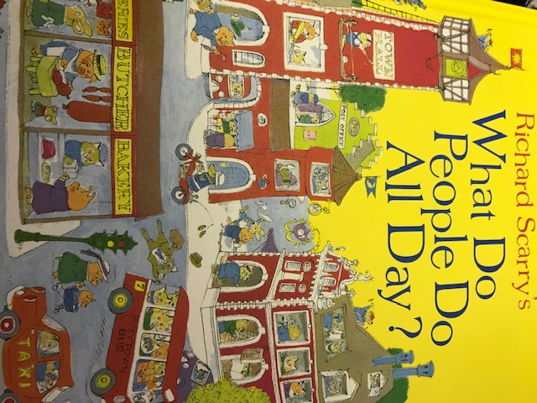

Still, the ‘new normal’ means that my anxiety, always on the alert in any case, has now reached new heights. Of course, at first, accessing groceries was the BIG issue on my list. I would stay up until past midnight trying to find a slot for home delivery as I had never done this before. I was pretty lucky right from the outset. I never found a slot at midnight but during my many ‘trips’ to the various websites throughout the days, one occasionally would show up. So we never actually starved. And then….a Tesco delivery person took a look at me in the doorway one day and asked me if we had ‘priority’. Actually …no. (I didn’t know I’d aged so much in three months!) So he tucked himself away behind his truck and a couple of minutes later came out with a number written in pencil on a small piece of paper. ‘Call this number’ he said. I don’t know who he was but if he ever gets to read this -THANK YOU for your care and thoughtfulness.
Then….it was….how am I going to unload these groceries in a risk free way? So I would leave the bags out on the front step and bring a few perishable things in at a time, place them on the counter by the sink, and then wash things like milk bottles with soapy water, leaving them to dry on a paper towel on the counter. But what about things like strawberries? Raspberries? Do I wash them or not before putting them away? So I decided to empty them from their plastic containers and put them into my own plastic containers which are in the cupboard. So I take my own containers out of my kitchen cupboard….but…oh…I forgot to wash my hands before taking them down. So now I have to wash my hands, and wash the cupboard handles…..and…you get the idea…
So what has helped me? Trying to keep busy. A routine of some sort as I have already mentioned has been pretty useful. My GP once told me that the most important pathway to mental health is DISTRACTION. Trying to be a bit creative. Trying to maintain a compassionate approach. And just summoning up the courage on a daily basis to keep going.
If I am to be really honest, the highlights of the day or rather the end of the day have, without fail, been bubble baths and sparkling wine. Truthfully, on occasion I have had to resort to Fairy liquid for the bubbles, when Jo Malone, or Molton Brown or the White Company have been unavailable to me. As for sparkling wine, well, I must confess that a glass of Prosecco has taken front row and centre in Sparking JOY, just ahead of watching Montalbano, the Sicilian detective and Murdoch, the Canadian.
And truthfully, time has been available to really consider what matters the most. Hope and generosity keep coming back to me. Hope for all of us that a solution will arrive REALLY SOON, hope that we will continue the generosity which has been so remarkable. Our neighbours with whom we have had little contact over these last 22 years, checked in with us every couple of days to ask what we needed and they were able to find milk, eggs, even brown sugar!
This profound shift in the rhythm of life has given me a chance to step back, to reflect, to revisit. and yes, to address those thoughts, questions, potential shifts in ways of doing and being that have been quietly simmering for quite some time within me and possibly you too. The central question is this: How can I live my life fully and meaningfully within the particular context in which I find myself? How much of my life do I need to change in order to achieve a sense of fulfilment? And, do I know what would bring me that sense of fulfilment? Of course, these are not questions that can be answered this afternoon, this week, maybe not even this month. But to have identified the questions is such an important step for it provides a focus.
I have revisited books, and other significant sources of wisdom that I haven’t touched for many a year to help me along this challenging path to fulfilment. I am a big fan of Martin Seligman, the founder of Positive Psychology. One of his many contributions have been his methods for helping us identify our personal strengths, through various means including a Strengths Inventory, (VIA-Values In Action) which you can find and take for free at: www.viacharacter.org. My good friend, colleague and former PhD student Ilona Boniwell has developed the wonderful Strengths cards which you can find and order on her at her company website: Positran.fr.
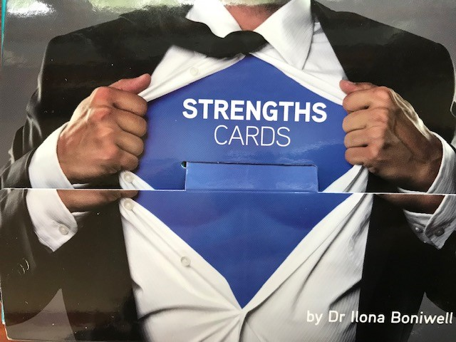
Last year, I had the good fortune to spend a bit of time with Martin Seligman, Ilona and a few others in Paris. It was there that Martin discussed his latest contribution to ways and means of enhancing our well-being- the development of PERMA model, Positive Emotion, Engagement, Relationship, Meaning and Accomplishment. Of course, you can find out a bit more about it on-line.
Though I have done some painting over this time, I had not created a Mandala for years. This profound approach, a simple, complex, visual way of revealing your inner self to yourself is another lovely ‘intervention’. You can still buy the book ‘Creating Mandalas by Susanne F. Fincher at Amazon.uk
And, I found amongst the other 999 books on my shelves, ‘On Becoming a Person’, by my all time favourite famous psychologist, Carl Rogers. (Hmmmm). Of his many contributions, to me the most important has been his description of the necessary and sufficient conditions to facilitate positive change-empathy, unconditional positive regard, genuineness. To listen to someone else without judgement or advice giving, but simply to reflect back to the other the thoughts and feelings they have conveyed, this can bring such a sense of relief to that person, of being understood. This ‘active listening’ can bring a consequent deepening in self- understanding, a profound sense of release, clarity, and movement forward, ultimately to that place of fulfilment. If we rest our interactions with each other on these three cornerstones, empathy, genuineness and unconditional positive regard, what amazing things we can all accomplish.
So this has been a ramble, from this to that. But I can’t leave you without sharing a few of my paintings and of course …a recipe.
The landscape painting is of the farm in which we live and I will be giving the painting to our lovely neighbours. The second is a copy of a photo by Matt Wilby of the Aberystwyth sea front. The third….well…I got carried away by a rose from the garden. The recipe is from…..you guessed it…my very very favourite tv chef…Ina Garten!
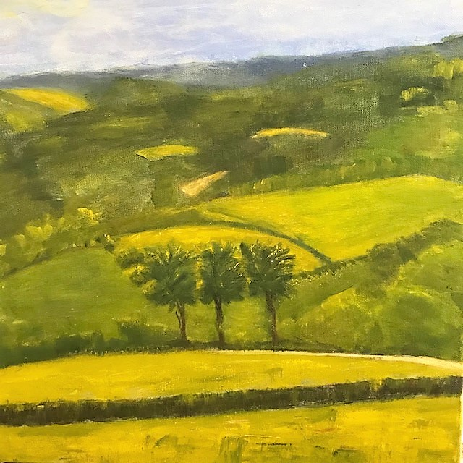
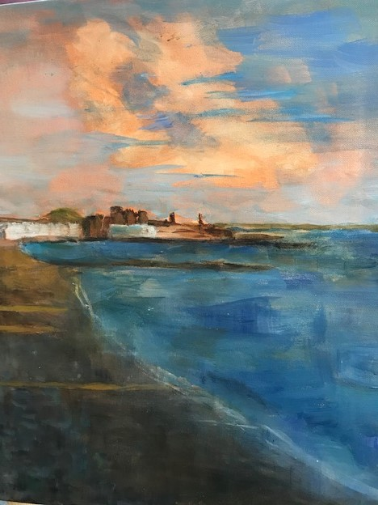
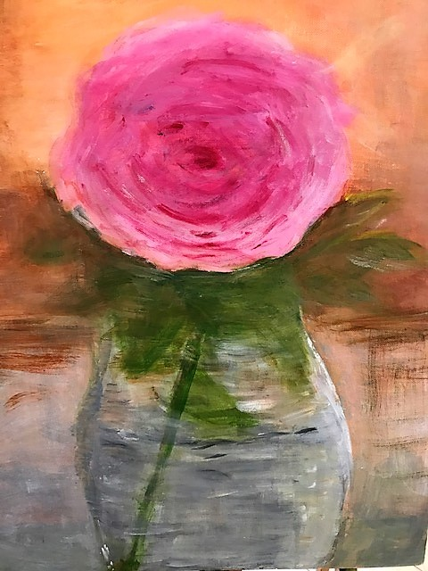

Pecan Pastries (Alias: Easy Sticky Buns)
I have cut Ina’s recipe in half but of course you can always double the ingredients to make a dozen. They freeze well.
Makes 6
Heat oven to 200C/180F
6 tablespoons unsalted butter, at room temperature
1/6 cup light brown sugar, lightly packed
¼ cup pecans, chopped into large pieces
1 sheet all butter puff pastry
Filling
1 tablespoon butter, melted and cooled
1/3 cup light brown sugar, lightly packed
1 ½ teaspoons ground cinnamon
½ cup raisins
Directions
Line a sheet pans with parchment paper.
Beat together 6 tablespoons butter and 1/6 cup light brown sugar. Place one rounded tablespoon of mixture into 6 muffin cups. Distribute pecans evenly on top of the butter sugar mixture.
Unfold the puff pastry so that the narrow ends of the rectangle are up and down, not sideways. I use a marble slab but anything smooth and not absorbent will work well. Ina’s recipe says to brush the whole sheet with the melted butter, but truthfully, I forgot and mixed the butter with the brown sugar, cinnamon and raisins. It worked fine. Leave a one -inch border on the puff pastry, sprinkle the mixture evenly on the sheet.
Starting with the ends nearest you, roll the pastry up snugly. Finish the roll with the seam side down. Slice the roll into 6 equal pieces about 1 ½ inches wide. Place each piece spiral side up in each of the 6 muffin cups.
Bake 30 minutes until the buns are golden to dark brown on top and firm to the touch. Allow to cool 5 minutes. Invert onto parchment paper. You can ease any remaining filling and pecans out onto the pastries with a spoon. Allow to cool completely.
Enjoy!
Anitaxx

