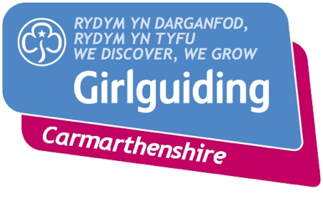

Guiding Development Co-ordinator
Name…………………………………………….
Date appointed…………………………………… End date……………………………….
Remit: Ensuring that the training and development needs of the County(ies) or area covered by the role are met in a timely and effective manner, for Members of all ages – youth and adult.
Reporting to: County Commissioner(s)
Liaises with:
Head of Youth Support – Girlguiding Cymru
Head of International and Outdoor Experiences – Girlguiding Cymru
Head of Adult Support – Girlguiding Cymru
Trainer Co-coordinator -– Girlguiding Cymru
Members in County(ies) – directly and/or via Commissioners
Appointed by: County Commissioner
Term of office: Three years, with an additional two years possible if appropriate

Purpose of the Role:
The Development Co-ordinator ensures that training and development needs in their area(s) are captured and action is taken locally to provide development opportunities to help meet the needs identified.
This role is a key enabler of ‘Being our Best’ and helping to Grow Guiding in Wales.
Key Responsibilities:
Working with local Members and Advisers (if applicable), the Trainer Co-ordinator and Trainers, Heads of Youth Support, International and Outdoor Experiences and Adult Support, to ensure that development needs in the County or area covered are seen and responded to.
- Capture training and development needs of all types in the County/area covered
- Establish how Members and new volunteers in the County/area covered prefer to access trainings and development opportunities (local, evenings, weekend, virtual, face to face, distance learning etc.) and ensure that the training and development opportunities provided meet local preferences as far as possible
- Liaise with the Wales Trainer Co-ordinator to ensure the identified training needs are met in a timely and effective way
Contd…..
- Ensure ‘core requirements’ trainings such as Safe Space and First Response are regularly available in a variety of delivery mechanisms to maximise access and take-up
- Regularly publicise and promote future training and development opportunities in the County/area covered
- Ensure that logistical and administrative arrangements in support of training and development are in place and operate smoothly (e.g. timely joining instructions provided, facilities and equipment suitable etc.)
- Ensure that Trainers are properly hosted (refreshments and meals provided if appropriate)
- Act as the point of contact for large-scale ‘Roll-outs’ in the County/area covered
Key personal attributes:
- Good networker
- Positive and forward thinking, able to enthuse and encourage
- Flexible and adaptable, willing to adopt and promote new ways of doing things to achieve the desired results
- A good enabler/co-ordinator (many of the key responsibilities will be delivered by others in the County)

