Guided Reading

 | I want to learn more about this
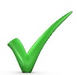 | I knew this or I predicted this
X | This is not what I expected
? | I need some clarification on this or don’t know this word
! | This is exciting  I enjoyed learning this
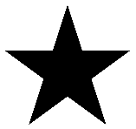 | This stands out to me
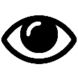 | This makes me visualize something or see something in my mind
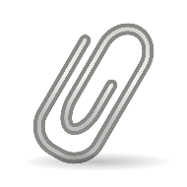 | This connects to the real world or to my own life

