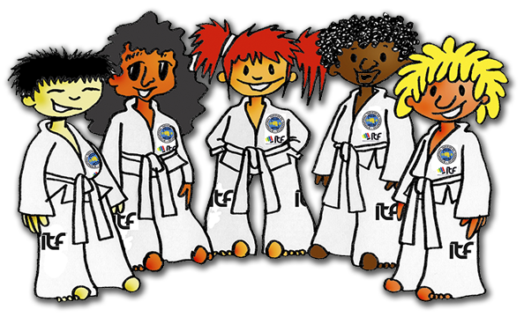

RAINBOW WORD
BOOKLET

NAME - - - - - - - - - - - - - - - - - - - -
CLUB - - - - - - - - - - - - - - - - - - - -

Rainbow System

The Rainbow system has been designed specifically for children between the ages of 3 and 8 years old. It aims to provide the child with a solid foundation in martial arts, whilst also instilling a sense of discipline and respect towards people in authority.

Another main objective of the program is to develop the child’s balance, co-ordination, flexibility and fitness. Children often have a natural ability for these skills, therefore this program allows their progress to be closely monitored and rewarded with a unique grading system.

Your child will be evaluated on their own merit, making the grading system very individual to the child’s own level of development. At the Instructors discretion, he/she will assess the child’s improvement and provide different training drills and exercise to meet their capabilities.

The grading system is as follows:
10th kup white belt
9th kup white belt red tag
8th kup orange belt
7th kup orange belt blue tag
6th kup purple belt
5th kup purple belt green tag
4th kup brown belt
3rd kup brown belt white tag
2nd kup brown belt white stripe
1st kup yellow tag

Your child would then be promoted to 8th kup yellow belt and take their place in the junior class. However, please remember that the majority of children do not have to go through the entire Rainbow grading system before they are accepted into the junior class. The Instructor may decide to promote them to the next grade if they show a certain amount of potential. Only very young children, or those with attention or physical difficulties, may have to complete the full Rainbow programme.
Prior to your child advancing up to the junior class, a good Instructor should let the Rainbow student train with the advanced class, whilst still attending their normal class, for a recommended 3 months. This should be at no extra cost to the parent, as it is of most importance that the child is comfortable with moving up to the next level.
Your child will never fail a Rainbow grading for not knowing their Taekwon-Do terminology, however, we would like to encourage parents to help their child get into the routine of revising for tests and help them learn their words relevant to their grade as often as possible. When your child reaches the junior class they will not be permitted to grade unless sufficient effort is made to learn the words. If your child has any learning difficulties we take this into consideration and offer personal help during the class.
We try to make the children understand that if they want something in life, they have to work for it. Although the Rainbow children are young, they have enormous absorption levels, and this is what we are looking to enhance.
I also encourage parents to talk directly to myself to obtain progress reports on their child’s martial arts future or any other TKD matter.

Yours Sincerely,
David Condie
Senior Instructor

WHITE BELT (10th Kup)

WORDS

Taekwon-Do means Foot, Hand, Art
Chariot Sogi means Attention Stance
Ap Joomuk means Front forefist
Sonkal means Knifehand
Hanna means One
Dool means Two

Now find them…

T | A | E | K | W | O | N | D | O | T | M | S | L
F | M | N | Q | A | Q | G | C | D | A | A | O | G
L | C | X | N | D | S | A | L | N | D | F | N | F
V | G | N | C | V | D | H | C | O | V | G | K | E
D | A | V | F | K | U | M | O | O | J | P | A | R
H | J | U | G | E | E | L | M | L | I | C | L | F
B | F | I | P | J | Y | C | H | J | F | G | J | G
C | H | A | R | I | Y | O | T | S | O | G | I | Z
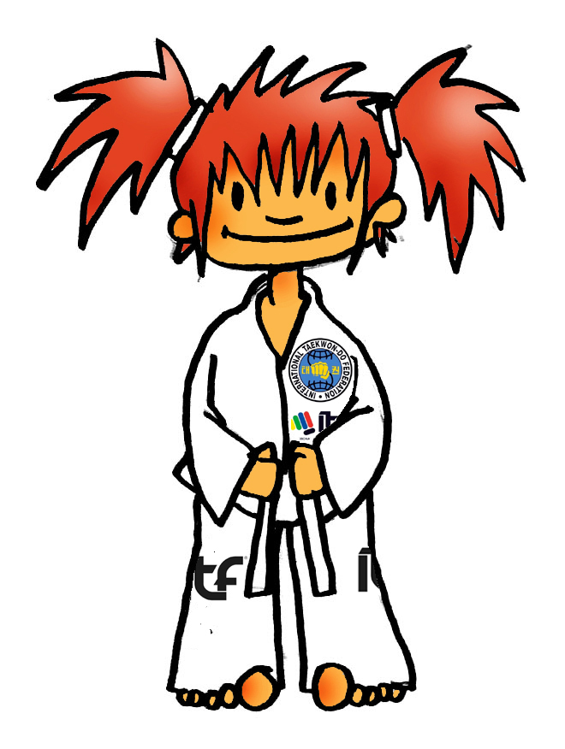
Respect your parents...
WHITE BELT RED TAG (9th Kup)

WORDS

Gunnan Sogi means Walking Stance
Pakat Palmok means Outer Forearm
1st Tenet of TKD means Courtesy (being polite & respectful)
Set means Three
Net means Four
Dobok means Training suit
Ti means Belt

UNSCRAMBLE THE LETTERS TO REVEAL WORDS...

TES _ _ _ ENT _ _ _

SYCUTORE _ _ _ _ _ _ _ _

KATAP KAMLOP _ _ _ _ _ _ _ _ _ _ UNAGNN SIGO _ _ _ _ _ _ _ _ _ _
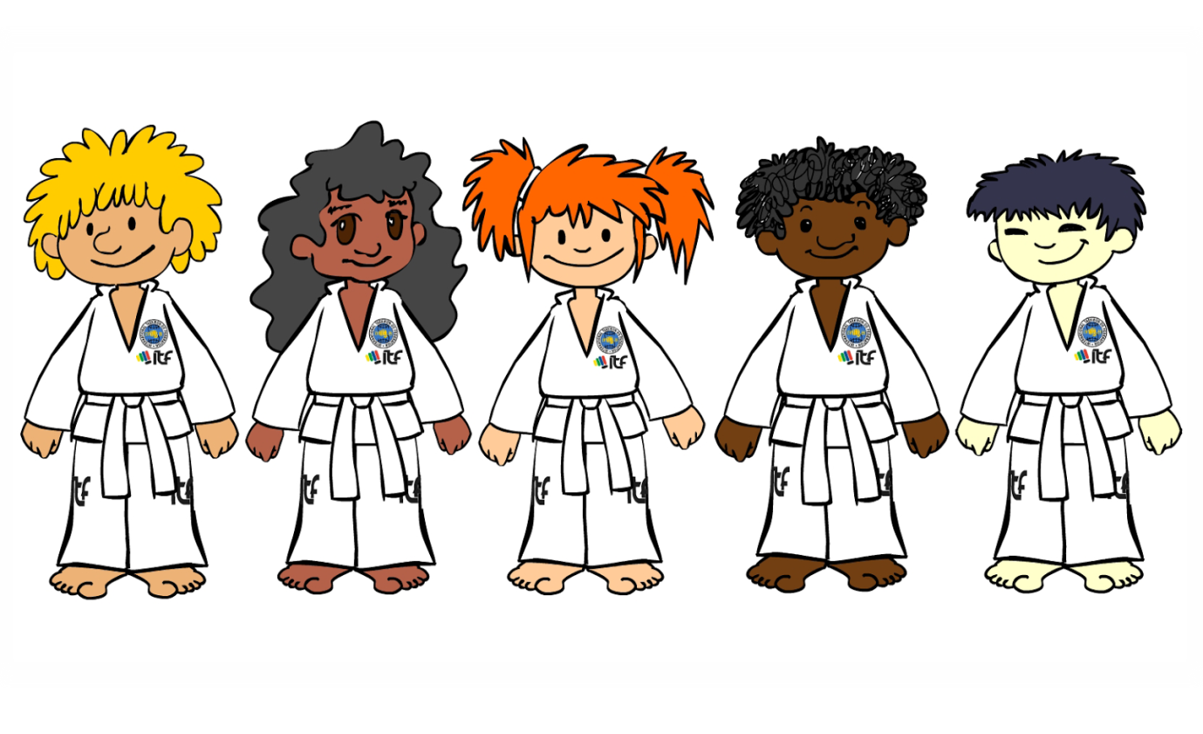
ALWAYS be strong and defend yourself, but NEVER be a bully.
ORANGE BELT (8th Kup)

WORDS
Annun Sogi means Sitting Stance
Narani Sogi means Parallel Stance
2nd Tenet of TKD means Integrity (doing what’s right)
Balkal means Sword edge of foot
An Palmok means Inner forearm
Dassot means Five
Yassot means Six
Sijak means Start

Colour in and design your own dobok.
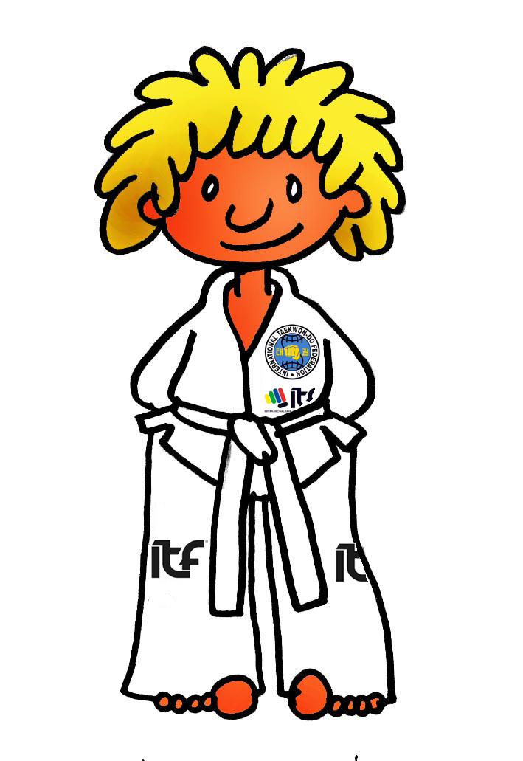

Always try your very best..
ORANGE BELT BLUE TAGS (7th Kup)

WORDS

Nuinja sogi means L-stance

Dojang means Training Hall
3rd Tenet means Perseverance (keep trying when hard)
Chon Ji means Heaven and Earth (has 19 moves)
illgop means Seven
Yodel means Eight
Guman means Stop

Can you colour the ITF fist with the correct colours?

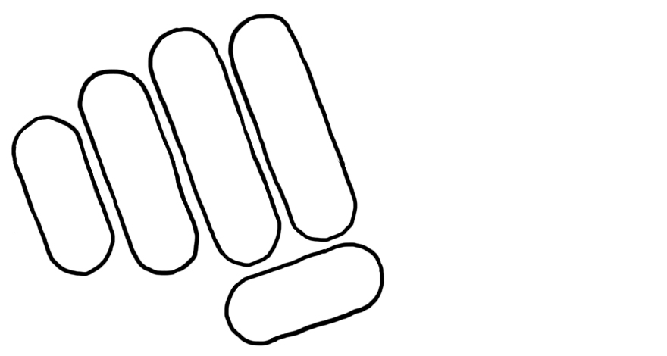

A good student always behaves...
PURPLE BELT (6th Kup)

WORDS

Saju Jirugi means Four directional punch
4th Tenet of TKD means Self control ( never lose your temper)
Sonkut means Fingertip
Dung Joomuk means Backfist
Ahop means Nine
Yoll means Ten
Swiyo means At ease

Can you spot the 6 differences?

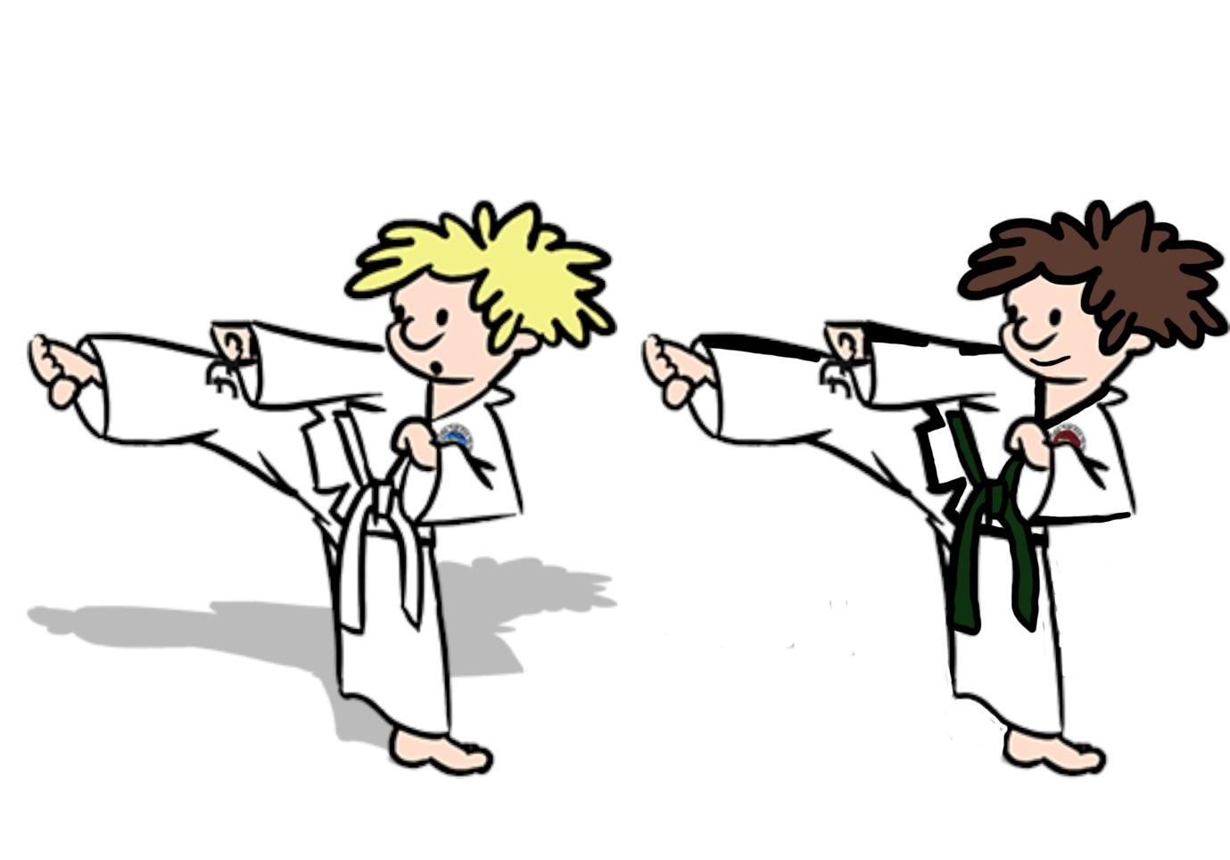

Always keep trying your best even when things get hard and you feel like quitting...
PURPLE BELT GREEN TAGS (5th Kup)

WORDS

White belt means Innocence
Yellow belt means Earth
5th Tenet of TKD means Indomitable Spirit
(Against all odds, show inner belief)
Makgi means Block
Chagi means Kick

TKD QUIZ

Can you name all 5 tenets of TKD?

How many movements has Chon Ji got?

How many stances can you name?

How many parts of the hand do you know?

Do you know what white and yellow belt mean?

If you can answer all of the questions above, tell your Instructor the answers. You are on your way to becoming a junior member of TKD.

A good student behaves inside and outside the training hall and should always show good manners...
BROWN BELT (4th Kup)
BROWN BELT WHITE TAG (3rd Kup)
BROWN BELT WHITE STRIPE (2nd Kup
YELLOW TAGS (1st Kup)

From brown belt and above your child should be in preparation for the yellow belt class. Your child’s age, balance, co ordination and confidence levels will determine what grade your child advances up to in the junior class.

All Instructors will be constantly breaking up movements into sections and grade accordingly. If the student can get through that is required of them, then they will be promoted to 8th kup junior yellow belt at their next grading.
WORDS
Tested on all previous terminology.

TAEKWON-DO MATHS!

hanna + hanna = _ _ _ _ _ ahop - set = _ _ _ _ _ _

net x dool = _ _ _ _ _ yoll – dassot = _ _ _ _ _ _

yassot + dool = _ _ _ _ _ illgop – hanna = _ _ _ _ _ _

Stretch daily and set new goals...

