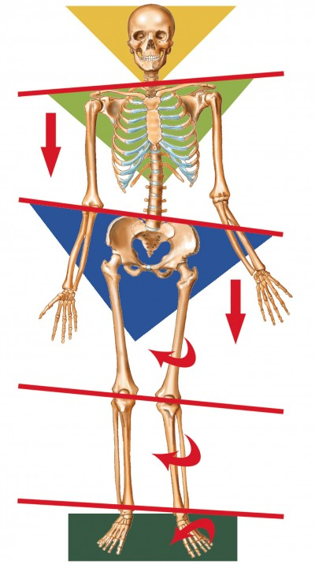
True leg length discrepancy is rare, but what is common is a tilted pelvis which creates the illusion of one leg being shorter than the other.
Imagine a puppet on a string If you tilt the bar holding the strings one leg will lift up.
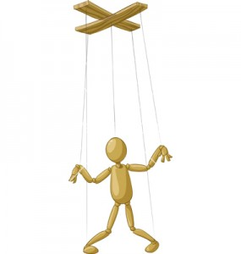
If you are only looking from the bottom it gives the illusion that one leg is longer or shorter than the other. In reality the entire puppet body is tilted affecting the pelvis, which in turn affects leg length.
In human beings this same effect happens when the spine and/or muscles get short and tight on one side, lifting the leg and foot or tilting the pelvis.
This is why Amatsu assesses and examines the WHOLE patient, everything is connected and a proper assessment should look to find the real, root cause of the problem. Just like a pebble dropped into a pond creating a ripple effect so an injury creates a similar effect and the site of a pain is not the only issue for the body, it is the tight muscles, just like the puppet strings, which Amatsu addresses to give back balance to the pelvis and subsequently balance to the whole body.

