Peninsula Piecemakers Quilt Guild 2019/2020 Mystery Quilt
(Finished Quilt size: 72” x 72”, Finished Block size: 12”)

Clue 3

3. . .
a. Sew a dark 3½” squares and a 3½” HST triangles from step 1 together to form Section B2 for a total of 4 sections.

b. Sew a section B and a section B2 to form Block 3. Square up to 6½”. Repeat to make 4 blocks.

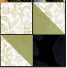

c. Sew Block 1, Block 2 and Block 3 as shown below. Square up to 12 ½ “. Repeat to make 4 Blocks.
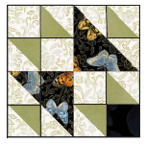
4. . .
a. Sew a dark and light 1¾” strip together to make a strip set. Repeat to make 12. Cut the strips sets at 1¾" increments to make 256 segments.
b. Sew 2 segments together to make a Four Patch. Repeat to make a total of 128 4-patch squares. Square up to 3”. (Sixty-four will be used in step 5a and 64 will be used in step 5b).
