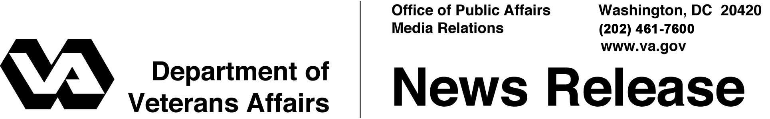

FOR IMMEDIATE RELEASE
August 4, 2011

VA Reaches Out to Veterans to Explain Upcoming Changes to GI Bill
Encourages Veterans to Visit VA Website to Learn More
WASHINGTON – The Department of Veterans Affairs (VA) is reaching out to inform Veterans of recent changes made by Congress to the Post 9/11 GI Bill that take effect in 2011.
General Allison Hickey, Under Secretary for Benefits, said “The Post 9/11 GI Bill is incredibly important because it reduces the financial burdens of higher education so that Veterans have an opportunity to achieve their education goals. VA believes it is important for Veterans to be aware of changes to the GI Bill this year and learn more about how these changes may affect them.”
“It’s hard to believe how far we have all come with the Post-9/11 GI Bill the past two years,” stated General Hickey. “Today, more than 537,000 students have received over $11.5 billion in GI Bill benefits to help them take charge of their future.”
Upcoming changes to the Post-9/11 GI Bill effective August 1, 2011 include paying the actual net cost of all public in-state tuition and fees, rather than basing payments upon the highest in-state tuition and fee rates for every state; capping private and foreign tuition at $17,500 per academic year; and ending payments during certain school breaks, to preserve Veterans’ entitlement for future academic semesters. Also, certain students attending private schools in select states can now continue to receive benefits at the same rate payable during the previous academic year.
Beginning October 1, 2011, eligible individuals will be able to use the Post-9/11 GI Bill for programs such as non-college degrees, on-the-job training, and correspondence courses, and they will be eligible to receive a portion of the national monthly housing allowance rate when enrolled only in distance learning courses.

-More-

VA is implementing the latest round of changes to the Post 9/11 GI Bill and has already begun processing fall 2011 enrollment certifications. Outreach by VA has helped to increase participation by colleges and universities in the Yellow Ribbon program, which helps students avoid out-of-pocket costs that may exceed the benefit. Today, more than 2,600 schools are participating in the Yellow Ribbon program.
“VA is committed to ensuring Veterans have the information and tools they need to succeed,” General Hickey concluded.
Complete information on the Post-9/11 GI Bill is available at: www.gibill.va.gov. VA’s education information phone number is: 1-888-GIBILL-1. For ongoing benefit information, Veterans and Servicemembers can log into the VA eBenefits website: www.eBenefits.va.gov. To ask a question in a secure e-mail, use the “Ask a Question” tab at: https://www.gibill2.va.gov/cgi-bin/vba.cfg/php/enduser/ask.php.

# # #

