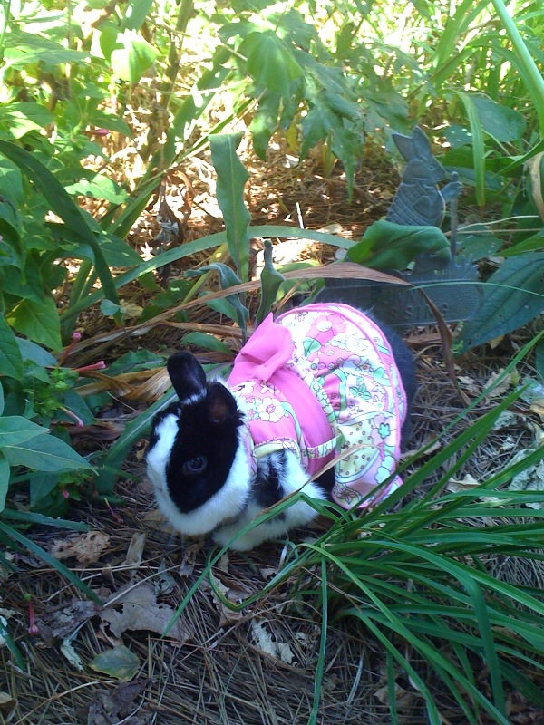

Mrs. Cottontail & Friends
Presents
Monthly Themes

January National Bunny Month & Chinese New Year
Bunnies come dressed in beautiful authentic Chinese attire!

February Hug a Bunny Day (Valentine’s Day Theme)
Bunnies come dressed in hearts and red!

March St. Patrick’s Day Spectacular
Bunnies come dressed in green dresses & shamrock hats!

April Easter Events – Here Comes Peter Cottontail!
Present Beatrix Potter stories & themes with Peter Rabbit as the guest.
Bunnies come dressed in their Easter finest!

May Be Kind to Animals Week (First Week in May) & Spring Fling
Bunnies come dressed as fairies and flowers!

June Summertime
Bunnies come dressed in summer attire complete with Hawaiian shirts!

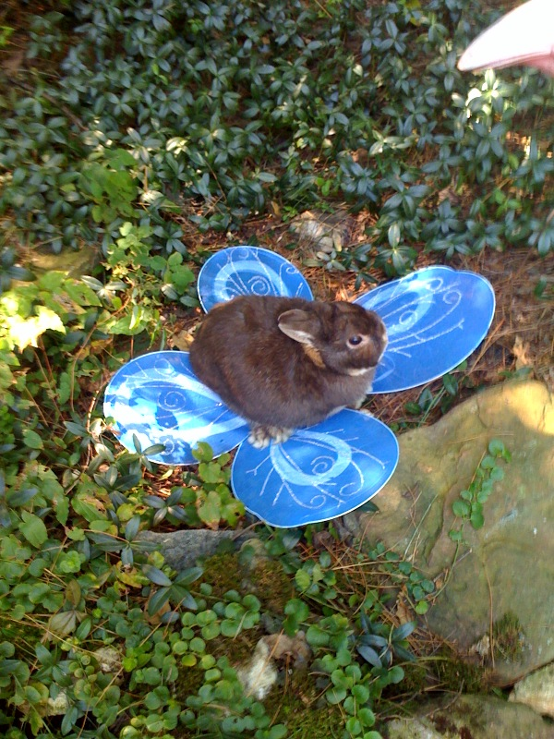

Mrs. Cottontail & Friends
Presents

Monthly Themes

July Summertime
Bunnies come dressed in red, white and blue for the 4th of July!

August Summertime
Bunnies come dressed in Royalty attire – here comes the King, Queen, Princess & Prince!

September National Apple Month & Fall Spectacular featuring Johnny Appleseed
Bunnies come dressed in apple themed clothes (and may even get a few apple treats!).

October Halloween Spectacular
Rabbits come dressed in Halloween costumes!

November Thanksgiving Get-Together
Rabbits come dressed in character for Pilgrims, Indians and Turkeys!

December Christmas Around the World
Rabbits come dressed as Santa, Mrs. Clause, Elves & Reindeer!

