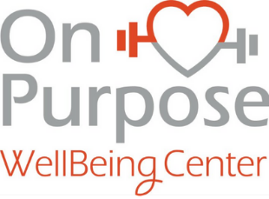

Instructors and student Participation practices for On Purpose WellBeing Centers Re-Opening

Wash your hands frequently
Use soap and water to wash for at least 20 seconds or use an alcohol-based hand sanitizer.
Maintain social distancing
Avoid close contact with other individuals. Remember that some people without symptoms may be able to spread the virus.
Avoid touching your eyes, nose and mouth
Hands touch surfaces that pick-up viruses and once contaminated, can transfer and enter your body.
Practice respiratory hygiene
Cover your mouth and nose with a bent elbow or tissue when coughing or sneezing and dispose of tissue immediately.
Seek medical care early
Stay home if you feel unwell. If you have a fever, cough or difficulty breathing, consider seeking medical attention.
Stay informed
Follow advice from your healthcare provider and your national and local public health authority.

