Delayed Spay / Neuter
Spaying (females) and neutering (males) is a very common procedure done within North America, and is the surgical removal of the reproductive organs in a dog. While many veterinarians are continuing to recommend pediatric (baby) spaying/neutering (as young as 8 weeks) and insisting that the only responsible thing to do is alter (spay/neuter) your pet between 5 and 7 months of age there are many benefits to waiting! And finding a vet that aligns their beliefs with the most up to date information and recommendations for these commonly preformed procedures, especially if you are going to have a large to giant breed dog, such as a giant schnauzer.

To contrast North America, in many European countries it is illegal to alter a pet without proper medical reasoning, so most pets are left intact their whole lives (without the North American myth of over population, and millions of “street animals” in said countries)! Given the vast cultural contrast it has opened up many studies into the benefits of each for our beloved pets and the important role of the reproductive hormones have in multiple organ systems, many of which are compromised and adversely affected by altering.

Some vets work at owners to convince them into altering at a very young age to make the owners life simpler with training, and reduce the risks of some cancers. With females the longer they are intact the higher the chances of reproductive problems arising, such as infections (pyometra) and mammary cancers, both of which are EXTREMELY rare in young healthy dogs, and almost non-existent once the female is altered after a (few) heat cycle(s).
Males carry a few risks as well, such as prostate cancer, which is again almost non-existent after neutering, and the majority of authentic health concerns with intact males are dealt with by castration at the time of the diagnosis.
These vets also tend to leave out the invaluable information that when altering young (prior to puberty and skeletal maturity) that you INCREASE the chances of far more traumatic and even greater, deadlier issues, such as, but not limited to: increased risks of hip dysplasia, cranial cruciate ligament tear, lymphosarcoma (the third most common deadly form of cancer in dogs), hemangiosarcoma (a rapidly growing, highly invasive variety of cancer not commonly detected until it has spread), mast cell tumors, and possibly decreased lifespans!

One issue that isn’t life threatening in itself, but does harm the dog, and is fairly common among female dogs that are spayed prior to maturity (18-24 months) in the Giant schnauzers is the high incidence in “spay incontinence” (dribbling or leaking urine uncontrollably) which the most common treatment is to put the dog onto a hormone supplement to help the body strengthen muscle tone, and control lost with the spay procedure. This is seen due to puppies loosing these vital hormones before they finish growing allowing parts to “grow longer” than they were initially “designed” for, and creating an opening within the body to fill space that shouldn’t be there, causing a weakening in the organs and leading to the observed symptoms.

There are many (scientific and veterinary written) articles available for your further information, with statistical values, that we would be happy to pass along to you for the purpose of knowledge, and being able to have an open, educational, informative conversation with your veterinarian. Our goal is to help people learn about the new information out there, to have communicative conversations with their veterinary team as we feel that the best medical team for your pet includes you!

There are many studies that are readily available; a few that we like to keep close are in regards to delayed gonadectomies:

An article created in 2010, about longevity of female Rottweilers, which has been referenced in many different writings, most commonly seen on the AVMA (American veterinary medical association).
https://www.avma.org/News/JAVMANews/Pages/100301g.aspx

Another article a few years later in 2013 cited again by the AVMA is in regards to joint disease and cancer in prematurely neutered Golden retrieves.
https://www.avma.org/News/JAVMANews/Pages/130401s.aspx

There are many more examples and scholarly articles available and plenty of information in regards to alternatives if one is adamant that they need to alter a pet prior to maturity.

Along with all of this information is the myth that altering your pet will make issues “disappear” things such as aggression, roaming, marking, humping, etc. This is a complete fallacy and good trainers can help you work around any of these and many more with an intact animal just the same as an altered pet.

There are 2 photos that we like to share with people as well with regards as to why we recommend waiting until complete skeletal maturity that you can find on the page below.
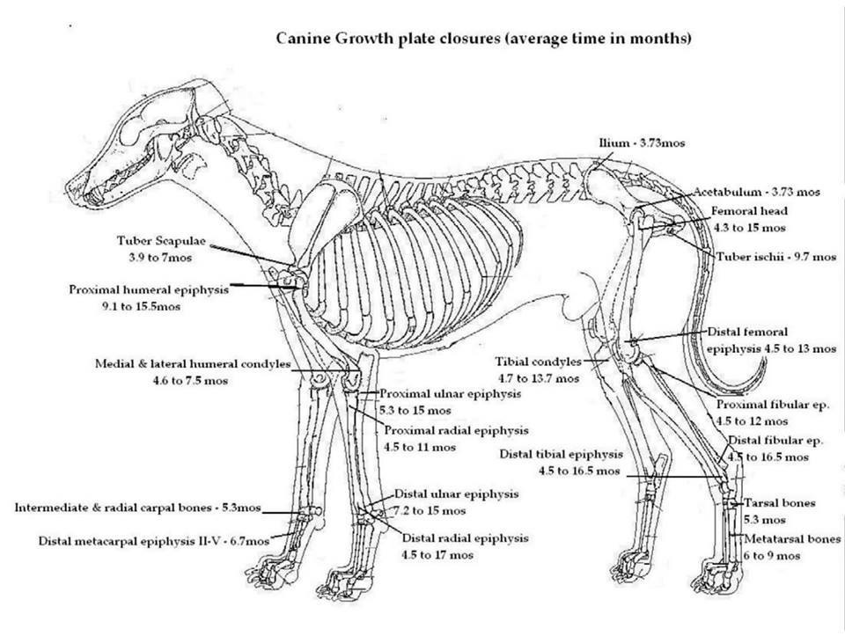

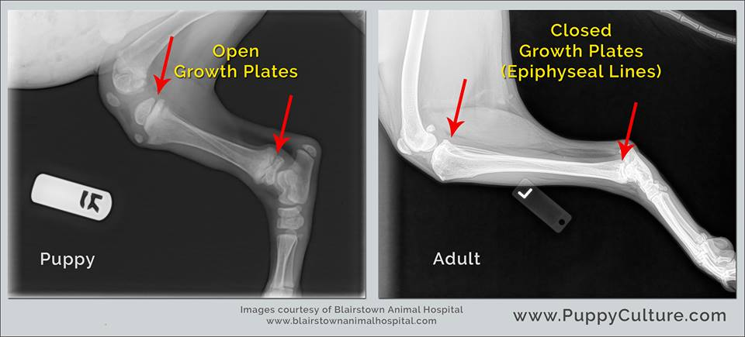
Puppy culture is a group to aid in the knowledge of puppy owners with training and starting their new puppies off right. A great source for people with new pets!

