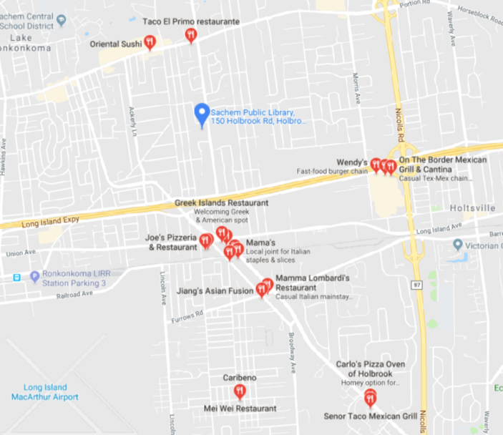
Lunch Break
Sachem Library has a café on the main level, to the right of the circulation desk, filled with scrumptious fast food and beverages.
If you’d like other restaurant choices, below is a list of local eateries that are nearby.

Mamma Lombardi's Restaurant
400 Furrows Rd, Holbrook, NY

Izumi Sushi and Hibachi Steak house
5745 Sunrise Hwy, Holbrook, NY

Hummus Mediterranean
1066 Main St, Holbrook, NY

Mama's
1057 Main St, Holbrook, NY

On The Border Mexican Grill & Cantina
45 Middle Ave, Holtsville, NY

Chili's Grill & Bar
50 Middle Ave, Holtsville, NY

Caribeno
1231 Grundy Ave #2, Holbrook, NY

Taco El Primo
704 Portion Rd, Lake Ronkonkoma, NY

Oriental Sushi
600 Portion Rd, Ronkonkoma, NY

New Century Chinese
1079 Main St, Holbrook, NY

Greek Islands Restaurant
315 Main St A, Holbrook, NY

Wendy's
175 Morris Ave, Holtsville, NY

Lotus Dynasty Restaurant
338 Union Ave, Holbrook, NY

Joe's Pizzeria & Restaurant
346 Union Ave, Holbrook, NY

China 4
315 Main St M, Holbrook, NY

Jiang's Asian Fusion
380 Furrows Rd, Holbrook, NY

Holbrook Diner
980 Main St, Holbrook, NY

The Irish Times Pub
975 Main St, Holbrook, NY

Outback Steakhouse
325 Main St, Holbrook, NY

Island Lake Diner
625 Portion Rd, Ronkonkoma, NY

