www.KarensTravels.com
2010
Route of the Maya
And Belize Extension
Karen Drummey

Contents
Introduction 4
Day 1 El Salvador and Travel to Honduras 4
Arrival in San Salvador 5
Day 2 El Salvador 5
Joya De Ceren 9
Lake Coatepeque 11
Crossing the Border into Guatemala 11
Entering Guatemala 11
Entering Honduras 11
Day 3 Copan, Honduras 12
Copan Ruins 13
Day 4 Honduras to Guatemala 17
Chiquimula 18
Day 5 Guatemala City to Lake Atitlan 21
Guatemala Center 21
Chicken Buses 23
Chupol 25
Panajachel 27
Day 6 Lake Atitlan Villages 27
Lake Atitlan 28
Santiago 29
Nicholas, Maximon, and Xibalbaj 29
Santiago Church By Way of the Basketball Court 31
San Antonio 32
Day 7Mudslide Re-Routes Path to Antigua 33
Antigua by St Lucas 33
Al Paso Mysterioso 34
Day 8 Antigua 36
Walk to Antigua Center 36
A Day in the Life of a Guatemalan 36
Chicken Bus Ride 37
Home Hosted Visit 38
Potato Chips and Coffins 40
Textile Museum 40
Macadamia Plantation 41
Day 9Antigua Continues 42
Jade Factory 42
El Fondo 42
Coffee Museum 42
Music Museum 43
El Baile De Diablo 44
Day 10 Antigua to Flores 45
Day 11 Flores and Tikal 45
Day 12 Last Day in Guatemala, Onto Belize 47
Renewable Resources 47
Chickle 47
Elegance Plant 47
All Spice 47
Colonization 48
Yuxha Ruins 49
Last Meal in Guatemala 49
Belize Border 49
Day 13 Last Adventure for Group 71 53
Belize Post Trip 54
Belize City to San Pedro 54
Belize Departure 56

Introduction
These are just a few notes from my trip of Route of the Maya, June 21-August 6, 2010 with OAT Travel. Because a lot of this was scribed on some bumpy bus rides, taken from illegible notes on-the-go, I take no responsibility for inaccuracies, international incidents, or misspellings. Spoiler alert, if you are going on this trip, you might not want to read this since it could ruin some of the surprises.
Thank you to my travel mates: Barb, Marilyn, Howie, Dianne, Steve, Mary, Carlene, Jessie, Jim, Kay, Bob, Jaime, Sammy, and our fearless trip leader, Carlos for making this a truly unique and special experience.

Day 1 El Salvador and Travel to Honduras
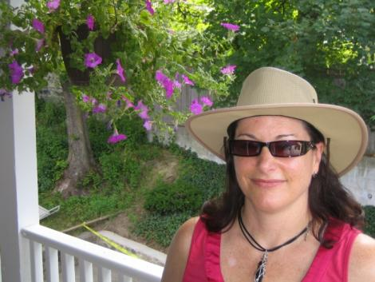
Today’s the day! After repacking my bag four times, I’m ready to go. My backpack weighs a million pounds and my suitcase is almost empty. It only takes one trip with a lost bag for four days to make strategic packing a priority.
Micki and I have a few sips of coffee on our deck, and it’s off to the airport. Easy sailing even though it’s rush hour and when I get to Logan, there’s no line at check in or security; a traveler’s dream. I stop at the Virgin Bookstore to get my reading material. The bookstore clerk starts chatting it up with me about books. I’m not sure if he just guesses or there is something about me that tells him I’m a real reader and not just an airport browser killing time. Suddenly, the electricity goes out! I tell my new friend that this might be a good time to push the battery operated book lights. A couple of minutes later the generator comes on. It’s dim, but I can see enough to find a couple of books. I choose Buddha by Deepak Chopra and What a Pretty Fat by Jen Lancaster and we complete the transaction with a calculator.
1 Ready for takeoff
As I make my way towards the gate standing out from the dimly lit store fronts is a very brightly lit Dunkin Donuts. Even in a power outage, they are cranked up and taking orders. There’s not much that stop the people of Boston from getting their Dunkies.
Maybe I can use the time to finish my Pimsler’s Learn to Speak Spanish series on my iPod while I’m waiting. I left off at Chapter 27 and have about another eight chapters to go. Then again, maybe I can just read my Glamour magazine.
I’m not too worried given that I have a four hour layover in Miami. About a half hour later the lights come on and everyone cheers. My plane leaves on time for a very uneventful first leg of my journey where I devour an entire Reader’s Digest and I get a few good laughs from some of the crap in Sky Mall Magazine. Although I have to admit, I actually purchased something from them once, but I’m not staying what.

Arrival in San Salvador
The flight to San Salvador is easy and I have a whole row to myself. As we get close to landing, I move to the window seat and see the ocean. There seems to be one row of houses along the ocean and then going inland there are big fields of very green land that from the airplane remind me of Ireland.
Upon landing, our trip leader, Carlos is waiting, but even more comforting, my bag is waiting. Six other people on my plane are part of my tour. Everyone is very friendly from the start. One woman introduces herself and whispers that she is originally from Dorchester where I lived for six and half years. I think I could have guessed since she introduces herself as Meeeeary, which is Bostonian for Mary.
The ride from the airport to San Salvador is about 40 minutes. Even though it is night, you can tell the city is really packed. There is a Pizza Hut advertisement on every bus stop and many billboards which would make you think it is the national food of El Salvador. Where is Pupusa Hut?
Carlos gives us some logistic info and some info about the country. It’s about the size of Massachusetts and he jokes that its main export is people. They don’t have counties or states, and are broken into 14 departments. In the newspaper they give a Department report and always include Department 15, Los Angeles, where two million El Salvadorians live.
We arrive at the Crown Plaza Hotel, which is a lot nicer than I expected. After getting my bag, I head to the pool. It’s big and no one is in it. There is a jazz duet in the bar/restaurant that abuts it, so I can swim laps in style.
I also discover a great sandwich shop in the lobby, Desessa, where I get a freshly made prosciutto Panini and a small piece of chocolate mousse cake. I did the pool laps after all. It’s not El Salvadorian, but it is fabulous.
After repacking and reading I finally think I can sleep. I forget that the water is not drinkable, and after brushing my teeth, I have a second of panic and rinse with bottled water and hope for the best. I go to sleep in the big fluffy king bed I get to myself. I dream that my hair turns pink from the pool and wake up. I realize it was just a dream and my hair is still a lovely halo of emerging white that is taking over.

Day 2 El Salvador
This morning I got up at 5 am, an hour before my wake up call. I’m too excited to sleep. I head down the restaurant and see the pool I swam in last night. Above the pool is a view of a volcano and it is amazing. I head to the buffet which is a great spread including fresh fruit, red beans and pupusas. It’s delicious. I meet up with my group and we are ready for our first day together.
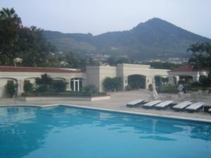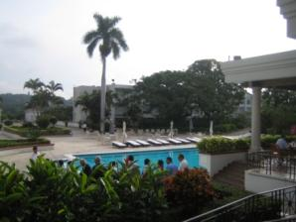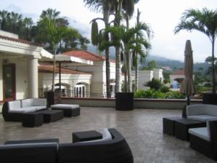
2 Crown Plaza El Salvador
Our group meets at the pool and we introduce ourselves. Everyone is so well-travelled and I hope I will get an opportunity to go on some of the journeys they have been on. I am the least travelled person there.
Carlos tells us that OAT (our travel group) brings 80% of the tourism to El Salvador. They have brought 197 groups here and OAT is known for being cultural travelers and an asset to tourism. It makes sense because the treatment at the hotel is top of the line.
Carlos gives us a lot of information about himself and it is quite fascinating. He is actually part of the tour. He grew up in Uaxactun, a small jungle village north of Tikal in Guatemala. He has eight siblings and he is the only one that has left the village. His first language is Mayan, second is Spanish, and he has only been speaking English for six years. I am amazed because he knows a lot of words in English that I’m not sure I know, and he can make a joke on the fly, which to me, is true command of knowing a language.
Everyone takes the toiletries from their hotel room and gives them to Carlos. They will be packaged as gifts and given to some of the families we meet along the way. I like this. I used to do that in Jamaica and people really appreciated it.

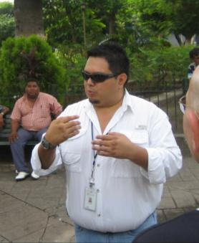
We embark on a drive by tour of El Salvador with a local guide, Eric. There are 25 volcanoes, 14 volcanic lakes, and 7 mountain ranges in El Salvador. The sand at the beach is different colors because of different types of volcanic ash. Some of it comes from smashed coral reef. It is known as El Baile de Las Hamacas, which means the dance of the hammocks due to volcanic tremors. They have had a lot of tremors over seven on the Richter scale, so when they have a 5.5 it doesn’t seem to faze people and they just keep doing what they are doing.
The civil war was form 1980 to 1992 and tourism is just starting to return. During that time 80,000 people died. Once the soldiers came back from the war, many of them turned to jobs in the security business. The country is heavily armed and most businesses and stores have heavily armed guards. Soldiers with brown uniforms are municipal and carry a stick and a pistol, and blue uniformed soldiers are the police. We are told they also help out with some other things such as day to day business tasks. One of the purposes is to protect the businesses against extortion more than anything else
3 Eric
The Poma family controls quite a bit of the country: Intercontinental Hotels, most of the auto companies, and 80% of the shopping centers in Central America. They built a 24 story building outside of center. That size building is not part of El Salvador and the units go for about 1.5 million dollars.
San Salvador is the city of buses. They seem to be endless. There are 6 million people in the country, 2 million in the city, and only 1 million people have cars. The buses are privately owned, but regulated by the government. They are also subsidized by the diesel companies. Many of them are kitted out with lights, music, or decorations. One passes by us with a shark fin on top.

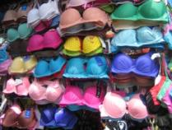
We get off the bus and walk through the downtown markets of San Salvador. It has a flea market flavor, but no one gets pushy with us. Several of the stands have a lot of sexy bras a la Victoria Secret style. Maybe Victoria’s Secret is that their bras come from El Salvador.
4 Bras of San Salvador

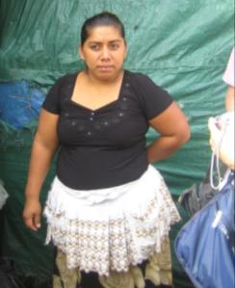
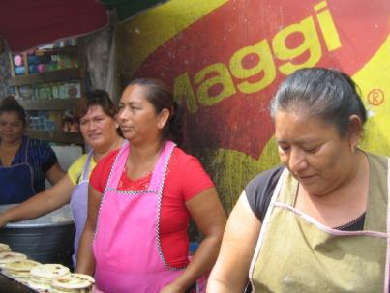
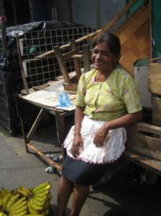
5 Women making pupusas
Many of the vendors are women and they all wear real frilly aprons with lots of pockets. Many of the women choose to struggle peddling at the markets because they can make twice as much as the minimum wage, which is about $90 every two weeks and cannot sustain their families. The average education is 6th grade. The vendors get no benefits and no pension.
6 Apron common for San Salvador vendors

The currency is US dollars. In 2001, the president decided to change from Colones to dollars. The Colones were still supposed to be supported, but with the 8.75% exchange rate, it became difficult to support both currencies and Colones became obsolete.
The good thing that has come from the change is that some items have become a bit more affordable. Cars are about $10,000 to $12,000 and mortgages have a 6-8% interest rate. A six room house in downtown is only $40,000, but it isn’t very desirable. When there is flooding from the river, the downtown area is affected.
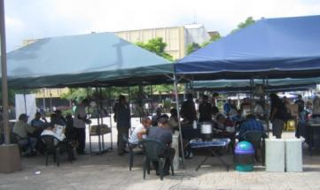
We stop at the Central Plaza and there are a lot of men sitting on the walls. We are told the women are working. It is clear they take notice of the strangers in town, but no one bothers us except for one man without an arm who asks for money. I’ve been panhandled much more in Harvard Square.
There are some outdoor tents in the middle of the plaza with tables, a coffee maker and some books; kind of like a make-shift Starbucks. It is an initiative by the government to have mobile libraries. Most of the seats are full and it seems to be a successful program.
7 Mobile Library
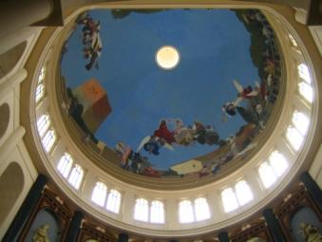
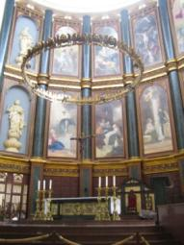
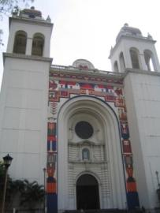
8 Cathedral in San Salvador

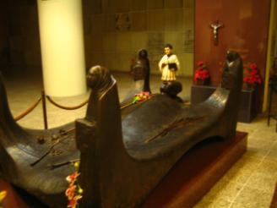
The cathedral El Salvador is across from the Plaza. Seventy-two percent of the country is Catholic. The exterior has beautiful color tiles. It was built in the 50’s, but could not be open to the public because of the guerillas. Our tour guide didn’t actually get to go in there until 2000. We went inside and it is quite big and impressive. There is a lot of work in progress.
We go downstairs and see the entombed body of Archbishop Oscar Romero. In the 1970s, the Archbishop called for peace and the Pope and the Vatican were not pleased. They didn’t want him involved in government issues. In 1980 the Archbishop was shot at a mass. At that time the bounty on farmers was 5,000 colones, teachers, 10,000 colones and priests, 25,000 colones. The Pope was shot a year later. He later went to El Salvador and had the marble platform made for the Archbishop’s tomb.
9 Entombed Archbishop Oscar Romero
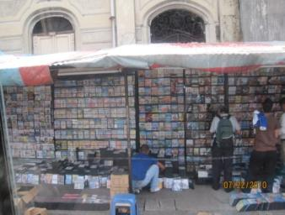
We get back in the bus and in a couple of turns, we see “Pirateland,” a big market stand of pirated DVDs that sell for about $1. The penalty for burning the DVDs is about eight years in prison, but the market vendors seem to be ignored.
First Street West is one of the hairiest streets to navigate. People must be 18 to get a license and First Street West is often used for driving test. If a driver can handle that, they can handle the rest.
10 Pirateland
There is only one private hospital with reasonable rates. There are hospitals part of the national system that are free. The wait is very long, but they have certified doctors and are well-equipped.
The schools have greatly improved and for the first time children are now provided uniforms, books, 800 of English, and most are given computers. They are also fed at school. Illiteracy has dropped 10% in the last two years and is down to 17%. There is now a campaign to not give money to children begging because there is no reason for them not to be at school.
If an El Salvadorian wants to get a visa to go to the US, they need a good stable job, a car, a piece of property, credit cards, at least $10,000 in the bank. Applying for a visa is $150 and about 95% get turned away. Some then resort to the CTA, Coyote Trade Agency. It’s about $7,000 US dollars. There are some scam coyotes, but the good ones respected because they help reunite families. Some look for Plan B. About 80-100 El Salvadorians move to Guatemala every day with no more than $100 in pocket to shoot for the American dream by way of Mexico through Tijuana.

Joya De Ceren
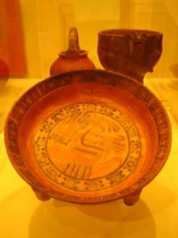
Our next stop is Joya de Ceren, a ruins site. At quick glance it is not really impressive, buy it is a key piece of the journey because it is the initial route of the Maya and where the common people lived.
We start out in the newly-built museum and only one piece is a replica. The pottery is about 1,400 years old. We learn that the Mayan women would grind corn, but not for themselves. It is the food of the elite. The Mayans eat ground food such as yucca.
11 Pottery at Joya de Ceren

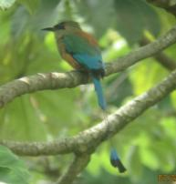
We see the national bird of El Salvador, the Turquoise Mot Mot. It is a beautiful bird and I am excited to see it through my new binoculars, an early birthday gift from Micki.

12 Turquoise Mot Mot national bird of El Salvador
This is the location of the common people and the beginning of the Mayan world. The dig shows that the people must have been a lot shorter. The way some of the site is broken down shows lots of layers of volcanic matter. Bamboo is exposed showing it being used like rebar to support the structures.
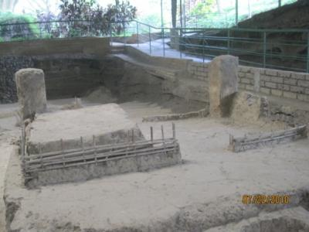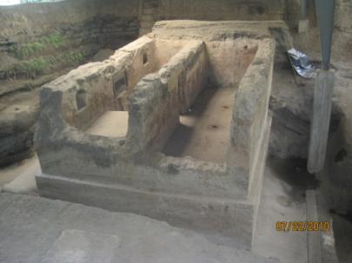
13 Joya de Ceren
The theory is that the people could see the volcano and when it erupted, they were able to leave in time. No human remains have been found.
An accident happened at one point with a bull dozer hitting the side of one of the buildings. There is not a lot of exploration because there is no such thing as an archeological field in El Salvador and no money to support it.

Lake Coatepeque
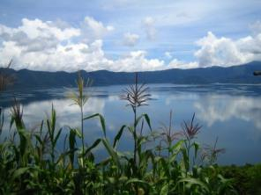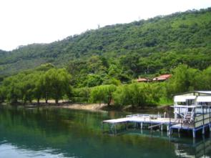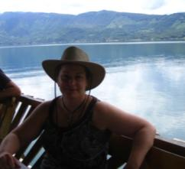
14 Lake Coatepeque
For lunch we go to Lake Coatepeque. It is beautiful and has a big volcano abutting it. The homes along the shore are mostly vacation homes for affluent El Salvadorians. People pay the locals $1,000-2,000 for the land, but they would build a little home for the former owner to have a lifelong job being a watchman for the house when they are not there.
There are not a lot of restaurants, but there is one on the water, Rancho Alegre. We get to sit on the outer deck. For me lunch is the chicken soup, fish that is caught in the lake, and a Pilesener (the local beer) and ice cream with pistachios. To top it off, there is a four-piece mariachi band.

Crossing the Border into Guatemala
As we get to the border, there are lots of trucks along the road. For them, there is a physical inspection. If they are 100 boxes of medicine, each one gets checked. If there are boxes inside those, they get checked as well. Once an inspector is assigned, they move to the loading zone and they have to hire someone to unload and load the trucks for the inspections. Carlos has talked to some of the drivers and some have spent up to 2.5 weeks to get across to declare what is inside the truck.

Entering Guatemala
We enter the Border through the department of Chiquimula. It is not very populated. The country itself is the most populated country in Guatemala. It is about 42,000 square miles and has about 14 million inhabitants and there are several languages. Spanish is the official languages and there are 23 Mayan languages and 8 dialects. Most people are considered full-blooded indigenous people. Sixty percent is Mayan.

Entering Honduras
Awhile later, we get to the Honduras border. It’s pretty low key and there is a group of men playing soccer at the border line. Our trip is taking us through the Sierra Madres and the altitude is pretty high.

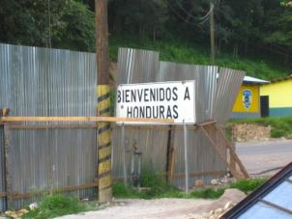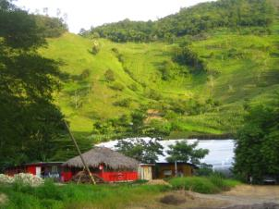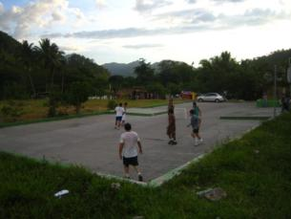
Figure 15 The Honduras Border

Our hotel, Posada Real, is only 20 minutes from the border. Everyone seems to be in awe because it is so cute. It is family owned and has a lot of indoor/outdoor blur. It is 2,100 feet above sea level. The temperature is more comfortable.
Our dinner is homemade tortilla soup and sea bass with garlic sauce. Fantastic. Beer $2.50 at a hotel. More fantastic. I sit by the pool after dinner and have one.
Our bus driver, Jaime from El Salvador, doesn’t speak English and eats with us. While we aren’t going to have any big political discussions, I can chat with him enough to make it interesting. I tell him I used to be a bus driver and he laughs. Now that I think of it, I didn’t see any women bus drivers, so he probably thinks I’m joking.

Day 3 Copan, Honduras
Breakfast at the hotel is outdoors and a beautiful view of a volcano. We have a good laugh when one of our travel mates cracks what he thought was a hard-boiled egg turned out to be raw. He took the egg from a basket for the made to order omelets.
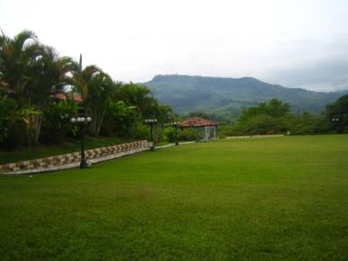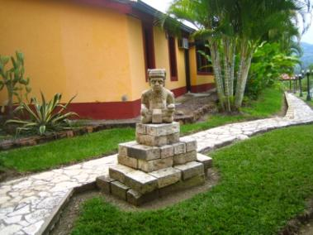
Figure 16 La Posada Real

We then head out to the Mayan ruins at Copan. It’s not uncommon to be riding down the highway and seeing cows or horses wandering in the road.

Copan Ruins
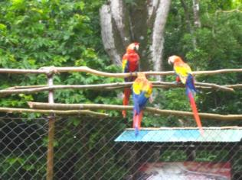
We first get to see Scarlet Macaws which look kind of like parrots. At one point a couple of them get into a fight.

Figure 17 Scarlet Macaws

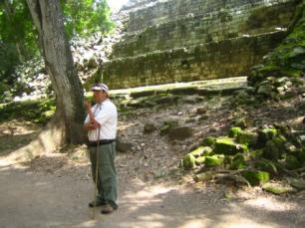
Our guide is Rodolfo. He is a great guide and very entertaining. Rodolfo wants to dispel some myths about sacrificing virgins for rain. He jokes that they tried it after the first virgin when no rain came they decided to rethink their plan.

Figure 18 Rodolfo

The ruins are amazing and the view from them is even more amazing with the surrounding mountains and jungles. There are few pictures that are true interpretations of what the city would look like when people loved there. It is much like cities of today with a plaza, amphitheater, and ball court, except everything is stone. Another myth Rodolfo wanted to dispel is sacrificing the winner of a ball game in the ball court.
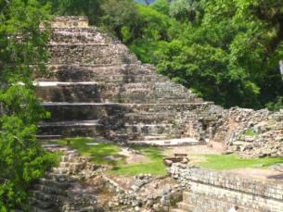
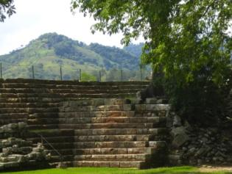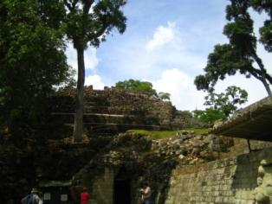
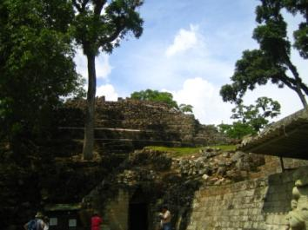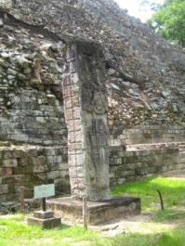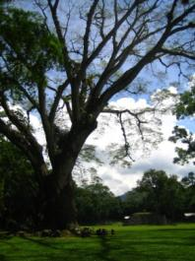
Figure 19 Copan Ruins
We learn a lot about the ruler Eighteen Rabbits who ruled Copan for 20 years. His real name is very long and they needed to shorten it. When archeologists looked at the profile of the figure, they couldn’t figure out what it was. The locals said it looked like an agouti which is a rodent. Many people didn’t know what an agouti is, so they decided to say rabbits instead. Eventually 18 Rabbits was captured and sacrificed.
The Mayans were a lot more sophisticated about astronomy than other parts of the world. In the tropics where the temperature is the same all the time, they needed a way to figure out when the rainy season would come.
They had books on paper made of bark in an accordion style. However, stone was propaganda, written word was knowledge. Therefore, the ruler had books destroyed. There are only three major books that survived which are housed in France, Dresden and Madrid.
There are three important Mayan periods: the pre classic, the late classic and the post classic. The classic time is when the Mayans developed their temples and created societies. Pre-classic goes to 1,100 years BC. They had already settled bases which is the beginning of people that were no longer nomads.
The Mayan calendar goes back to 3014 years before Christ. The Mayans began to develop an important calendar. Compared to the Gregorian calendar, they were only 12 seconds apart. Both calendars talk about end of the world predictions in 2012.
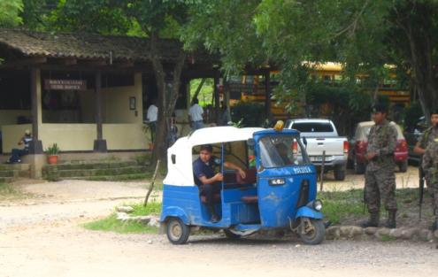
Honduras has a lot of tuc-tucs, vehicles dwarfed by smart cars and have no doors that are used as taxis. There is only one wheel in the front. When we are leaving the Copan Ruins, I notice one of the tuc-tucs is a police car. I don’t know what they would do if they arrested someone, but it’s so small they probably have to handcuff the person, who has to follow along.
Figure 20 Police tuc-tuc
After the ruins, we have lunch at Llama del Bosque in the town of Copan. The meal is excellent and probably the best beans of the tour so far. They are served in a clay plot, with coals on the bottom to keep them hot.
After lunch, we have some time to explore the city. It’s pretty small and has a colonial flavor to it. There are a lot of restaurants. It’s clear they cater to tourists because there are a lot of souvenir shops. However, a lot of the goods are not from Honduras, but from Guatemalan.
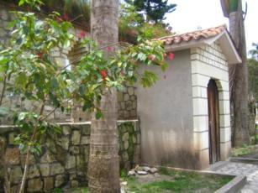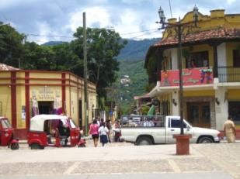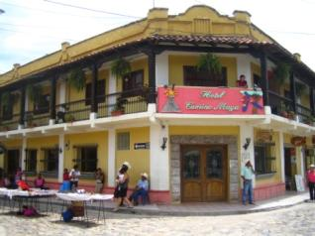
Figure 21 Copan

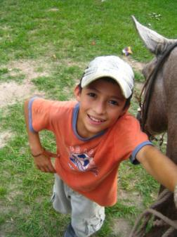
That afternoon we take horses to the village of Pintada. I’m skittish of horses, but I give it a go. A ten year old boy, Gonzalo, leads my horse. I chat with him in Spanish about school. It is up a very long incline and the homes along the way are basically one room with a corrugated tin roof.
We get to the top of a long incline some girls approach me getting off my horse to sell me a corn husk doll. I buy a couple and then I get swarmed and surrounded by lots of girls with an echo of, “one dollar, one dollar,” all holding the dolls to my face. I feel overwhelmed and I feel guilty giving to one girl and not another. I have to say no and walk away from the group. The rest of the tour group comes and Carlos gives a talk, but I am not really able to pay attention. The only part I absorb is something about how the Japanese government has given them electricity.
Figure 22 Gonsalo
I hear Carlos say that it doesn’t matter which girl you buy from because they pool the money as a community. I feel somewhat better, but I don’t totally recover and can’t completely reconcile it in my mind.

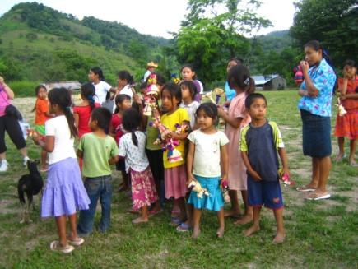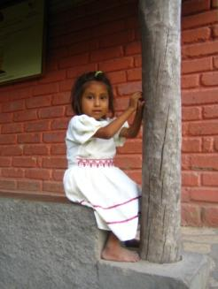
Figure 23 La Pintada
The girls are asked to sing the national anthem. They are proud to do so and sing with smiles on their faces. I’m having mixed feelings that they are singing with such enthusiasm and their government allows them to live this way. But, I guess the national anthem is about a pride that represents a lot more than just your government.
We go into the building where they make the dolls. It is very simple. It is sponsored by the NGO Care. The experience is the live version of the commercials that you see on TV late at night.
When we return, a truck passes us with lots of men on it. They are coming back from working which is either working in field such as a jalapeno field or getting sand to be sold for building materials.
Carlos points out that even though they are poor, you see a lot of the kids smiling and playing. I know that there is no stigma to being poor, and I come from a culture of abundance and privilege, but I still can’t settle it in my mind. Some of my tour mates think it is the best part of the trip. I guess we just have different perspectives.
That night we go to dinner at Tun Club . I really like my group and have been getting to know them more along the way. I sit next to Mary and diagonal from Jaime, our bus driver. I discover that I speak the best Spanish out of the group, which isn’t saying much, and I translate as much as I can. I struggle a bit, but I’m all they have and I think Jaime is happy there is a way to include him in the conversation.
I also learn that Mary is turning 85! Mary had done the earlier horseback riding. Carlene, who is almost 72 tells me that when Mary was 81, they went to Machu Pichu and she climbed to the top of the mountain. Mary tells me over Mojito numero dos, she stopped to take a picture and when she was done she didn’t see the group and thought they went up already, so she went as fast as she could. She was actually the first up. Mary is my inspiration.

Day 4 Honduras to Guatemala
We leave Posada Real and cross back in Guatemala. We don’t even get stopped. The original name of Guatemala is Coatemala, which stands for the land of the trees. The Saber tree is the national tree and we know it is the Kapok. It has lots of thorns while it is growing so that it cannot be chewed on. It is the only tree not susceptible to the Strangler Fig, a tree they preys on and kills other trees. Once the Kapok is grown, it loses its thorns. A 30 year old tree looks 100 years old.
Sugar cane is the largest export in Guatemala and they also sell a lot of rice and bananas. The bananas we get are considered the worst kind. Because of fast production, the trees don’t grow the roots system and a lot of trees fall. When the bananas reach a certain size, they cut them from the tree for sale, but it really isn’t the best time to cut. Every time a banana is produced, the tree dies, but ten more trees grow off the routes. They figure out the timing and to push the ripening, they put them in a container and put chemicals on them.
Central American nationalities have nicknames. Costa Ricans are known as Ticos. Guatemalans would refer to themselves as Chapin. El Salvadorians are called Guanacos. Nicaraguans are called. Nicas. Panamanians are called Canaleros. Hondurans are called Caterachos.
Most Mayan people are in Guatemalan. The government would see people no longer see people in their traditional dress; they are no longer considered Mayans. A lot of people stopped referring to themselves as Mayan because of discrimination. Some people in Guatemala still wear the traditional costumes that are hand woven. Based on the pattern of the weavings, you can tell if someone is widowed, single, or married.
In the 1840s the countries united except Panama and Belize. The independence of Central America was about 1821. Each country would celebrate the same date. Guatemala didn’t have a lot of celebration because they never really needed to celebrated independence in their nation. The people who fought for independence were mostly mixed cultures that happened when local cultures mixed with Spaniards, called Mestizos.
When Spaniards arrived, there were not mixed marriages. There were a lot of rapes of women and that was how the Mestizo population started. The title of the Mestizos was called Don. It stands from De Origen Noble, Of Noble Title. It means that you could be able to betray your people and help the Spaniards.
Mestizo leaders were told to go conquer people and place a religion on them. They would impose their cultures on the society and then it belonged to that representative. They would put all the properties together and that is how the Central American countries were created.
Spaniards realized Central America did not offer as much as other countries such as silver. If they returned to Spain, they would just return as poor people. Instead they decided to conquer and become landlords.

There are four ethnic groups in Guatemala. Sixty percent are Mayan. Twenty percent are Mestizo. Eighty percent of Mestizos are not proud to call themselves Mayan. The third ethnic groups are Latinos, people who came from Spain for wealth. The fourth ethnic group is Garifona, African descendants who ran away from slave owners in Belize.
Conquering requires imposing your culture and religion. People who wore traditional clothes and speaking their language was often forbidden and shot. There are some places that the Spaniards never found and inhabited such as Carlos’ village.
In the 1500s the first Mayan village was invaded and they started spreading out and killed 14 Mayan leaders.
When Spaniards inhabited Guatemala, they wanted Guatemalans to keep wearing their traditional dress. The Spaniards were afraid they would be invaded by someone else and they wanted to be able identify the Guatemalans.
When people started disagreeing with the Spaniards, they began to leave some parts of Guatemala and decided to move to some of the jungles.
Knockers on the door were put over the doorways to identify class. If there was a knock on a tall unreachable knocker, they knew someone would have to be on a horse to reach and they would let them in.

Chiquimula
We stop at a mall to change money and use the bathrooms or Pee Pee Tanango. Tanango means “place of,” so Pee Pee Tanango, means the bathroom. The mall looks pretty similar to a lot of American malls. You can buy a TV in Max which looks a lot like a small Circuit City and you can buy a flat screen TV for about the equivalent of $360 US. The currency is Quetzeles.
The quarter has a profile of a woman with a turban. It was the traditional head dress head dress. There is only one place where women still wear this and the strap is about 60 feet long and when wrapped, forms the turban and we a privileged to see it later in our journey. It’s believed it is the oldest tradition. We will see this in person later on. The coin goes back to the 1960s and the woman on it, is still alive.
The 10 cent coin has an Estile (a stone monolith that is commonly found in ruin sites) on it. The one on the coin features the tallest Mayan monument of the world at 18 feet.

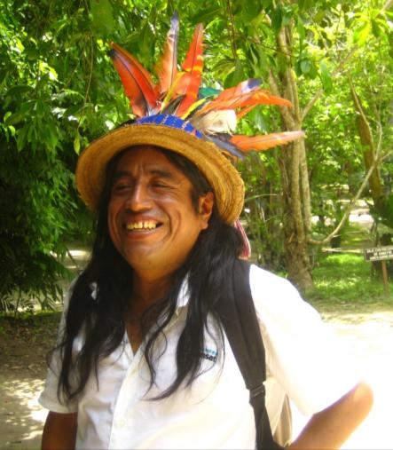
I asked Carlos about a man back at the hotel wearing a hat with big colorful feathers. He says he is a guide who wears the hat and feathers to represent the head dress of the Mayan culture. He speaks French. He gets to do lectures in France about Mayan culture and does them with the hat. Later on in the trip we see him again in Tikal and Flores. He is very friendly and he lets me take his photo.
We are encouraged to take as many pictures (respectfully) as we can of the people, particularly of men since wearing traditional dress is dying out. We are recording history.
On the way to Guatemala City there is site of an earthquake from 1976 was the last devastating earthquake in Guatemala that was a 7.8 and killed 25,000 people.
Figure 24 Tour guide who speaks French
We stop at a restaurant for lunch at Saritas, and fortunately Carlos has given us laminated exchange cards. It’s the first meal not included on the tour and the first country where I have exchanged money. I can feel confident that my 23 Quetzeles soup is really about $3 US dollars. I get the national soup which turns out to be black bean. The sprinkler system at Saritas is quite unique. It is made of PVC pipe and attached recycled soda bottles with holes poked in them. They are quite effective.
The ride to Guatemala City is very interesting, not because of the sights, but because there are many points where we are on a two lane highway with lots of trucks where people have no qualms about passing us. We are also climbing mountains and going from a 2,100 feet above sea level to about 5,000 feet above sea level.
We stop just before Guatemala City to use the bathroom. Even though it is Saturday, we could run into a lot of traffic. Our stop is at an On the Run, the same exact gas station/convenience store you find in the US. A man from the US asks where we are going and I tell him about Route of the Maya. He is originally from Texas and lives in Chiquimula. He and his friend are missionaries. They have built a church and they feed 600-700 children a day.
As we get to the city, it is clear we are going through a poverty area. We see some homes, if you can really call them that, and they are just squatter areas built under overpasses. They are the most rustic of shelters. If there is flooding, the people there are greatly affected.
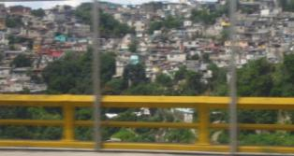
Carlos talks a little about the drug and crime situation. In the barrios, there are well-organized drug lords, in particular in Zone 3. People in the barrios depend on the buses. In the last year, the drug lords began killing bus drivers, one driver a day over a four month period. Two people would ride the motorcycle so one could drive and one could kill the driver. The government passed a law that no more than one person could ride a motorcycle and bikers need to have a number stamped on a vest and a helmet. While this seems like a good solution to a problem, it creates problems for families who only have a motorcycle for transportation; a husband might drop a spouse off at work or drop off the kids at school. You see some people are still riding double.
Figure 25 Zone 3
How Guatemala City is broken into zones has no logic to how they are laid out. They were developed in the order where people were populating. As we move through the city, the neighborhoods morph into better neighborhoods.
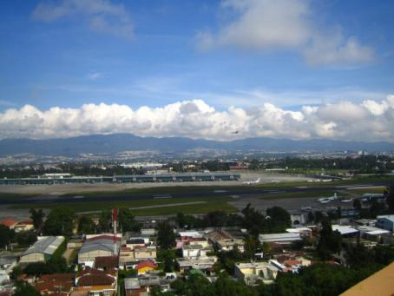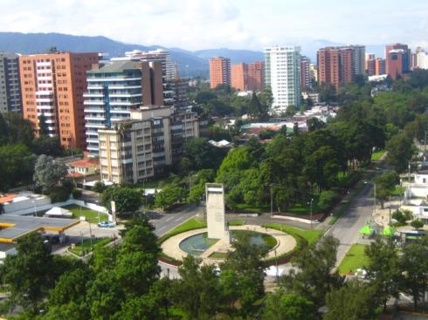
Figure 26 Airport view from Crown Plaza and Avenue of the Americas, Guatemala City
When we reach our hotel, the neighborhood is very nice. I take a walk with two of my travel mates, Steve and Diane, along the Avenue of Americas for about a mile and turn around. There are a lot of statues and in one area, kids can get donkey rides and there is a playground. We’re free to roam the area without anyone bothering us.
Dinner is at a beautiful open restaurant with a lot of stone walls and colorful scarves draped from the ceiling. The food is traditional Guatemalan food with taquitos, fajitas, tamales, and beans. I don’t really know how it’s different from Mexican, but it is delicious. Because we are advised not to drink the water, we don’t get salads for dinner and almost of our meals start off with a soup. I would not have not have thought of Central America as having good soup, but the soup in all the restaurants is excellent.
After dinner I join Barbara, and Carlos and Jaime at the bar. There is a Cuban band of two people, a keyboardist and a conga drummer. We have a good laugh because there are recorded backup singers. Barbara comments that they don’t even need the conga drummer since that could be recorded. I say at that point, they could skip the band and just have a CD. Two dancers do a number that is on par with a dance recital from a dance school class. Their costumes are somewhat revealing with a lot of cleavage.
We decide to call it a night. I ask Carlos what the word for “cheesy” is in Spanish.

Day 5 Guatemala City to Lake Atitlan

Guatemala Center
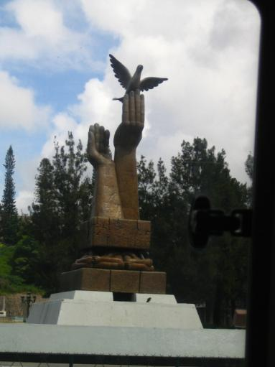
We start out to the center plaza. We pass by the peace memorial which has two hands. They are both left hands because the left hand is closer to the heart. The peace treaty was signed in 1996.
Figure 27 Sculpture Guatemala City
We also pass by the US embassy. People in Guatemala who want to go the US have a lot of the same requirements as El Salvador. It is $150 just to apply plus the applicant buys a phone card and gets an appointment to talk with an agent for three minutes. The agent decides whether or not to give the applicant an in person appointment. The day of the appointment the applicant lines up at 4 am and gets to briefly meet with an agent through glass. Some people take out loans to show they have money and return it after they go through the application process. Only 5% are granted a visa. The process is about 10 hours. Even when granted, when the person reaches the US, the person meets with an agent and can be turned away. About 20% of people are sent back. People are willing to take a risk because the alternative is to pay the coyote $7,000.
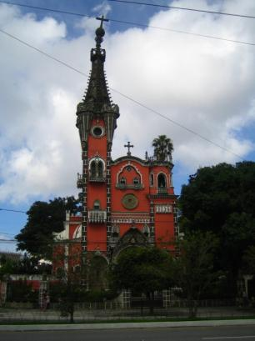
We head toward the center and we are lucky that it is Sunday because it is the day of the outdoor market which is only on Sunday and the only day the vendors can wear their traditional costumes. We first stop by the church, Nuestra Senora.

Figure 28 Nuestra Senora

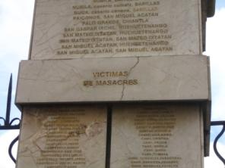
We get to the church in the city plaza and the tiled columns of the gates have the names of the people who have died or are missing carved into the tile. We learn that Carlos’ father's name is on the tile for the missing. He lost him when he was eight. The tiles are categorized with labels such as “executed” and “tortured.”
Figure 29 Tiles with names of people massacred from the war

The Palacio National which is also called the big guacamole because of the avocado color. There are three flags on it; Mayan, Guatemalan, and one for the unification for the Central American countries. The Mayan flag has black represents the underworld and the west, red represents the east and the sun rising, yellow represents corn, the center, the background is white and represents purity, blue is in the middle and represents jade. These colors are seen a lot in Mayan culture.
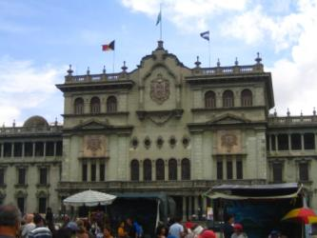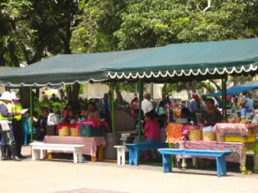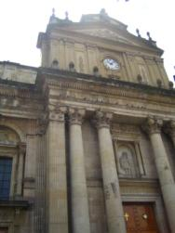
Figure 30 Guatemala City Plaza
The Mayan cross intersects in the middle as opposed to the Christian cross where the horizontal part is closer to the vertical part. They also bless themselves a bit similar to Catholics, but instead of the Father, Son, and the Holy Ghost, it is for north, south, east, and west.
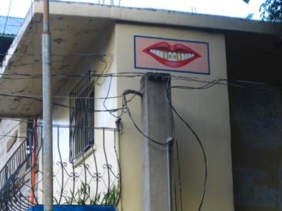
It is very common to see a Mayan person with gold teeth or teeth decorated with tattoos or initials. This represents the history of the Mayans when they would replace their teeth with jade. Outside of the city is common to see dentist advertising for teeth art. A crown in Guatemala costs about $150. I’m thinking that I should cancel my upcoming dentist appointment and get my dental work done here instead of shelling out $2K at home.
Figure 31 Dentist office

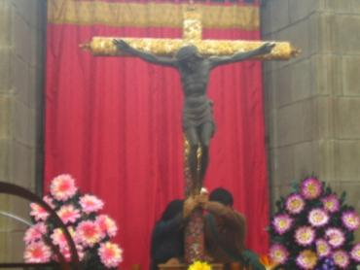
We go into the church and the mass is supposed to start. The church is very beautiful and one of the features of the church is the black Jesus. There are only four statues of Black Jesus in Central America. People line up to have a moment to touch the feet of the statue that is natural wood.
During the time of the war, the army was taking people and putting them in the jungle and telling them that they were in a different country. It was easy to believe because the vegetation was so different. The men then were bombing villages and without knowing, they were bombing their own villages.
Figure 32 Black Jesus
We head out of the city and head to Lake Atitlan.
Chicken Buses
On our ride we see a lot of the chicken buses or polleras. Carlos tells us a very animated story about the chicken buses that has everyone laughing hysterically and no matter how I write it here, it won’t translate with the same effervescence. The history is that people transported chickens and people. The buses are very colorful and painted in the Mayan colors on old school buses from the United States. They are put on a ship and sent to the “taller,” the bus hospital. They are privately owned and the owner can decide how to paint it. The unpainted school buses have not been to the bus hospital. To ride depends on the distance. A 30 mile ride will be about $.70 to $1.00.
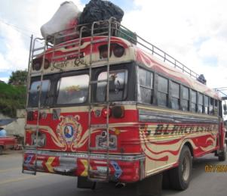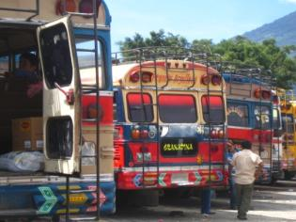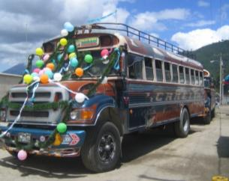
Figure 33 Chicken buses
In some of the villages the tires are so bald there is a joke that the drivers need to put mosquito nets on them so they won’t get a puncture.
The cost for a Guatemalan to buy a school bus that the US donates for free is about $1,000. Before it enters into the country, the purchaser needs to decide what colors the bus will be. The buses usually come with automatic transmission, but that’s not optimal in Guatemala. Automatic transmissions take more gas and not as robust to drive. As soon as they come, they are taken to the “taller” or bus hospital.

There are two families that make the manual parts and other parts to make the engine more powerful. For example, they install larger pistons as part of the process. They can go the same speed uphill as downhill. They are probably the most powerful buses in the world and can handle the mountains. They also have special brakes.
The bus needs a lot of adjustments. Let’s say a bus driver is going to use the bus in a town with a narrow street. The bus hospital will cut the bus and re-weld it and shrink the bus. In the end you would not be able to tell it has been through this process.
One adjustment is that reducing the leg room since Guatemalans are shorter than Americans. They move the seats to get more rows. This is also the only area where you will see roof racks. To support the weight, rebar has to be installed on the bus along with ladders.
The final cost of the birth of a chicken bus is $4,000 for the purchase and all of the work. Some bus owners add other things like speakers, TVs, and display sayings such as, “Pass me if you can.” Once you see them in action, you know what they mean, because the drivers don’t even break around winding curves and barely stop before a passenger jumps out.
Once the owner buys buses, they need to find a driver. Drivers need a Class A license. An applicant is tested is not for how safe the driver is, but how crazy he drives, because in order to compete, the bus has to go fast. The drivers will also make more money with more ground covered.
Now the bus owner needs to find a star of the show which is the doorman. He interacts with the people and has to do everything fast. He has to be able to carry 200 pounds on the bus. Time is essential so a lot of times the doorman is still on top of the bus when the bus starts going. You might see him hanging out the door or rolling under the bus to check out the traffic.
Chicken bus passengers towards the back of the bus get off through the back door instead of going through the aisles. The bus needs to go maximize its time to maximize income.
The passengers need to make sure they have exact change. If you don’t have it, the bus will leave without you. The driver will remember where you get on and off. People are expected to squish in even if filled to capacity. If you are two in a seat, you have to squish three and the aisle person gets what is called the half butt seat. People get on with chickens and other people with a free hand may be told to hold a chicken. If someone has something on the roof, the doorman will hoist himself out the door, climb on top of the roof and gets the person’s package. And the packages aren’t necessarily packages. They might be items up to 200 pounds! The doorman also hangs out the bus to tell the driver when to pass and the curves.
The inside of the bus is its own a market. If someone takes their chickens on the bus to bring to market, and someone on the bus wants to buy, the seller will make the deal and get off the bus.

Carlos said one time he was on a chicken bus that was packed and it stopped for a man with five six piglets. The man was let on. People started asking how much and when the deal was made, other passengers were asked to pass the pig. Within five miles he sold all five.
There are lots of joke about the buses. Here is one. People were sad when Pedro, a chicken bus driver, died. The same died a priest died. Their souls went to heaven. St. Peter said he was only letting in one person that day, and he told them that they need to write down what they did when they were alive. The priest wrote that for 30 years he was a priest, went to the Vatican, etc. Pedro the bus driver wrote that he drove the bus for 20 years. They gave the papers and a while later St. Peter comes and gives Pedro the keys to heaven. The priest said to St. Peter that he must have read the papers incorrectly. Saint Peter said, “When you were a priest for 30 years, everyone was sleeping in your services. When Pedro was driving the bus everyone was praying the whole way, so he has washed more sins than you have!”
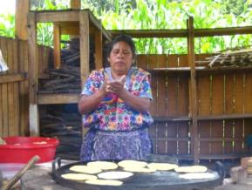
We stop at lunch at Cabana de Robert. In the back there is a woman making tortillas from scratch. We enjoy our lunch and get back on the road. A lot of the road is wiped out from the volcanic activity that happened a few days earlier. The road was only developed in 2006.
We stop at the local Mayan market of Chupol. First we watch the technique of the chicken bus driver and I get a video.
Figure 34 Cabana de Robert

Chupol
The booths are set up like a flea market or fair and it is for locals and not tourists. This one is only on Sundays. Most of the people are dressed in traditional Mayan costume. A lot of people have gold teeth representing the Mayan tradition as well. The colors are vibrant with the and there are all kind of woven textile goods in addition to other items such as food, shoes, and other household goods.
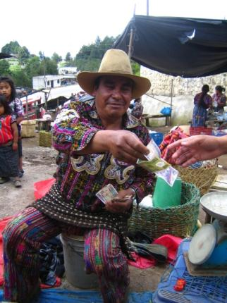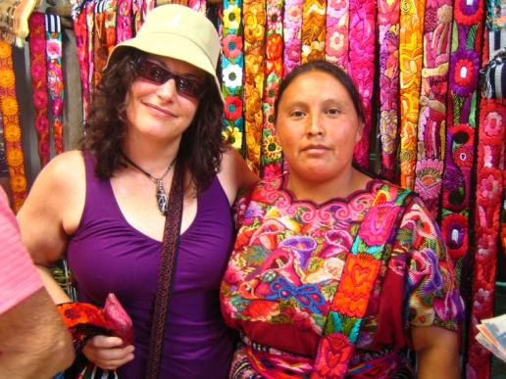
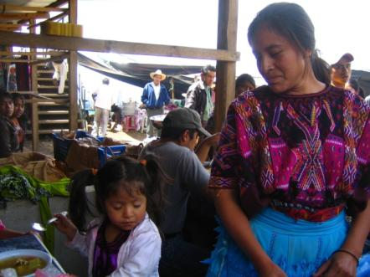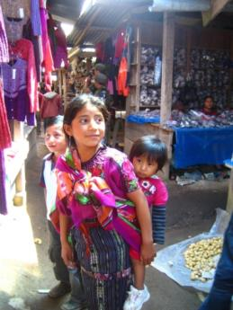
Figure 35 Chupol Market
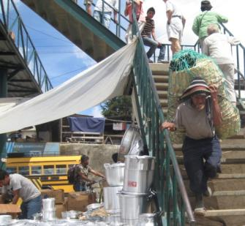
We can see people carrying very heavy load through the market and up and down the stairs of the overpass. Many of the women are carrying loads on their heads about the size of hefty bags without the use of their hands and nothing moves or falls off. Carlos talks to a chaparero, one of the men who carry bulk items. He has a very small frame and has the stature of a horse jockey. Carlos asks him about how much can he carry and jokes around asking of he can carry two women. Everyone from our group laughs as well as the locals. He can lift two hundred pounds.
Figure 36 Men can carry about 200 pounds
As Carlos is explaining everything to us people, mostly children seem to be interested in us and smile at us. Carlos takes us to one booth with amazing colorful sashes and bargains the price from 100 quetzales to 75, which is less than $10 US Dollars. We are trying to not be too assuming taking photos unless given permission.
After we leave the market, we are now on the chicken bus watch and we laugh at a lot of what we see because it looks like something from a movie. Later on the road, we are close to passing one and everyone encourages Jaime. He succeeds without putting us in any kind of danger, and we cheer. But we are the leader for only a few seconds.
The scenery is getting more beautiful and the elevations are the slopes are more impressive. We get to Solola, which represents having to do with bats. There is a bat on the church signifying the church as a cavern, which a place where rituals can be performed. Many men still wear the traditional Mayan dress, which are colorful woven pants and shirt and the bat is woven into the shirt.

Panajachel
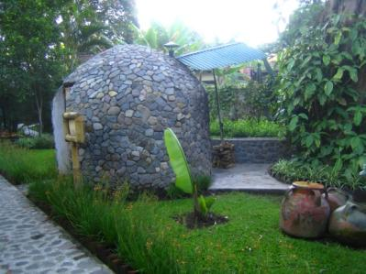
We get to the Hotel Regis and it is my favorite place so far. The rooms are cute single story stucco buildings. The grounds are beautiful with a lot of greenery, flowers, and stone. It is a family-owned place, and not a chain.
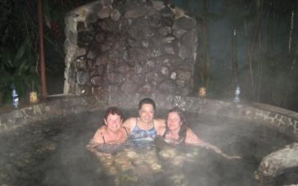
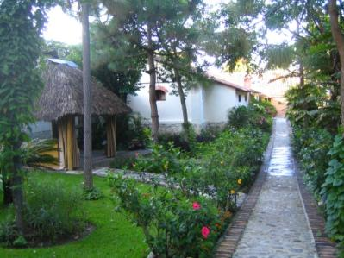
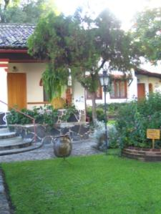
Barbara, Diane, and I decide to go to the hot spring tub. We look like we are being boiled in a big stew pot. It is made of stone and set in a beautiful tropical garden area with a waterfall shower. Jim joins us. It doesn’t seem that hot, so we ask for an adjustment. More hot spring water comes out as a waterfall into the tub. It starts raining. The hot tub is covered, so we can stay and it is really great. We have it to ourselves for about an a half when some other people come. We’re looking like prunes, so we should probably get ready for dinner.
Figure 37 Hot spring or stew pot?
Figure 38 Hotel Regis Panajachel
We have dinner at the hotel. I had the tortilla soup and some chicken crepes. The soup is great, but the dinner is my least favorite on the tour. Not bad, but kind of plain. However, one so-so meal on a tour where the other meals are fantastic is a big win in my book.
Some people went around the town and they report what Carlos warned us of. The store owners, are a little more aggressive and bargaining is the norm. However, it is safe to walk the streets. There are a lot more tourists here, and it is known as a Gringo Tanango.

Day 6 Lake Atitlan Villages
I get up early and walk the town before it opens. People are setting up their shops and going to work. It is nice to see the town without all the business once the shops open. It’s amazing how clean the streets are and I see lots of shop owners cleaning up in front of their shops.
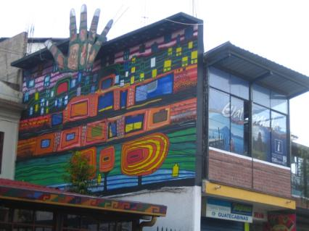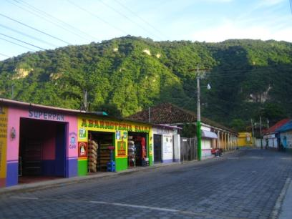
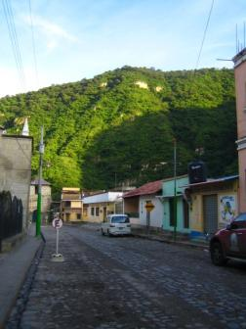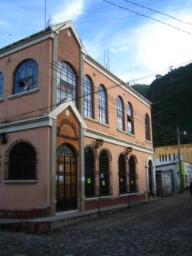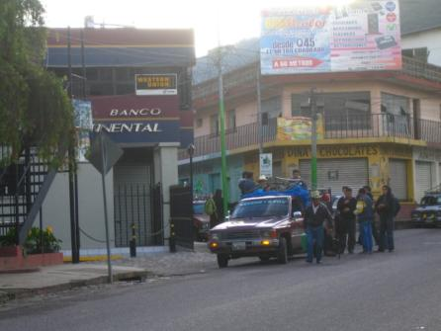
Figure 39 Panajachel early morning

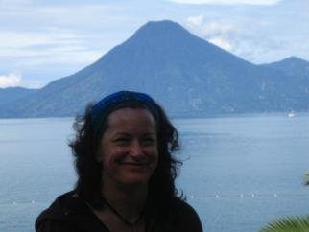
Lake Atitlan
We walk the lake and get a talk about the three volcanoes across the lake. They are San Pedro, Toliman, and Atitlan, which is the only active one. It’s stunning.
No one knows how deep the lake is. Jacques Cousteau estimated 1,000 feet. Someone took a boat and dropped an anchor a mile, but it didn’t reach the bottom.
Figure 40 Volcano at Lake Atitlan

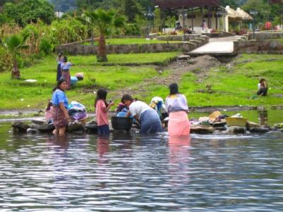
Santiago
We meet our boat driver, Ochenta, who takes us about 14 miles to the town Santiago. We are privileged because we have arrived on the holiday of Santiago, St. James the Apostle, so we will get to see a bit about how the town celebrates. There was concern about polluting the lake with detergents, so they went to a shaman for a solution. They found a tree where they could use something from the tree to make biodegradable detergent.
Figure 41 Washing clothes at Santiago

Our first stop when we get off the boat (in addition to the children trying to peddle their goods) is to meet three women who Carlos knows. They give us a demonstration about how they wind their turbans. There are 60 feet strands that wrap around their heads are used to keep them shaded when they are at the markets. They don’t have mirrors and they start the winding. In a couple of minutes, they are done. It is really impressive especially since it took Marilyn and me a really long time just to figure out how to wrap our sashes we bought in Chupol.
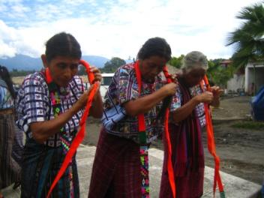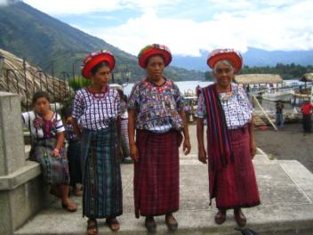
Figure 42 Turban wrapping
We are approached the entire tour by people offering to sell us something at a good price. One woman is very good sales woman and can make her pitch in several languages.

Nicholas, Maximon, and Xibalbaj
Our next excursion is to see a Mayan ritual. To get there, we travel like the locals, all standing in the back of a pickup truck. It is a lot of fun and even though we are probably not going very fast, it feels like we are flying uphill through the street.
We meet a famous (not the movie star American famous kind) shaman, Nicolas. Nicholas is wearing the shaman costume of long white shorts with blue pinstripes that are embroidered on the bottom of most of the leg portion.
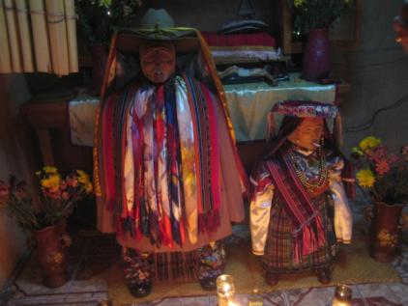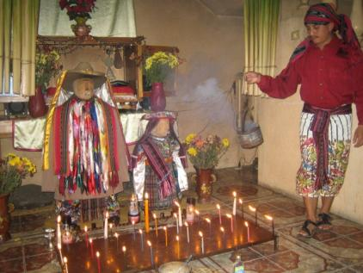
Figure 43 Maximon ritual with Shaman Nicholas
The other part of this trip is to see Maximon, a deity who is worshiped in the village and very important in the culture. It was thought that he would fool the Spaniards and help protect the village. We also get to see, Xibalbaj, Maximon’s wife. They have the appearance of mannequins and they wear masks. Maximon has many ties and scarves around him. They represent miracles. Maximon circulates in the village and spends a year in a villager’s home. In order to accommodate Maximon, the hosting family needs to clear out one of the rooms for Maximon. During Holy Week, Maximon is moved by a big procession where they put colored sawdust on the ground.
The ritual is about to begin. Nicholas ties a woven scarf around his head and begins the ritual. During the ceremony, Nicholas lights Maximon’s cigar and gives him a drink. Xibalbaj has a drink as well. Nicolas is speaking in a Mayan dialect that Carlos doesn’t understand, but it’s easy to recognize then names of all of our stops. He is paving the way for safe passage for the rest of the journey. After the ritual, we get to see several of the masks on Maximon, including the original.
There are times that Carlos has gone to show a group and is told that Maximon is tired. He needs to be respectful of that and the group will not be able to have the experience we have had.
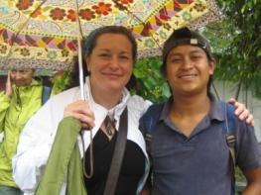
Before we leave the house we meet Luis. He is friends with Roberto. Carlos sponsors Roberto for his education. He cannot make it today. Carlos tells us to pick a number and Steve wins. In a matter of a couple of minutes, Luis has taken a pen covered in thread, unwraps the thread and rewraps it in a way that spells Steve’s name. It is quite amazing. We can buy them from him for $1, give him the name and he will find us at the end of our stay. He gets a pretty good order of about 30 pens.
Figure Luis-the pen man-and me
We leave and as we are walking down the street, there is a procession of shamans for the festival. We cannot take pictures out of respect. Nicholas is with them.

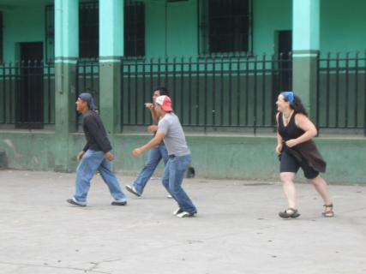
Santiago Church By Way of the Basketball Court
Our next stop is supposed to be to the church, but we get side tracked by a group of men playing basketball. Some of us join in. Marilyn and I join one man for a team and Jaime and Jim join another. Our team doesn’t make any baskets, but we play serious and I’m sure it is very seldom that women are seen playing basketball. I can definitely feel the difference in the activity due to the altitude, but it’s good to get a quick workout.

Figure 44 Basketball with local players

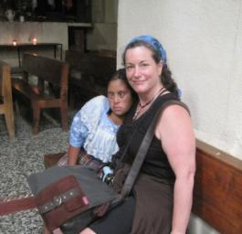
We head to the church and as we approach, a little girl approaches Carlos and gives him a big hug. She is mentally challenged. Her name is Michaela. She gives each of us a hug and she now has a dozen new friends and joins us for the rest of the tour in the area of the church.
I asked Carlos how he got to know her, and he said she was the only child not selling items, so he started talking to her. She is actually 27. Someone says that some countries are not kind to mentally challenged people, but Carlos said it is not like that in Guatemala.
Figure 45 Michaela and me

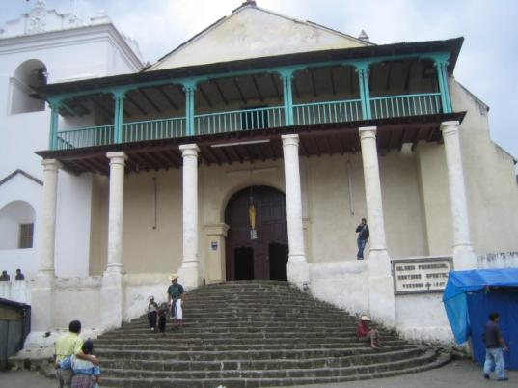
We go into the church and get some respite for being approached to purchase. One thing to not say to the children is “later” or “maybe later,” because they are waiting and will remember. It’s better to just say no and not show any interest in the goods if you don’t want something.
The ceiling of the church has a lot of red lace panels that are hung specifically for the festival. We read a plaque on the wall that describes about the massacre of the people. We also learn about Brother Stanley, a priest of Oklahoma, who served in this church and was assassinated in the church, similar to Archbishop Romero in El Salvador.
Figure 46 Santiago church
The sides of the church are lined with apostles and a Virgin Mary that has twins. One baby represents the Earth and one baby represents the underworld.
At the front of the church there are seven large statues of St. James with scarves and ties around the necks also representing the miracles. They all look a bit different and are an interpretation from each Mayan village from around the lake. At the altar, Carlos shows us a chair, but Michaela waves me over to sit with her, so I sit with my new pal.
After, we go behind the altar and there is a wood carved wall. Even though this is a Catholic church, there are many Mayan representations. The statue of Jesus has its face covered in a clothed and ties wrapped around it as well.
We walk through the village and there is a festival with a few rides and game booths for the kids. It is interesting to see the children doing the same they Americans do except many of them are in their traditional Mayan dress.
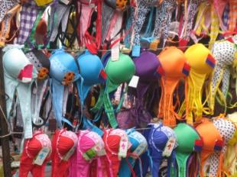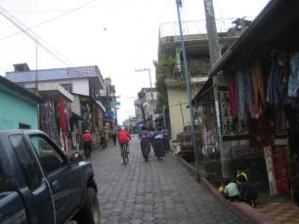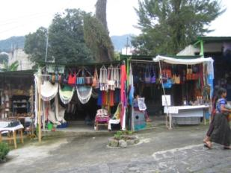
Figure 47 Santiago Market
The market is also set up. Making our way through the market is a bit rough. It is really crowded and people are trying to sell us things. We get to the main vendor street. Some of my travel mates make a few purchases along the way. As a team we do pretty good battering, the expected form of transaction.
When we get to the waterfront, there is big crowd all getting ready for the festival activities. Luis is there with our pens. We get on the boat and go to another village along Lake Atitlan, San Antonio.

San Antonio
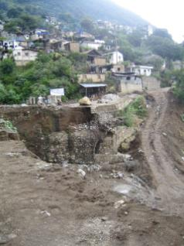
San Antonio is a smaller village. We see in one direction where the road had collapsed from Hurricane Agatha and it doesn’t look like it is going to be fixed soon. We walk to the home of Dona Juanita and Don Juanito. Their home is typical of a lot of homes. The home is set up for weaving. One room has the loom and materials. There is a small courtyard. One small room in the courtyard is the kitchen which is what Americans would call primitive, but functional. I wasn’t even sure if there was electricity, but someone pointed out there was a bulb on over the loom.
Figure 48 Road out in San Antonio
Dona Juanita and Don Juanito are in their 70s, have had 14 children, and they have never left their village, not even to go across the Lake to another village. They are very welcoming. This is the family who will receive the toiletries we have been collecting over the journey.
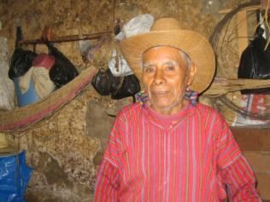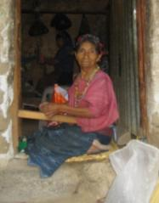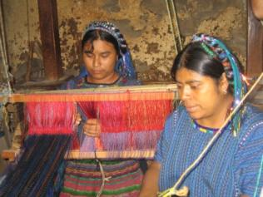
Figure 49 Don Juanito, Dona Juanita, and their daughters
Their daughter shows us all of the goods they are making for sale and the group goes into a buying frenzy. There is no haggling here and the group is happy to purchase from the family that has let us come into their home.
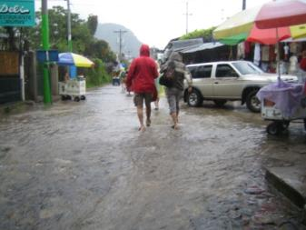
It starts pouring on the boat ride to Panajachel. We get to the end and Jaime is going to get the bus, but a few of us are adventurous and walk. The streets are gushing with water and I’m glad I’m wearing shorts and rubber sandals. It was a bit of an adventure. I make sure to give my legs a good scrub back at the hotel.
That night I go to dinner with Barbara, Howie, and Marilyn to Café Atlantic. It has a very American menu, but the food is really good. From the front it looks like a regular bar/restaurant, but the back has outdoor seating area with lots of green. The chorizo is delicious.
Figure 50 Rain in Panajachel

Day 7Mudslide Re-Routes Path to Antigua

Antigua by St Lucas
After a last minute walk to the lake, we prepare for a 9 am departure. However, there is a situation. Our bags are not on the bus. The rain last night has created a mudslide and now the two roads to Antigua are obstructed. Onto Plan B.
We need to take a day’s worth of clothes out of our suitcases. Our suitcases are staying with Jaime. We walk to the lake and we are going to take the boat to St. Lucas. Carlos has called some drivers in Guatemala City to meet us in St. Lucas and take us to Antigua. Jaime stays back and when the roads are clear he will join us later with our suitcases. This isn’t the first time an OAT group was impacted. One group had to leave by helicopter after six days of being stranded at Lake Atitlan.
We pass by Santa Catarin, a lakeside village with beautiful homes. People have built homes for about $50,000.
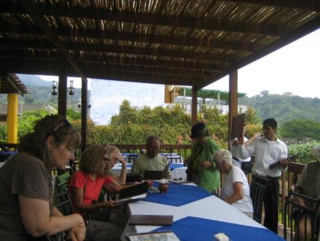
St. Lucas is not a bad detour. We go to Restaurant el Rancho, which overlooks the lake and have lunch. Everyone is being a good sport about the detour and I sense Carlos is relieved that we are an easy group. Our bus arrives and we meet Fernando and Gato.
Because we are taking an unscheduled route, we have a police escort from the Policia de Tourisma. The reason is not because of safety from banditos, but to make people feel comfortable to maintain tourism. If there is a traffic jam, the police will clear it go through. There is no charge to the tour company for this service.
Figure 51 Detour to St. Lucas
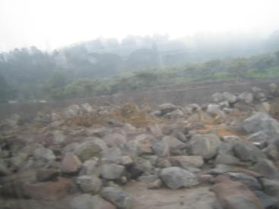
The road if very tenuous and was seriously impacted by Hurricane Agatha. There are huge boulders and holes on the sides of the road. We pass areas where bridges have been taken out. There are boulders on the sides of the road and only one road in some spots. Even the oncoming chicken buses stop to let us pass.
Many of the impacted homes are still visible. They are collapsed and many of them had been under water.
Figure 52 Roads from St. Lucas to Antigua

Al Paso Mysterioso
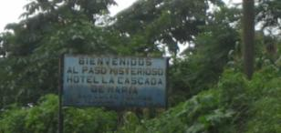
We stop on the road and we are the first OAT group to experience Al Paso Mysteroso. We are at a dip in the road with an incline ahead of us. The driver turns off the bus and the bus begins to move UPHILL! We get out and pour water on the ground. It goes uphill! We run up the hill and it pulls you to run faster. The spot was discovered when the road was being built.
Figure 53 Al Paso Mysterioso
We continue to see the impact of Agatha. One town we pass through is Pochuca. The people were stranded over 25 days.
We then travel to Cocales, a place where they sell lots of coconuts. Our police escort leaves because it is where we pick up the highway. We are lucky. Jaime is still at Panajachel and the earliest he would be able to leave is six pm and there will be a long line to leave.
We reach the planes of the Pacific and see lots of sugar cane. This area has the most sugar cane production of the country. They set fire to it and there isn’t a clear view of Lake Atitlan. We also see rubber plants. The closer you get to the Pacific Coast, the crops change to rice.
We finally arrive at Antigua. The gate of our walled hotel, Hotel de Casona, opens and we drive into the courtyard. We get out of the bus and when the group walks into the courtyard, there are lots of “Wows.”The hotel is a Spanish type villa just for us. There are rooms on the first and second floor facing a beautiful courtyard with a fountain. Each room is beautifully decorated with simple amenities, but extraordinary because it is part of the original architecture of stone wall. The second floor has a lot of open seating and there are a few volcanoes in view.
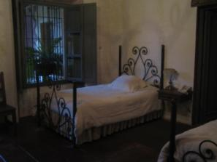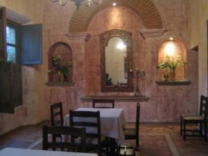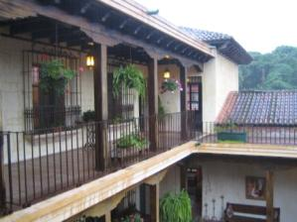
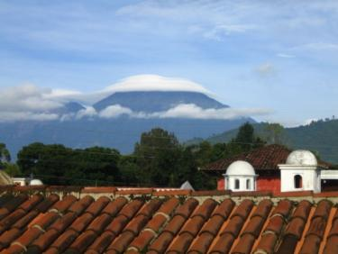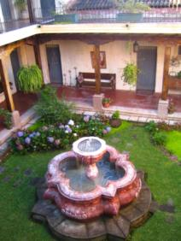
Figure 54 Hotel de Casona
We meet our host, Anival, who is the caretaker. He is very nice and he takes good care of me the entire visit.
That night we go to dinner at Hotel Villa de Monica. The restaurant is only open for our group. I have the spaghetti because it was the only choice I like. It is fantastic and not what I would have expected in Central America.
Our suitcases don’t arrive and Jaime is still stuck in Panajachel.

Day 8 Antigua

Walk to Antigua Center
Today we engage in an activity, A Day in the Life of a Guatemalan. Our day begins with breakfast and a walk into the town which is about a mile and a half. All of the streets are cobblestone and the houses are not really visible because they are mostly long walls. The beauty of the houses is in the interior similar to our hotel. The purpose is to have open space to go to if there is an earthquake.
We see big round kites in some shops and we learn that kites were born in Guatemala. It was a way to connect people with the spirits and send them messages.

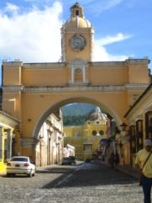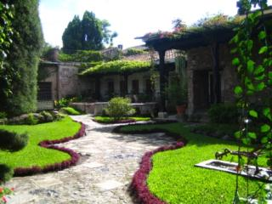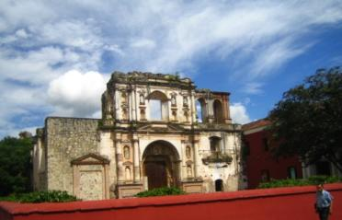
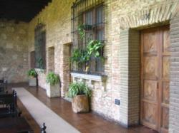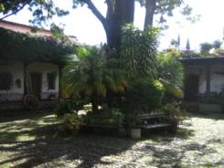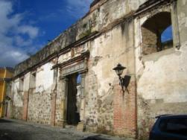
Figure 55 Antigua
First we go to Hotel Posada de Don Rodrigo La Antigua which is another beautiful hotel with the courtyard setup that has been declared a historical monument.
You can still bargain even though we are out of the villages. It won’t be the same as the villages, but you can still negotiate 20-25% off the site.

A Day in the Life of a Guatemalan
We break up into groups and are given a list of items written in Spanish of items to purchase to donate to a school we will visit. It was easy enough. We see something in a little packet called Snot Rockets and has a picture of a gorilla with a runny nose. We think it is candy. Marilyn almost buys one for her class, but she doesn’t have any small bills.

Chicken Bus Ride
The other groups are also successful. Our next task is to find the next chicken bus going to Santa Catarina de Baharona. It’s pretty easy to figure out. We board and as we are waiting, there is a parade of vendors that get on the bus selling food, papers, and one man comes on and does an entire commercial on the headache medicine as he is peddling. The driver gets on and even as the bus makes its way out of the bus yard, people are getting on and off the bus for some last minute sales.

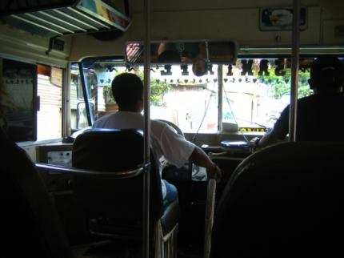
We get on the road and it is a very mellow chicken bus compared to what we have seen. We get to the school, Santa Catarina de Baharona. There is a sense of excitement as guests of the school. Along with us are several guides in training. We are personally greeted by a class of smaller children in traditional Mayan dress. They take our hands and we get pictures taken with them.
Then the children sing the national anthem. They put their right hand at the heart, but it is horizontal rather than flat against the body.
Figure 56 Inside the chicken bus
The children perform some traditional Mayan dances and we dance with them. After, we go to their classroom and play some games. The classroom is very meager and they don’t have a lot of supplies.
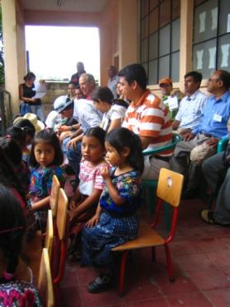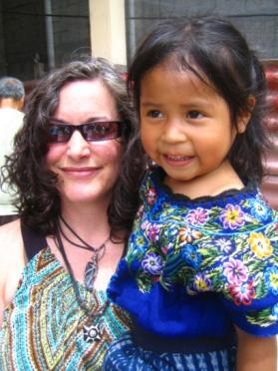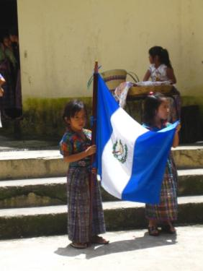
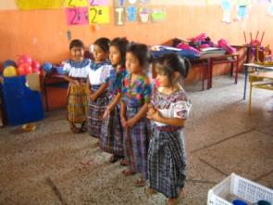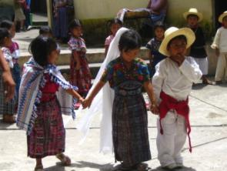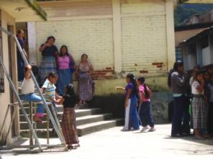
Figure 57 Santa Catarina de Baharona

Home Hosted Visit
After the school, we split up to go to home hosted lunch. Our hostess is Daisy and her daughter Marlin. We walk to their home which is a small courtyard that has a few rooms made of cement blocks. In the kitchen/dining room, there is a very small stove, but very small, something you might see in an RV. Daisy’s mother and sister are not using it and are making tortillas over a fire.
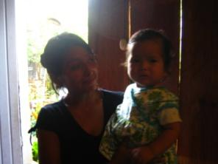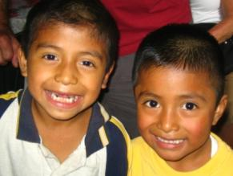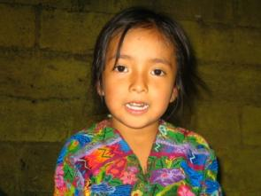
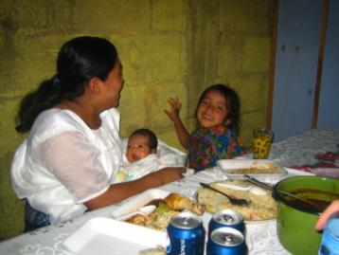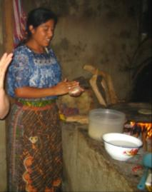
Figure 58 La Casa de Daisy
Between Daisy’s mother, Daisy, her sisters, her aunt, children and spouses, there are probably 15 people living here in this very modest home. I take some pictures and I let the kids take some pictures as well. Barbara, Marilyn, and I make tortillas while Howie holds one of the babies. When the lunch is ready, we have rice, sauce, chicken, tortillas, and vegetables. The taste is very good although I have to admit, I am a little nervous about eating something from a home where I don’t know how the food was stored.
Even though they speak hardly any English, we all figure out how to communicate. After we eat there is an uncomfortable moment when one of the relatives asks us if we want to buy one of the weavings she made. We figure out how to move it along and try to focus on the visit. I go outside with the kids for a bit. When I go back into the kitchen, Daisy is showing photos and braiding Marilyn’s hair. Then she braids my hair. It’s time for us to leave so we walk back to the school.
Jaime has just arrived with the suitcases and we are glad so we can give the gifts we have brought for Daisy to thank her for hosting us and the supplies we have brought to donate to the school.
While we are waiting for the other groups to return, we go into a convenience store that sells a lot of typical items you would find in convenience store, and I see the Gorilla Snot I had seen at the market in Antigua. I tell Marilyn the candy is there and a guide tells us, that is not candy, but hair gel! That explains how a lot of the young dashing men on motorcycles keep their hair slicked and it doesn’t move.

Potato Chips and Coffins
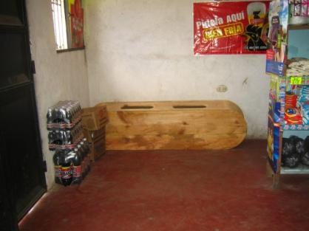
The other thing they sell just past the potato chip rack is a coffin. It is a simple wooden coffin on its side and costs about $35. So, you can get hair gel, chips, soda and a coffin, all in one spot. Later on when we talk to Carlos about funerals, he is shocked to find out that a lot of funerals can cost $10,000 in the US. The cost in Guatemala is around $400.

Figure 59 Coffin for sale with chips and soda

Textile Museum
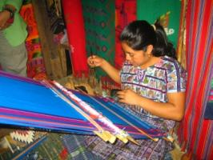
That afternoon we go to a textile museum in Antigua. We see a demonstration of a woman using the back strap loom where she sits on the ground with a belt around her back attached to the loom in front of her. It can take several days to set up the loom. The woman we see can sit and weave for two hours at a time.
Figure 60 Woman working on back strap loom
We learn about the sute, which is the head cloth and men use them for religious ceremonies. The Mayan blouse is a huepil, the skirt is a corte, and the sash is a faja. A wide belt signifies a woman is married and a half belt means she is single. The cross that is on the fabric is the Mayan cross.
The tour isn’t very long and the guide at the end goes in another direction telling us that he knows there is a Jesus Christ because he used to be addicted to drugs.
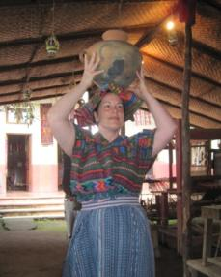
At the end of the tour, we go to a small gift area. The guide asks me to volunteer and they dress me in the Mayan dress. I agree and everyone takes my photo. Then they give me my crown, a basket that I have to balance on my head. I cannot do it for more than a couple of seconds. The woman who dressed me pops the basket on her head and it stays. It is a common sight in Guatemala to see a woman walking with a basket of bag on her head without the use of her arms.
Figure 61 Me in traditional Mayan dress

Macadamia Plantation
The next stop is the macadamia plantation. The plantation we go to is owned by a man from California who married a Guatemalan woman. He donates lots of trees for people in Guatemala to start businesses. This plantation uses no chemicals and they use no electricity.
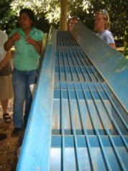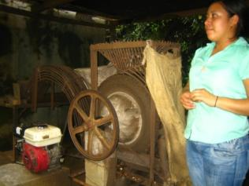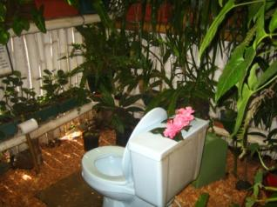
Figure 62 Macadamia nut machinery and fancy toilet
Macadamias are from Australia. They produce nuts 365 days a year and harvesting is cheap and easy because they fall off the tree when they are ready. A tree will last 200 years. The green husk is used for compost and given to the community for their trees. It takes 6-8 months for the nut to fall. The shells can be used for fire which saves trees. When the shells are do not give off smoke when lit. Macadamia nuts can be used in flower and tortillas.
They use a very simple machine to sort the nuts. It looks like a kid’s game where you drop the nuts at the top and let them roll down long bars. The size will dictate where they fall through into a bag below. The bag is taking to a machine that is powered by gasoline or by a special bicycle type machine that requires peddling to take off the shells. Because gas is expensive, many communities use the bicycle style machine. In an hour, the gas powered machine can crack one ton.
At the end we get to have some coffee with a macadamia nut pancake drizzled with macadamia butter. In addition, we get massages and facials using macadamia products. Out come the wallets and the group makes some purchases.
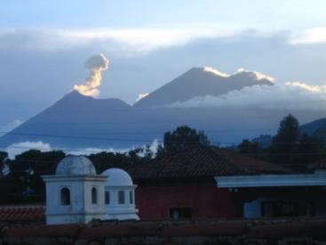
We stop at the supermarket and everyone picks up some items for a little party. We go back to the hotel and the happy hour starts on the roof terrace. While we are there, one of the volcanoes has an eruption. It is a stunning sight and everyone grabs their cameras.
Figure 63 Volcano erupting
The rest of the night is good food, good music, and good fun.

Day 9Antigua Continues
Our day begins with an optional walk with a very steep incline to the large cross on top of a hill what overlooks Antigua. Even though it is a bit challenging, it is definitely worth it to see the view.
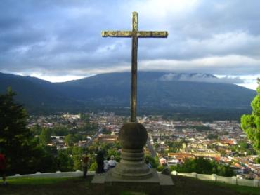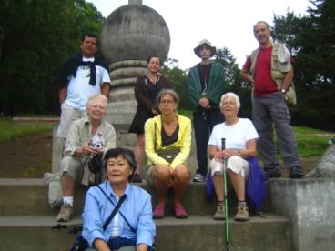
Figure 64 View of Antigua

Jade Factory
Our next trip is to the Jade factory and we all are in for a surprise. Today is Mary’s 85th birthday and Carlos surprises us all at the Jade factory with a surprise party for her. Carlos has a beautiful cake with fresh blackberries. They give her a gift of a jade pendant.
We learn a bit about the history of jade and the production. The most interesting part is that there are some types of jade that you wouldn’t think is jade such as a lavender color. We all get a jade sample to take with us. A couple of men try their hands and hammering the jade to break it. It is pretty tough, but Jim manages to hack off a piece.

El Fondo
After the jade factory, we have time to explore on our own. In my travels in the city, I bump into Carlos and Jaime and I have lunch with them at a restaurant called El Fondo. It is a very nice place and there are pictures of the owners with Bill Clinton there.

Coffee Museum
There are two types of coffee, Arabica and Robusto. Guatemala grows Arabica. Most coffee is used for export and most Guatemalans drink instant coffee. No one really knows how people figured out how to use coffee in drinks, but one theory is that in Ethiopia a shepherd noticed that when the goats at the coffee plants, the goats couldn’t sleep. Coffee trees have a life span of 40 years and 20 of them are productive.
We learn a lot of facts about coffee, but one of the most interesting is Cluet coffee. A cat like animal in Central America feeds off the coffee. The coffee is processed and passes through the animal’s system. The droppings are collected and washed and sold for $100/pound.

Music Museum
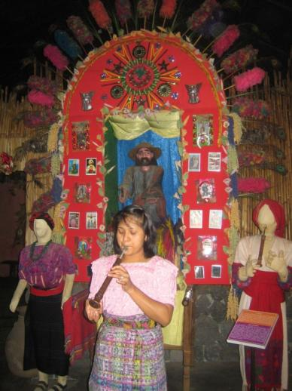
The music museum is at the same location. The guide knows enough about all of the instruments to give us a quick demo on each one of them. Some of the instruments are conch shells, tortoise shells, and even a horse jaw. The national instrument of Guatemala is the marimba, which resembles a xylophone made of wood.

Figure 65 Music museum
We take another museum tour. Even though we have been to lots of museums, we are promised that it will be different from any other museum we have seen. We head to the Santo Domingo Hotel and we are impressed as promised. The hotel is one of the top 500 museums in the world and the best in Central America.
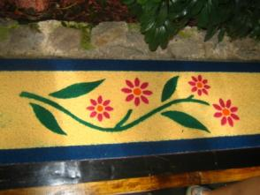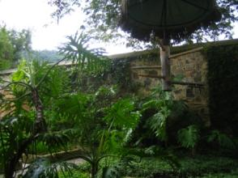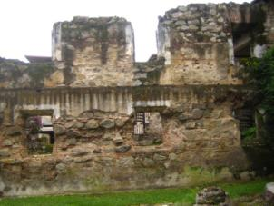
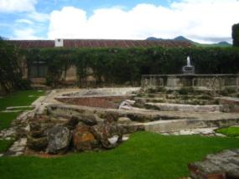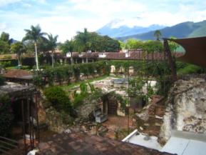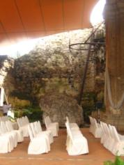
Figure 66 Hotel Santo Domingo

A man purchased the land that was an area of ruins and over 13 years he made the hotel and private museum. The entire place is absolutely stunning and the integration of the ruins with the new structure is unique and breathtaking.
During a big earthquake, the church had fallen in and people left the city. In the 1980s, a lot of statues and artifacts were being burned and thrown away by inhabitants. The owner of the hotel began purchasing and acquiring items for the hotel and museum.
The only reason our group cannot stay here is that they do not take group reservations.

El Baile De Diablo
That night we have dinner at Posada de Don Rodrigo La Antigua. I sit with Diane, Steve, and Barb. Our table abuts the dance floor and once the dinner is served, a performance begins, El Baile de Diablo. The costumes of the performers are very colorful. At this meal we get two complimentary drinks. I think the reason is to get us to dance with the performers! Most people from my group get up to the floor and we have a lot of laughs and photos.
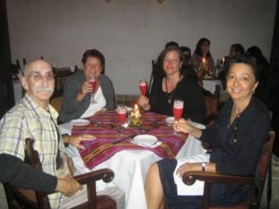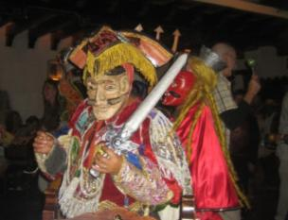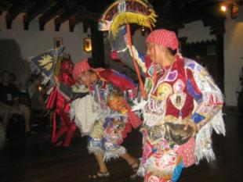
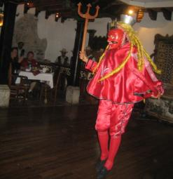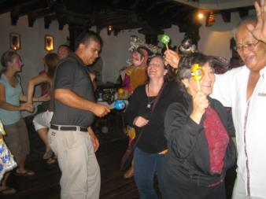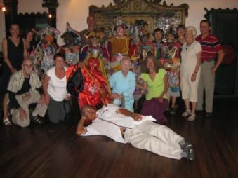
Figure 67 Dance of the Devil

Day 10 Antigua to Flores
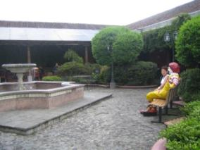
Today is pretty uneventful. We have a morning to ourselves in Antigua. I go shopping with Marilyn, Howie, and Barbara, and my big purchase for the day is a T-shirt for Michael. We stop the McDonalds. The shocker is how nice it is. There is a big beautiful courtyard and except for the same putrid smell and the plastic Ronald McDonald on a bench, I would never guess where I am.
We travel back to Guatemala City to catch a flight to Flores. This is where we say goodbye to Jaime, our bus driver, who has been an integral part of the tour.
Figure 68 Antigua McDonalds
The flight is only about 50 minutes, but if feels much longer due to a twenty something know-it-all American, who feels the need to spew his ignorance. He is traveling with his family small group of Americans chat with Marilyn and even though I am wearing my Bose headphones, my ear starts to catch him on his soap box. He talks emphatically about how useless it is for the Mayan people to learn their language. Marilyn politely expresses her different opinion and tries to point out the importance of preserving heritage. Carlos is sitting across the aisle from me and I feel terrible that he has to listen to the guy as well.
Before we reach our hotel, we meet Carlos’ family. Everyone is very honored that he has chosen the share this personal part of his life with us.
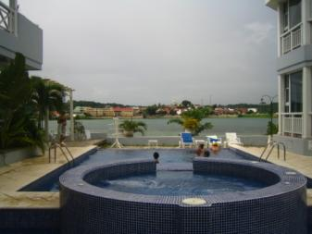
Our hotel is Casona del Lago, which is a lovely hotel that overlooks the lake between Santa Elena and Flores. The rooms are non-descript, but roomy with a much needed powerful shower. There are lots of balconies and areas to sit outside and look at the lake.
Figure 69 Casona del Lago

Day 11 Flores and Tikal
We head to Tikal which is about an hour from Flores. The vegetation is much different since we are in the lowlands. It is a lot more tropical and reminds me of Florida. The highest elevation here is 600 feet.
The military in this area are mostly protecting national parks. There are 10,000 square miles of jungle. There are about 450 species of birds in this area.
Mahogany is one of the most well known as well as a non-coniferous Cedar tree. Both are redwood slow growing trees with lifespan of about 600 years. The tree with the longest lifespan is the Chickle tree which lasts about 1,000 years.
The first car made it to Petén in 1965 from Belize, but it wasn’t a big surprised because the people had seen planes. An airstrip was built and owned by Wrigley’s to get gum. The chickle is considered the white gold. All spice is found here, and it comes from one tree. People climb the trees and cut the unripened berries with a machete before the berries turn sweet. This is the only place where the tree is found growing naturally.
We arrive at Tikal Ruins. We are loaded up and sunscreen and DEET and about to sweat our butts off. The furthest temple we are going to see is about 2.5 miles, but we are lucky that Carlos has arranged for a truck to go to the furthest temple we will see so that we will not exhaust ourselves for some of the climbs and later structures. There are stairs up to the top which makes it possible for everyone to go. The view is breathtaking.
This trip offers more nature. We see spider monkeys, toucans, a quatamundi, Cahones de Caballo-a tree that means horse balls and you can guess why, Strangler figs, and Mahogany trees.
We rub all spice on our ears to serve as bug repellent.
We see both pyramids and temples at Tikal. One difference is the staircase. For temples, there is one set of staircases that jut out from the structure. Pyramids have the stairs inset. There are four sets, one on each side, but on the ones on the east and west go all the way to the top.
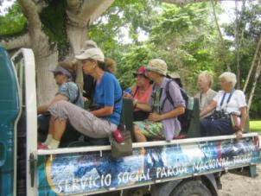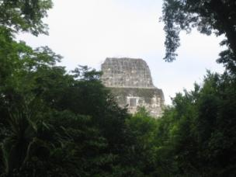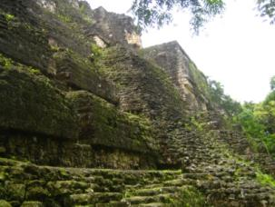
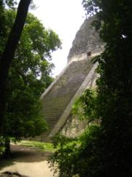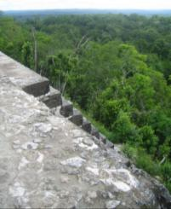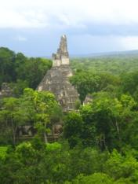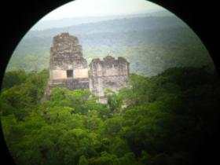
Figure 70 Tikal
Some of the temples are very steep and you have to use a ladder and to go up and down. Several people get nervous along the way. The entire ruins area is fascinating. I climb them all even though it seems a bit scary, more on the going down part than the going up part.
That night I walk with Marilyn, Howie, and Barbara into Flores. We eat dinner at La Luna that has a great nacho platter with refried beans. At the end of the meal, our server gives us a free shot of Guatemalan rum.

Day 12 Last Day in Guatemala, Onto Belize

Renewable Resources

Chickle
Carlos worked in the jungle as a child after he lost his father. He couldn’t go to school because teachers were afraid of being shot. At 11, Carlos learned how to climb the Chickle tree. It’s hard because you have to climb with a machete and then slash the tree. You have to tie yourself on a vine. If you miss one cut and goes into the rope, people fall. People must get training on how to deal with snakes, deal with the vines, and how to identify and use a water vine so you can get liquid without killing the vine.
To get the gum, the tree is slashed and it coagulates. They discovered that if they put it in a pot and boiled it with some honey, it got a honey flavor and boiled off. It was used to help keep the Mayan’s teeth clean. The first 1826-1829 John Quincy Adams started a gum business with Mexico. When he was done with done with his presidency he started his business Chicklet Adams. He decided to quit after a few years and he abandoned. A few years later the Wrigley family came to Guatemala to see the source, and they started buying the gum from 1882—1991.
This played a role in the airline industry and that is how TACA airlines was born. It stands for Transportes Arials Central American.
When Wrigley’s stopped buying, Carlos’ village was the only one to keep the business going. The government looked for another buyer and they began to sell to Japan.

Elegance Plant
Another resource is an ornamental plant was found where you could cut the leaves and People were interested in buying the leaves, rolling them and sending them to Southern Florida, the flowers are decorated with the leaves on the side.

All Spice
Even when the products are sold, the villagers wouldn’t know what they were being used for. Carlos found out and discovered in 1991 there was a lack of Novocain for dentistry and Carlos found out dentists were using the unripened berries as a source of numbing. The leaves can also be used as insect repellent, but the people who are born here develop and immunity.
We see the lake from the other side. It is called Chalctunha, meaning white stone water. Divers have go 450 feet in the blue area which means it is below sea level.
The forest abutting the lake looks like the profile of a crocodile. There are crocodiles in the lake, but there has never been an attack on humans. People swim in the lake. The crocs can’t chew under water. They are nocturnal. There isn’t anywhere else in the world crocs behave this way. The croc can survive for about 1.5 months without water and can move around to other areas.
You see beware of crocodiles signs because of a past issue with a crocodile. A man brought a crocodile named Pancho from the Yucatan to Tikal. U Penn had an archeological dig going on and they created a way to collect water.
Villagers would help and go back to the village on their time off and not return. U Penn decided to create a village in Tikal to have full time workers. The only place to get the water was where Pancho was and that is when people were attacked. Pancho was 11 feet long. Pancho was murdered by police in 1991. That is why you see beware of crocodile signs.

Colonization
The governor decided to cut down a lot of jungle and colonize the jungle. The government began to advertise the land for free and you just needed to tell the organization how much land you wanted for you and your children. In exchange, the new owner would have to chop down the trees and plant corn. This would help ensure the guerillas will not have an area to train. They remove a lot of trees such as mahogany. The trees would be burned. Wildlife was also killed such as jaguars and their pelts were sold for $2. In the 80s, 70 jaguars were killed each day.
The trees have a shallow root system and thin layers of humus were maintaining the system. When people came and the area was cleared and slopes were created, humus was cleared and limestone was brought to the surface. Crops would only be good for one time, so people would request more land. The area went from 15,000 people to 300,000 people.
Another impact is that the leaves cannot be produced to build thatched roofs. Therefore, they need to get corrugated roofs. In the hot weather the corrugated roof makes the home a lot of hotter.
There is a fear that if UNESCO declares Carlos’ village, the people could be moved out.
We get to an area where a ranger is selling maps, but we are encouraged not to support. Mayan history is not taught in Guatemalan schools. Unfortunately, people graffiti the temples and take some pieces such as pieces of wooden lintels. The rangers are only put at an area of the road and not at the structures which could protect them. Tour guides have been sending letters to the department of tourism to make a law that you cannot go to Tikal without a tour guide to help protect the ruins.
These products still keeps Carlos’ village running. Carlos’ siblings still work in the jungle with renewable resources.

Yuxha Ruins
These ruins are the area where a season of Survivor was produced. For five months, they rented out the place and invested $28 million dollars. Our bus driver, Sammy, was the driver for the contestants. The intentions was to bring more people to the area and one of the positive thing that happened was that some of the ruins were excavated.
Our first discovery is Spider monkeys. They are up high in the trees and even though they seem to be unaware of us, they put on a show and swing from one tree to another.
There are hardly any people there and we are able to climb several of the structures by ourselves. A few of them have wooden steps to the top. One of them has a magnificent view of the lake. It is so still that it mirrors the sky.
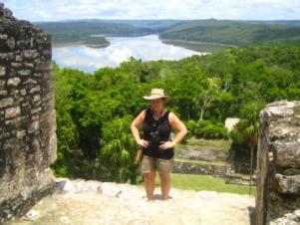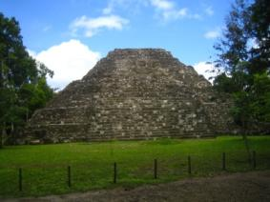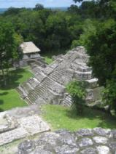
Figure 71 Yaxha
We make our way to the Acropolis which is the only structure that you can climb that doesn’t have a staircase. A few of us venture up there. It is really a privilege because it is unlikely that they people will be able to climb here much longer. The same is likely to happen with Tikal.

Last Meal in Guatemala
Our last meal in Guatemala is at El Protal de Yaxha. It is our last day for tortillas. It is owned by Minola, who started the business when Survivor went to film. I get a chicken fajita that is different from regular fajitas. It comes with a stew-like sauce. It is not very spicy, but it is good. This is my last chance for homemade tortillas and I manage to eat three.

Belize Border
We are warned that the border is going to be tough. We are told the questions to expect and that all of our luggage will need to be removed from the bus and we will have to carry it over the Border and the bus goes over empty.
OAT incurs a lot of extra fees to get the bus in, insurance, entrance fees. We will have to pay $35 each to leave the country. One day they did not allow Guatemalan buses in and now they won’t to let OAT tour guides give us the tour. We have to have a different guide from Belize on our bus. There have been groups where they were forced to take extra rides and whatever rules are imposed for the day.
In Belize the native language is English and the unofficial language is English Creole. Belize has done a lot to save nature and claims to have the most jaguars in Central America in the reserves. Education is required and if a child doesn’t go to school, it is against the law.
Tourism is the biggest money generator. There is a real mix of Asian, Mennonites, Amish, and other cultures, therefore it isn’t really possible to describe a Belizean. A lot of the goods we will see are Guatemalan items that just say Belize and will be a lot more expensive.
When the British got there, they said it was theirs because the Spaniards didn’t settle there. Indigo dye is considered blue gold of Belize. It comes from trees. The British started logging to get the dyes and brought African slaves to do the job. As they cleared the area and the migrated until they got to jungle areas with Mahogany trees which was the red gold. They devastated all of the Mahogany for ships and to make goods for Europe. When they reached Guatemala, they offered to make a railroad from Guatemala to Belize. Guatemala agreed and gave the British land for 100 years, but the railroad was never built. In 1995 when Belize was supposed to give it back. Belize decided to declare independence in 1981. It is the youngest nation in Central American. They created a flag, money, and national symbols. The currency is BH.
In 1976 Guatemala organized to invade Belize and take the land back. The government encouraged the organization and they said they would send the army in behind them. On Feb 4, 1976 they went in and started shooting and burning. They placed the Guatemalan flag. The army never showed up because on that day at 1:38 am, Guatemala had an earthquake that killed 25,000 people. The organizers were captured and taken to prison in England. In 1993, the Guatemalan president under the Mas party signed the papers to give Belize their independence. The president bought an island in Panama with business in Belize.
A Belizean perspective of what happened is likely to be different.
We are mentally prepared for a difficult border crossing and we get very lucky and cross without issue. Now everything is written in English, and I’m kind of sad to leave a Spanish-speaking country and having an opportunity to learn and practice Spanish.
When the bus reloads, we meet our guide Leonidez. We learn later that Carlos has never met him before and he was just the guide imposed on us. He tells us that 1830s when explorer arrived in Belize, Creole people arrived in Belize City. Belize City is also known as the Black Republic.
We pass by one of the biggest urban areas that Banque de Viejo del Carmen. It has 6,000-7,000 people. This is where a lot of mahogany logging happened. Our guide identifies himself as Mayan. He tells us that there are three groups of Mayan people in Belize.
Belize was called the British Honduras until 1973. There are several theories on why it is called Belize. The first is that it was morph from a political person Wallace. The second is that Belize in Mayan meets muddy water. The third is there is a river in Angola called Belize. Creole’s say it was the only thing to identify from Africa.
We take the Western Highway that bisects the country west to east. It travels parallel to the Belize River. It is 73 miles to Belize City. The population is of Belize 320,000.
We pass by Xunantunich, a reserve and you can ride a hand-cranked ferry. From 1993-2000 UPenn and UCLA did an archeological dig. The highest structure is there and is called El Castillo and the second highest building is there.
The capital of Belize is Belmopan. There are about 8,000 people there and it is one of the smallest capitals in the world. It was built in 1971. The government wanted to build it for people who left Belize City to Hattieville after it was devastated by a hurricane. However, people didn’t like it and returned to Belize City. The language there is mostly Spanish.
The fertile soil is in the Southern part of Belize and has bananas, pineapples, and papaya. Their bananas are not part of Chiquita and part of a company in Ireland.
There’s about 30 miles of coast and shares 10 miles from Mexico. It is the Mesoamerica Barrier Reef. There are a lot of lagoons where cruise ships can go. There are not any man made beaches because they cannot remove the turtle grass. To swim you would have to take a boat to an island. There are about 200 islands.
There are six districts in the area and we go through the Cayo District. There are no sky scrapers. The highest structure is a nine story building.
The Canadian government donated a bridge in 1949. Before, people would travel by boat. There are a lot of Chinese restaurants and businesses, which looks strange in this tropical area. It’s Sunday so only the Chinese businesses are open.
The Mennonite community has a big presence in Belize. They arrived in 1949 and 1950s when they left Chihuahua because they didn’t want to pay the taxes. There are conservative and liberal Mennonites.
Belize is known for basketball and softball. There isn’t a lot of money in the country to support sports and they cannot compete with other countries every year.
It’s common to see a Taiwanese and Belizean flag on the same sign.
A lot of people go to the Galen University for agriculture. They also want to learn English. The teachers can make $60-100/hour. A lot of the students are doctors and business people who want to make their way to the US.
Getting a Belize visa to the US is similar to Guatemala and costs $250. Over 75% of the population has a relative in the US.
The flag has red and blue bands to represent the red and blue parties. There are 50 leaves because the first political movement started in 1950. There are two people, a Creole and a Mestizo. The saying on the flag means, “Under the shade I flourish,” to refer to the Mahogany tree.
Spanish was introduced as a second language in the 1990s. Citizens said they were being marginalized and companies were looking for bilingual speakers. However, everything is written is written in English.
Property is $50,000-$100,000 per acre and it is mostly purchased by foreigners. A lot of people come here to retire because they don’t need to learn another language. Most Belizeans own their homes, but mortgages are 60%. Many people start with the minimum number of rooms and build over a long period of time. There is one program at age 18 you get 25 acres of land.
Our guide tells us that they eat rodents and Queen Elizabeth supposedly ate a royal rodent at once. Our guide jokes that if you order chicken, make sure to ask for the wing. He also tells us about bamboo chicken which is the green iguana.
Belize has crocodiles and no alligators. One type of crocodiles they have is less aggressive and people will tube in the rivers even though there are crocodiles are there. The American Salt Water crocodiles are more aggressive.
We pass the Belize Zoo and there are only animals native to Belize. None of them were brought there. It is more like an educational center. Some of the animals are tapirs, five species of jaguars. Belize is the only country that has a reserve for jaguars. The zoo has a jaguar, Junior, for a small fee you can get a kiss or a high five from him.
To get medical care is very inexpensive and you could see a doctor for about $5. You are likely to get a Belizean or Cuban doctor. However, medicine is very expensive.
There are a lot of speed bumps that are called sleeping policeman.
There is only one prison with about 1,000 people. They still have the death penalty, but it hasn’t been used since 1971. Death penalty is really life in prison.
We arrive in Belize city and we see the cemetery that has above ground stone crypts.
We are on the south side that is considered a not very safe. This area is least clean place on the tour and there is a lot of trash on the ground. It reminds me of where I used to live where people just don’t take pride in there they live. As we go through the town, people sitting on the road watch the bus go by. It’s the only time on the entire tour that I don’t feel entirely safe and I’m glad to leave the area and arrive at the hotel.
Our hotel is the Belize Biltmore, which is the Best Western. I’m pleasantly surprised. It has a nice courtyard and pool area. I’m glad about this because I am not inclined to go walking in the area.

Day 13 Last Adventure for Group 71
Today we take a boat ride to Lamanai with our local guide Isidro. The boat ride is 25 miles. Along the route, we see a lot of stunning birds including a baby white throat herring still in its nest. There had been two other babies, but they must have learned to fly.
We reach Lamanai and we get a tour of the ruins and I climb the ruins available. Even though we have been to a lot of ruins, the special part is at the top. One of them is so steep, that you need to use a rope going down.
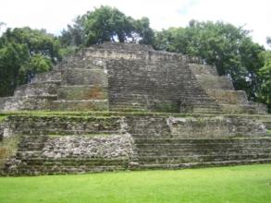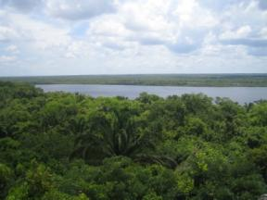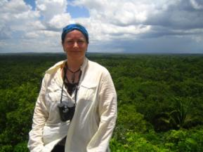
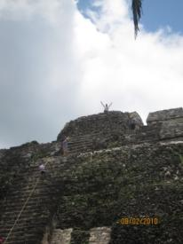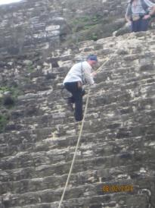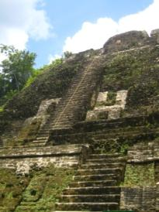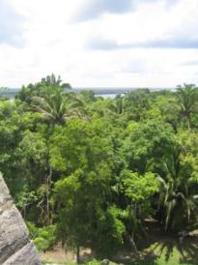
Figure 72 Lamanai Ruins
At the end, Isidro has a lunch. It is chicken, rice and beans, but it has a different flair than the other meals in Central America with the same ingredients.
There is a shop there where the proceeds go to Honduran and Guatemalan refugees and I buy two necklaces. It also turns out that the woman working in the shop knew Carlos’ father.
That night we have our farewell dinner. We meet at the bar and have a toast with the drink that Carlos has made and we talk about the highlights. We have a great dinner and some of us continue the “party” in the pool area.
The next morning there are lots of goodbyes and hugs.

Belize Post Trip

Belize City to San Pedro
I get on the bus with Bob, Kay, Diane and Steve to catch the ferry to San Pedro. The terminal is a very busy place and feels like a chicken boat.
Upon arrival, we meet Ben, our local guide. It is overcast and rainy and remains so for the rest of the night. I’m kind of having some regret about my decision for the extension, but I know I need to be open.
We walk to the hotel, Seabreeze. I get situated and go for a walk. The staff is very welcoming. I venture into the supermarket and it is quite expensive. It caters to Americans and a lot of items are 3-4 times the price at home. For example, a Sara Lee small frozen cake is $24 Belize, which is $12 US. It’s cheaper to get something a local restaurant. I get some homemade hummus and pita bread at Ali Babas and it is a great snack.
Tonight I meet up with Ben, Kay, and Bob for dinner. The place we are supposed to go to, Carambas, is closed for vacation, so Ben has arranged for us to go to Micky’s. The place in non-descript and has the atmosphere of an American Chinese takeout, but when the garlic Grouper comes, it is very good.
We learn more about Ben. He has a family on the main land, but works here because there is more work year round. However, since the recession, there has been a lot less tourists. It’s easy to see since restaurants are far from full.
After dinner, Ben gives us a night tour of the downtown area. We see the first hotel and restaurant. It feels very safe to walk around.
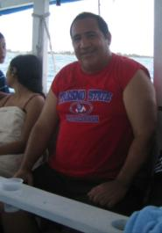
The next morning the sun is shining. Breakfast is included for us at the Blue Water Grill which is the outdoor restaurant at our hotel. It is a huge breakfast and I’m able to take half of it for the snorkeling trip. We get on one of the two glass bottom boats in the area and head to Shark Ray Alley. The driver throws out some chum and the nurse sharks and sting rays swarm. I’m quite anxious to get into the water with them. I finally talk myself in. Ben then leads us on a tour and he point out about 20 different fish. We then go to Ho Chan and we see a lot more fish. It’s great having a guide who can point things out and Ben even swims through a hole in the coral. There is a man on the boat who is wearing a Fresno State t-shirt, which is funny because that is where Bob and Kay are from. The man doesn’t know where it is and bought it at a five and dime store.
Figure 73 Small world
That afternoon I rent a bike which is really cheap. It’s $12.50 US for 24 hours and even though it is a clunker, it’s easy to navigate the island except for some of the potholes.
I make my way to the north island in search of the Akbol Yoga Retreat Center for the 3:30 advanced yoga class. I like this part of the island. There is a lot more vegetation and probably a lot more monied people. I find the yoga center and get there so early, I have a light lunch at the bar outside and a fresh squeezed orange juice. The best $5 lunch around and served by the friendly bar man, Johnny.
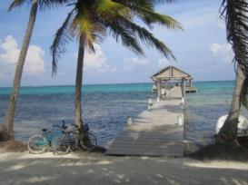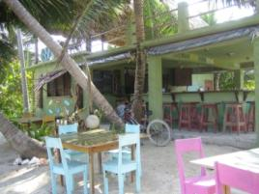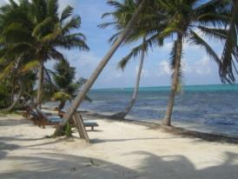
Figure 74 Akbol Yoga Retreat Center
The class is exactly what I need since I feel like the rusty Tin Man from the Wizard of Oz. The class is at the end of the pier with a thatch roof and island breeze. The owner, Kirsten, is from the States and owns the whole center. One of the women in the class invites me to the Bikram Yoga on Friday, but I tell her I am leaving before then.
The wireless at my hotel is $15/day, but I find a cheaper plan. Each afternoon I venture to The Baker for a cappuccino which gives me free access to wireless. There is a very nice woman from Whales who works there or maybe she owns it.
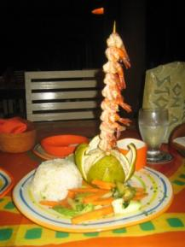
That night I want a quiet dinner and I go to the Pineapples that is at the restaurant at Ramon’s. It is a Maya-inspired theme, but I find it quite lovely with the breeze. I get the shrimp skewer with satay sauce for about $15, but the dinner is really upscale with the coconut rice.

The following day I ride the bike to the south side of the island. There is a lot of development and not much there. It is not a pretty as the north side unless you are on the water side.
Figure 75 Dinner at Pineapples

Diane and Steve meet at my hotel room for lunch. They think it’s funny that I am on a first name basis with Rubio, one of the hotel staff. We walk around the town and end up at Fido’s. We get the fish fajitas and they are very good. It is a big open space facing the water. They also have homemade hot sauce that is excellent. Our server is an American man from California who visited a friend, went home and sold everything, and four days later moved to San Pedro.
The part about Belize that I don’t care for is that even though the water is nice, there aren’t any real beaches. Most of the shoreline are docks, and where there is sand that goes to the shore, there is not a lot of sand to sit on. It is more of a path for walker and cyclists.

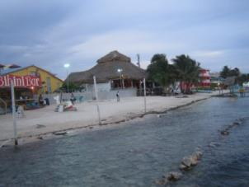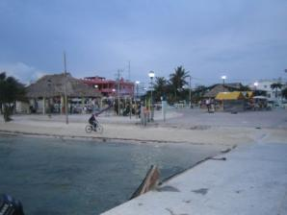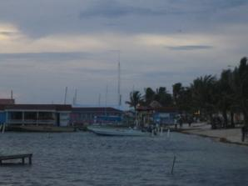
Figure 76 San Pedro Waterfront
The parts I like about Belize are the people are very friendly and there is no sense of pressure to purchase anything on the street or in the shops. The whole atmosphere is very laid back. Even when I rent a bike, I’m not asked for my name or deposit; I just tell the guy my room number and my hotel. I also like that you can sit at an outdoor restaurants and get really good fish at a very reasonable price.
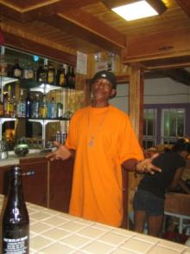
After an afternoon of walking, a siesta, and an Internet fix, I am ready for dinner. I see a bar called Hurricane on a pier next to my hotel that has a lot of people and is over the breezy water, so I decide to have a beer and see how it goes. I’m working on this journal and as people come and go, they ask me what I’m doing. I meet people from the UK, California, Louisiana, and other parts of Belize. The main barman, Emerson, is also interested in what I’m doing and I promise to include him in this blog. He wants me to tell you that it is the best ceviche bar on the island. I don’t care for ceviche, so I have to take his word for it. What I can tell you is that the grilled chicken is phenomenal and the Beliken beer is cheap. It’s a great spot because there is a great island breeze, and no bugs.
Figure 77 Emerson at Hurricane Ceviche Bar

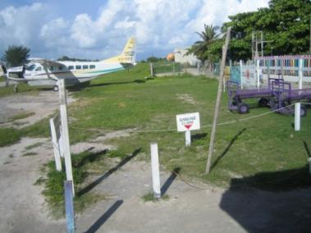
Belize Departure
It’s time to return to the States. Our departure from Belize is a one minute walk from the hotel, through a fence that says “Do not enter,” across an air strip, to a building that is smaller than most car rental places I’ve been to. I’m about to get in the smallest plane I’ve been in, and the baggage claim area is funny to me; a small sign staked into the ground.
The plane ride is 15 minutes and it’s a cool view of the islands.
Figure 78 Baggage Claim San Pedro Airport

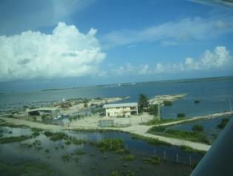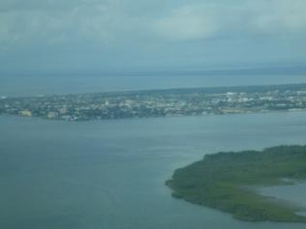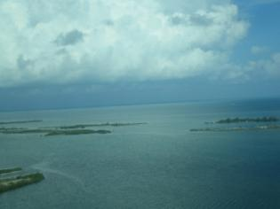
Figure 79 Arial photos of Belize
This adventure is over, but I now have some memories that will stay with me for the rest of my life.

