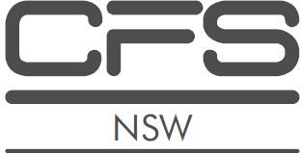
NSW Complete Financial Services Group Pty Ltd
NSW Complete Financial Services Group Pty Ltd
SELINA SIU CHUN CHENG
Authorised Representative
No. 233347
NSW Complete Financial Services Group Pty Ltd
Education
- Diploma of Financial Planning 1.
- Financial Planning RG146.
- Advanced Diploma of Financial Planning.

SELINA SIU CHUN CHENG

NSW Complete Financial Services Group Pty Ltd
ABN 791 284 037 98

1/11 Manning Street
TUNCURRY NSW 2428

Mobile: 0416 032 888
Email: selinacheng@tpg.com.au

Selina Siu Chun Cheng is an Authorised Representative of NSW Complete Financial Services Pty Ltd. Selina is authorised to provide you with advice in the following areas:

- Life Products (including Life Products under Superannuation).

Selina specialises in advising clients regarding personal protection insurance which includes:

- Death.
- Total and Permanent Disablement (TPD).
- Income Protection.
- Trauma/Critical illness.
- Business Expenses.
NSW Complete Financial Services Group Pty Ltd
ABN: 791 284 037 98
AFSL: 457600
ACL: 424396
Head office: 1/11 Manning Street
Tuncurry, NSW, 2428.
Phone: 1300 700777
Email: nswcfs@bigpond.com
Web: www.completefinancialservices.com.au

Selina’s commitment is to provide educated, experienced advice for her clients to help protect them and their dependents should any of the insured events occur.

Experience
Selina has had 22 years of experience in the financial planning industry.

Page 1 of 1

