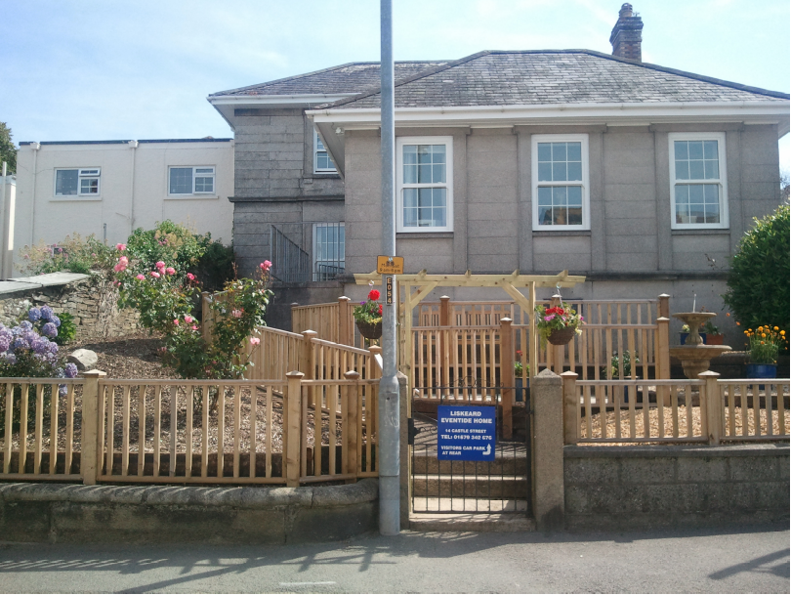

[Type a quote from the document or the summary of an interesting point. You can position the text box anywhere in the document. Use the Drawing Tools tab to change the formatting of the pull quote text box.]

[Type a quote from the document or the summary of an interesting point. You can position the text box anywhere in the document. Use the Drawing Tools tab to change the formatting of the pull quote text box.]
[Type a quote from the document or the summary of an interesting point. You can position the text box anywhere in the document. Use the Drawing Tools tab to change the formatting of the pull quote text box.]

LISKEARD EVENTIDE
HOME

BROCHURE

Providing care since 1952
‘Independence with care you can trust’

‘A not for profit making Home’

Reviewed March 2017



Residential Care

What we offer
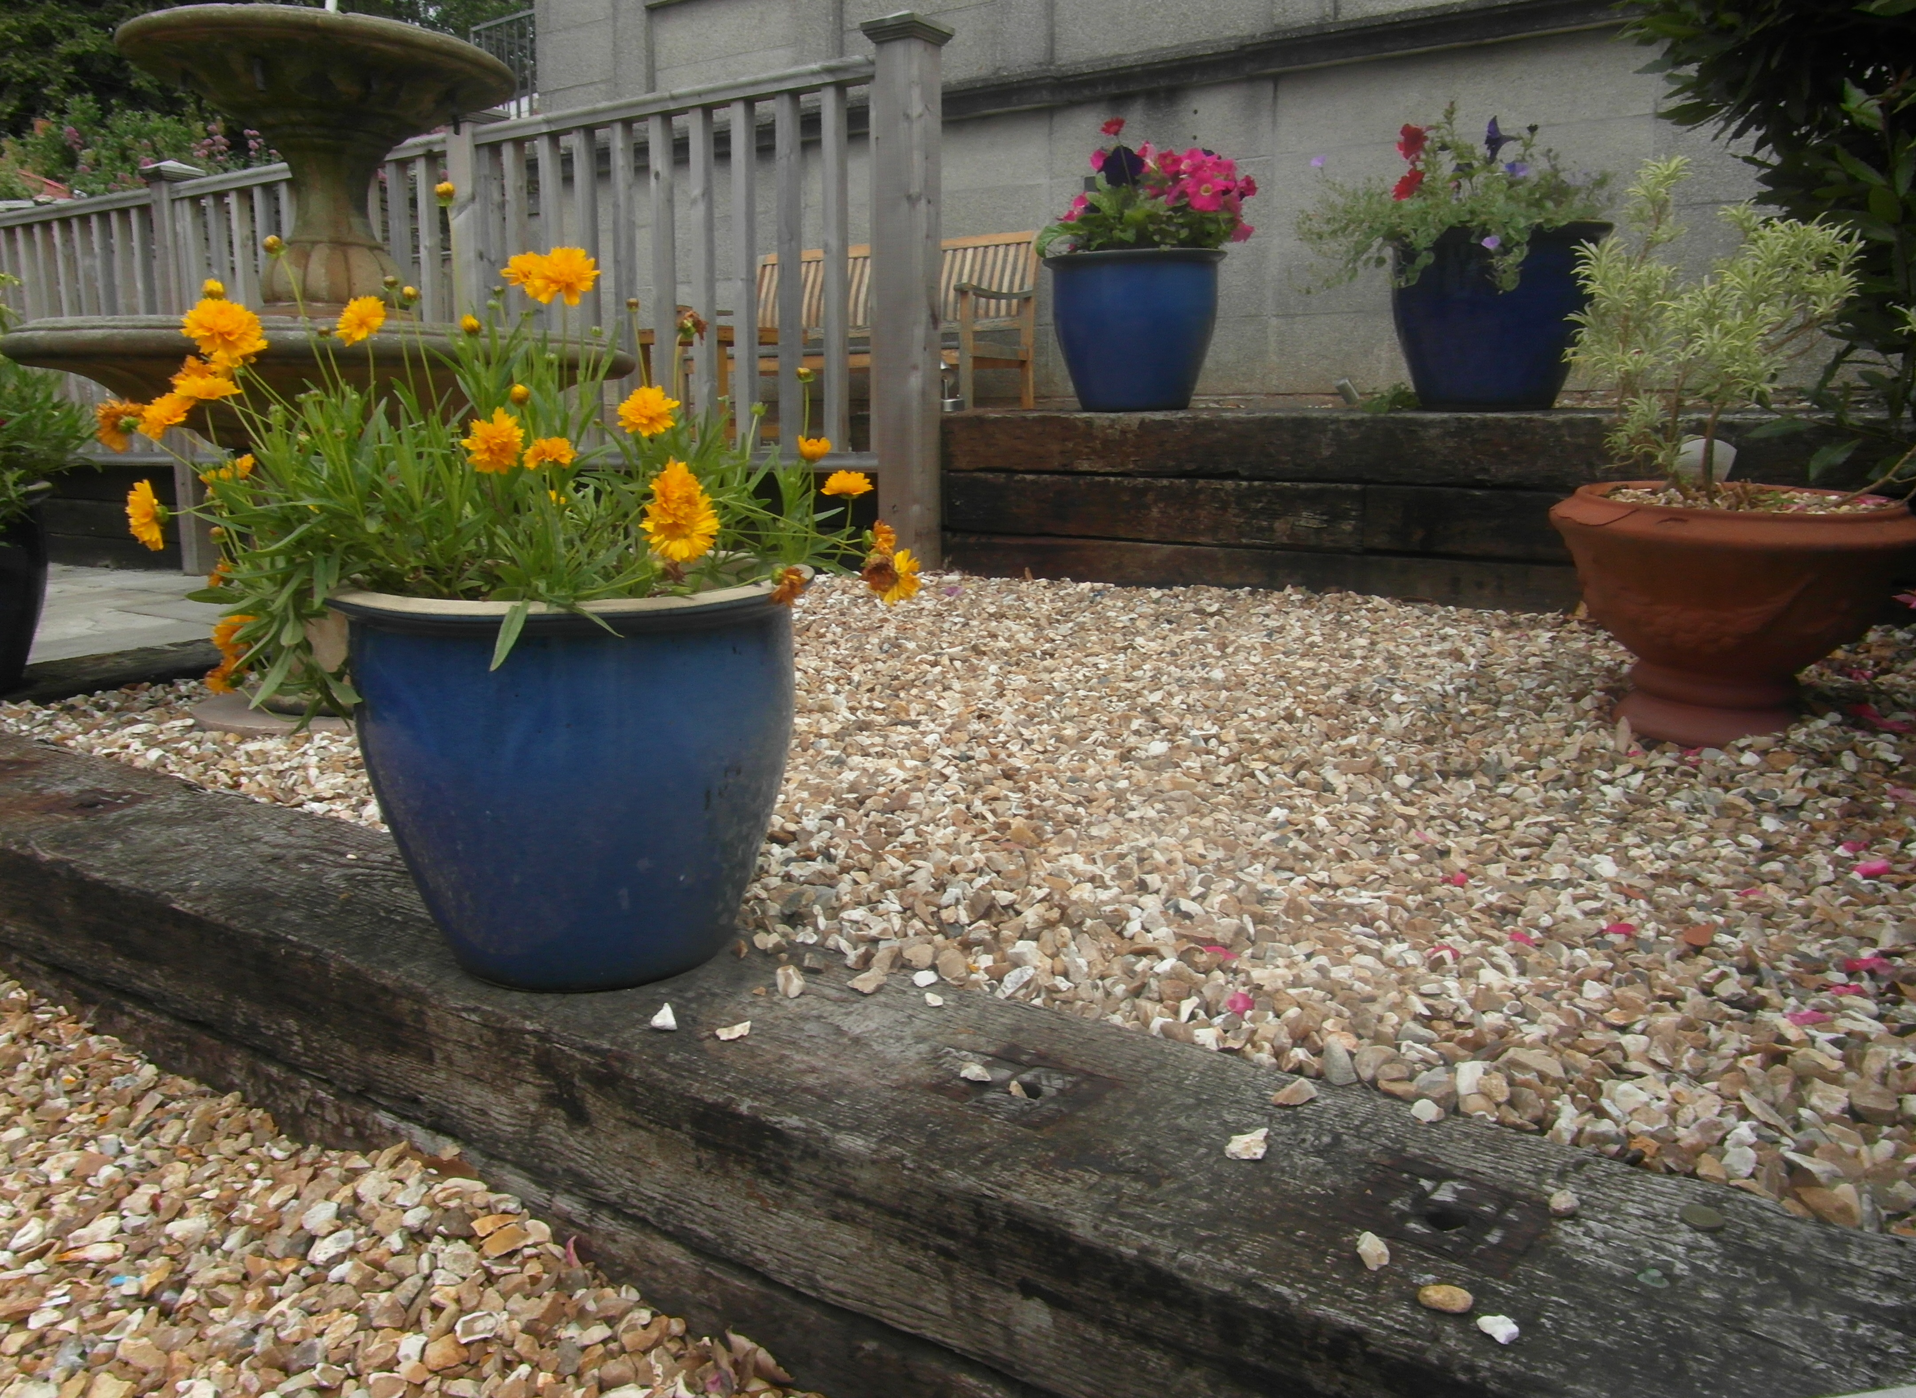

- Warm, friendly environment
- Quality of life
- Tailored services
- Privacy and choice
- Fully qualified staff

Eventide offers a range of services to enable older people to get the best out of life. Our residential care home offers a warm, safe and friendly environment, where people can maintain their independence if they wish, but have access to support when they need it.

We understand that many older people value keeping their independence. We respect that and encourage you to choose how your care is planned and delivered.

Our aim is to retain our residents’ quality of life. Privacy and choice are high on our priority list and personal care is tailored to meet individual needs.

In addition, to enhance our residents’ quality of life, we provide a carried range of social activities. These can range from quizzes to regular entertainers. We are a NAPA – (National Association for Providers of Activities for Older People) member.

Residents can rest assured that Eventide’s carers undergo an intensive ongoing training programme and are encouraged to complete Level 2, 3 and 4 Health and Social Care qualifications. The Care Manager holds a level 3 in Care & Management and the Home Manager holds a Degree in Management, in addition to Level 4 in Care. Our Head Cook and Housekeeper hold level 3 qualifications also.

The Home is fitted with a call bell system, ensuring help is at hand 24 hours a day.

We appreciate that it is possible the prospect of finding a suitable elderly care home may have come about suddenly. There is a lot to think about and consider, so please be assured we are here to help.

ACCOMMODATION
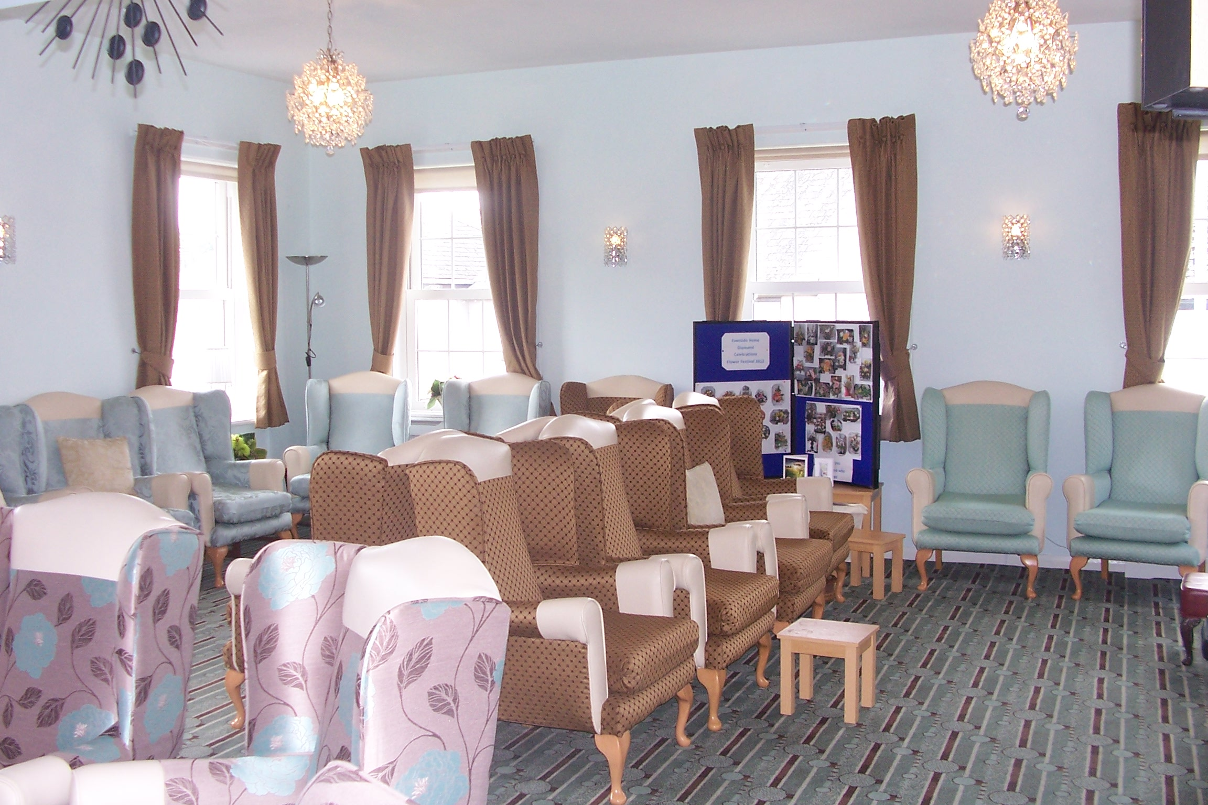
The Home is decorated to a high standard.
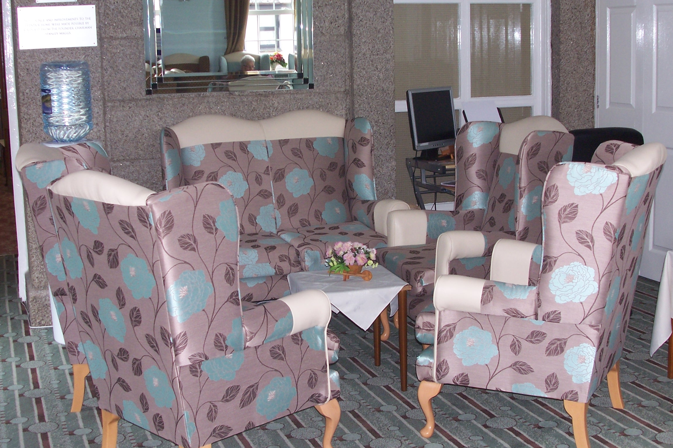
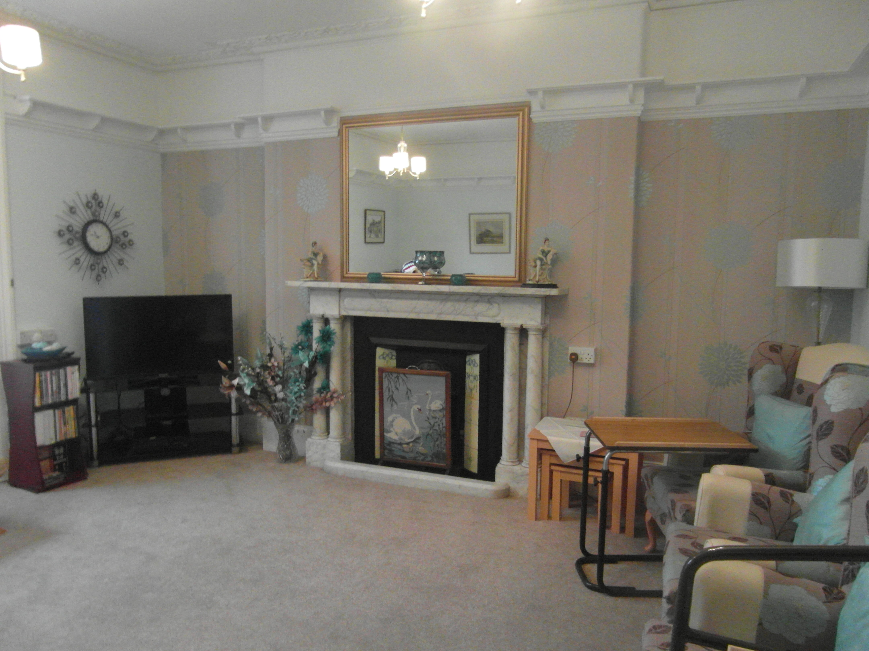
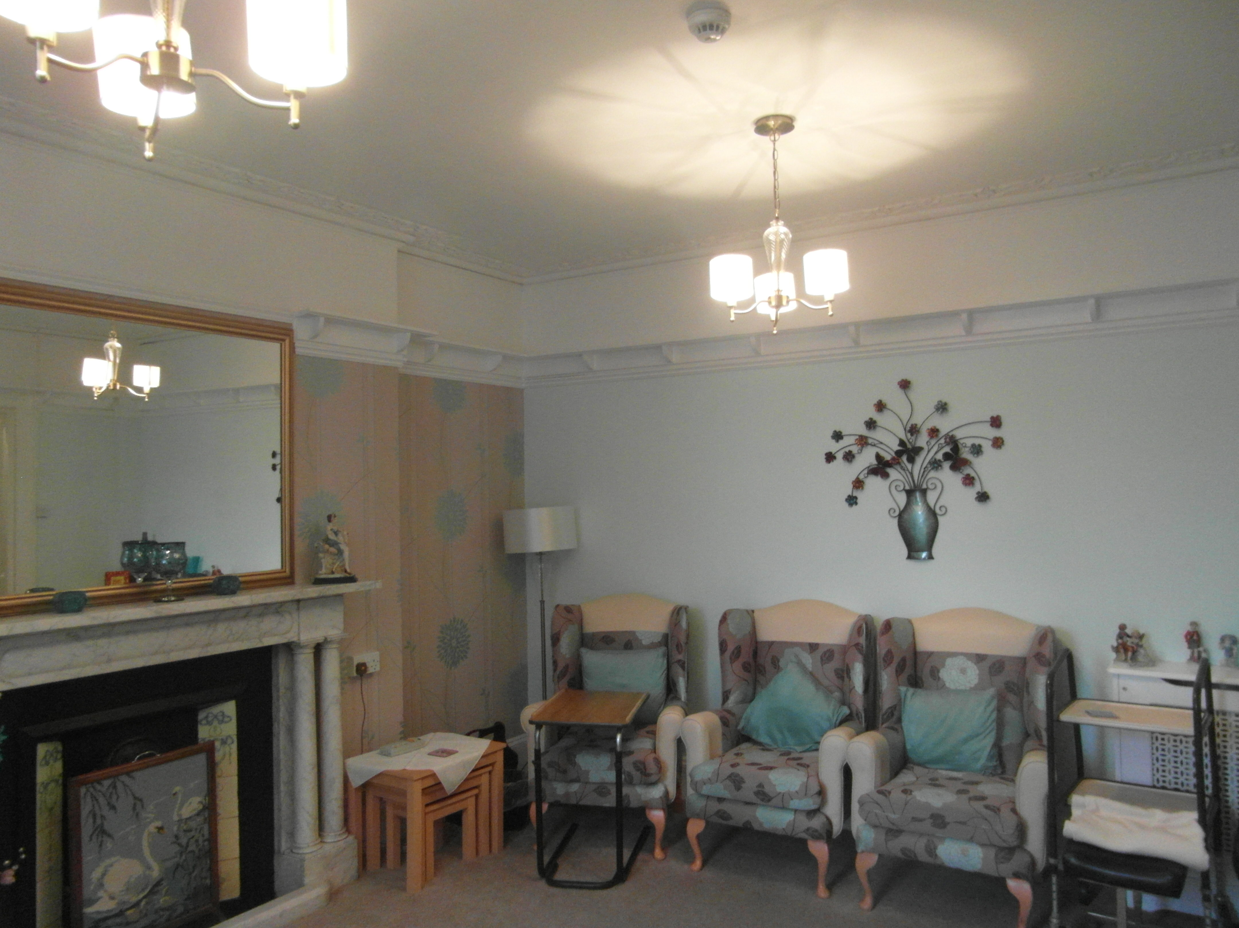
Our residential care home offers a wide array of facilities and include visits from the library and a weekly trolley with small items such as sweets and toiletries. We also have a hair dresser who visits on a weekly basis. A pay telephone is made available to residents. A private telephone line is available in every bedroom and newspapers can be arranged There are two lounges, both bright and cheerful with personalised furniture. One has a piano and music system as well as large print books loaned by the public library and a restful fish tank &a 52” TV for video evenings & special programmes which all residents enjoy watching together. The smaller lounge has a television and a video player. All lounges are for the use of all the residents, there are quite seating areas around the home and additional seating is available in the garden during fine weather. A computer and printer is available to Residents and families in the lounge.

Dining Room

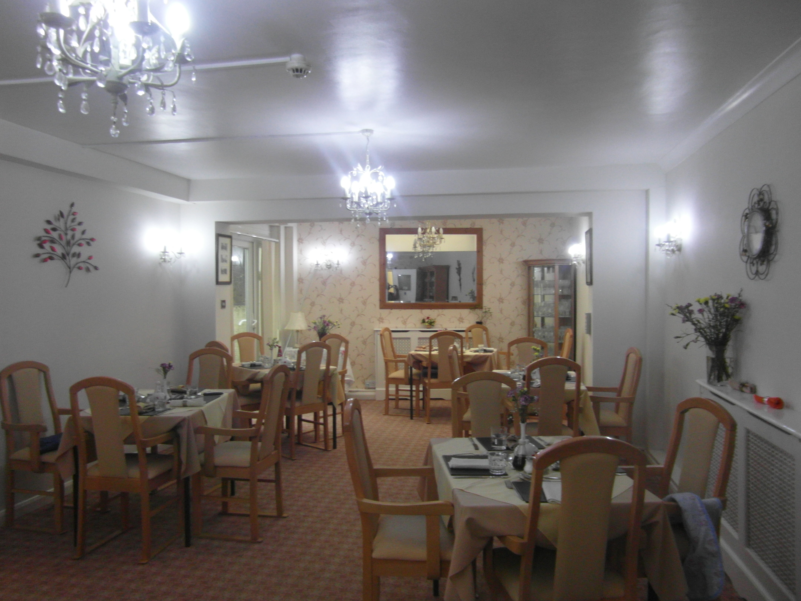
We are aware how important mealtimes are in our Home and we like them to remain a sociable and enjoyable part of the day. Our experienced cooks are trained in the nutritional requirements of elderly people and to ensure all meals are prepared from fresh, seasonal ingredients. All main meals are served in the dining room. We can also cater for any special dietary needs e.g. low sugar, low fat, liquidised, gluten free. In addition, we use the ‘Malnutrition Universal Screening Tool’ (MUST), which has been designed to help identify adults who are at underweight and at risk of malnutrition, as well as those who are obese.

Lift

An eight-person passenger lift connects the ground and first floor and is an especially great asset to those with mobility problems, enabling level access to gardens and first floor rooms. Almost all areas of the home are accessible to wheelchair users.

Bedrooms
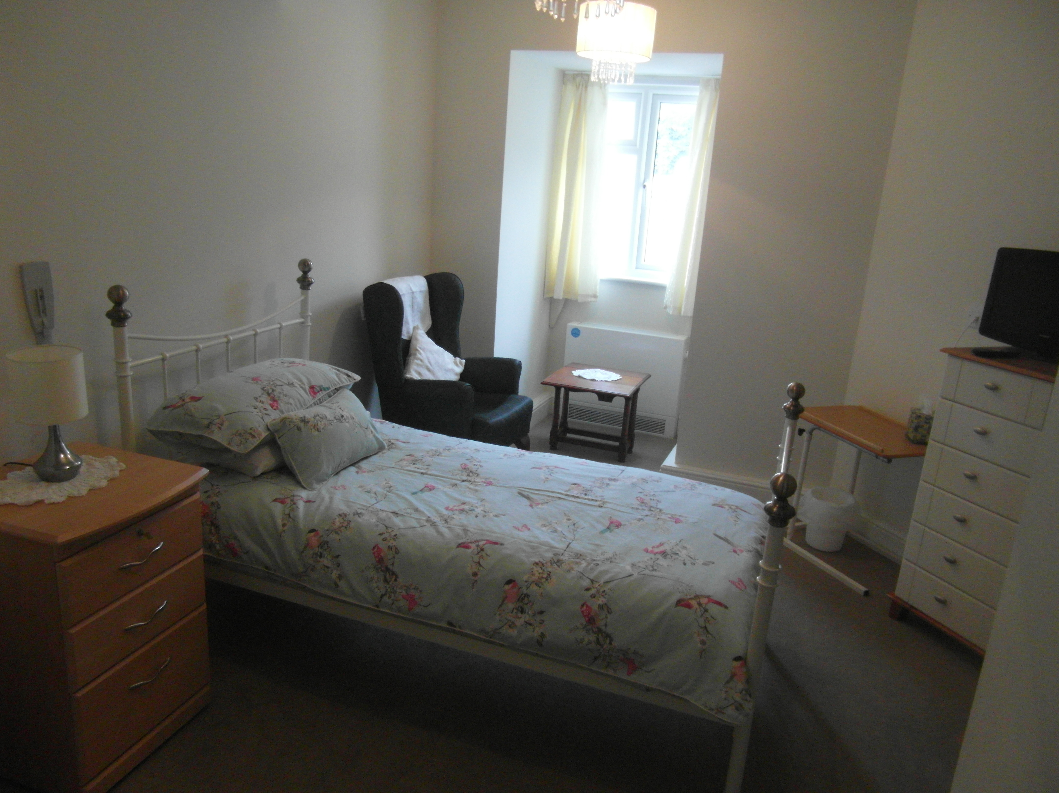
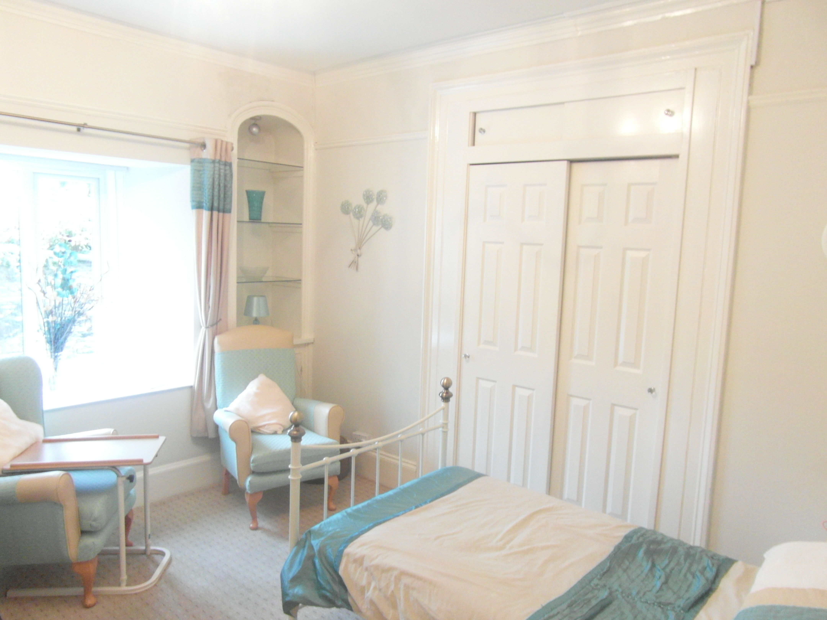
All the bedrooms are single, so each resident can have care and comfort in privacy. Fifteen rooms have en-suite toilets and wash basins, three rooms have en-suite showers toilets and washing facilities. Four rooms have washing facilities. All have an efficient radio call system to summon immediate help. There are telephone and television points in the bedrooms for those who wish to have individual access although complete financial responsibility for these rests with the residents. Many residents bring in some of their own furniture as well as ornaments, pictures and photographs. Individuals may like to have their own curtains and matching bed linen. All furniture and furnishings are supplied if preferred.

Bathing Facilities
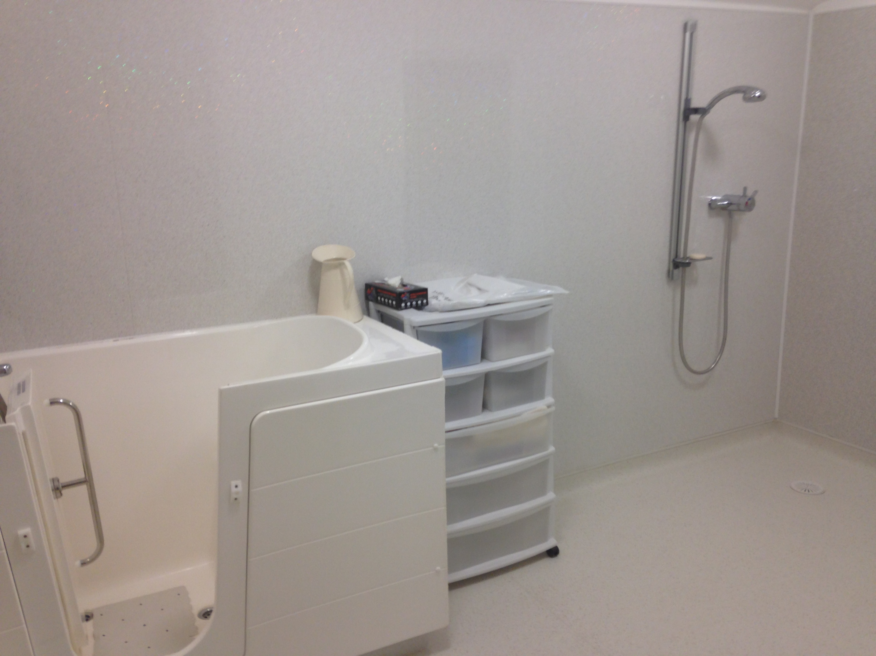
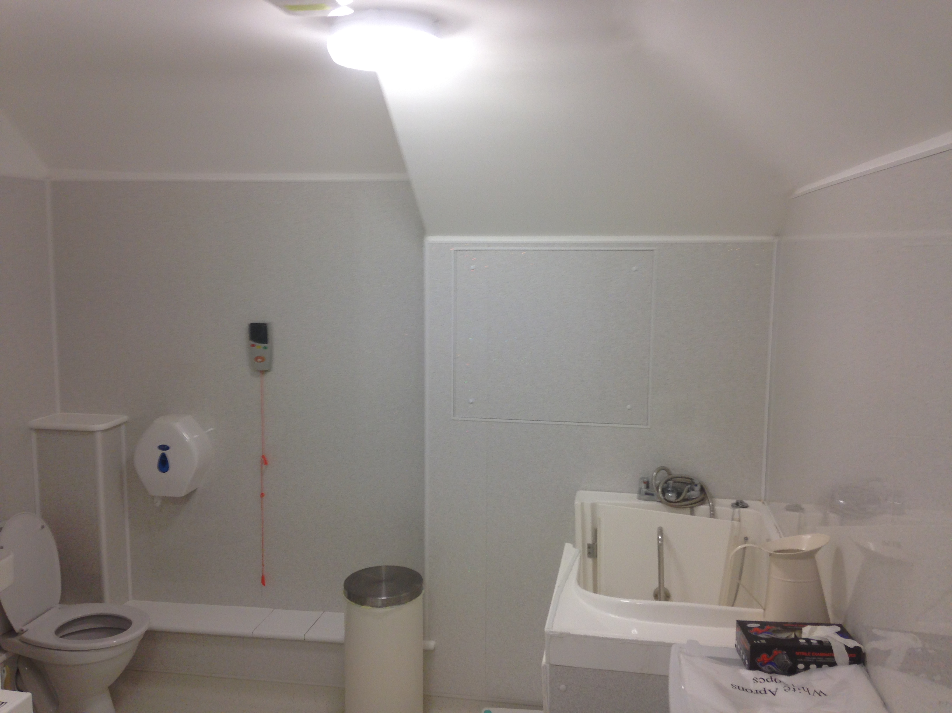
Special bathing facilities are available around the home. There is one wrap around Medi-baths, an ordinary bath with a Bath-Knight and one with a bath chair. An independent shower room/wet room is also available.

Management and Staff

The home is run by a voluntary Management Committee and is managed on a day-to-day basis by Mrs Jennifer Nancarrow-Allen. The manager is supported by staff who are selected for their abilities in caring, in being scrupulously honest, in having a sense of humour, in being able to maintain confidentiality at all times and to work as part of a team. The staff have a wealth of experience in dealing with all aspects of care and are encouraged to participate in the National Vocational Qualification system that leads to a recognised certificate in care. All members of staff have a personal development plan & update their knowledge & skills on a regular basis.

Activities

We are a member of the National Association for Providers of Activities (NAPA) for Older People and encourage activities that enhance our residents’ lifestyle, health and wellbeing. We employ an Activities Co-ordinator to support & encourage regular activities. They including bingo, handicraft sessions, quizzes and music and movement sessions. Various local entertainers visit and outings are booked during the year. One to one sessions are carried out for services users who prefer this style of activity.
Weekly religious services take place and Holy Communion is administered in the home. Services are held every Sunday, at present. Although non-denominational, they are conducted by the Salvation Army, Methodist Church, Ark Mission and Church of England in rotation for residents who are unable to attend their own Church. Other faiths would be accommodated similarly at the request of residents and subject to a representative of any particular faith being available to take services. The weekly shopping trolley service is much appreciated and there are regular visits from personal clothing retailers. A hairdresser and chiropodist visit the Home. Residents’ individual interests and activities are encouraged.

Medical Care

We know how important it is to look after our residents with the dignity and respect they deserve. Attentive staff at Eventide work with our residents and their loved ones to create a detailed care plan. This ensures our residents’ individual health and care needs are continually met. Our commitment to training for our staff has helped the Department of Health pass its goal of 3,000 Dignity Champions nationwide and we are proud to be associated with this scheme. The two local General Practitioner surgeries provide excellent medical care and visit as required.
If a resident becomes unwell we will try to care for him/her as one would a relative at home. Should a resident’s care needs become such that the home feels that they are unable to meet them adequately, the Manager would arrange for assistance and advice to help the person concerned choose a more suitable environment.

Finance

Eventide Home welcomes residents funded privately or by the local authority, with a ‘Top up’ (if necessary) to meet our fee levels. Fees are payable four weekly, in advance at the appropriate rate. A dependency level will ascertain the weekly fee and this will be discussed at the Pre-Admission Assessment.
Each Resident’s personal belongings are insured for up to £500, beyond this the individual will need to make his/her own arrangements.
We encourage new residents to set up enduring Power of Attorney with a relative or solicitor before or on admission. We recommend the advocacy service of Care Aware or Age UK.
Where there is no relative or friend available, the local social services department or the above-mentioned agencies, should be asked to recommend someone to act as agent. No member of staff is able to take on this role.

Clothing

Clothing should be labelled with embroidered nametapes which can be ordered through the Home, (at the resident’s expense), to avoid losses and should preferably be machine washable. We can organise a dry-cleaning service with the local laundry. The cost is the responsibility of the resident.

Complaints

Any complaints or comments about Eventide Home should be referred to the Manager. If you are unable to resolve a matter following discussion, please write to the chairman of the Management Committee of the Home. If you are still unable to resolve the matter, please write to: -

Adult Care and Support
Old County Hall
Truro
Cornwall Telephone: 0300 1234 131

Complaints can be made directly to CQC at any time if felt necessary.

CQC South West
Citygate
Gallowgate
Newcastle Upon Tyne
NE1 4PA Telephone: 0300 0616 161

We need to know from yourselves or your relatives if you are happy with your care or if we can improve anything. We welcome any ideas you may have to keep Eventide homely and they are always considered.

Residents’ Visitors

Visitors are welcomed to the home at all reasonable times. Staff reserve the right to deny access if a resident has expressed the wish not to see a visitor or visitors on temporary or permanent basis. It is their choice.

No Smoking

A ‘No Smoking’ policy exists in the home.

Visiting the Home

You are most welcome to view the home and meet the staff and residents. Please telephone the Manager to arrange a visit without obligation. A list of fees are attached.
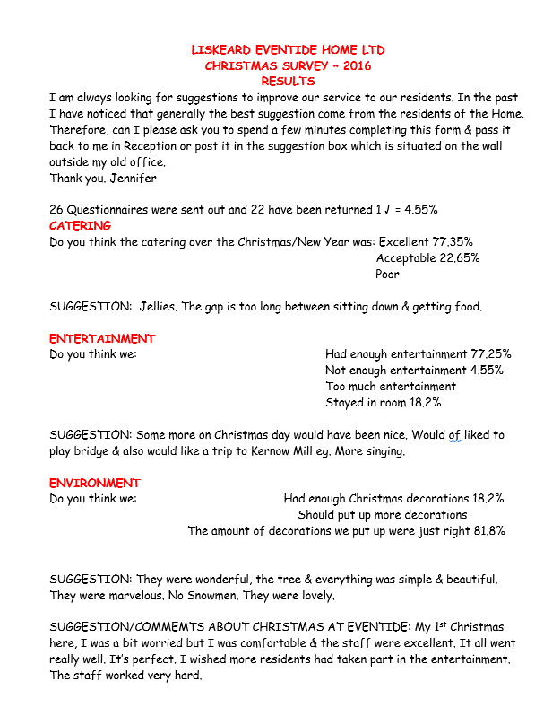

Residents’ views of the Home

“The jolly and friendly staff, good food and cleanliness makes Eventide a happy Home for me”.

“The quality of care received at Eventide is first class”.

“I am always grateful for the courtesy given to my visitors”.

“The excellent staff are kind and helpful”.

“The food is very good and I participate in all the activities”.

“The food is plentiful and one can always ask for more!”

“Thank you all very much for all your helping and making this a happy home”.

ROOM CHARGES FOR NEW ADMISSIONS
PER WEEK
FROM 1 APRIL 2019

ROOM TYPE | Low  Dependency | Medium  Dependency | High  Dependency | Total Dependency,  Continuing Care & Palliative Care
EN-SUITE TOILET | £703.09 | £737.37 | £771.66 | £805.98
EN-SUITE TOILET AND SHOWER | £737.37 | £771.66 | £805.98 | £838.32
ROOMS 14 & 18  EN SUITE TOILET  & LOUNGE AREA | £880.00 | £907.50 | £935.00 | £962.50
RESPITE  ROOM | £728.89 | £764.42 | £799.98 | £835.55
GROUND FLOOR ROOM  (WITH EN SUITE) | £764.43 | £799.98 | £835.55 | £869.08

DAYCARE

Daycare with lunch £25.00 per day, £35 at weekends

Daycare with lunch & shower/bath £30.00 per day, £40 at weekends



Phone: 01579 342676
Fax: 01579 340728
eventidehome@btconnect.com
www.liskeardeventidehome.co.uk

Liskeard Eventide Home
14 Castle Street
Liskeard
Cornwall
PL14 3AU

APPLICATION FORM

LISKEARD EVENTIDE HOME
14 CASTLE STREET, LISKEARD, CORNWALL, PL14 3AU
TELEPHONE: 01579 342676
REGISTERED WITH SOCIAL SERVICES OF CORNWALL COUNCIL
PLEASE PRINT

MR/MRS/MISS
1. NAME IN FULL ...................................................................................................................

2. ADDRESS………………….........................................................................................................
…………………………………………………………………………………………………………………………………………………….

3. TELEPHONE NUMBER …....................................................................................................

4. DATE OF BIRTH ............................................. PLACE OF BIRTH .........................................

PLEASE TICK APPROPRIATE BOXES

5. ARE YOU: SPINSTER o WIDOW o BACHELOR o WIDOWER o
DIVORCED o SEPARATED o MARRIED o

MAIDEN NAME (IF APPLICABLE) ................................................................................

6. DO YOU LIVE IN (A) PRIVATE DWELLING o
(B) SHELTERED HOUSING o
(C) RESIDENTIAL HOME o
(D) WITH RELATIVES o

7. NAME OF LOCAL AUTHORITY COVERING THE AREA WHERE YOU LIVE

...........................................................................................................

8. ARE YOU ABLE TO WALK WITHOUT YES o
ANOTHER PERSON'S ASSISTANCE WITH DIFFICULTY o
USING A STICK, FRAME, ETC IF REQUIRED? NO o

9. ARE YOU ABLE TO WASH AND DRESS YOURSELF? YES o
WITH DIFFICULTY o
NO o

10. ARE YOU ABLE TO BATH YOURSELF? YES o
WITH DIFFICULTY o
NO o

11. DO YOU HAVE PRIVATE MEDICAL INSURANCE? YES o
NO o

12. DETAILS OF YOUR NEXT OF KIN (OR ACTING NEXT OF KIN)
NAME...............................................................................................................................
ADDRESS ..........................................................................................................................
TELEPHONE NUMBER ........................................................................................................
RELATIONSHIP ..................................................................................................................
13.IF YOU HAVE GRANTED AN ENDURING POWER OF ATTORNEY TO ANYONE PLEASE GIVE HIS/HER NAME ADDRESS (PLEASE LET US HAVE A COPY OF THE RELEVANT DOCUMENT):

NAME ………………………...............................................................................................

ADDRESS ....................................................................................................................5r

14. Funding Details:

My fees will be paid by………………………………….
(if social services funded, please specify Social Worker)
SOCIAL WORKER…………………………………………………………………………………………………………………..
Contact Details…………………………………………………………………………………………………………...

15.NAME AND ADDRESS OF YOUR PRESENT DOCTOR FROM WHOM YOU AGREE WE OBTAIN A REPORT IF NECESSARY

NAME ....................................................................................................................

ADDRESS ................................................................................................................

16.IN ORDER TO COMPLY WITH LEGISLATION WE NEED TO KNOW OF YOUR CHOSEN ARRANGEMENTS/WISHES FOR THE FOLLOWING; -
CREMATION/BURIAL___________________

CHOSEN UNDERTAKER AND CONTACT DETAILS FUNERAL PLANS OR POLICIES IN PLACE? _______________________________________

17.SIGNATURE .....................................................................................................................

DATE ....................................................................................................................................
LISKEARD EVENTIDE HOME

DETAILS OF CARE NEEDS

Medical Conditions
Personal Care
Dietary Needs

Sight, hearing & communication

Oral Care

Foot Care

Mobility & Dexterity

Continence

Cultural Needs

Social & Recreational Needs

MEDICAL CERTIFICATE IN RESPECT OF APPLICANT FOR
ADMISSION TO THE HOME

NAME AND ADDRESS OF APPLICANT

NAME ....................................................................................................................................

ADDRESS ..............................................................................................................................

........................................................................................................................................

I HEREBY CERTIFY that the applicant referred to above is suitable for communal life and

- If a diabetic, please state if insulin is self-administered.
- Is not suffering from any physical defect or disability which would render him/her dependant upon personal nursing care as nursing facilities are not provided.

SIGNED ........................................................................................................

ADDRESS .....................................................................................................

....................................................................................................................

DATE .....................................

