WINDAMERE HORSE HAVEN
HORSE SPONSORSHIP

For a minimum of $10 a week up to a nominated sum of your choosing you can help contribute to saving a rescue horse here At Windamere Horse Haven.
Your sponsorship money will go towards providing your horses with the necessary essentials required. Things like:
- Feed
- Farrier visits
- Veterinary care
- Specialist visits required e.g. Chiro, Equissage etc.
- Worming
- Equipment e.g. Bridles, girths etc.
- Rugs

We encourage our sponsors to spend time with their sponsored horses and are more than welcome to give them special gifts e.g. Treats, Toys, Rugs etc.

When you sponsor a horse you will receive 3 monthly progress reports and photos so you can keep informed of their progress.

We have many horses available for sponsorship so please contact us to find out what horses are available.
- Ph. 0423586384
- Website - www.windamerehorsehaven.com
- Facebook – www.facebook.com/#!/WindamereHorseHaven

When your sponsored horse is rehomed you can either choose another horse to sponsor or you can end the sponsorship. You can also end your sponsorship at any time by simply notifying us with 2 wks. notice in writing.

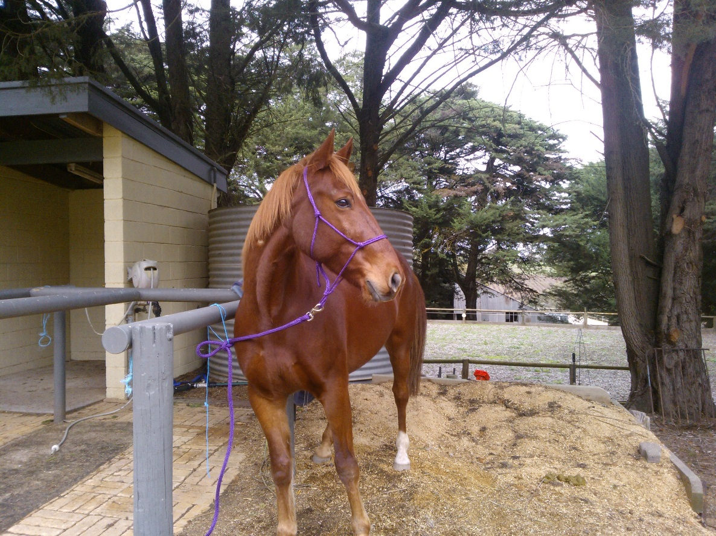

SPONSORSHIP FORM

FULL NAME:

POSTAL ADDRESS:

TELEPHONE:

EMAIL:

I WOULD LIKE TO SPONSOR____________________________________________________
FOR $_____________ PER WEEK/FORTNIGHT/MONTH
COMMENCING _______________________________
SIGNED ____________________________________________________________________
SPONSORSHIP CAN BE CANCELLED ANYTIME WITH 2WKS NOTICE IN WRITING
We recommend setting up a direct debit into our account for easy transaction.

BANK DETAILS
Windamere Horse Haven Inc
BSB 105 025
ACC 060478640

