Summer Camp 2019
at Hill Farm Preschool
2-6 year olds!!!
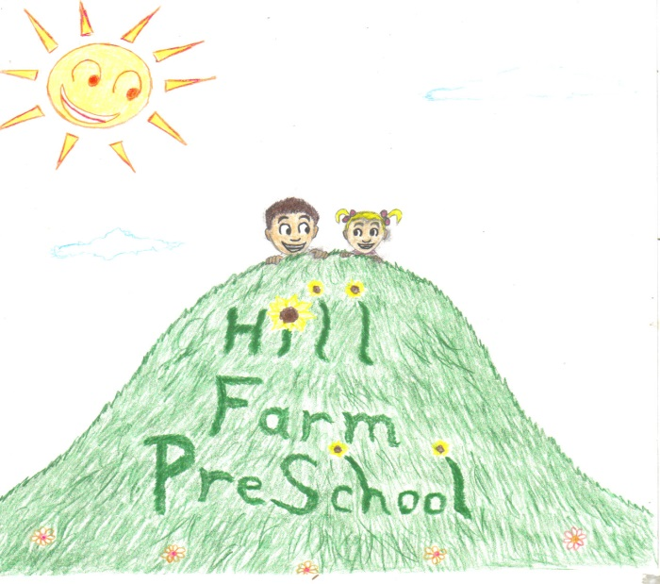

160 Hill Farm Rd. Fairfield, CT
Hillfarmpreschool.com
(203)292-9533
Email-hillfarmpreschool@yahoo.com
Camp Fees
(multiple day pricing applies to the same week)
50% deposit due at time of registration. Balance due by May 10th.
Please note: NO changes can be made after May 17th
Adding days after 5/17 is allowed if there is space available.
There are NO make-up days
Sibling Discount-
First child full price. Second child receives a 10% discount.
9:15am-12:30pm | Tuition | 9:15am-2:00pm | Tuition
1 day | $55 | 1 day | $70
2 days | $110 | 2 days | $135
3 days | $155 | 3 days | $195
4 days | $195 | 4 days | $250
5 days | $230 | 5 days | $290

Please ask for pricing info if you would like to enroll your child in only a few longer days from 9:15am-2pm
For example- Mon/Wed 9:15am-2pm and Fri 9:15am-12:30pm

Each week is a new and exciting theme!!!!
Week 1: June 4-7 (No camp-Mon 6/3) Let’s Party Week
Each day of camp we will celebrate and have a party to kick off summer camp!
Tuesday-Happy Birthday to Us, Wednesday-Luau, Thurs-It’s a Fiesta, Friday-Dance Party U.S.A
Week 2: June 10-14 Hill Farm Diner
What’s better than breakfast at the diner? Come spend the week at Hill Farm Preschool Diner where each day we will make some delicious breakfast classics such as hot cocoa, pancakes, and fresh squeezed orange juice!
Week 3: June 17-21 The Wonderful World of Disney
We will sprinkle a little bit of pixie dust at Hill Farm Preschool this week! Disney magic is all around us as we search for Dory, design Mickey ears, make Olaf with cotton balls and so much more.
Week 4: June 24-28 Summer Storybook Club
Let’s jump into a good book!! Through acting out a story, art, cooking, and more we will make some of our most beloved stories come to life! There’s nothing better than a good book in the summer sun!
Week 5: July 1-3(No camp Thurs 7/4 or Friday 7/5) Happy 4th of July
Let’s show our American spirit!! The campers will enjoy making red, white and blue parfaits, Independence Day hats and wave American flags in our parade. Of course, there will be dancing and bubbles at our party!
Week 6: July 8-12 Craft and Create
Paint, Draw, and more! We will explore different art techniques such as water colors, sculpting with real clay, paper mache, oil pastels, and canvas painting! We might get a little messy this week but that’s part of the fun!
Week 7: July 15-19 No Camp-Church VBS
There is no camp this week due to the church hosting Vacation Bible Camp. The camp is open to the public-if anyone is interested. Enrollment forms are available thru Hill Farm Preschool.
Week 8: July 22-26 Secret Agents
Oh no! Our favorite toys are missing!! Where could they be? Let’s get out our detective gear and solve this mystery!! Campers will follow clues to solve a new mystery each day!
Week 9: July 29-Aug 2 Wild, Wild West
Howdy Partner! This here week is going to be the wildest camp in the west! The cowboys and cowgirls will decorate cowboy hats, make a sandpaper cactus, and look for gold!! Watch out their face just might appear on a wanted poster!
Weeks 10: Aug 5-9 Backyard Bash
Just like back in the day when we used to play outside in our backyard for hours-campers will get to spend the day playing hopscotch, throwing water balloons, chalk art on the sidewalk, popsicles and so much more!

Hill Farm Preschool Summer Camp 2019
Enrollment Form for 2-6 year olds

Child’s Name_____________________ Date of Birth_______________
Parent’s Names______________________________________________
Address___________________________________________________
Home Phone___________________ Cell Phone___________________
Email_____________________________________________________
Please circle days:
Week 1 | June 3-7 | --- T W TH F | 9:15-12:30 | 9:15-2:00 | $__________
Week 2 | June 10-14 | M T W TH F | 9:15-12:30 | 9:15-2:00 | $__________
Week 3 | June 17-21 | M T W TH F | 9:15-12:30 | 9:15-2:00 | $__________
Week 4 | June 24-28 | M T W TH F | 9:15-12:30 | 9:15-2:00 | $__________
Week 5 | July 1-5 | M T W --- --- | 9:15-12:30 | 9:15-2:00 | $__________
Week 6 | July 8-12 | M T W TH F | 9:15-12:30 | 9:15-2:00 | $__________
Week 7 | July 15-19 | No Camp | VBS | ------------------ | ------------------
Week 8 | July 22-26 | M T W TH F | 9:15-12:30 | 9:15-2:00 | $__________
Week 9 | July 29-Aug 2 | M T W TH F | 9:15-12:30 | 9:15-2:00 | $__________
Week 10 | Aug 5-9 | M T W TH F | 9:15-12:30 | 9:15-2:00 | $__________
Total due $______________
(check which applies) 50% Deposit__________ or Pay in full__________
Balance due by May 10th $_____________
Payment type- check______ credit card______ cash_______
Credit card #_______________________________________________
Exp. Date___________ CVC#(3 digit number on back of cc)___________
Please mail enrollment form and deposit to: or email enrollment form with credit card information to:
P.O. Box 491. Fairfield, CT 06824 hillfarmpreschool@yahoo.com

