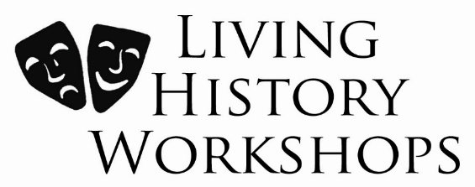

Historical Workshops for
Schools & Community Groups

Dear Parents

Your child’s class will shortly be taking part in a Living History Workshop, held within the school, during normal school hours. The day will involve the use of costume, drama and historical artefacts.

Occasionally we use face paint or make-up (Snazzaroo brand) on the children as part of their costumes. Please notify us of any allergies and give permission using the form below.

Thank you

Corrine Crawford
Living History Workshops

Name of child ___________________________ Class_________________

Is your child allergic to Snazzaroo face paint? _____________________________________________

I confirm that I have no objection to the use of make-up or face paint on my child:

Signed__________________________________Parent/Guardian Date_________________

PLEASE RETURN TO YOUR CHILD’S TEACHER BY ____________________________________________

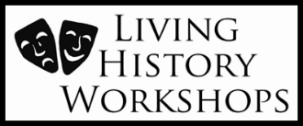
Telephone: 07985 165801
Email: corrine@livinghistoryworkshops.co.uk
Website: www.livinghistoryworkshops.co.uk

