Holster Selection

Everyone that has a handgun has a drawer full of holsters. The more guns the more holsters. And it is not just one holster for each gun or carry option. There are 2 or 3 holsters for each of many different configurations.
The problem is that like most things we each have our likes and dislikes and also depending on our body type and wardrobe some holsters are comfortable and some are not. Some conceal well on others and are comfortable but not on us. And unfortunately there are few places to try them before you buy. Hopefully this tutorial may help you iron out some of the facts.

Lets first talk about the kind of holsters:
Holsters can be divided into four broad categories by use: duty holsters, worn by uniformed peace officers and security personnel; tactical holsters, worn by military, security, and law enforcement personnel in certain situations; sporting holsters, worn for shooting sports and hunting; and concealment holsters, worn by plainclothes peace officers and private persons
Duty Holsters: are designed to be carried openly, so concealment is not an issue, but retention and appearance are. Duty holsters can be made of leather, nylon, or plastic; they are designed to be attached to a duty belt, and worn on the dominant side. Retention is an important issue with these types of holsters.
Tactical/Military holsters: are usually made of nylon or plastic. They may be made in a camouflage pattern to match the wearer's uniform. They are often of a drop-leg design. Some military holsters still use the old flap design (also referred to as a "suicide" or "widow maker" holster), which is cumbersome and slow on the draw, but provides greater protection for the holstered firearm against the elements.
"Sporting" holsters: cover the widest range, from holsters with maximum access for Fast Draw shooting, to highly adjustable holsters used in IPSC and pin shooting, to old-fashioned holsters used in Cowboy Action Shooting such as the Bridgeport rig, to high retention, maximum protection holsters used for handgun hunting, to simple holsters used to hold a handgun while out plinking. Like any sporting equipment, sporting holsters evolve to maximize the benefits given the rules of the game, where applicable, so the competitive sports have the most specialized holsters.
Holsters for hunting tend to be unique, as they are designed to carry the largest handguns, and often must make allowances for telescopic sights. The largest handguns are often carried in holsters that are slung across the shoulder, and removed from the body before the handgun is drawn. Slow access is acceptable in this case because the handgun is not expected to be used for defensive purposes.

Concealment holsters: are designed to be easily concealed, as well as lightweight and unobtrusive; they are generally designed for subcompact and compact handguns, since they are easier to conceal.
Concealment holsters are designed to be worn under clothing (such as on the belt under a coat, under pants in an ankle holster, or in a trouser pocket). Since the holster is held close to the body, comfort is important, and concealment holsters often have broad surfaces in contact with the user's body, to distribute the pressure across a wider area and prevent abrasion of the skin. Protecting the handgun from the user's perspiration is often an important consideration in such carry locations.
Often the outside of the holster is broader, to help break up the outline of the handgun and prevent printing, where the outline of the gun can be seen through clothing. For pocket holsters, the external flat side is often the side with a nap, or rougher surface, to hold the holster in place when drawing the pistol.
Types of Concealment holsters:
- Outside the waistband (OWB) or belt holsters, are most commonly used by police and military, and by citizens who choose to open carry. Belt holsters can be worn relatively high and close to the body, slightly behind the hip bone ("4:00 position"), and can be concealed under a long, untucked shirt or jacket.
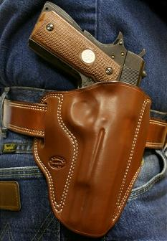
- Inside the waistband (IWB) holsters, which clip or mount to a belt and allow one to securely holster the weapon inside the pants. Some IWB holsters give the wearer the option of tucking a shirt over the firearm and holster.
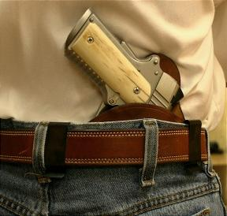
- Shoulder holsters consist of two straps connected in a manner similar to a backpack, with the actual holster mounted to a strap on the right or the left side. Shoulder holsters are designed to position the handgun: 1. in a vertical position, with the barrel pointed generally toward the ground; (large guns) 2. in a vertical position, with the barrel pointed generally upward; (questionable since gun is pointing in a dangerous direction) 3. in a horizontal position, with the barrel pointed generally behind the wearer. (not good for small framed people)
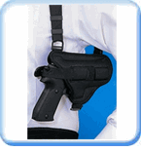

- The "belly band" holster is a wide elastic belt with a built-in holster, usually worn under an untucked shirt, to facilitate access. There are various types, worn at the belt line or higher, with the gun placement anywhere from in front to under the armpit. In order to remain in place, a belly band must be extremely tight; this is generally uncomfortable - it is comparable to wearing a girdle.
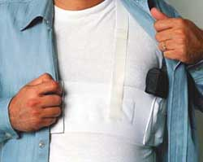
- Pocket holsters are used for very small weapons, such as a back-up gun or a mousegun. They usually have one side flat to keep the gun from printing (showing) in the pocket and the outside of the holster is usually rough so that when the gun is drawn from the pocket, the holster stays in the pocket.
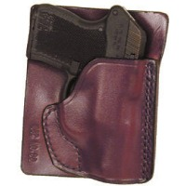

- Small of Back (SOB) holsters place the weapon directly over the center of the back, allowing for even large handguns to be carried with little printing. While both comfortable and stylish, should the wearer fall onto the weapon (such as in a close quarters fight) serious spinal injury (including paralysis) may occur. For this reason, in recent times many police departments in the US have disallowed any equipment, gun, handcuffs, etc, to be worn in this position.
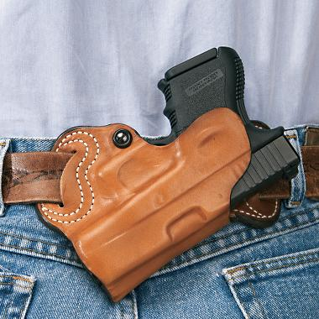
- Groin holsters place the handgun mostly below the waistline around the 12:00 position. There are no body movement restrictions and very few clothing restrictions with this holster type. Very difficult to draw the weapon when sitting or in a car.
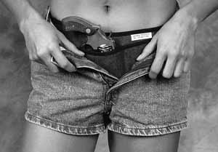
- Ankle holsters offer excellent concealment and are used often by law enforcement officials who wish to carry a secondary weapon to back up their primary firearm. You must practice to be able to draw from this type of holster.
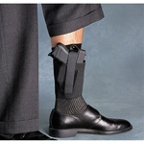
- Cross Draw Holster are excellent for concealment and a great choice for people that sit at desk or drive a lot since drawing the holster is much easier.
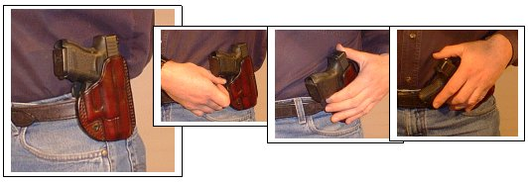

- Chest holsters can be attached to MOLLE (Military Attachment system) compatible vests and chest carriers. Like shoulder holsters, chest holsters are often easier to draw from than belt holsters when the operator is seated inside a vehicle.
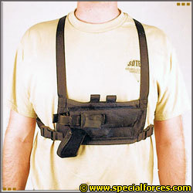
Other, specialized types of holsters are designed to be mounted inside briefcases, day planners, fanny packs, purses or even articles of clothing.
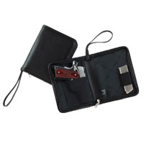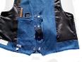
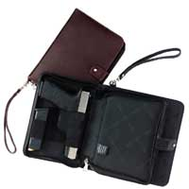
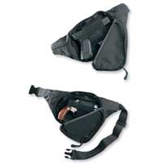
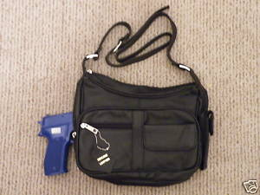

Top of Form

Bottom of Form

The use of these types of holsters is available but care should be exercised in using them due to the difficulty to get to the firearm, the chance that the purse, briefcase or day planner can be set down and be out of your control or taken away easily.
When choosing a holster for a firearm, factors to consider include:
- Safety - a well designed holster will provide protection to the handgun during insertion into or removal from the holster or while being carried that will: 1. prevent accidental trigger movement; 2. prevent accidental disengagement of the safety mechanism; 3. prevent forward or rearward movement of the hammer. These features will vary greatly as applicable to the action of the handgun. The safety features of a holster very much require that the holster be engineered and designed for each specific manufacture and model of handgun.
- Retention - a holster designed with retention in mind will help prevent a gun from being removed from the holster by anyone other than the person wearing it. Modern duty holsters have multiple hidden retention devices to this end. Frequently, retentive holsters are custom designed for a specific model of gun. For civilian use level one retention is maximum suggested.
- Concealment - it is often desirable not to alert other people of one's being armed. A carefully designed and worn holster can make a gun virtually invisible. Almost all concealment holsters are designed to be worn with a covering garment that is part of the wearer's everyday attire.
- Comfort - ability to wear a gun for an extended period without excessive discomfort.
- Finish - a well designed holster should not snag a pistol or excessively abrade its finish.
- Draw ease - practical shooting holsters allow a gun to be presented quickly, but drawing ease is often compromised in concealed carry. Drawing practice is frowned upon at many gun ranges. You should practice at home to become comfortable with drawing and presenting your firearm. “SAFETY FIRST” Make sure the gun is unloaded….
- Durability - ability to withstand abuse and long-term usage without mechanical failure or impaired performance
- Ease of reholster - a rigid holster will allow a gun to be returned to it with one hand, while a flexible one may collapse after the gun is drawn, requiring the use of both hands to reholster.
- Adjustability - a holster that provides for the adjustment of gun cant and position can aid in both comfort and concealment.
- Price - modern holsters for a $500 handgun can cost $20 to $200. Some users will require multiple holster types per gun, while others may prefer a generic holster for carrying multiple gun types.

This by no means covers everything. There are tons of options within these choice and many more. The important facts to remember is that what is right for me may not be the best for you. How you dress is important. You should learn to dress around the firearm. You will need a few different holsters for different dress attire. Remember, if you have a concealed carry permit the firearm must be concealed. But as important, is, if you have a concealed carry permit you should be carrying. Don’t let poor holster choices force you to leave your gun home. It is of no use to you home in the safe or locked in your car.

More discussion on this with examples will be provided in many of my classes.

